**Nama : Septwu Muhammad R  
Npm : 085020028  
Tugas : Pemrograman Mobile 1**

**Bicycle :**

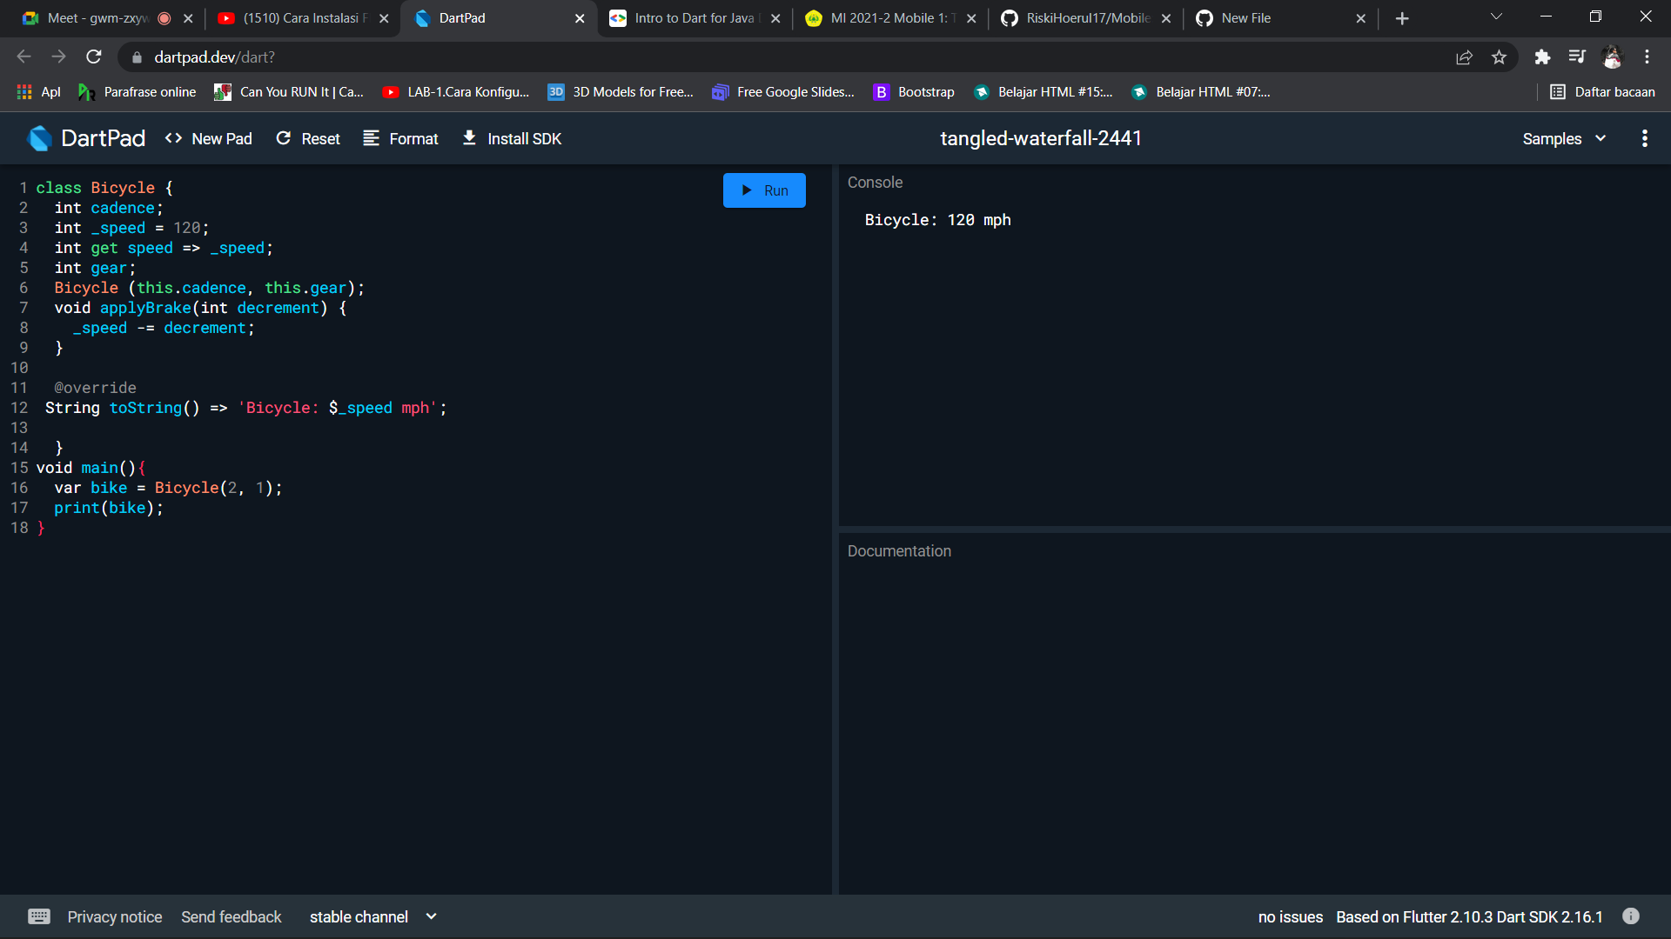

**Rectangle :**

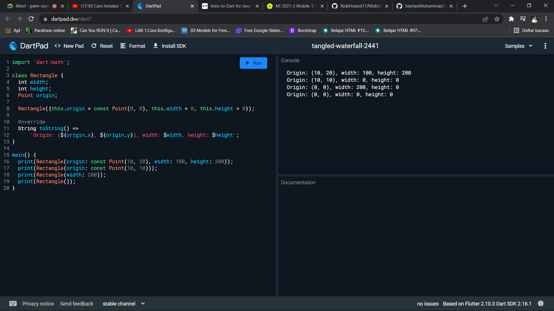

**String scream :**   
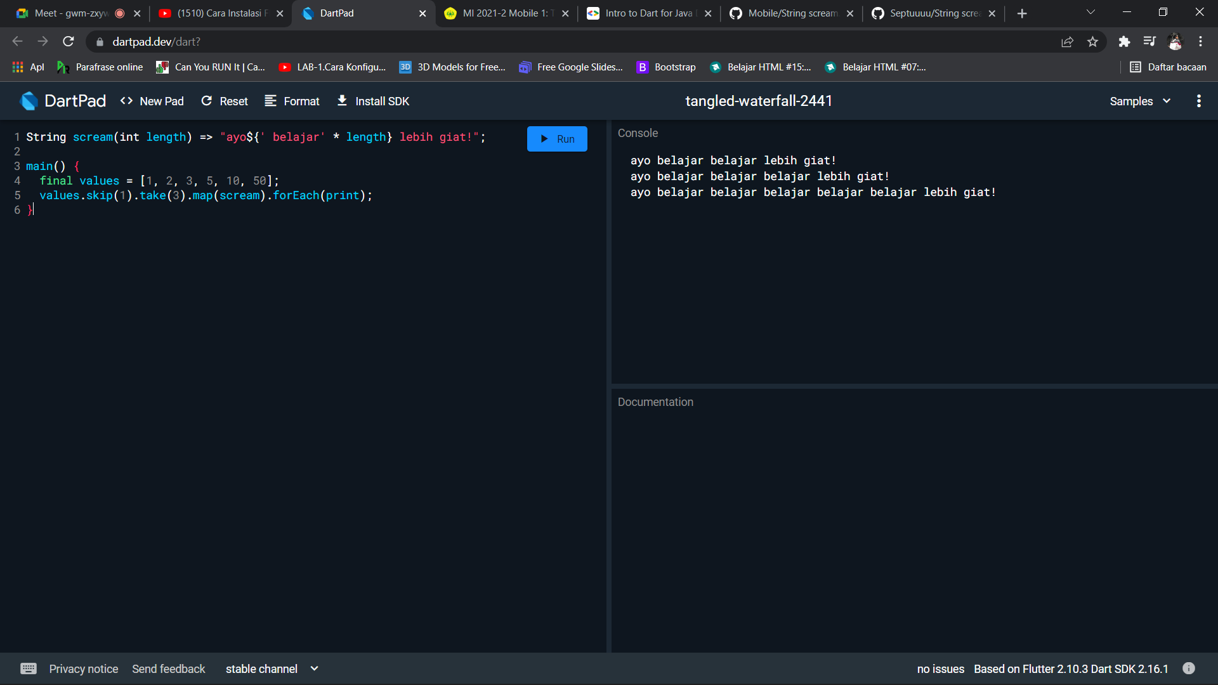

**Abstract :**