Estimating Exponential Growth Rate of European Population of SARS-CoV-2

Iason Karatarakis, Nikolas Dritsas

1. Abstract

This report aims to estimate the rate of exponential growth of the European population of SARS-CoV-2. The analysis utilizes observed and simulated datasets to calculate three statistics: w, k, and D. The values obtained for the observed dataset are compared with the simulated datasets to determine the similarity between them. The Euclidean distances between the observed and simulated datasets are calculated, and the parameter values corresponding to the smallest distances are obtained from the pars_final.txt file. The mean and median of these parameter values are calculated and further analyzed through histograms and density plots. Finally, the implications of the rate values for the population of SARS-CoV-2 are discussed.

2. Introduction

The ongoing COVID-19 pandemic caused by the SARS-CoV-2 virus has had a significant impact on global populations. Understanding the rate of exponential growth of the virus is crucial for effective mitigation and control measures. This report focuses on estimating the growth rate of the European population of SARS-CoV-2 using observed and simulated datasets.

3. Methodology:

3.1 Data Collection

The observed dataset, ms_obs_final.out, contains the actual data for the European population of SARS-CoV-2. Additionally, simulated datasets, ms_sim_final.out, are available for comparison.
We read those files using the following functions :
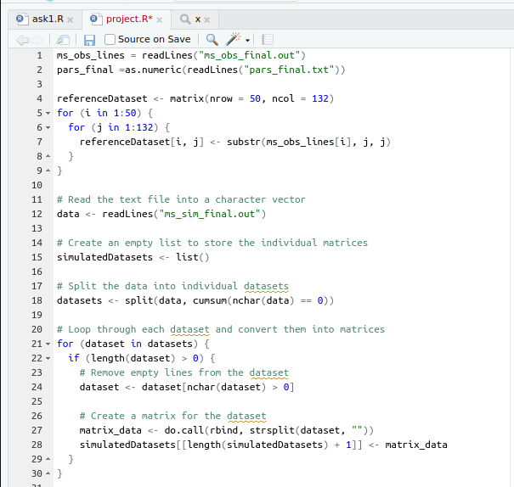

Figure 1 : Functions to read the files

3.2 Calculation of Statistics

For each dataset, the three statistics (w, k, and D) are calculated using custom functions. These statistics provide insights into the exponential growth rate. To calculate the k statistic we compared each sequence of the dataset with every other sequence after it in the same dataset . Thus n = 50 .
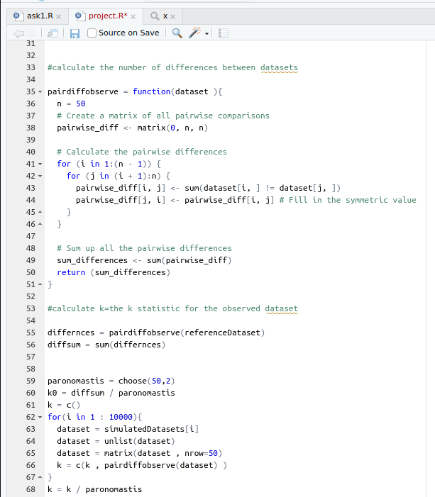
Figure 2 : calculating the k statistic for all datasets

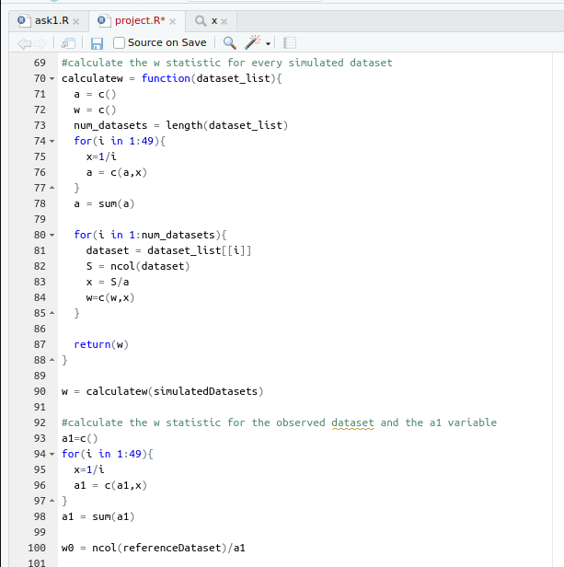
Figure 3 : Calculate the w statistic for all datasets and the a1 variable

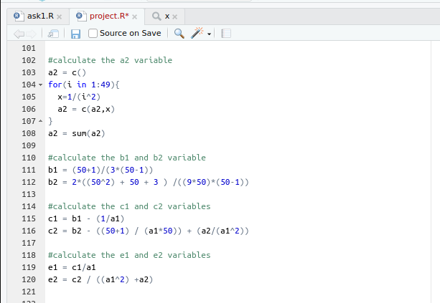
Figure 4 : Calculate the a2,b1,b2,c1,c2,e1 and e2 variables

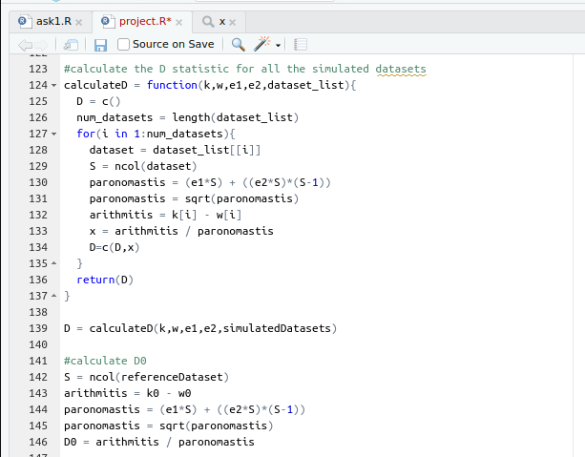
Figure 5 : Calculate the D statistic for all datasets

3.3 Normalization

The vectors w, k, and D are normalized by calculating their mean and variance. The normalized values are obtained to ensure comparability between the datasets.

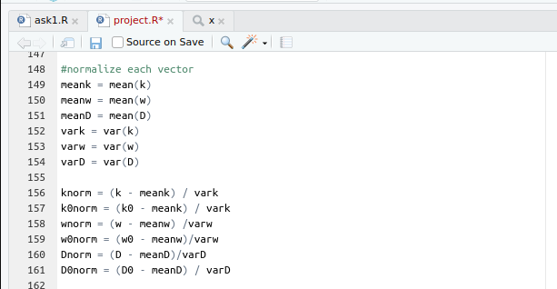
Figure 6 : Normalize the values

3.4 Euclidean Distance Calculation

A function is developed to calculate the Euclidean distances between the observed dataset and each simulated dataset. The distances, denoted as d1, d2, ..., d10000, represent the similarity between the observed and simulated datasets.

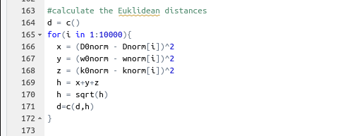
Figure 7 : Calculate the distances for all datasets

3.5 Parameter Extraction

The 500 smallest distances are identified, and their corresponding indexes are noted. The parameter values associated with these indexes are extracted from the pars_final.txt file.

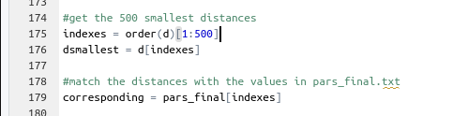
Figure 8 : Find the 500 smallest distances and keep their indexes

3.6 Statistical Analysis

The mean and median of the 500 extracted parameter values are calculated. Histograms and density plots are generated to visualize the distribution and density of these values.

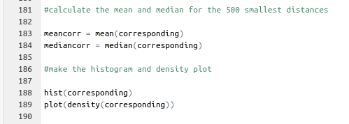
Figure 9 : Calculate the median and mean of the 500 values

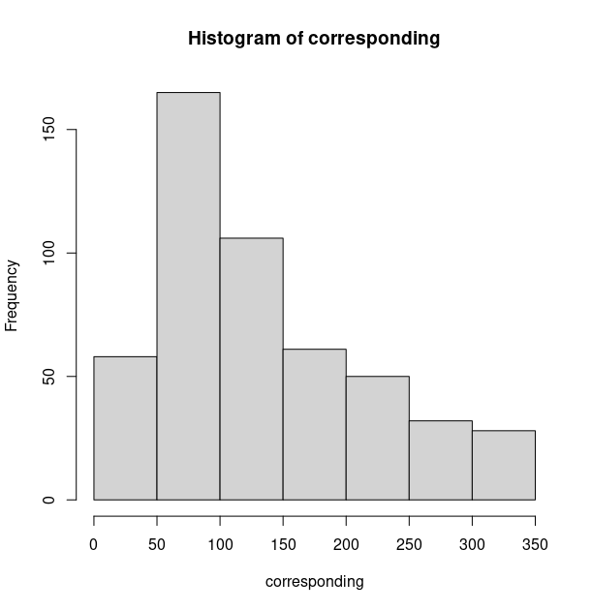

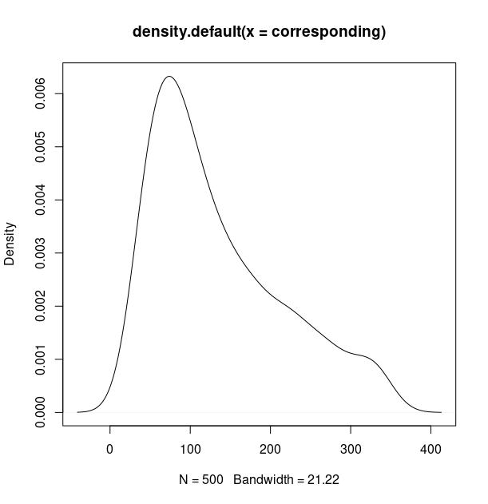
4. Results

The mean and median values obtained from the extracted parameters provide insights into the similarity between the observed and simulated datasets. The histogram and density plot illustrate the distribution of parameter values and highlight any potential trends or patterns.

5. Discussion

The final results indicate the proximity of the simulated datasets to the observed dataset in terms of the growth rate of the European population of SARS-CoV-2. The extracted parameter values offer a range of potential growth rates that align with the observed data. Interpreting these values in the context of a year, they provide an estimation of the virus's population growth rate over a specific time period.

6. Conclusion

The estimation of the exponential growth rate of the European population of SARS-CoV-2 using observed and simulated datasets provides valuable insights for public health professionals and policymakers. The analysis highlights the similarity between the observed and simulated datasets and offers a range of potential growth rate values. Understanding these growth rate values can contribute to better preparedness and response strategies for mitigating the impact of SARS-CoV-2 on the European population.

