Práctico FCEFyN

Redes de computadoras

Trabajo Práctico 7

***Integrantes:***

* Sleiman, Mohamad
* Zabala, Guillermo

Docente: Matías R. Cuenca del Rey

Ayudantes alumnos: Elisabeth Leonhard - Andrés Serjoy

Redes de computadoras

Facultad de Ciencias Exactas, Físicas y Naturales

Universidad Nacional de Córdoba

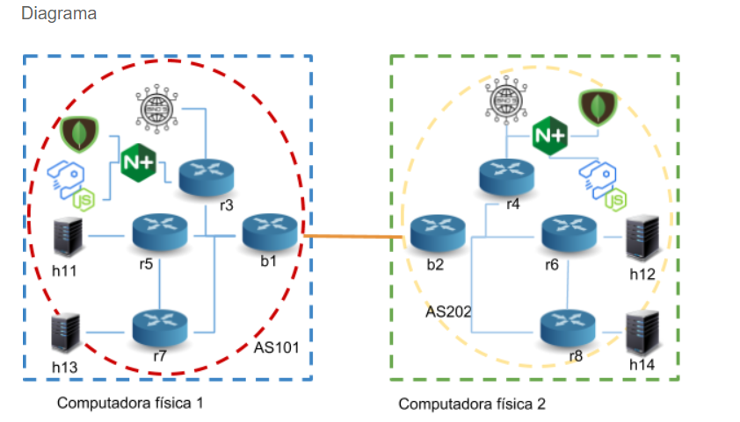

### Ejercicio 1: Ruteo internet.

##### Configuración de Red

1.- Asignar redes IPv6 para cada sistema autónomo.

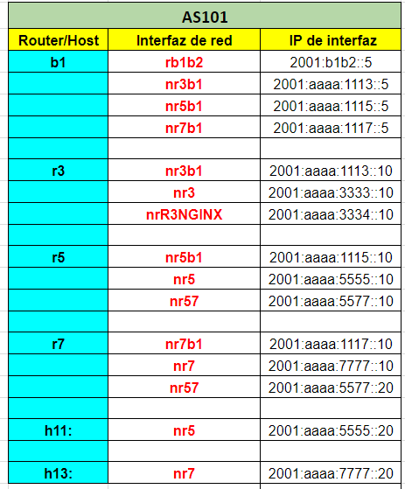

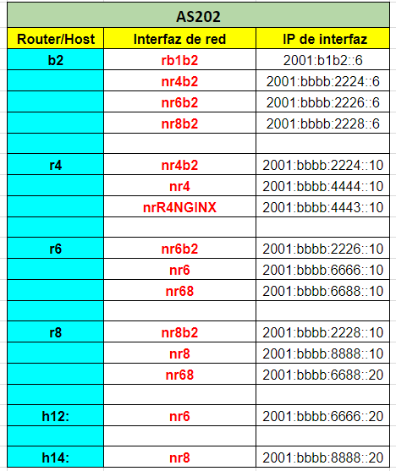

2.- Asignar un nombre de dominio único para cada sistema autónomo.

3.- Completar la tabla de asignación de redes.

4.- Configurar los sistemas autónomos con BGP.

5.- Interconectar los sistemas autónomos.

6.- Configurar OSPFv3 como protocolo de ruteo interno dentro de cada sistema autónomo

**Archivo Docker-compose PC1**

|  |  |
| --- | --- |
| version: '2.1'  services:  web:  image: nginx  container_name: nginx  volumes:  - ./volumes/nginx/default.conf:/etc/nginx/conf.d/default.conf  ports:  - "8080:80"  environment:  - NGINX_HOST=foobar.com  - NGINX_PORT=80  networks:  nrSTRAPINGINX:  ipv6_address: 2001:aaaa:3335::10  nrR3NGINX:  # NGINX con router r3  ipv6_address: 2001:aaaa:3334::20  ##para entrar por navegador por container nginx a strappi (no borrar default gateways)  #http://[2001:aaaa:3335::10]:80  ##para entrar por navegador pero por el router 3 a strappi  #http://[2001:aaaa:3334::20]:80  ##para entrar por cualquier container por NGINX  #docker exec -ti router_r5 curl get http://[2001:aaaa:3334::20]:80  #docker exec -ti router_r5 curl get http://[2001:aaaa:3334::20]:80  ## tambien se usa el GET desde el navegador unicamente (no borrar default gateways)  #GET http://[2001:aaaa:3334::20]:80  ##hago el ejemplo del strapi "quick start"  ##desde el container para ver lo que se ingresa uso desde cualquier container  #docker exec -ti router_r5 curl get http://[2001:aaaa:3334::20]:80/product  api:  ## build: ./strapi/.  image: strapi/strapi  container_name: strapi  environment:  - APP_NAME=strapi-app  - DATABASE_CLIENT=mongo  - DATABASE_HOST=db  - DATABASE_PORT=27017  - DATABASE_NAME=strapi  - DATABASE_USERNAME=  - DATABASE_PASSWORD=  - HOST=2001:aaaa:3335::20 | ports:  - 1337:1337  volumes:  - ./volumes/strapi-app:/usr/src/api/strapi-app  #- /usr/src/api/strapi-app/node_modules  depends_on:  - db  restart: always  networks:  nrSTRAPINGINX:  ipv6_address: 2001:aaaa:3335::20  db:  image: mongo  container_name: mongoDB  environment:  - MONGO_INITDB_DATABASE=strapi  ports:  - 27017:27017  volumes:  - ./volumes/db:/data/db  restart: always  command: mongod --ipv6 --bind_ip_all  networks:  nrSTRAPINGINX:  ipv6_address: 2001:aaaa:3335::30  b1:  build: ./bgp/.  container_name: router_bgp1  volumes:  - ./volumes/bgp/b1/zebra.conf:/etc/quagga/zebra.conf:ro  - ./volumes/bgp/b1/ospf6d.conf:/etc/quagga/ospf6d.conf:ro  - ./volumes/bgp/b1/bgpd.conf:/etc/quagga/bgpd.conf:ro  - ./volumes/bgp/supervisord.conf:/etc/supervisor/conf.d/supervisord.conf:ro  image: bgp:20180426  privileged: true  ports:  #admin  - 10101:2601  #ospf ipv6  - 10103:2606  #bgp  - 10104:2605  networks:  rb1b2:  ipv6_address: 2001:b1b2::5  nr3b1:  ipv6_address: 2001:aaaa:1113::5  nr5b1:  ipv6_address: 2001:aaaa:1115::5  nr7b1:  ipv6_address: 2001:aaaa:1117::5 |

|  |  |
| --- | --- |
| r3:  build: ./ospf/.  container_name: router_r3  volumes:  - ./volumes/ospf/r3/zebra.conf:/etc/quagga/zebra.conf:ro  - ./volumes/ospf/r3/ospf6d.conf:/etc/quagga/ospf6d.conf:ro  - ./volumes/ospf/supervisord.conf:/etc/supervisor/conf.d/supervisord.conf:ro  image: ospf:20180419  privileged: true  ports:  #admin  - 10331:2601  #ospf ipv6  - 10333:2606  networks:  nr3b1:  ipv6_address: 2001:aaaa:1113::10  nr3:  ipv6_address: 2001:aaaa:3333::10  nrR3NGINX:  ipv6_address: 2001:aaaa:3334::10  r5:  build: ./ospf/.  container_name: router_r5  volumes:  - ./volumes/ospf/r5/zebra.conf:/etc/quagga/zebra.conf:ro  - ./volumes/ospf/r5/ospf6d.conf:/etc/quagga/ospf6d.conf:ro  - ./volumes/ospf/supervisord.conf:/etc/supervisor/conf.d/supervisord.conf:ro  image: ospf:20180419  privileged: true  ports:  #admin  - 10551:2601  #ospf ipv6  - 10553:2606  networks:  nr5b1:  ipv6_address: 2001:aaaa:1115::10  nr5:  ipv6_address: 2001:aaaa:5555::10  nr57:  ipv6_address: 2001:aaaa:5577::10 | r7:  build: ./ospf/.  container_name: router_r7  volumes:  - ./volumes/ospf/r7/zebra.conf:/etc/quagga/zebra.conf:ro  - ./volumes/ospf/r7/ospf6d.conf:/etc/quagga/ospf6d.conf:ro  - ./volumes/ospf/supervisord.conf:/etc/supervisor/conf.d/supervisord.conf:ro  image: ospf:20180419  privileged: true  ports:  #admin  - 10771:2601  #ospf ipv6  - 10773:2606  networks:  nr7b1:  ipv6_address: 2001:aaaa:1117::10  nr7:  ipv6_address: 2001:aaaa:7777::10  nr57:  ipv6_address: 2001:aaaa:5577::20  h11:  build: ./hosts/.  container_name: host_h11  volumes:  - ./volumes/hosts/h11/zebra.conf:/etc/quagga/zebra.conf:ro  - ./volumes/hosts/supervisord.conf:/etc/supervisor/conf.d/supervisord.conf:ro  privileged: true  tty: true  ports:  #admin  - 10111:2601  networks:  nr5:  ipv6_address: 2001:aaaa:5555::20  h13:  build: ./hosts/.  container_name: host_h13  volumes:  - ./volumes/hosts/h13/zebra.conf:/etc/quagga/zebra.conf:ro  - ./volumes/hosts/supervisord.conf:/etc/supervisor/conf.d/supervisord.conf:ro  privileged: true  tty: true  ports:  #admin  - 10113:2601  networks:  nr7:  ipv6_address: 2001:aaaa:7777::20 |

|  |  |
| --- | --- |
| bind:  build: ./dns/.  container_name: DNS_service  environment:  - ROOT_PASSWORD=ubuntu  volumes:  - ./volumes/webmin_datos:/data:rw  networks:  nr3:  ipv6_address: 2001:aaaa:3333::20    networks:  rb1b2:  driver: "bridge"  enable_ipv6: true  ipam:  driver: default  config:  - subnet: 2001:b1b2::/64  nr3b1:  driver: "bridge"  enable_ipv6: true  ipam:  driver: default  config:  - subnet: 2001:aaaa:1113::/64  nr5b1:  driver: "bridge"  enable_ipv6: true  ipam:  driver: default  config:  - subnet: 2001:aaaa:1115::/64  nr7b1:  driver: "bridge"  enable_ipv6: true  ipam:  driver: default  config:  - subnet: 2001:aaaa:1117::/64  nr3:  driver: "bridge"  enable_ipv6: true  ipam:  driver: default  config:  - subnet: 2001:aaaa:3333::/64  nr5:  driver: "bridge"  enable_ipv6: true  ipam:  driver: default  config:  - subnet: 2001:aaaa:5555::/64  nr7:  driver: "bridge"  enable_ipv6: true  ipam:  driver: default  config:  - subnet: 2001:aaaa:7777::/64 | nr57:  driver: "bridge"  enable_ipv6: true  ipam:  driver: default  config:  - subnet: 2001:aaaa:5577::/64  nrSTRAPINGINX:  driver: "bridge"  enable_ipv6: true  ipam:  driver: default  config:  - subnet: 2001:aaaa:3335::/64  nrR3NGINX:  driver: "bridge"  enable_ipv6: true  ipam:  driver: default  config:  - subnet: 2001:aaaa:3334::/64 |

**Archivo Docker-compose PC1**