西 安 邮 电 大 学
（计算机学院）
IntroDuction to java programming
课内实验报告

实验名称: 类和对象 I

专业名称: 软件工程
班 级: 1505
学生姓名: 王一妃
学号（8位）: 04153161
指导教师: 王博
实验时间:

一. 实验目的及实验环境
1 熟悉java的类的定义和对象的生成
2 掌握java的类的抽象
3 方法重载overload
4 能够根据给定问题进行类的设计
二. 实验内容
1 基本内容（实验前请及时熟悉如下相关内容）
1.1 类的定义及对象的创建和使用
1.2类的构造方法
1.3 方法重载overload
1.4 对象的赋值与比较
1.5 引用型参数传递
2 综合应用
2.1 (英文版八版 8.7 The Account class)
Design a class named Account that contains:
A private int data field named id for the account (default 0).
A private double data field named balance for the account (default 0).
A private double data field named annualInterestRate that stores the cur-
rent interest rate (default 0).Assume all accounts have the same interest rate.
A private Date data field named dateCreated that stores the date when the
account was created.
A no-arg constructor that creates a default account.
A constructor that creates an account with the specified id and initial balance. The accessor and mutator methods for id,balance, and annualInterestRate. The accessor method for dateCreated.
A method named getMonthlyInterestRate() that returns the monthly
interest rate.
A method named withdraw that withdraws a specified amount from the
account.
A method named deposit that deposits a specified amount to the account.
Draw the UML diagram for the class. Implement the class. Write a test program
that creates an Account object with an account ID of 1122, a balance of $20,000,
and an annual interest rate of 4.5%. Use the withdraw method to withdraw
$2,500, use the deposit method to deposit $3,000, and print the balance, the
monthly interest, and the date when this account was created.

2.2 (英文版八版 8.8 The Fan class)
Design a class named Fan to represent a fan. The class contains: Three constants named SLOW, MEDIUM, and FAST with values 1, 2, and 3 to
denote the fan speed.
A private int data field named speed that specifies the speed of the fan
(default SLOW).
A private boolean data field named on that specifies whether the fan is on
(default false).
A private double data field named radius that specifies the radius of the fan
(default 5).
A string data field named color that specifies the color of the fan (default
blue).
The accessor and mutator methods for all four data fields.
A no-arg constructor that creates a default fan. A method named toString() that returns a string description for the fan. Ifthe fan is on, the method returns the fan speed, color, and radius in one combined string. If the fan is not on, the method returns fan color and radius along with the string fan is off in one combined strin
Draw the UML diagram for the class. Implement the class. Write a test program
Fan objects. Assign maximum speed, radius 10, color yellow,that creates two and turn it on to the first object. Assign medium speed, radius 5, color blue, and turn it off to the second object. Display the objects by invoking their toString method.

2.3 Think and design a class named Person in HuaRong road game ,and write test programs (or class) that create person objects with the class person . You need not implement the game completely in this experiment and maybe implement the whole function next time. The view of the game is as follows:

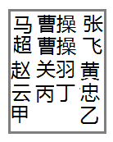

三．方案设计（核心代码和流程设计）
3.1


3.2
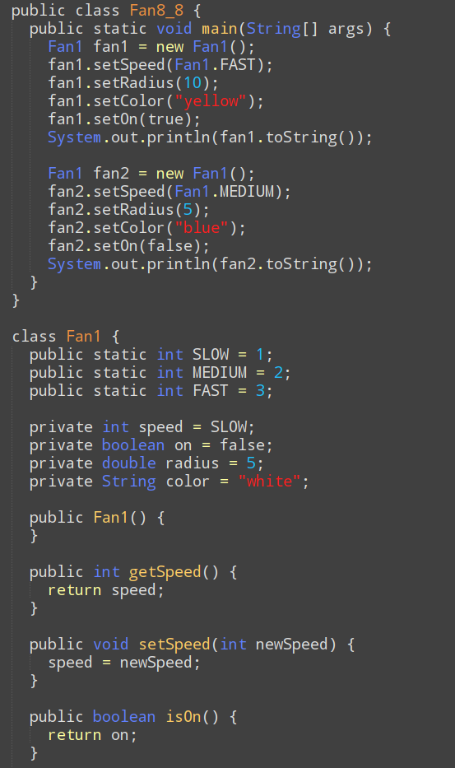

3.3

四．测试数据及运行结果

- 正常测试数据（3组）及运行结果；
2.1

2.2
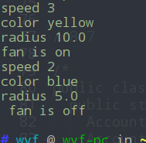
2.3

2．非正常测试数据（2组）及运行结果。

五．总结
- 实验过程中遇到的问题及解决办法。
（例如：记录编译时错误信息，根据实验过程中出现的编译错误信息分析出错原因，并改正错误。）

- 对设计及调试过程的心得体会。
（例如：记录运行时错误结果或者信息，根据实验过程中出现的运行时错误信息进行分析，并利用设置断点、单步跟踪等方法定位错误，改正错误。）

六．附录：源代码（请把源代码按照实验内容附到其后）

