MITSS

Sergi Sanz Carreres

Ejercicios Asociados al seminario de redes sociales y teoría de grafos

ERS : Extracción de Información Desde la Red Social

Table of Contents

Chapter 2: 2

Exercise 1: 2

Exercise 2: 3

Chapter 3: 4

Exercise 1: 4

Exercise 2: 5

Chapter 4: 5

Exercise 1: 5

Chapter 18: 6

Exercise 1: 6

Chapter 19: 6

Exercise 1: 6

Chapter 20: 6

Exercise 1: 6

Exercise 2: 6

# Chapter 2:

## Exercise 1:

### Give an example of a graph in which every node is pivotal for at least one pair of nodes. Explain your answer.

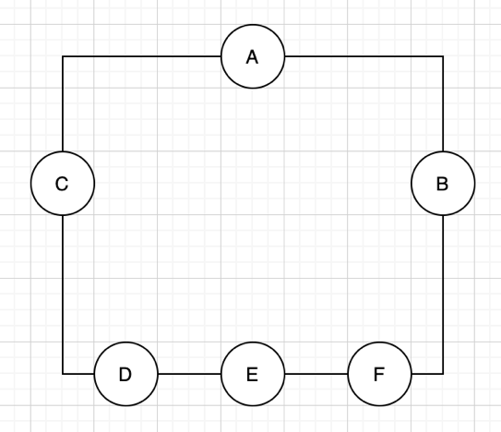

In this case, every node is pivotal at least one pair of nodes, because A is pivotal between C and B, C is pivotal between A and D, B with A and F, D with C and E, F with E and B, and E with D and F, for this reason all nodes are pivotal.

### Give an example of a graph in which every node is pivotal for at least two different pairs of nodes. Explain your answer.

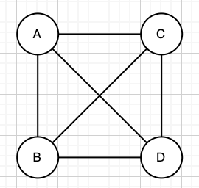

In this graph every node is pivotal at least two different pairs of nodes, you can check that for example:

* A is pivotal to B – C, B – D, C - D
* B is pivotal to A-D , C-D, A-C
* C is pivotal to A-D , B-D, A-B
* D is pivotal to B – C , A-B, A-C

### Give an example of a graph having at least four nodes in which there is a single node X that is pivotal for every pair of nodes (not counting pairs that include X). Explain your answer.

In this example we can check how all nodes have in common that the node pivotal is A

## Exercise 2:

### Give an example (together with an explanation) of a graph in which more than half of all nodes are gatekeepers

In this example the nodes D,B and E are gatekeepers because all paths passes through they.

### Give an example (together with an explanation) of a graph in which there are no gatekeepers, but in which every node is a local gatekeeper

In this case all nodes are local gatekeeper

# Chapter 3:

## Exercise 1:

When we have three nodes and two nodes have an edge (for example A and B) and we have other two nodes that they have an edge (for example A and C), then we suppose that C and B are “friends” or will be “friends” for that we add a closure between B and C.

Example:

## Exercise 2:

The property said that “*if the node has strong ties to two neighbors, then these neighbors must have at least a weak tie between them*”. For this reason, the answer is that the edge connecting b and c to be labelled like weak tie.

# Chapter 4:

## Exercise 1:

We have the following possibilities, an edge between a and c, an edge between c and e, and an edge between a and e. Any of these possibilities is equally probable, since the graph does not present any degree of homophilia.

# Chapter 18:

## Exercise 1:

In my opinion, the effect that will occur in the behaviour of people who browse the web will be that there will be a tendency to click where the visit counter is highest. This feature will achieve a much stronger power law than in the previous version without the counters. Therefore, there will be much more difference in visits between the most viewed article and the second, the second and the third, etc.

# Chapter 19:

## Exercise 1:

The procedure for carrying out this exercise is as follows, we must bear in mind that a node B can go towards A, for each node of the graph you take and calculate:

*numerodeVecinosAdeEseNodo/numTotalVecinos* , si es >=0.5 then it is marked as A.

You do that on all nodes until you can't change anymore.

Resulting in: {e, f, c, i, k}.

# Chapter 20:

## Exercise 1:

If we rely on the statement, a person connects to ten others, and those ten to another ten, would be as follows with the 6 iterations from that person:

1+10+100+1000+10000+100000+1000000 = 11.111.111

The world population is estimated to be around 7,000,000,000 people, so, based on this statement, it is not possible to connect all pairs of 2 people along a 6-node path.

## Exercise 2:

The D is larger, since in the groups if you connect to the 10 with which you have the most connection, it is more likely that there is a connection between them as well.