|  |  |
| --- | --- |
| Sersports instruction Manual  SER316 Project G | Colton Rose Kristel Basra Graydon Svendson Ashley Mannon Gabriella Gabby Tikhonova & Nick Krogstad  Team G  SER316 |

1. Installation

Installing the software is as straightforward as following the onscreen prompts and waiting as the files are copied to your computer. No further action needs to be taken to finalize the installation the software is now ready for use.

Windows:

Users should run the “Ser Sports.msi” installer located in the install/Windows/ directory to install the application.

Mac:

Users should just run the “SerSportsServerDB” file located in the install/Mac/ directory to run the application.

Note: If there are any issues installing the application, users can use the “SerSportsV1-0-2.jar” located in the install directory, to run the application.

1. User Account Creation

When the software is started you are presented with the screen shown in Figure 2.1. This screen prompts for a username and password, as this is the first time the software has been run you do not currently have a username as password, you will have to click the button `CREATE ACCOUNT`.

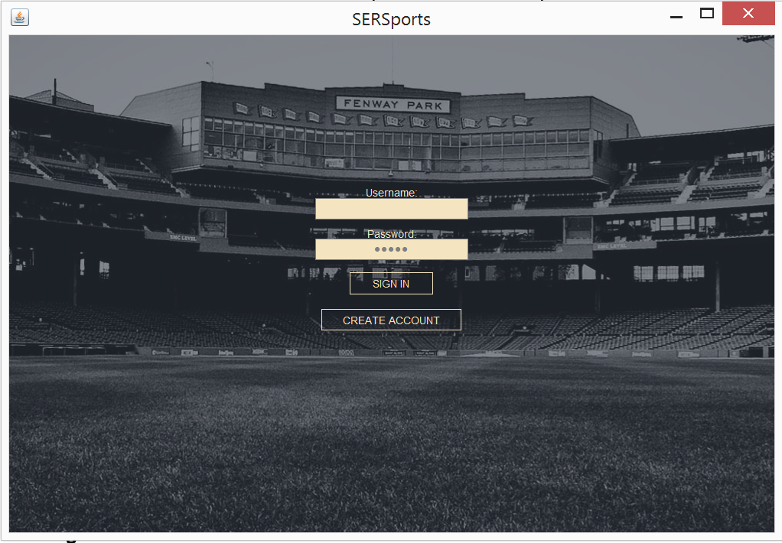

**Figure 2.1**

At this point you are at the User Account Creation screen shown in Figure 2.2. From here you can enter the information prompted for in the text boxes.

User Name: The unique username that will be used to login

Password: The password that pairs with your username to login

First Name: Your first name

Last Name: Your last name

Age: Your current age

Local Team: The name of local baseball team that you are on.

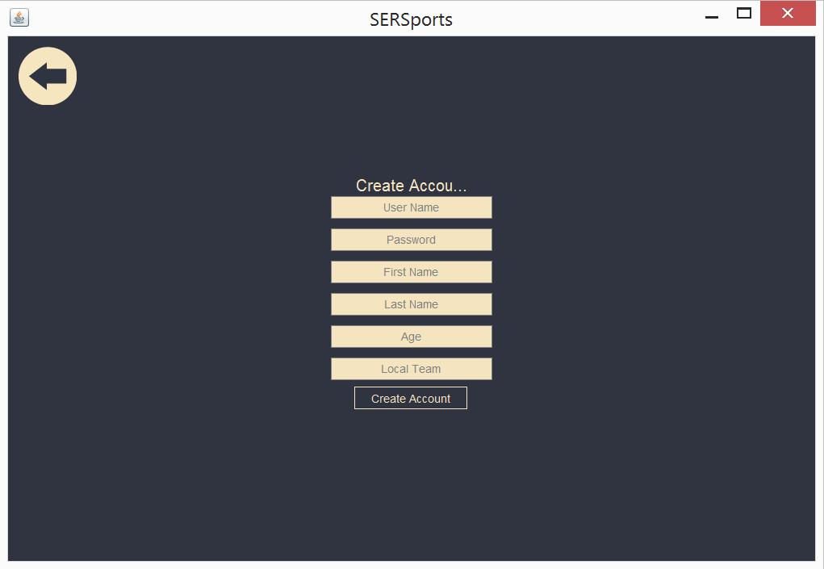

**Figure 2.2**

1. Entering a New Game

After logging in to the system with your new Username and Password you are presented with the `home` screen shown in Figure 3.1, from here you can see the top ten players that you compared to, right now you have no stats or games entered so the list will be blank for you. To enter a new game click on the `Enter New Stats` Button near the top of the screen. Your screen should change to look like Figure 3.2.

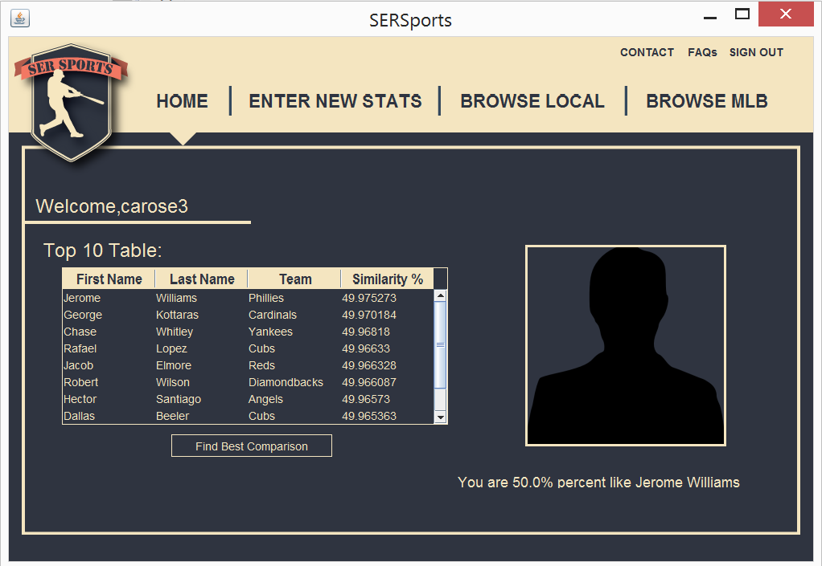

**Figure 3.1**

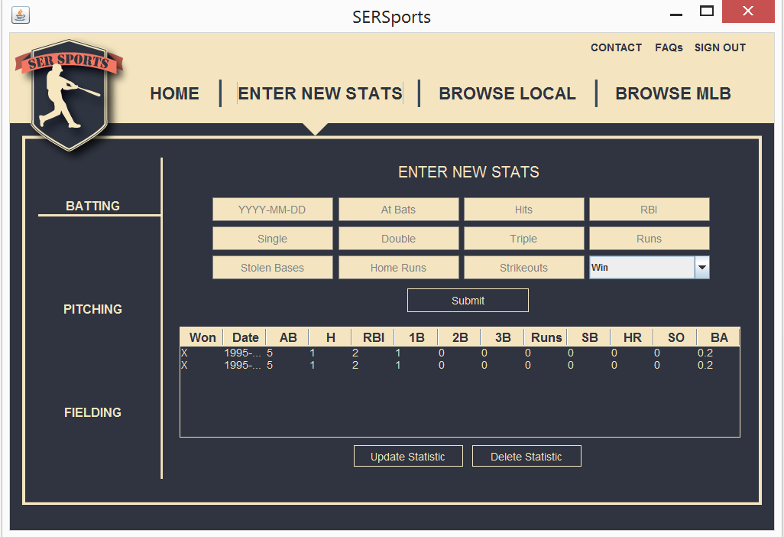

**Figure 3.2**

From this screen you can select which kind of stats you want to enter, you can enter Batting, Pitching, or Fielding stats on a per game basis. If you are having trouble remember the different stats used in baseball visit the FAQ found at the top of the screen, we’ve included a glossary of common baseball terms and statistics shown in Figure 3.3.

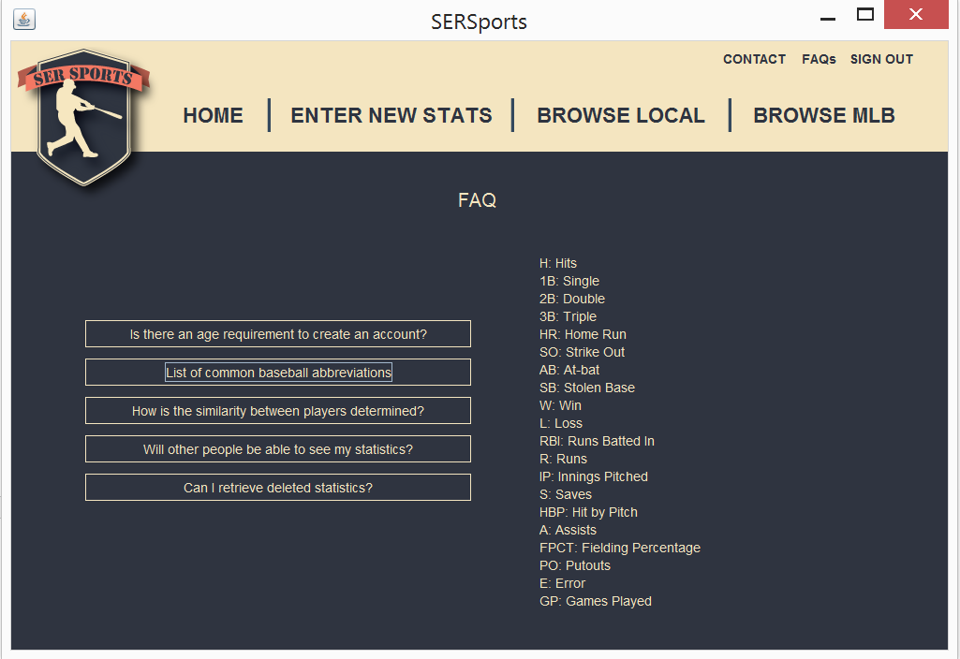

**Figure 3.3**

Below the stat entry area there is a table that shows all the games that you have entered so far along with the stats that are most useful at a glance, this is shown in Figure 3.4

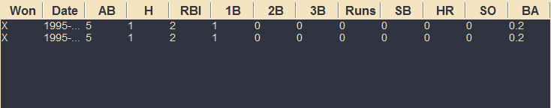

**Figure 3.4**

From this screen you can also update and delete games you have previously entered.

1. Browse Local Players

You have the ability to see the stats of all users that have registered on the current in use server. See the list of the players click the ‘Browse Local’ button near the top of the screen. Your screen should now look like Figure 4.1. You can search for a particular player using their Last Name, First Name, or Team Name or any combination of those criteria.

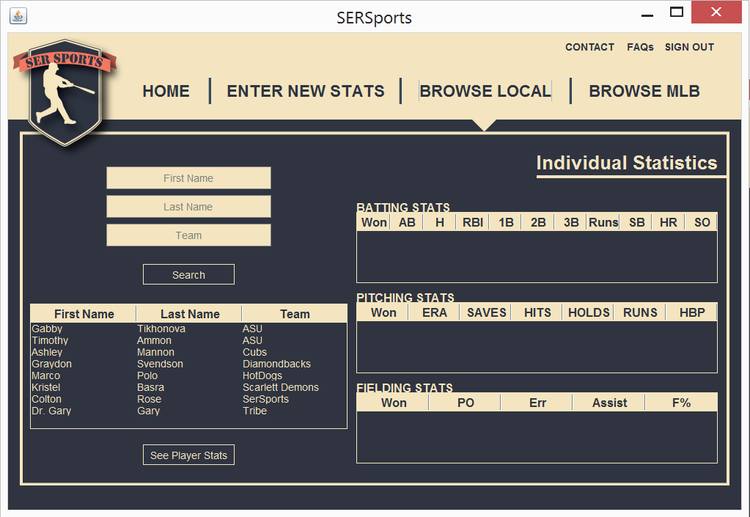

**Figure 4.1**

Once you have found the player that you are looking for click their name in the table below the search button and now you can click the button ‘See Player Stats’ The three tables on the side of the screen now have the game stats for the selected player as seen in Figure 4.2.

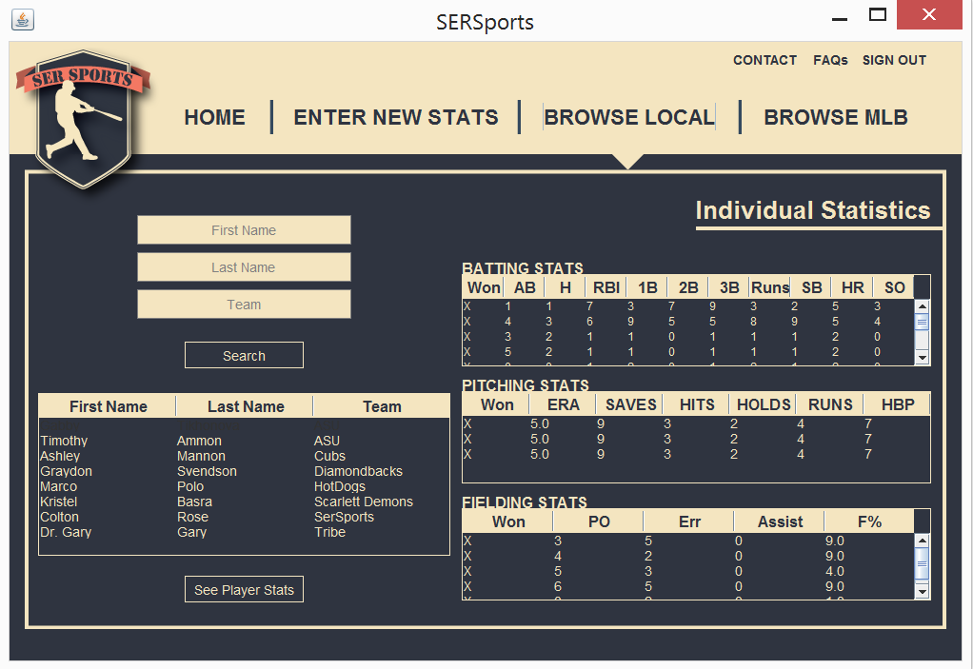

**Figure 4.2**

1. Browse MLB Players

Along with searching local players you also have the ability to lookup a professional MLB player’s stats, you can use this functionality by clicked the ‘Browse MLB’ button next to the ‘Browse Local’ at the top of the screen. Your screen should now look like Figure 5.1.

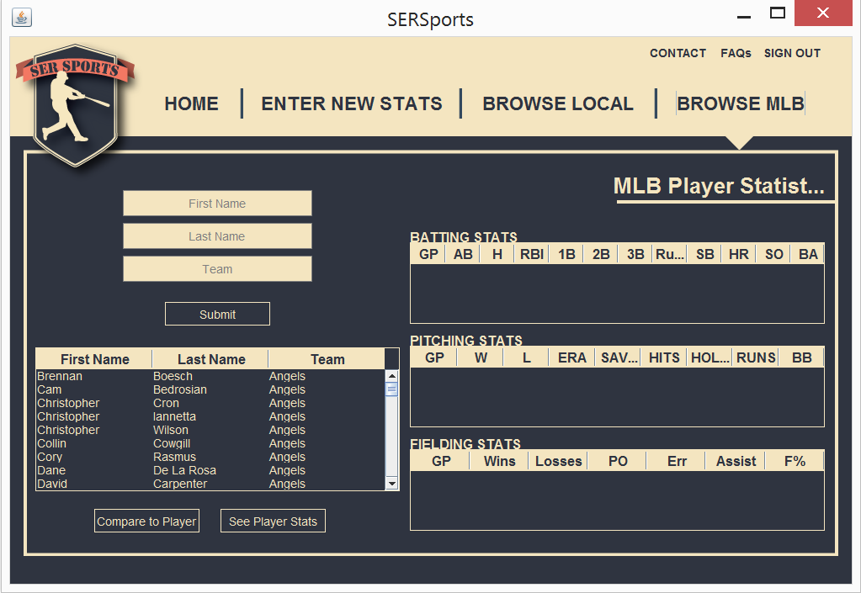

**Figure 5.1**

To see a player’s statistics you follow the same process as browsing local players. First you can either search the table or use the search function, then click ‘See Player Stats’. The result is shown in Figure 5.2.

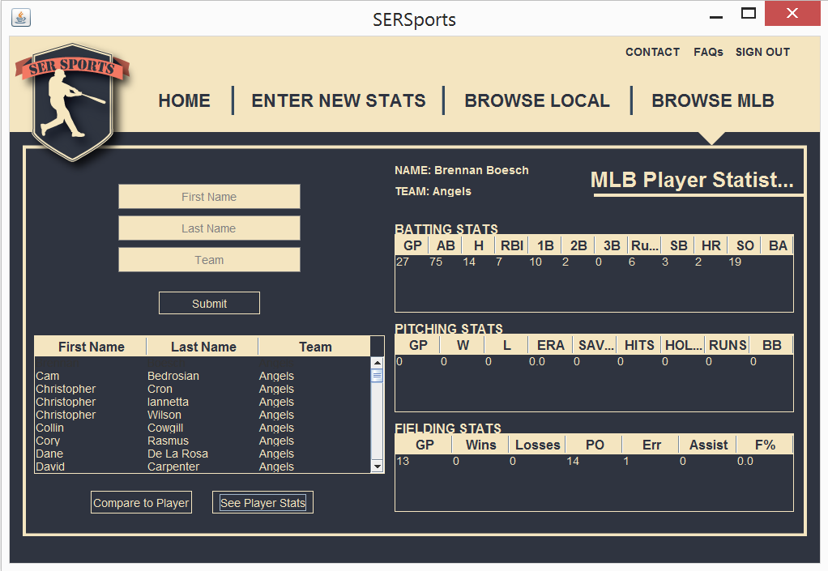

**Figure 5.2**

This screen also gives you the ability to compare yourself to a specific player by first selecting a player and then clicking ‘Compare to Player’ this will bring up a message box showing how similar you are to that player, this message box is shown in Figure 5.3.

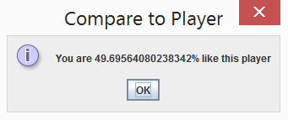

**Figure 5.3**