Тельнов Сергей, M3435

Домашнее задание по курсу «Введение в систему баз данных»

СУБД - psql (PostgreSQL) 11.5

ERD

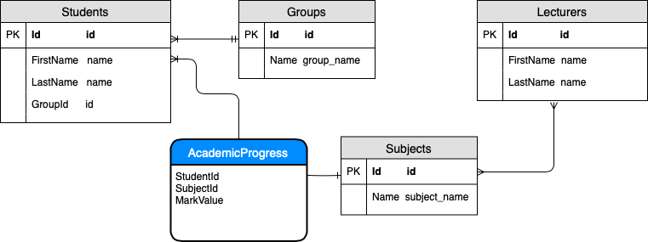

PDM

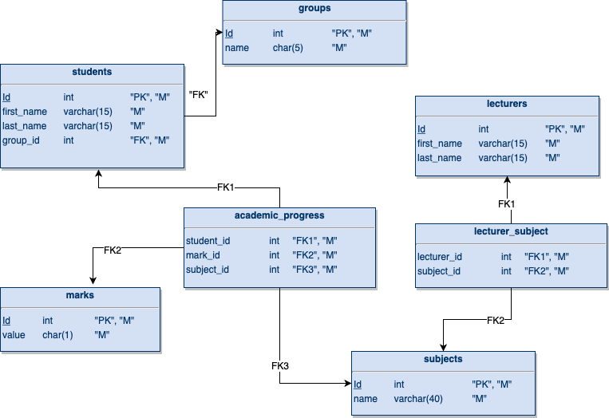

university.sql

|  |
| --- |
| */* Создание базы данных*/*  **create** **database** UNIVERSITY;  */* Смена базы данных */*  \**c** university;  */* Создание таблиц */*  **create** **table** groups (  id int **PRIMARY** **KEY**,  name char(5) **NOT** **NULL**  );  **create** **table** students (  id int **PRIMARY** **KEY**,  first_name varchar(15) **NOT** **NULL**,  last_name varchar(15) **NOT** **NULL**,  group_id int **REFERENCES** groups (id)  );  **create** **table** lecturers (  id int **PRIMARY** **KEY**,  first_name varchar(15) **NOT** **NULL**,  last_name varchar(15) **NOT** **NULL**  );  **create** **table** subjects (  id int **PRIMARY** **KEY**,  name varchar(40) **NOT** **NULL**  );  **create** **table** lecturers_subjects (  lecturer_id int **REFERENCES** lecturers (id),  subject_id int **REFERENCES** subjects (id),  **PRIMARY** **KEY** (lecturer_id, subject_id)  );  **create** **table** marks (  id int **PRIMARY** **KEY**,  value char(1) **NOT** **NULL**  );  **create** **table** academic_progress (  student_id int **REFERENCES** students (id),  subject_id int **REFERENCES** subjects (id),  mark_id int **REFERENCES** marks (id),  **PRIMARY** **KEY** (student_id, subject_id, mark_id)  ); |

test_values.sql

|  |
| --- |
| */* Смена базы данных */*  \**c** university;  */* Добавим группы */*  **insert** **into** groups  (id, name)  **values**  (1, 'M3435'),  (2, 'M3437'),  (3, 'M3439'),  (4, 'M4139');  */* Попробуем обмануть группы */*  **update** groups  **set** name = **null**  **where** id = 1;  */* Добавим оценки */*  **insert** **into** marks  (id, value)  **values**  (1, 'A'),  (2, 'B'),  (3, 'C'),  (4, 'D'),  (5, 'E'),  (6, 'F');  */* Добавим преподавателей */*  **insert** **into** lecturers  (id, first_name, last_name)  **values**  (1, 'Andrew', 'Stankevich'),  (2, 'George', 'Korneev'),  (3, 'Pavel', 'Mavrin');  */* Добавим предметы */*  **insert** **into** subjects  (id, name)  **values**  (1, 'Algorithms and data structures'),  (2, 'Java technology');  */* Добавим к предметам преподавателей */*  **insert** **into** lecturers_subjects  (lecturer_id, subject_id)  **values**  (1, 1),  (3, 1),  (2, 2);  */* Добавим студентов */*  **insert** **into** students  (id, first_name, last_name, group_id)  **values**  (1, 'Michael', 'Putilin', 3),  (2, 'Eugene', 'Feder', 3),  (3, 'Nina', 'Zhevtyak', 2),  (4, 'Sergey', 'Telnov', 1); |