**Assignment #1**

**Derivation of solar differential rotation from meassuring sunspot positions**

Team members

* Valerii Serpiva MSC1 Space and engineering system. [Valerii.Serpiva@skoltech.ru](mailto:Valerii.Serpiva@skoltech.ru)
* Daniel Kekere, Engineering systems. daniel.kekere@skoltech.ru

**Step 1. Download data.**

FITS files are the standard format for all astronomical data. For opening FITS files download **“astropi.io”** liability of python. Generally, the image information is located in the PRIMARY block. The following info was extracted for the task: *DATE-OBS, SOLAR_P0, SOLAR_Rб, CENTER_Y, CENTER_Z.*

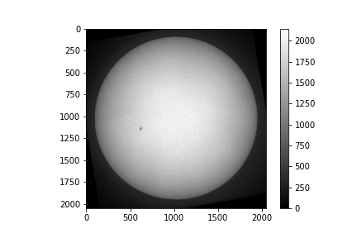

Figure 1. Images #5 from fts-file, June 2016

**Step 2. Determine the coordinates (in pixels) of sunspots (center of masses) for every image.**

The position of the sunspot was extracted manually. The coordinates 𝑧, 𝑦 was corrected for the center of Sun coordinates. (Sheet 1)

|  |  |  |  |  |  |  |  |  |  |  |  |  |
| --- | --- | --- | --- | --- | --- | --- | --- | --- | --- | --- | --- | --- |
| June 2016 | | From image | | Corrected for sun | |  | Dec 2010 | | From image | | Corrected for sun | |
| № | Date | y, pix | z, pix | y, pix | z, pix |  | № | Date | y, pix | z, pix | y, pix | z, pix |
| 1 | [2016, 6, 10, 10, 42, 7] | 130 | 935 | -894 | -90 |  | 1 | [2010, 12, 4, 13, 39, 1] | 406 | 1480 | -619 | 455 |
| 2 | [2016, 6, 11, 11, 41, 26] | 196 | 928 | -829 | -96 |  | 2 | [2010, 12, 5, 11, 11, 28] | 523 | 1488 | -502 | 463 |
| 3 | [2016, 6, 12, 9, 42, 26] | 290 | 925 | -735 | -100 |  | 3 | [2010, 12, 6, 9, 36, 6] | 667 | 1501 | -358 | 475 |
| 4 | [2016, 6, 13, 6, 32, 49] | 416 | 920 | -608 | -105 |  | 4 | [2010, 12, 7, 12, 55, 45] | 864 | 1514 | -160 | 489 |
| 5 | [2016, 6, 14, 11, 13, 0] | 626 | 914 | -399 | -110 |  | 5 | [2010, 12, 8, 8, 14, 41] | 1000 | 1522 | -25 | 496 |
| 6 | [2016, 6, 15, 7, 29, 48] | 793 | 917 | -232 | -107 |  | 6 | [2010, 12, 9, 13, 12, 11] | 1216 | 1541 | 191 | 516 |
| 7 | [2016, 6, 16, 7, 39, 18] | 1005 | 911 | -19 | -114 |  | 7 | [2010, 12, 10, 11, 2, 20] | 1366 | 1551 | 341 | 525 |
| 8 | [2016, 6, 17, 6, 13, 49] | 1207 | 914 | 181 | -110 |  | 8 | [2010, 12, 11, 10, 8, 20] | 1508 | 1556 | 483 | 530 |
| 9 | [2016, 6, 18, 5, 59, 45] | 1411 | 917 | 385 | -107 |  |  |  |  |  |  |  |
| 10 | [2016, 6, 19, 7, 31, 1] | 1601 | 919 | 576 | -105 |  |  |  |  |  |  |  |
| 11 | [2016, 6, 21, 6, 29, 5] | 1858 | 938 | 832 | -86 |  |  |  |  |  |  |  |
| 12 | [2016, 6, 22, 8, 9, 55] | 1924 | 943 | 899 | -82 |  |  |  |  |  |  |  |

Sheet 1. Coordinates of the sunspot.

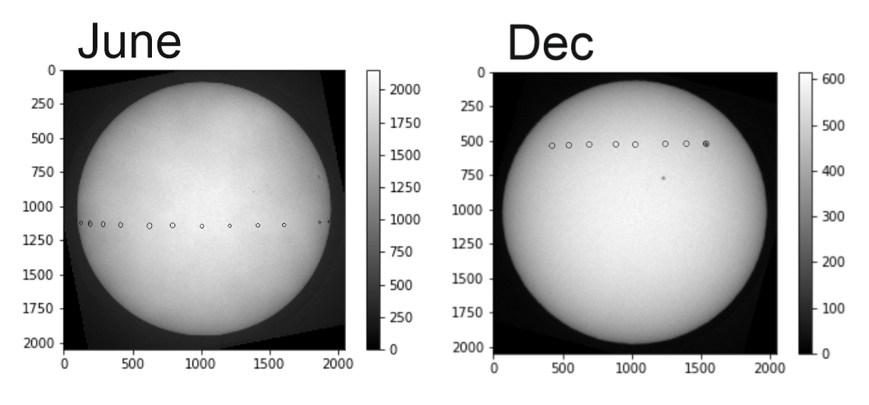

Figure 2. Extracting the position of sunspots.

**Step 3. Determine latitude and longitude of the center of masses of every sunspot.**

According to the plots, the sunspots do not have a constant position by latitude; it changes by time, the first and second plots show it. The size and position of the sunspot can change over time.

In the third plot shows a linear relationship between Longitude and time (day), it means that the velocity of surface Sun is constant on the particular latitude.

If the angle of deviation of the solar rotation axis (SOLAR_P0 ) doesn’t change, the plot (Latitude, Longitude) will look like a horizontal line, but the angle changes with time and graphs are Non-linear.

The position of sunspot depends on the relative observer angle of the sun (it varies for June and December) and thus we see the variation in latitude/longitude with time. (Figure 3)

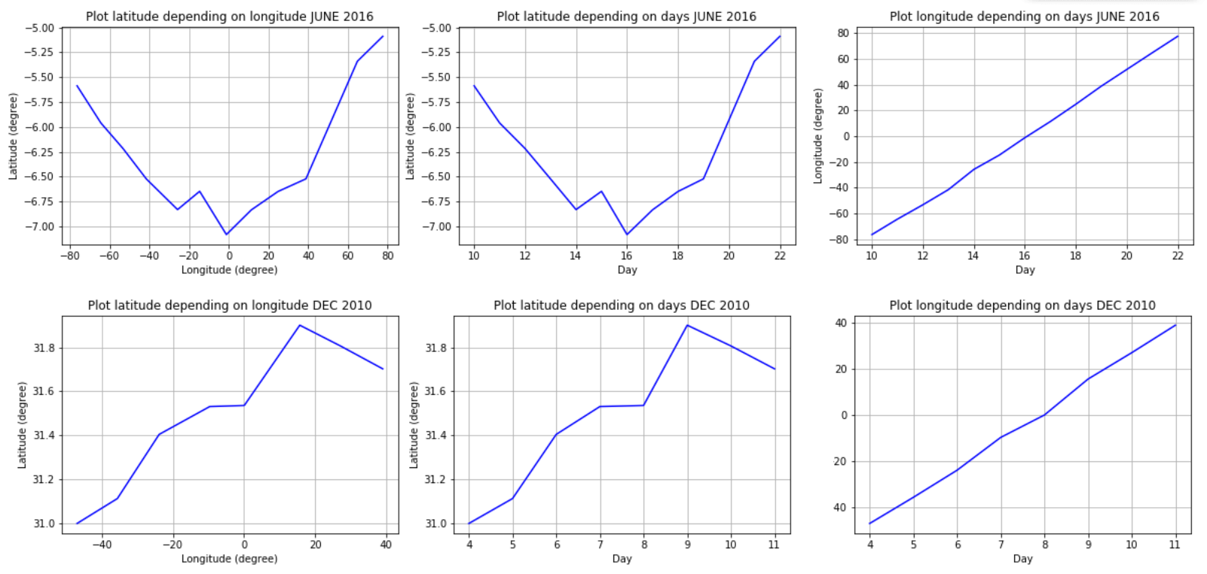

Figure 3. Plotting relationships between latitude, longitude and day.

**Step 4. Determine the angular velocity of solar rotation per day using the obtained longitude and taking into account the time between images.**

To calculate the angular velocity of the sunspots the time of observation was extracted from the files and converted to seconds *t*.

Angular velocity (grad/day) JUNE 2016:

days 10-11: 11.503

days 11-12: 12.162

days 12-13: 13.521

days 13-14: 13.146

days 14-15: 13.156

days 15-16: 13.360

days 16-17: 13.350

days 17-18: 13.557

days 18-19: 13.203

days 19-21: 13.236

days 21-22: 11.967

Angular velocity (grad/day) DECEMBER:

days 4-5: 12.634

days 5-6: 12.586

days 6-7: 12.508

days 7-8: 12.073

days 8-9: 12.939

days 9-10: 12.572

days 10-11: 12.394

Speed of sunspots at two altitudes is different.

**Step 5 – 6. Determine the sidereal rotation rate. Compare the obtained angular sidereal rotation rate with the functional form of solar differential rotation obtained from statistical studies.**

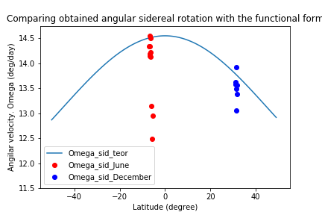

Figure 4. Sidereal rotation rate

To calculate more accurate results needs to have images with good resolution and determine more accurately the center mass of sunspots. The speed of sunspot in a limiting value (90 - 70 on the image) is slower than in the center. It means that despite very approximate estimation of speed (it can be done more accurate than just following the center of sunspot), we get that our scatter is close to this curve as it should be

**Step 7. The steps should be repeated for both datasets (2016 with sunspots close to equator and 2010 at high latitudes).**

Done in step 1-6.

**Step 8. Make conclusions to the Assignment.**

In conclusion, we can say that the sunspots do not have a constant position and size by latitude and changes with time. We also noticed a linear relationship between longitude and time which goes to show that the velocity of the surface of the sun is constant on a given latitude. Also, according to the plots, one can conclude that the positions of sunspots depends on the relative observer angle of the sun (it varies for June and December) and thus we see the variation in latitude/longitude with time. The angular velocity for June varies from 11.50 to 13.56 grad/day while the angular velocity for December is fairly constant and varied only negligible from 12.3 grad/day to 12.9 grad/day