|  |
| --- |
| College LaSalle |
| Project - Internet Programming Technical Manual |
| By Serafino Pampena |
| Presented to: Mihai Maftei. |

|  |
| --- |
| Author: Serafino Pampena  3/17/2023 |

**Tested with browser: Brave, Internet Explore,Opera GX**

Languages:

1. HTML
2. Javascript
3. CSS

**Presenting how the files/folders are organised.**

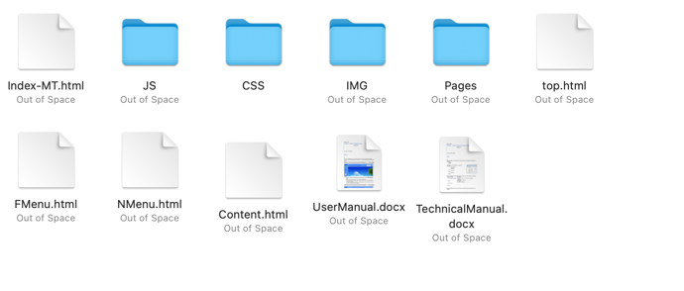Index.html

* 1. Content.html
  2. Top.html
  3. FMenu.html
  4. Nmenu.html

1. Css
   1. Style.css
2. Img
   1. Img1.jpg
3. Pages
4. infoPage.html
5. Welcome.html
6. MapPage.html
7. Search.html
8. References.html
9. SUForm.html
10. Cookie_view.html
11. JS
    1. JSForm.js
    2. Jform.js
    3. SUForm.js
12. UserManual.docx
13. TechnicalManual.docx

**Present the functions and/or methods that you create or you did use into the web project.**

|  |  |
| --- | --- |
| **Function/Method** | **Description** |
| 1. Checkuserlogin() | Will run after pressing login to see if the login info was correct and will show the interactive links |
| 1. Checklogout() | Will hide all the interactive links to the page when the user logout |
| 1. Load() | Upon the page loading it will show the login button and hide the logout button |
| 1. Nopr() | ………… |

**Present the difficulties that you have, what was the hardest and the easiest part of your project.**

Difficulties: Most difficult part was finding all the information about each settlement and displaying the information from the sign up with the cookies, as it kept on failing to show the information it allegedly saved.

DISCLAIMER: The viewing of the saved information with the cookie, while working on FireFox (as shown in the screenshots), on at least Microsoft Edge and Opera GX, the information appears as “undefined”. This can be seen if you run server on vscode before opening the index page on the desired browser.

There is also the error where the map format on the site, doesn’t follow the row of three, when the page is opened by itself it follows the format as shown in the screenshot, but when through the index.html as the website should run it becomes row of 2 (in past experience this was due to my laptops resolution so this may not appear on your side)

Easy Parts: The easiest part was page 1 to 3, as it was html and css that we had done in previous assignments and thus familiarized ourselves with very well and comfortably. On the other hand, the search page, once understanding that it can be functioned as an array proved to be easy theory wise, thought admittedly annoying to write the information into.