- Explain regression
- Help me understand SQL
- Create a dataset

- Explain Linear regression to a beginner using 5 points. Explain why this might be useful to a data analyst.
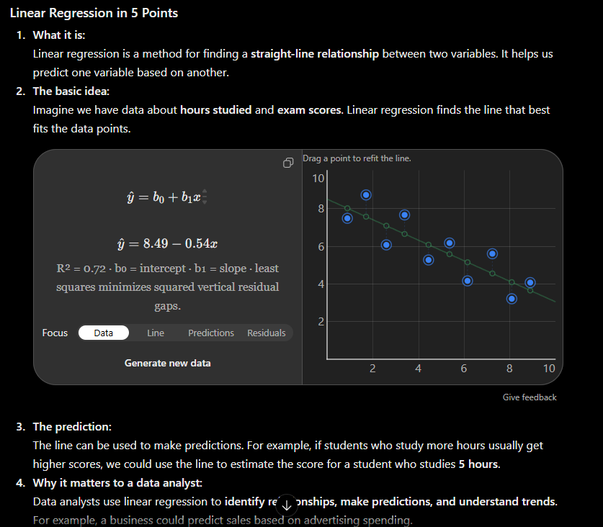
A1) The improved prompt summarized the concept in 5 points and it provided a visual. It gave me a section on how this might be useful to my career.

- Teach the basics of SQL to someone who has had experience coding.
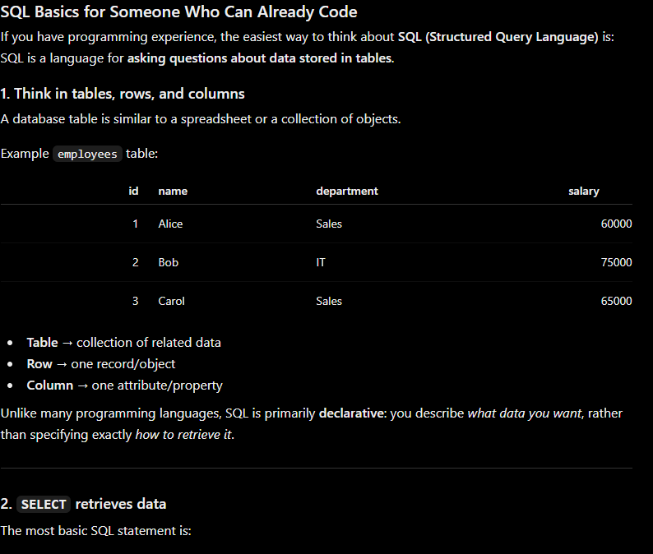
B1) It explains the basics of SQL and how it functions. It summarizes how I as a programmer interact with the data and how I can modify/search it

- Create a small data set of 20 locations with varying sale numbers varying from 100-500 items sold, and a specialty sold at that location.
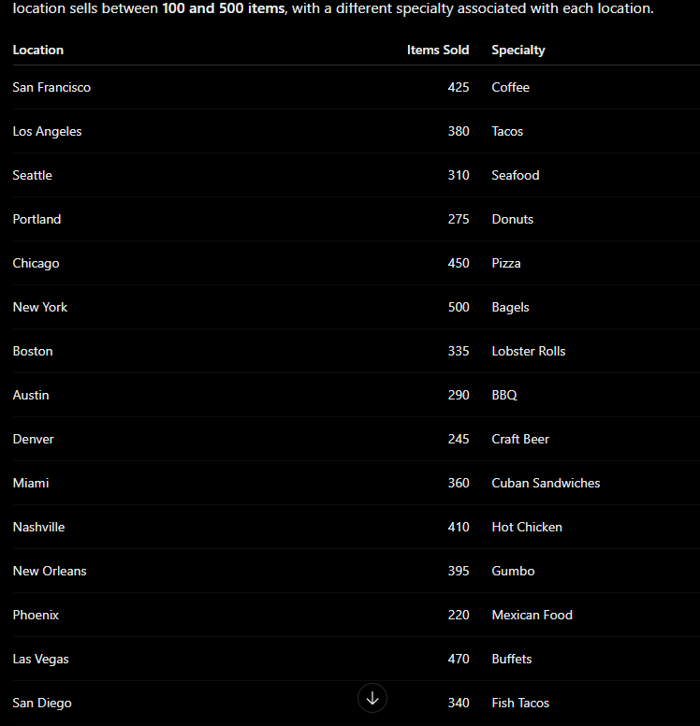
C1) It created a nice chart with multiple sets of information I specified it to. It is specific to my needs and what I want to use it for.

