Exploratory Data Analysis of Gen-Z Social Media Usage and Its Impact on Mental Health

Name: Serajum Munira

Course: IFSC 77003-H02 - Data Science & Technologies

Instructor: Dr. Elizabeth Pierce and Dr. Serhan Dagtas

University of Arkansas at Little Rock

Spring 2026 – Date: May 3, 2026

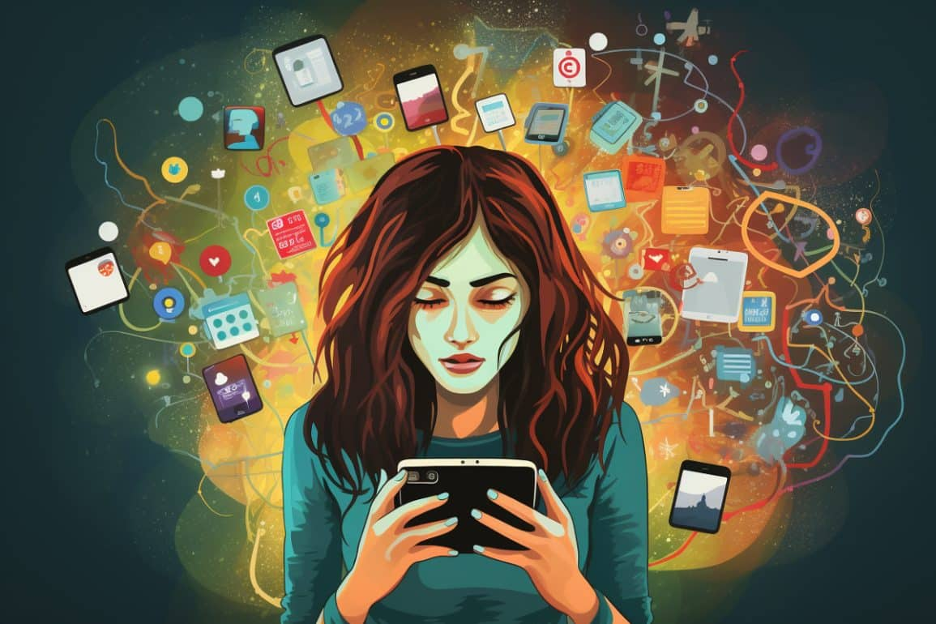

ABSTRACT
This study investigates social media usage patterns among Generation Z (Gen-Z) and examines their potential relationship with mental health outcomes. Using a publicly available dataset from Kaggle containing approximately one million records, a random sample of 10,000 observations was selected to ensure computational feasibility while preserving the statistical characteristics of the original dataset. The analysis focuses on key variables including daily usage hours, primary platform, number of platforms used, night-time usage behavior, and mental health scores.
Exploratory Data Analysis (EDA) techniques, including descriptive statistics, data visualization, and correlation analysis, were applied to identify trends and relationships within the data. The findings aim to provide insights into how usage intensity, platform preference, and behavioral patterns such as night-time engagement may be associated with mental well-being among Gen-Z users.
A strong negative correlation (r = -0.76) was identified between daily social media usage and mental health score, indicating that increased usage is associated with lower well-being.
INTRODUCTION
Social media has become an integral part of daily life, particularly for Generation Z (Gen-Z), who are among the most active users of digital platforms. Platforms such as Instagram, TikTok, Snapchat, and YouTube play a central role in communication, entertainment, and information sharing. While these platforms provide numerous benefits, increasing concerns have been raised regarding their potential impact on mental health and well-being.
Existing discussions in both academic and public domains suggest that excessive social media usage may be associated with issues such as anxiety, reduced attention span, and sleep disruption. At the same time, social media can also support communication, learning, and community building. This dual nature creates a need for data-driven analysis to better understand usage patterns and their implications.
This project aims to analyze social media usage behaviors among Gen-Z users using a large-scale dataset. Specifically, it seeks to explore platform preferences, daily usage patterns, and behavioral factors such as night-time usage, and to examine how these factors may relate to mental health outcomes.
The motivation for this study lies in the need to move beyond general assumptions and provide empirical insights based on real-world data. By applying data science techniques to a verified dataset, this project contributes to a more informed understanding of how social media influences the lives of younger users.
However, many existing studies focus on single variables rather than integrating multiple behavioral and demographic factors. This study addresses this gap by applying a comprehensive exploratory data analysis approach.

LITERATURE REVIEW
The relationship between social media usage and mental health has been extensively examined, particularly among adolescents and young adults. Existing literature presents mixed findings, with some studies highlighting negative psychological impacts, while others suggest minimal or context-dependent effects. This section reviews prior research, compares methodologies, and identifies gaps addressed by this study.
Early psychological research emphasizes the negative consequences of excessive social media use. Twenge (2019) argues that increased screen time among adolescents is strongly associated with higher rates of depression, anxiety, and reduced life satisfaction. Similarly, Kross et al. (2013) found that frequent use of social networking platforms, particularly passive browsing, leads to declines in subjective well-being over time.
In contrast, more recent studies challenge the magnitude of these effects. Orben and Przybylski (2019) argue that the relationship between digital technology use and mental health is statistically small and often overstated. Their large-scale data analysis suggests that usage patterns, rather than total screen time, play a more critical role in determining psychological outcomes. This introduces an important debate between time-based vs. behavior-based analysis approaches.
Another important dimension explored in literature is type of engagement. Verduyn et al. (2017) differentiate between active and passive social media use, showing that active engagement (e.g., communication) may enhance well-being, while passive consumption can lead to negative outcomes such as social comparison and loneliness. This distinction highlights a limitation in studies that rely solely on usage duration without considering behavioral context.
Sleep disruption has also been identified as a key mediating factor. Woods and Scott (2016) found that night-time social media use is associated with poor sleep quality, increased anxiety, and depressive symptoms. Similarly, Levenson et al. (2017) reported that individuals with higher social media engagement are more likely to experience sleep disturbances, suggesting an indirect pathway through which social media affects mental health.
From a behavioral data perspective, Montag et al. (2021) emphasize the importance of combining psychological measures with large-scale behavioral datasets to better understand digital addiction and its consequences. Their work supports the integration of quantitative usage metrics (e.g., time, frequency) with psychological indicators, which aligns closely with a data science approach.
Other studies have focused on platform diversity and intensity of use. Lin et al. (2016) found that individuals using multiple social media platforms are at greater risk of depression and anxiety. This suggests that multi-platform engagement may amplify exposure effects, an aspect often overlooked in simpler analyses.
Additionally, the concept of problematic or addictive use has gained attention. Andreassen et al. (2016) developed measures for social media addiction and found strong associations with poor mental health outcomes. However, critics argue that defining “addiction” in the context of social media remains inconsistent across studies, indicating a lack of standardized measurement frameworks.
Methodologically, prior research varies significantly. Many studies rely on self-reported survey data, which may introduce bias and limit reliability (Scharkow, 2016). In contrast, recent data science approaches utilize large-scale datasets and computational analysis, enabling more objective measurement of user behavior (Lazer et al., 2009). However, these approaches may lack contextual understanding of user intent and psychological nuance.
Despite extensive research, several gaps remain. First, many studies focus on single variables (e.g., time spent), rather than integrating multiple factors such as platform type, session duration, and behavioral patterns. Second, there is limited use of exploratory data analysis (EDA) to visualize and interpret relationships holistically. Third, few studies combine demographic, behavioral, and psychological variables within a unified analytical framework.
This project addresses these gaps by applying a data-driven exploratory analysis on a large-scale dataset, integrating multiple variables such as daily usage hours, number of platforms, night usage, and mental health scores. By combining statistical analysis and visualization, this study contributes to existing literature by providing a more comprehensive and interpretable understanding of how social media behavior relates to mental health among Gen-Z users.

RESEARCH QUESTIONS
Based on the objectives of this study, the following research questions are formulated:
- What are the most popular social media platforms among Gen-Z users?
- How much time do Gen-Z users spend on social media on a daily basis?
- Is there a relationship between daily social media usage and mental health scores?
- Does night-time social media usage influence overall usage patterns and mental health outcomes?
- Do social media usage patterns vary across demographic factors such as gender and country?
These questions are designed to guide the analysis and ensure that the results are directly aligned with the objectives of the study.

METHODOLOGY
This study adopts a quantitative data analysis approach using a real-world dataset obtained from Kaggle. The original dataset contains approximately one million records related to Gen-Z social media usage, including demographic information, behavioral patterns, and mental health indicators.
Due to the large size of the dataset, a random sampling technique was applied to select a subset of 10,000 records. Random sampling was used to ensure that the selected subset remains representative of the overall dataset while making the analysis computationally efficient. The sampling process was conducted using Python to ensure reproducibility.
Feature | Description
Dataset Source | Kaggle Gen-Z Social Media Dataset
Original Size | ~1,000,000 records
Sample Size | 10,000 records
Sampling Method | Random Sampling
Tools Used | Python, Google Colab
Analysis Type | EDA (Statistics + Visualization)

Table 1. Dataset Summary
Dataset Structure and Data Quality
The sampled dataset consists of 10,000 records with 12 variables representing demographic, behavioral, and mental health attributes. The dataset includes a combination of numerical and categorical features, enabling both statistical analysis and group-based comparisons.
All variables in the dataset are complete, with no missing values observed across any columns. Additionally, no duplicate records were found, indicating high data quality and consistency for analysis.

Column Name | Data Type | Description
age | Integer | Age of the user
gender | Categorical | Gender of the user
country | Categorical | Country
daily_usage_hours | Float | Daily social media usage (hours)
primary_platform | Categorical | Main platform used
num_platforms_used | Integer | Number of platforms used
purpose | Categorical | Purpose of usage
avg_session_minutes | Float | Avg session duration
night_usage | Integer (0/1) | Night-time usage
mental_health_score | Float | Mental health score
addiction_level | Categorical | Addiction level
screen_time_before_sleep | Float | Screen time before sleep

Table 2. Dataset Structure and Variable Description
The dataset includes variables such as age, gender, country, daily usage hours, primary platform, number of platforms used, purpose of usage, night-time usage behavior, and mental health score. These variables were selected for analysis due to their relevance in understanding user behavior and psychological outcomes.
The analysis was performed using Python in Google Colab, utilizing libraries such as Pandas for data manipulation, Matplotlib for visualization, and NumPy for statistical computations. The methodology primarily relies on Exploratory Data Analysis (EDA), which includes descriptive statistics, frequency distributions, and visualization techniques such as bar charts, histograms, scatter plots, correlation heatmap, and box plots.
In addition, correlation analysis was conducted to examine the relationship between key variables, particularly daily usage hours and mental health scores. All code used for data processing and analysis is included in the appendix to ensure transparency and reproducibility of results.
A complete codebook describing all variables is provided in the Appendix.

DATA ANALYSIS AND RESULTS
This section presents the findings obtained from the exploratory data analysis (EDA) conducted on the 10,000-record sample dataset. The analysis includes descriptive statistics, visualizations, and correlation analysis to address the research questions. The analysis focuses on identifying patterns in social media usage and examining relationships between usage behavior and mental health outcomes.
Descriptive Statistics
After data preprocessing, including validation of missing values, duplicate removal, and data type verification, descriptive statistics were computed on the cleaned dataset consisting of 10,000 records. All variables were confirmed to be complete with no missing values or duplicates, ensuring reliability for subsequent analysis. These are all numerical variables statistics.
Variable | Mean | Std Dev | Min | Q1 | Median | Q3 | Max
age | 19.98 | 4.30 | 13 | 16 | 20 | 24 | 27
daily_usage_hours | 3.52 | 1.47 | 0.50 | 2.49 | 3.51 | 4.53 | 9.47
num_platforms_used | 3.01 | 1.42 | 1 | 2 | 3 | 4 | 5
avg_session_minutes | 25.10 | 9.87 | 5 | 18.19 | 25.00 | 31.71 | 61.20
night_usage | 0.59 | 0.49 | 0 | 0 | 1 | 1 | 1
mental_health_score | 7.16 | 1.49 | 1 | 6.12 | 7.20 | 8.23 | 10
screen_time_before_sleep | 39.97 | 19.34 | 0 | 26.55 | 39.76 | 53.20 | 115.59

Table 3. Summary statistics computed from the cleaned dataset
Table 3. summarizes the key numerical characteristics of the dataset after preprocessing. The average age of users is approximately 20 years, confirming the dataset represents a young Gen-Z population. Users spend an average of 3.52 hours per day on social media, with moderate variability across individuals.
The average number of platforms used is approximately three, indicating that multi-platform engagement is common. Session duration averages around 25 minutes, suggesting moderate interaction levels per session.
The mean mental health score is 7.16, indicating generally moderate well-being among participants. However, the variability suggests that some users experience lower mental health outcomes.
The interquartile range (Q1 to Q3) indicates that the middle 50% of users spend approximately 2.49 to 4.53 hours per day on social media, representing the typical usage range.
Nighttime usage is prevalent, with a mean value of 0.59, meaning more than half of users engage with social media at night. Additionally, users spend an average of approximately 40 minutes on screens before sleep, which may have implications for sleep quality and mental health.
Overall, the dataset demonstrates sufficient variability across variables, supporting further analysis of behavioral patterns and relationships.
Table 4. Final Summary of Key Metrics
Metric | Value
Sample Size | 10,000
Average Age | 19.98
Average Daily Usage Hours | 3.52
Median Daily Usage Hours | 3.51
Average Number of Platforms Used | 3.01
Average Mental Health Score | 7.16
Correlation (Usage vs Mental Health) | -0.76

Table 4. summarizes the key metrics derived from the dataset. The average daily social media usage is approximately 3.52 hours, with users engaging across an average of three platforms. The average mental health score is 7.16, indicating moderate overall well-being. Most importantly, the correlation coefficient between daily usage and mental health score is -0.76, demonstrating a strong negative relationship. This suggests that higher social media usage is associated with lower mental health scores, supporting the primary findings of this study.
Platform Popularity
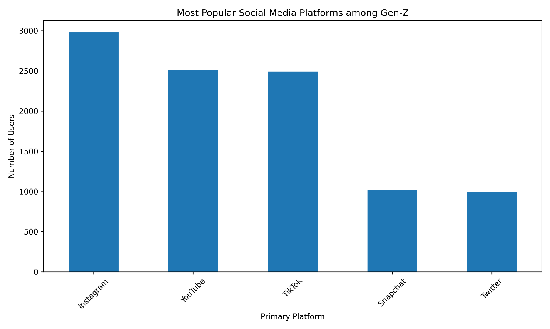
Figure 1. Most Popular Social Media Platforms among Gen-Z

The bar chart shows the distribution of users across different social media platforms. Instagram appears as the most popular platform, followed closely by YouTube and TikTok. Snapchat and Twitter have comparatively lower user counts.
This indicates that visually engaging and short-form content platforms dominate Gen-Z usage patterns, aligning with current trends in digital media consumption.

Distribution of Daily Usage Hours
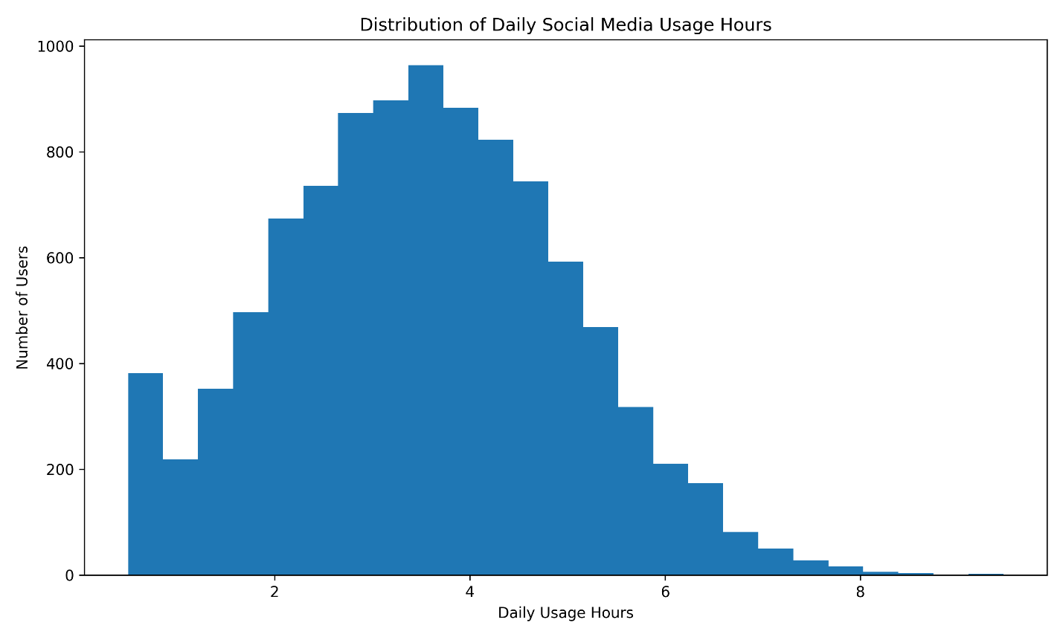
Figure 2. Distribution of Daily Social Media Usage Hours
The histogram shows that daily usage hours are approximately normally distributed, with most users spending between 2 to 5 hours per day. The average usage is around 3.5 hours.
This suggests moderate but consistent engagement with social media among Gen-Z users, with fewer extremely heavy or very low users.
Average Usage by Platform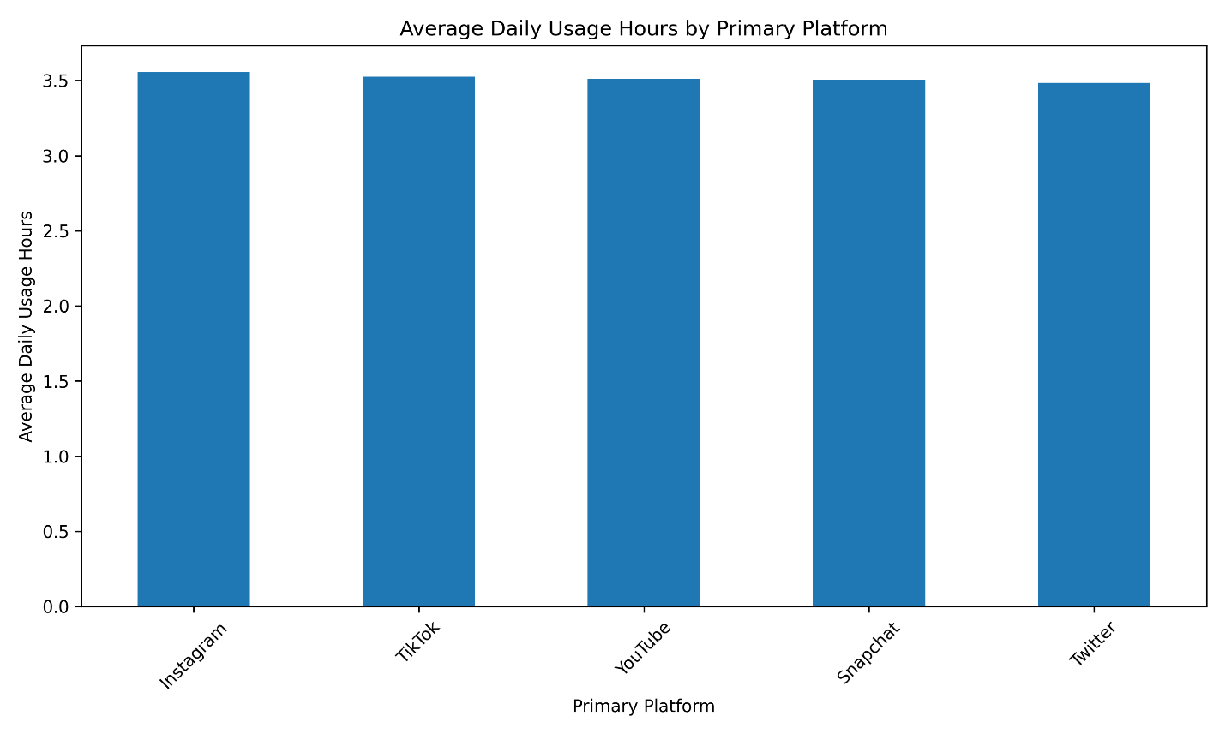
Figure 3. Average Daily Usage Hours by Primary Platform

The bar chart presents the average daily social media usage hours across different primary platforms. The results show that the average usage is very similar across all platforms, with values ranging approximately between 3.48 and 3.56 hours per day.
Instagram shows slightly higher average usage compared to other platforms, while Twitter has the lowest, although the differences are minimal. This indicates that platform choice does not significantly affect the total amount of time users spend on social media.
The small variation suggests that usage behavior is driven more by user habits than by platform features.
Overall, users appear to maintain a consistent level of engagement regardless of which platform they primarily use.

Purpose of Social Media Usage
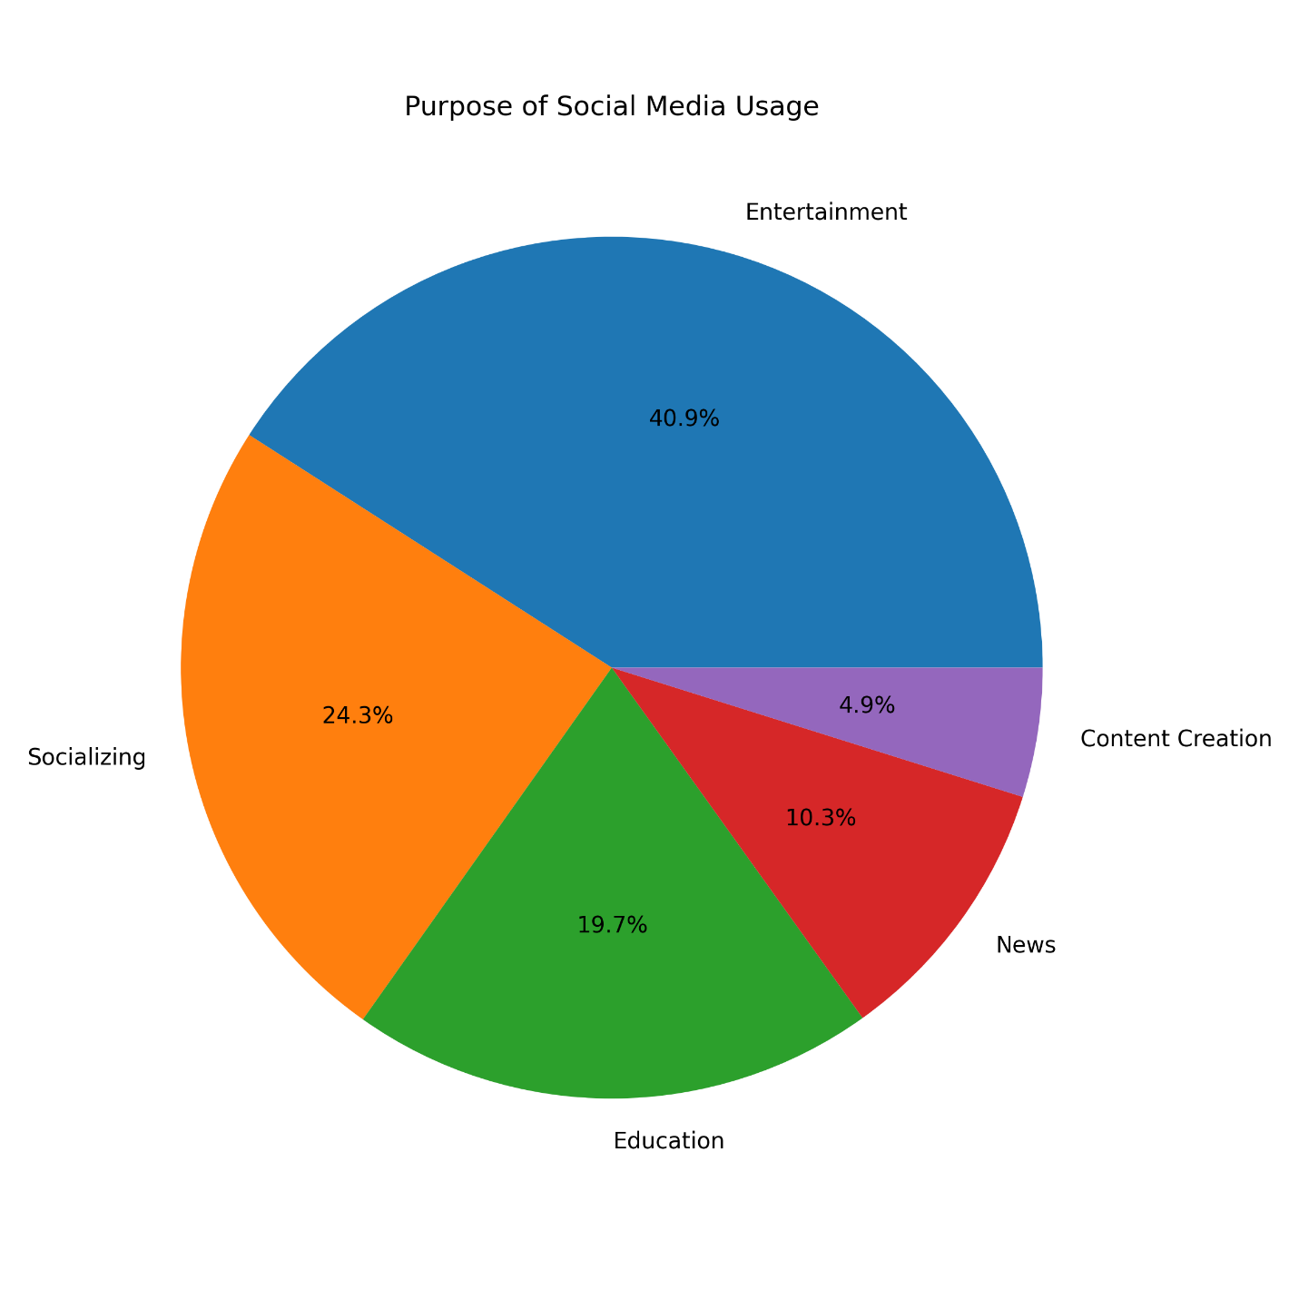
Figure 4. Purpose of Social Media Usage

The pie chart reveals that entertainment is the dominant purpose of social media usage (approximately 40.9%), followed by socializing (24.3%) and education (19.7%). News consumption and content creation represent smaller proportions.
This suggests that social media is primarily used for leisure activities rather than productive or professional purposes.

Gender Distribution and Usage Patterns
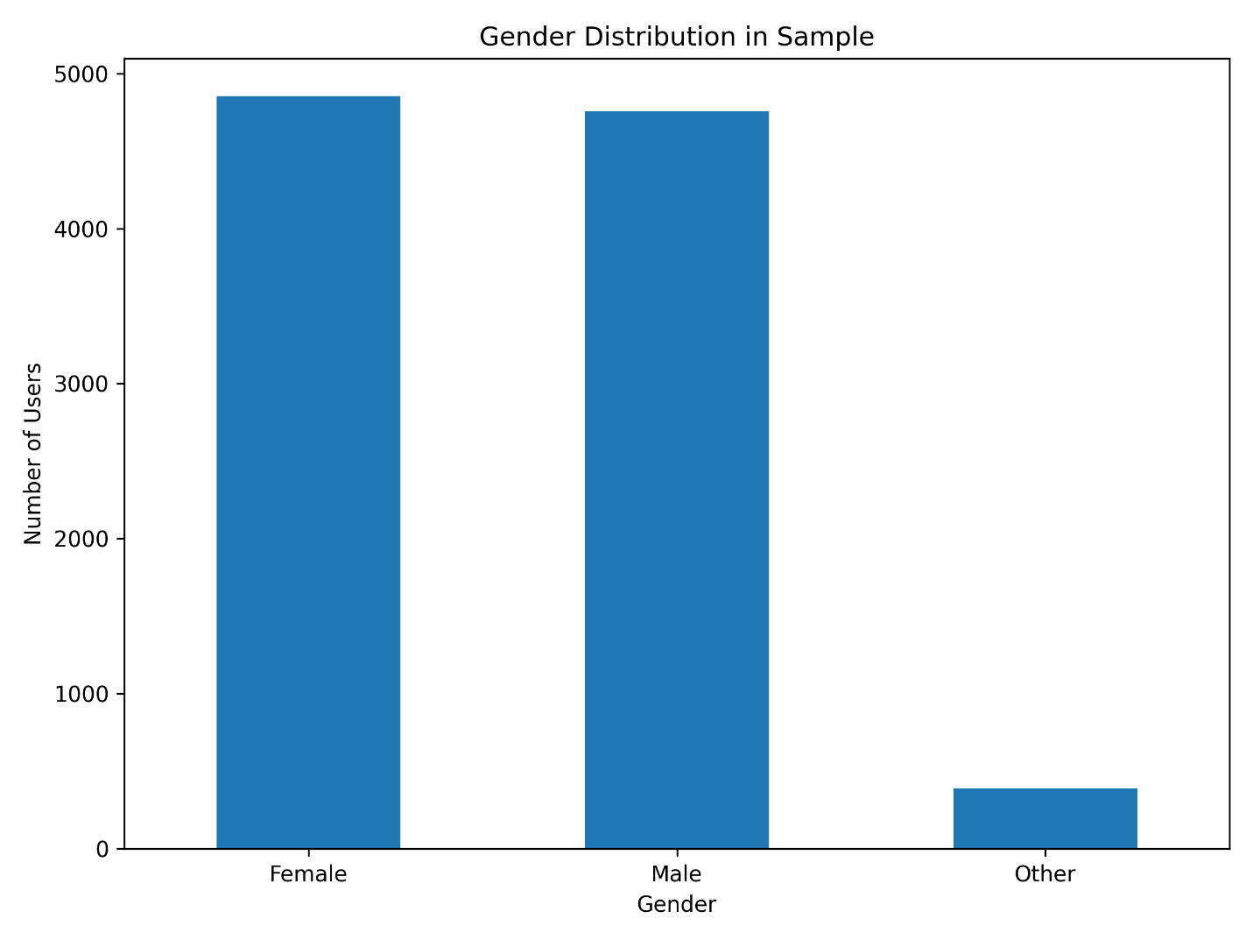
Figure 5. Gender Distribution in Sample

The bar chart illustrates the distribution of users across gender categories in the sampled dataset. The results show that female and male users are almost equally represented, with females slightly higher (approximately 4,800 users) compared to males (approximately 4,700 users). In contrast, the “Other” gender category has a significantly smaller representation, with fewer than 500 users.
This relatively balanced distribution between male and female users indicates that the dataset is not heavily biased toward one gender, which supports the reliability of comparisons made in subsequent analyses. However, the smaller sample size for the “Other” category suggests that conclusions related to this group may be less statistically robust.
This distribution allows for meaningful comparison of usage behavior across genders, particularly between male and female groups.
Overall, gender distribution ensures that the analysis reflects a diverse population while highlighting a limitation in representation for minority gender groups.

Gender vs Daily Usage
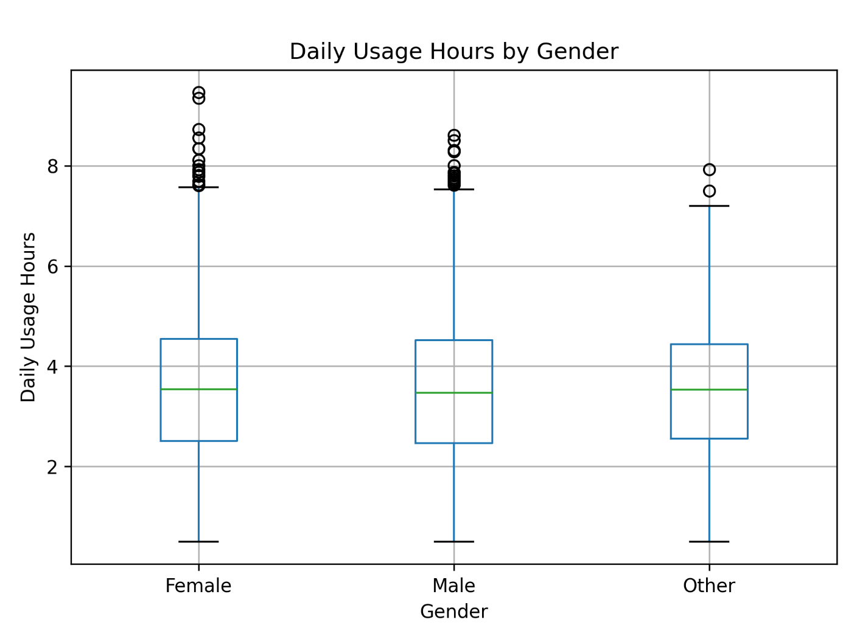
Figure 6. Daily Usage Hours by Gender

The boxplot compares daily social media usage hours across different gender groups (Female, Male, and Other). The median usage for all three groups is very similar, approximately around 3.4 to 3.6 hours per day, indicating consistent usage patterns across genders.
The interquartile range (IQR), which represents the middle 50% of users, is also nearly identical across all groups, suggesting that the variability in usage is comparable. While there are some outliers in each category particularly among female users who show slightly higher maximum values these differences are not substantial enough to indicate a meaningful variation.
This finding supports the earlier observation from the gender distribution analysis that usage behavior is relatively uniform across demographic groups.
Overall, the distribution demonstrates that gender does not significantly influence daily social media usage in this dataset. Users across all gender groups exhibit similar engagement levels, reinforcing the idea that social media usage behavior among Gen-Z is largely consistent regardless of gender.

Country vs Average Daily Usage
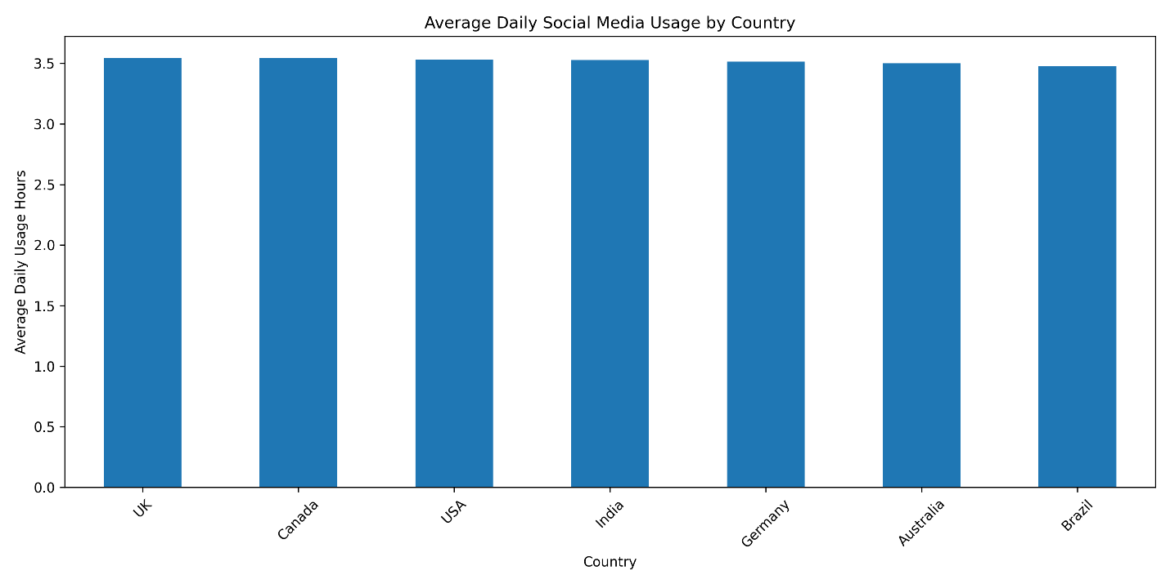
Figure 7. Average Daily Social Media Usage by Country

The bar chart presents the average daily social media usage across different countries, including the UK, Canada, USA, India, Germany, Australia, and Brazil. The results show that the average usage is highly consistent across all countries, with values ranging approximately between 3.48 and 3.56 hours per day.
The UK and Canada exhibit slightly higher average usage, while Brazil and Australia show marginally lower values. However, these differences are minimal and do not indicate any significant variation in usage behavior across countries.
This consistency suggests that social media usage patterns among Gen-Z users are globally similar, regardless of geographic location. It indicates that digital engagement behavior is influenced more by shared technological and cultural factors than by country-specific differences.
This finding supports the idea that social media platforms provide a standardized user experience across regions, leading to similar engagement levels worldwide.

Daily Usage vs Mental Health Score
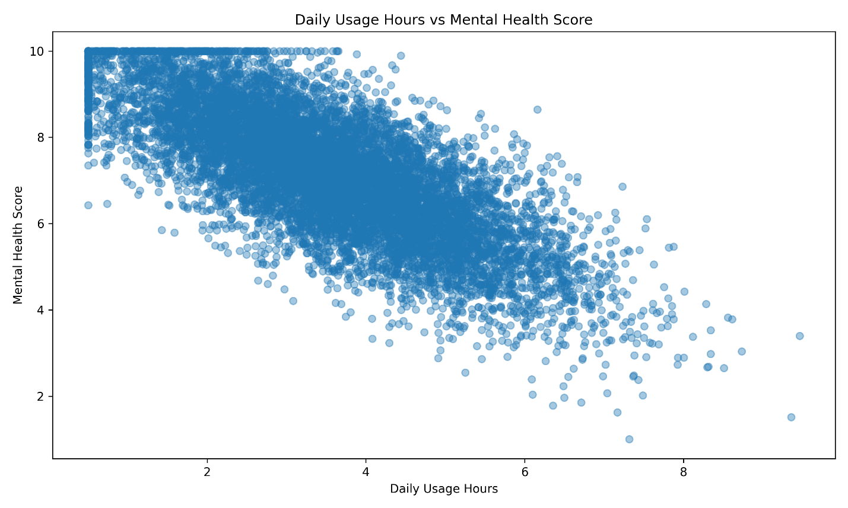
Figure 8. Daily Usage Hours vs Mental Health Score

The scatter plot illustrates the relationship between daily social media usage hours and mental health scores. Each point represents an individual user, with usage hours on the x-axis and mental health score on the y-axis.
A clear downward trend is observed in the distribution of points, indicating a negative relationship between the two variables. As daily usage hours increase, mental health scores tend to decrease. Users with lower usage (around 1–3 hours) generally show higher mental health scores (closer to 8–10), while users with higher usage (above 6 hours) tend to have lower scores (around 3–6).
This visual pattern is supported by the correlation analysis, which shows a strong negative correlation of approximately -0.76 between daily usage hours and mental health score. This suggests that increased social media usage is significantly associated with lower mental well-being.
Although the scatter plot shows some variability, the overall trend is consistent and indicates that excessive usage may have a negative impact on mental health. However, it is important to note that correlation does not imply causation, and other external factors may also influence mental health outcomes.
This finding aligns with prior research suggesting that excessive screen time may contribute to psychological stress and reduced well-being among younger users.

Night Usage vs Daily Usage
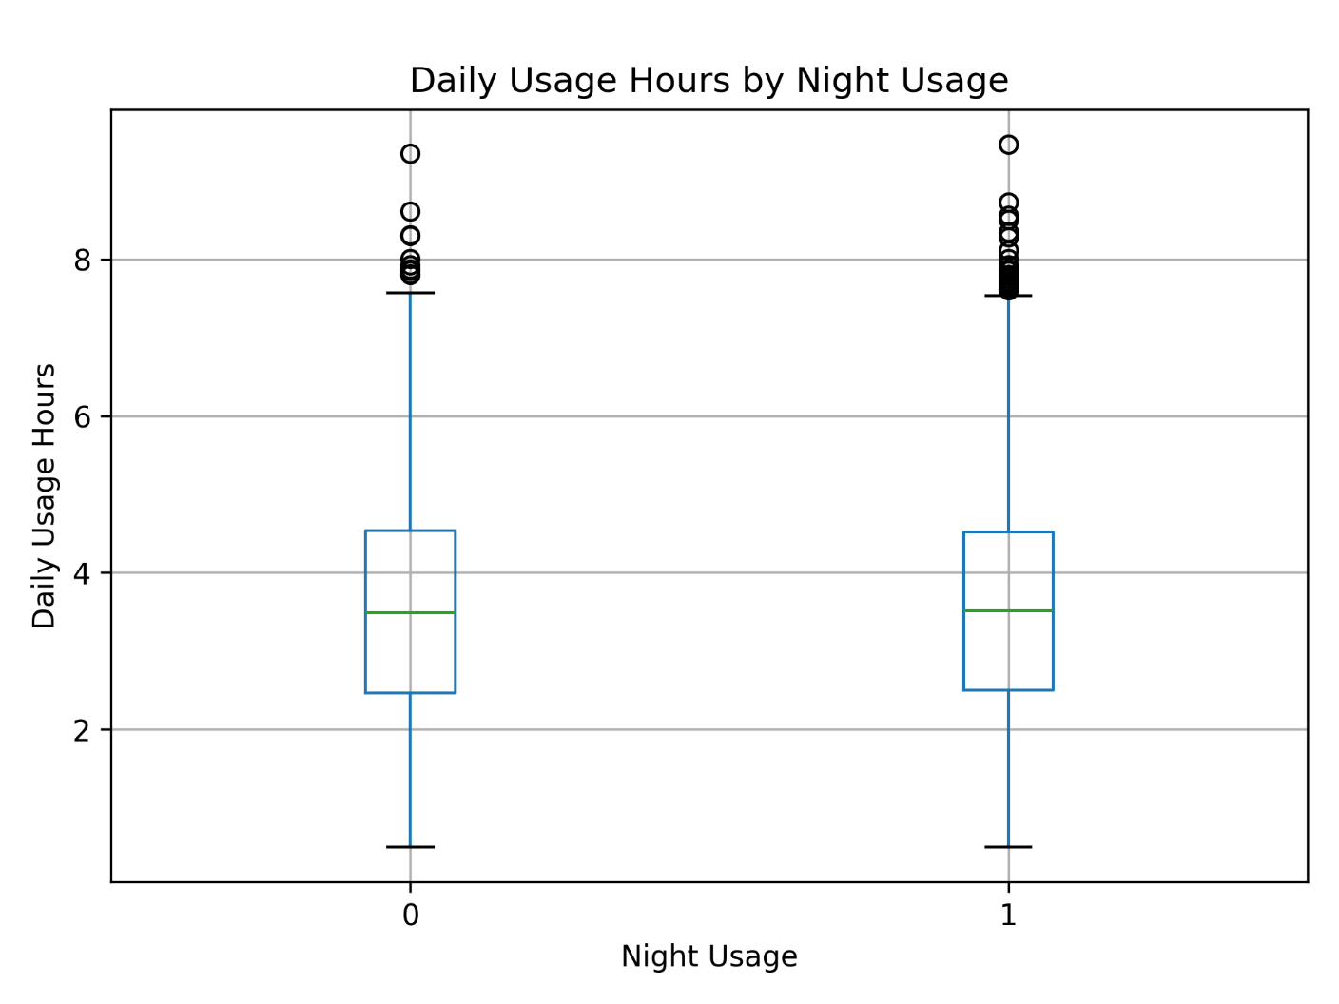
Figure 9. Daily Usage Hours by Night Usage

The boxplot compares daily social media usage hours between users who engage in night-time usage (1) and those who do not (0). The median usage for both groups is similar, approximately around 3.4 to 3.6 hours per day. However, users who engage in night-time usage show a slightly higher median and a marginally wider spread in the upper range.
The interquartile range (IQR) is comparable for both groups, indicating that the overall variability in usage is similar. However, the night usage group (1) exhibits slightly more high-value outliers, suggesting that some users who access social media at night tend to spend more time overall.
This indicates that while night-time usage does not drastically change average usage levels, it is associated with slightly increased usage intensity and higher extreme values. This pattern may reflect extended engagement periods during late hours.
This finding complements the earlier analysis suggesting that night-time usage may contribute to increased engagement and potentially impact user behavior patterns.

Night Usage vs Mental Health
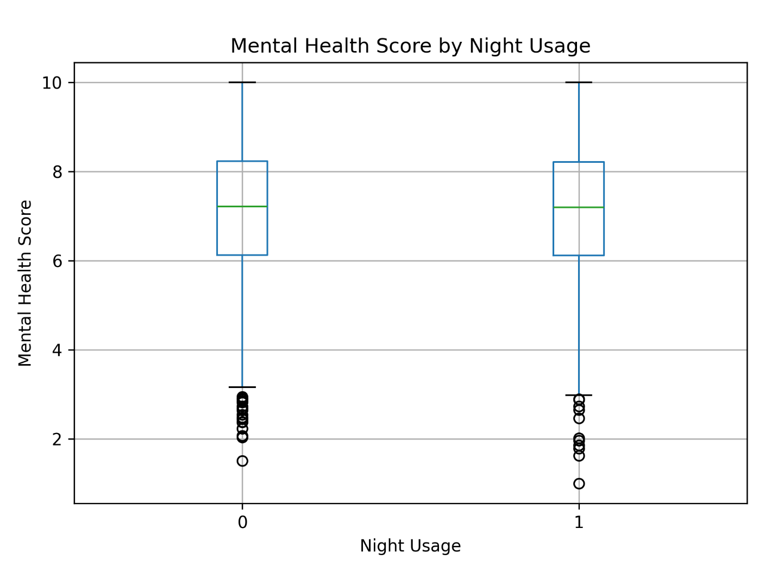
Figure 10. Mental Health Score by Night Usage

The boxplot compares mental health scores between users who engage in night-time social media usage (1) and those who do not (0). The median mental health score for both groups is relatively similar, approximately around 7.0–7.2, indicating that overall central tendencies do not differ significantly.
However, the night usage group shows a slightly wider spread and a greater number of lower-value outliers compared to the non-night usage group. These lower outliers represent individuals with poorer mental health scores, suggesting that night-time social media usage may be associated with increased variability in mental health outcomes.
Although the difference in median values is minimal, the presence of more extremely low scores in the night usage group indicates a potential negative impact on certain individuals. This suggests that night-time usage may not affect all users equally but could be linked to poorer mental health in specific cases.
This finding is consistent with the negative relationship observed between daily usage hours and mental health score in Figure 8, reinforcing the potential impact of usage behavior on well-being.

Number of Platforms Used vs Daily Usage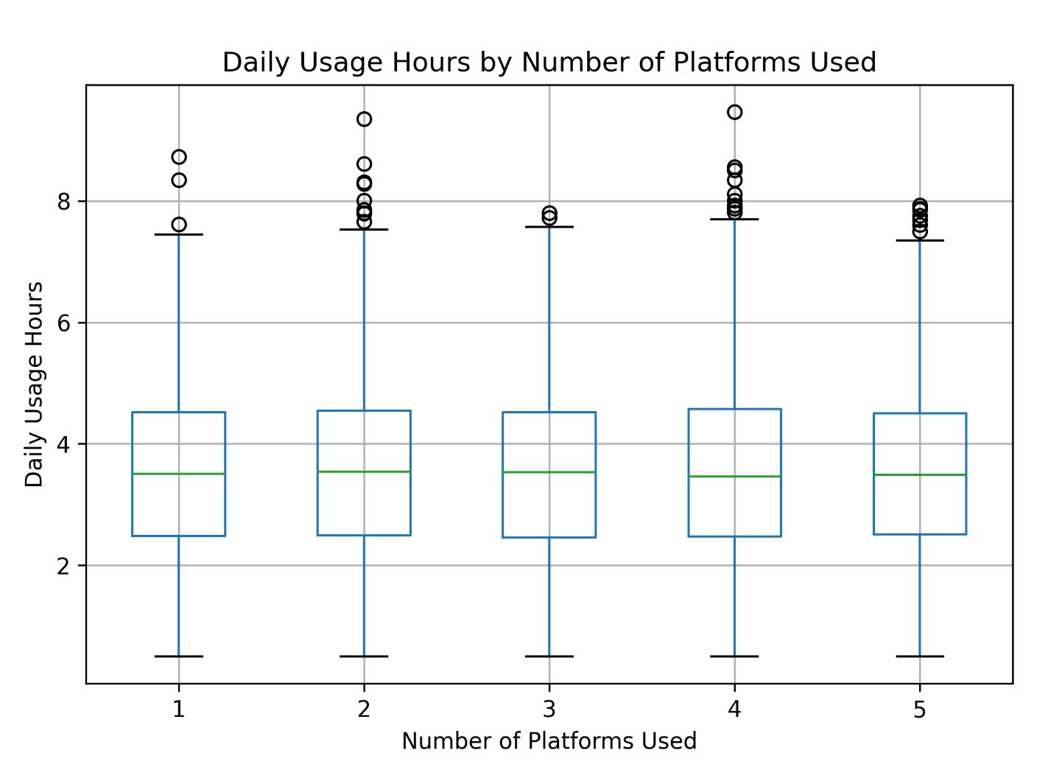
Figure 11. Daily Usage Hours by Number of Platforms Used

Figure 11 presents a boxplot comparing daily social media usage hours across users based on the number of platforms they use (ranging from 1 to 5). The median daily usage remains relatively consistent across all groups, approximately between 3.4 and 3.6 hours per day, indicating that using more platforms does not substantially increase overall time spent on social media.
The interquartile ranges (IQRs) are also similar across all categories, suggesting that variability in usage is consistent regardless of how many platforms a user engages with. However, each group contains several high-value outliers, with some users spending more than 8–9 hours daily, indicating the presence of heavy users across all platform counts.
This finding suggests that platform diversification does not necessarily lead to increased screen time but rather reflects how users allocate their existing usage across multiple applications.
Overall, the figure suggests that while users may diversify across multiple platforms, their total daily usage time remains relatively stable. This implies that users tend to distribute their time across platforms rather than significantly increasing total usage as the number of platforms increases.
Correlation Matrix
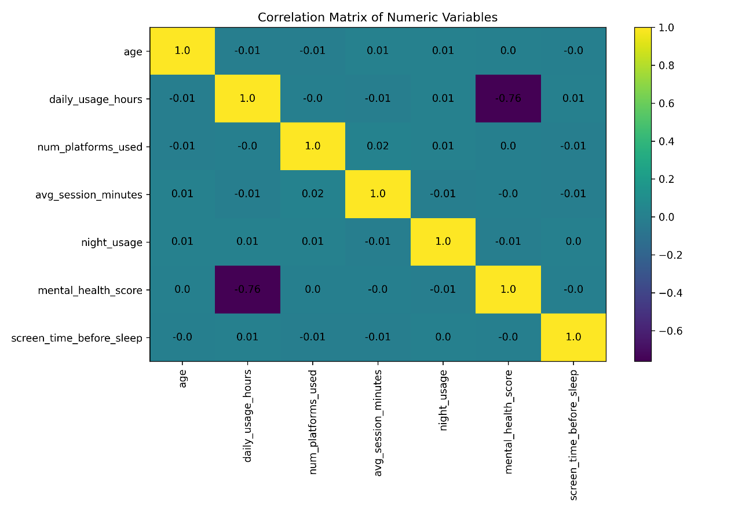
Figure 12. Correlation Matrix of Numeric Variables

Figure 12 presents the correlation matrix of key numeric variables, including age, daily usage hours, number of platforms used, average session duration, night usage, mental health score, and screen time before sleep.
The most significant relationship observed is a strong negative correlation between daily usage hours and mental health score (r = -0.76). This indicates that as daily social media usage increases, mental health scores tend to decrease, suggesting a potential adverse association between prolonged usage and well-being.
All other variable pairs exhibit very weak or negligible correlations, with coefficients close to zero. For example, age shows almost no relationship with daily usage hours or mental health score, indicating that within this dataset, usage behavior is relatively consistent across age groups. Similarly, the number of platforms used, and average session duration do not show meaningful relationships with other variables.
Night usage and screen time before sleep also display minimal correlation with mental health score, suggesting that overall usage duration may be a more influential factor than specific usage patterns such as timing.
The strong negative correlation observed supports the visual trend identified in Figure 8, reinforcing the consistency of the relationship between social media usage and mental health.
Overall, the correlation matrix highlights that daily usage hours is the primary variable associated with mental health outcomes, while other factors appear to have limited direct influence in this dataset.
Variables Compared | Correlation (r) | Interpretation
Daily Usage Hours vs Mental Health Score | -0.76 | Strong negative relationship
Age vs Daily Usage Hours | -0.01 | No meaningful relationship
Number of Platforms vs Daily Usage Hours | ~0.00 | No relationship
Avg Session Minutes vs Daily Usage Hours | -0.01 | No relationship
Night Usage vs Mental Health Score | -0.01 | Very weak relationship
Screen Time Before Sleep vs Mental Health | ~0.00 | No relationship

Table 5. Key Correlations Between Variables
Table 5. summarizes the key correlations among the variables. The strongest relationship observed is a negative correlation (r = -0.76) between daily usage hours and mental health score, indicating that higher social media usage is associated with lower mental health scores. All other variables show negligible correlations, suggesting that factors such as age, number of platforms used, and session duration have minimal direct relationships with mental health in this dataset.
Overall, the results indicate that while most demographic and behavioral variables show minimal influence, daily social media usage hours demonstrate a strong and consistent relationship with mental health outcomes. This highlights usage duration as the primary factor associated with well-being in this dataset.
DISCUSSION
The objective of this study was to analyze Gen-Z social media usage patterns and examine their relationship with mental health using a real-world dataset. The findings provide several important insights that address the research questions.
First, the analysis revealed a strong negative relationship between daily social media usage and mental health score (r = -0.76). This indicates that individuals who spend more time on social media tend to report lower mental health scores. This finding directly answers the primary research question and suggests that usage duration is a critical factor influencing well-being. However, this relationship is correlational and does not imply causation.
Second, the number of platforms used does not significantly impact total daily usage. Users engaging with multiple platforms exhibit similar total usage hours compared to those using fewer platforms. This suggests that users distribute their time across platforms rather than increasing overall usage, indicating that platform diversity is not a major driver of excessive screen time.
Third, night-time usage shows limited overall impact on mental health, although the presence of lower-value outliers suggests that certain individuals may be more negatively affected by late-night engagement. This indicates variability in user behavior and highlights that some usage patterns may disproportionately impact specific groups.
Additionally, demographic variables such as age and gender do not show strong relationships with usage behavior or mental health outcomes in this dataset. This suggests that social media engagement patterns are relatively consistent across these groups.
Overall, the findings demonstrate that the amount of time spent on social media is more influential than how or where it is used, providing meaningful insight into digital behavior among Gen-Z users.
These findings suggest that interventions aimed at reducing excessive screen time may be more effective than focusing on specific platforms. This aligns with prior research by Twenge (2019) and Kross et al. (2013), who also identified negative effects of excessive social media usage.
ETHICAL CONSIDERATIONS
This study uses a publicly available dataset obtained from Kaggle, ensuring that no personally identifiable information (PII) is included. All data used in the analysis is anonymized and intended for research purposes.
Care was taken to interpret the findings responsibly, avoiding any misleading or exaggerated conclusions. Since the dataset represents behavioral patterns, the analysis does not attempt to make individual-level judgments or predictions.
Additionally, the study acknowledges that mental health is a complex issue influenced by multiple factors beyond social media usage. Therefore, conclusions are presented as associations rather than causal relationships to maintain ethical integrity.
AI USAGE DISCLOSURE
AI tools were used in this project strictly for assistance in structuring, editing, and improving clarity of the written report. All data analysis, interpretation of results, and conclusions were carefully reviewed and validated by the author.
The dataset used in this study is a real-world dataset obtained from Kaggle, and all statistical analyses and visualizations were generated using Python. AI was not used to fabricate results or generate fictional analysis. Everything was done by the author.
LIMITATIONS
This study has several limitations. First, the dataset is observational, which means that causal relationships cannot be established. While a strong association between social media usage and mental health is observed, it cannot be concluded that increased usage directly causes changes in mental health.
Second, the dataset may include self-reported or simulated behavioral data, which could introduce potential bias or inaccuracies. Third, external variables such as socioeconomic status, lifestyle habits, and offline interactions are not included in the dataset but may significantly influence mental health outcomes.
Additionally, the analysis was conducted on a subset of 10,000 records sampled from a larger dataset. Although the sample was selected randomly and benchmarked against the original dataset, minor variations may still exist.
The author ensured that all findings are consistent with the data and aligned with the visualizations presented in the report.
CONCLUSION
This study examined Gen-Z social media usage patterns and their relationship with mental health using a real-world dataset. The results indicate a strong negative association between daily usage hours and mental health score, suggesting that increased social media usage is linked to lower well-being.
Other factors, such as the number of platforms used, session duration, and demographic variables, showed minimal influence on overall usage and mental health outcomes. These findings highlight that the duration of usage is a more significant factor than the specific usage patterns.
The study provides valuable insights into digital behavior and emphasizes the importance of managing screen time to support mental well-being. Future research could incorporate additional variables to better understand the broader factors influencing mental health.
This study demonstrates the value of data-driven analysis in understanding complex behavioral and psychological relationships in the digital age.

APPENDIX
- Project Timeline and Effort
Week | Task | Description | Hours Spent
Week 1 | Topic selection, initial literature search, dataset acquisition | Selected project topic and dataset | 8
Week 1 | Dataset Collection | Downloaded Kaggle dataset | 2
Week 2 | Data Preprocessing | Sampling (10K), cleaning data | 5
Week 2 | Deep Literature Review | Source verification | 10
Week 2 | EDA | Generated Descriptive Statistics and Charts | 6
Week 3 | Analysis | Interpreted results and correlations | 7
Week 3 | Report Writing | Completed methodology and results sections | 8
Week 4 | Final Edits | Reviewed report, fixed inconsistencies | 5
Week 4 | Presentation | Prepared 3-minute video | 4
Total |  |  | ~55–60 hours

B. Codebook (Data Dictionary)
Variable | Description
age | Age of user
gender | Gender
country | Country
daily_usage_hours | Daily usage time
primary_platform | Main platform used
num_platforms_used | Number of platforms
purpose | Usage purpose
avg_session_minutes | Avg session duration
night_usage | Night usage (0/1)
mental_health_score | Mental health score
addiction_level | Addiction level
screen_time_before_sleep | Screen time before sleep

C. Statistical Output
The full descriptive statistics generated using Python are provided in submission in Blackboard (summary_statistics.csv) file for reference. These results were used to construct the summarized tables in the Results section.
D. Code / Notebook
The full Python code used for data preprocessing, sampling, and analysis is provided in the submitted Google Colab notebook file. The notebook includes all steps required to reproduce the results presented in this report.
E. Dataset Source
The dataset used in this study was obtained from Kaggle:
https://www.kaggle.com/datasets/sharmajicoder/gen-z-social-media-usage-dataset

REFERENCE LIST
Twenge, J. M. (2019). More time on technology, less happiness? Associations between digital media use and psychological well-being. Current Directions in Psychological Science, 28(4), 372–379.
Kross, E., Verduyn, P., Demiralp, E., Park, J., Lee, D. S., Lin, N., & Ybarra, O. (2013). Facebook use predicts declines in subjective well-being in young adults. PLOS ONE, 8(8), e69841.
Orben, A., & Przybylski, A. K. (2019). The association between adolescent well-being and digital technology use. Nature Human Behaviour, 3(2), 173–182.
Verduyn, P., Ybarra, O., Résibois, M., Jonides, J., & Kross, E. (2017). Do social network sites enhance or undermine subjective well-being? A critical review. Social Issues and Policy Review, 11(1), 274–302.
Verduyn, P., Gugushvili, N., & Kross, E. (2022). Do social networking sites influence well-being? The extended active-passive model. Current Directions in Psychological Science, 31(1), 62–68.
Woods, H. C., & Scott, H. (2016). #Sleepyteens: Social media use in adolescence is associated with poor sleep quality, anxiety, depression and low self-esteem. Journal of Adolescence, 51, 41–49.
Levenson, J. C., Shensa, A., Sidani, J. E., Colditz, J. B., & Primack, B. A. (2017). Social media use before bed and sleep disturbance among young adults in the United States. Sleep, 40(9), zsx113.
Montag, C., Yang, H., & Elhai, J. D. (2021). On the psychology of TikTok use: A first glimpse from empirical findings. Frontiers in Public Health, 9, 641673.
Lin, L. Y., Sidani, J. E., Shensa, A., Radovic, A., Miller, E., Colditz, J. B., & Primack, B. A. (2016). Association between social media use and depression among U.S. young adults. Depression and Anxiety, 33(4), 323–331.
Andreassen, C. S., Pallesen, S., & Griffiths, M. D. (2016). The relationship between addictive use of social media and psychiatric symptoms. Psychology of Addictive Behaviors, 30(2), 252–262.
Scharkow, M. (2016). The accuracy of self-reported internet use: A validation study using client log data. Communication Methods and Measures, 10(1), 13–27.
Scharkow, M. (2019). The reliability and temporal stability of self-reported media exposure: A meta-analysis. Communication Methods and Measures, 13(3), 198–211.
Lazer, D., Pentland, A., Adamic, L., Aral, S., Barabási, A. L., Brewer, D., & Van Alstyne, M. (2009). Computational social science. Science, 323(5915), 721–723.

