THREAD

SERAN PANDIYAN CB.EN.U4CYS21069

1)Thread add

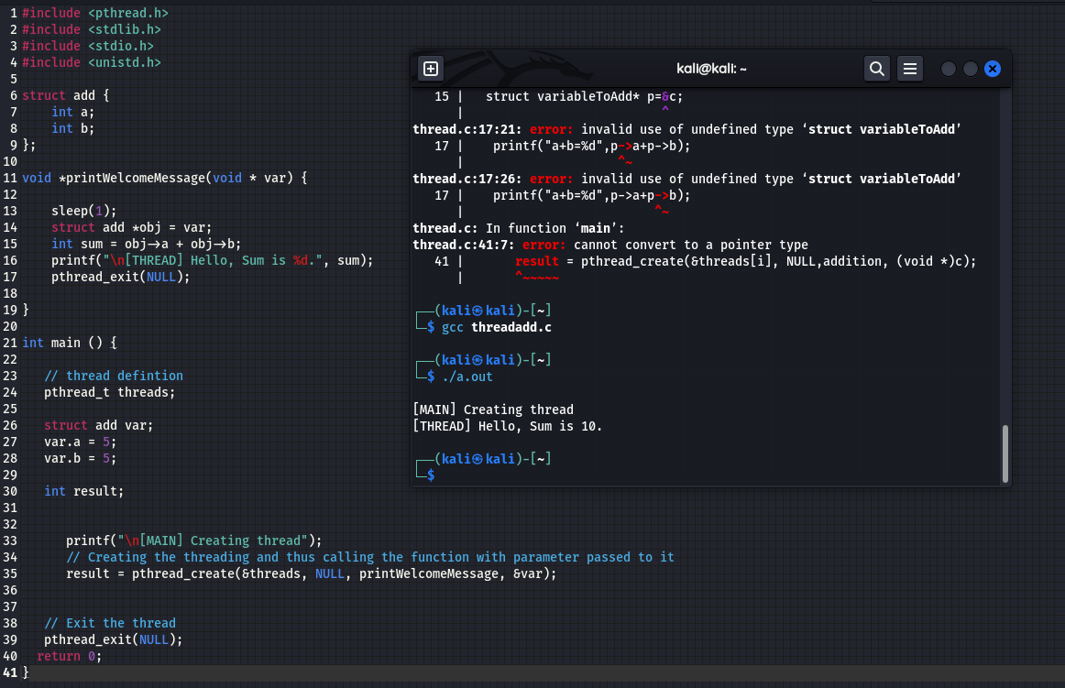

2)Thread

