Software

Help Desk Template

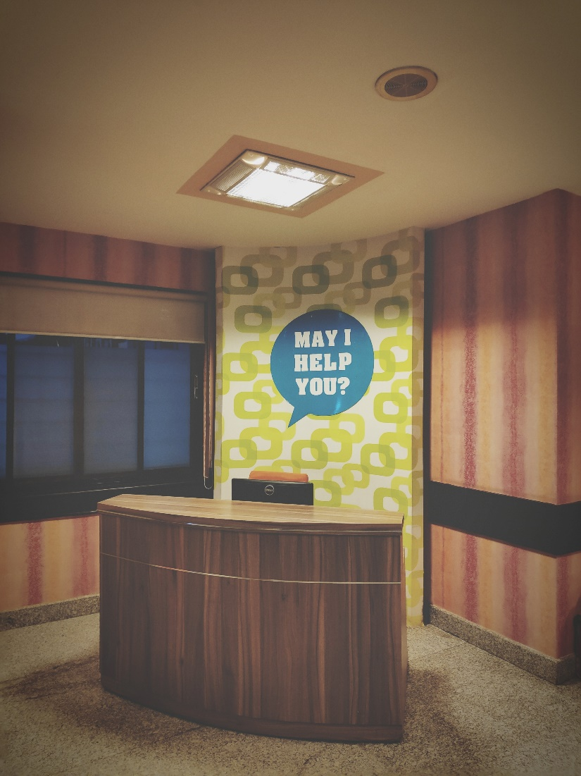
Photo by Gaurav Dhwaj Khadka on Unsplash

Enter text and/or add a screenshot under each following heading.

Help Desk Ticket 1

1. Identify the client’s ICT problem (insert screenshot).

2. Identify the priority Status (insert screenshot)

3a. Complete Impact Analysis Table (highlight the relevant row)
 |  | IMPACT
 |  | H | M | L
URGENCY | H | 1 | 2 | 3
 | M | 2 | 3 | 4
 | L | 3 | 4 | 5

Priority Code | Description | Target Response Time | Target Resolution Time
1 | Critical | Immediate | 1 Hour
2 | High | 10 Minutes | 4 Hours
3 | Medium | 1 Hour | 8 Hours
4 | Low | 4 Hours | 24 Hours
5 | Very low | 1 Day | 1 Week

3b. Explain the reason why you chose this Impact Analysis status. (1 paragraph)
4a. Research solutions to the problem (include references) and offer these solutions to the customer (insert screenshot).
4b. Reply to the ticket asking if the issue is resolved or if they have any further questions (insert screenshot).
5. Thank the client (insert screenshot).
6. Close the ticket (insert screenshot).

Hardware

Help Desk Template

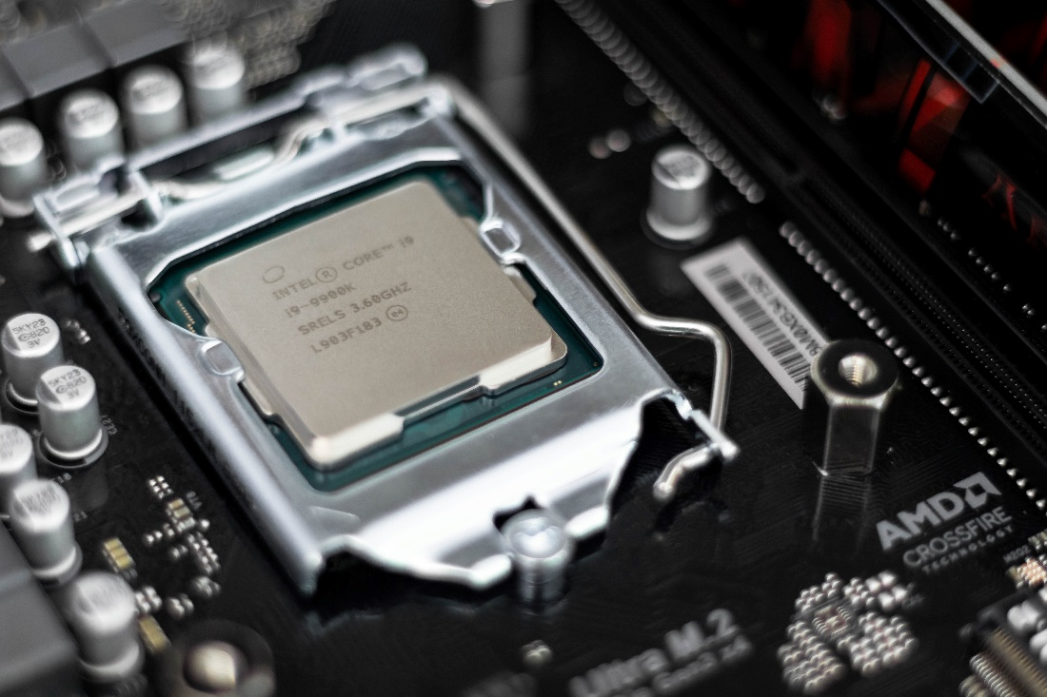
Photo by Christian Wiediger on Unsplash

Add a screenshot under each following heading.

Help Desk Ticket 2

- Identify the client’s ticket priority status according to the Help Desk Organizational Procedures (screenshot).
- Complete the Impact Analysis Table and summarize the selected status.
 |  | IMPACT
 |  | H | M | L
URGENCY | H | 1 | 2 | 3
 | M | 2 | 3 | 4
 | L | 3 | 4 | 5

Priority Code | Description | Target Response Time | Target Resolution Time
1 | Critical | Immediate | 1 Hour
2 | High | 10 Minutes | 4 Hours
3 | Medium | 1 Hour | 8 Hours
4 | Low | 4 Hours | 24 Hours
5 | Very low | 1 Day | 1 Week

- Research a 3rd party business that can help supply the hardware parts required to solve the problem and inform the client of your recommendation.
- Identify the client’s hardware problem and reply to the ticket summarizing the problem (screenshot).
- Name and website of the 3rd party business and the support they can provide (screenshot). Highlight the main inclusions of their Warranty.
- Provide required steps to install the new part (screenshot).
- Write a paragraph outlining the hardware maintenance steps needed to ensure the new part (and computer) continues to operate (screenshot).
- Suggest options to dispose of the old computer part (screenshot).
- Ask the client if the issue is resolved, and if they are satisfied with your service and if you can close the ticket (screenshot).
- Thank the client (screenshot).
- Close the ticket (screenshot).

