Setting up a Sense HAT
These instructions will guide you through setting up your Sense HAT with your Raspberry Pi computer.

You will need: .
Hardware
- A Raspberry Pi computer (Raspberry Pi setup instructions)
- A Sense HAT

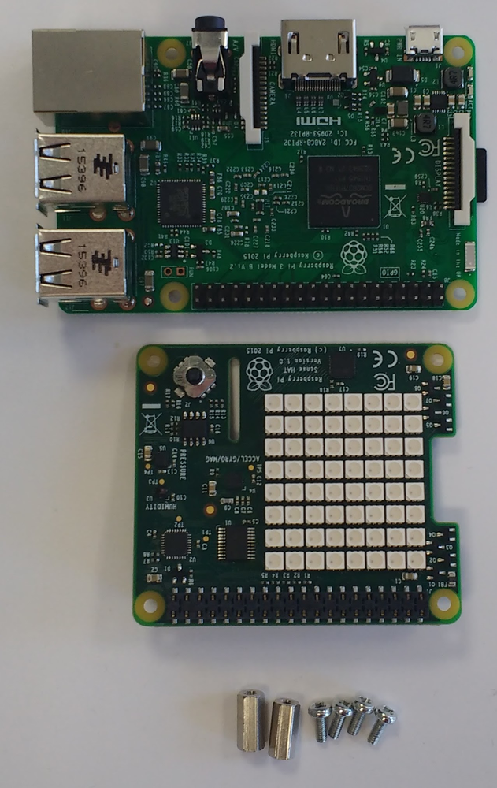
Software
- The latest version of Raspberry Pi OS
- Python 3 (included with Raspberry Pi OS)
- Sense HAT for Python 3 (included with Raspberry Pi OS)

Task  Power down your device
Steps | Instructions
- Make sure that your Raspberry Pi computer is switched off. | 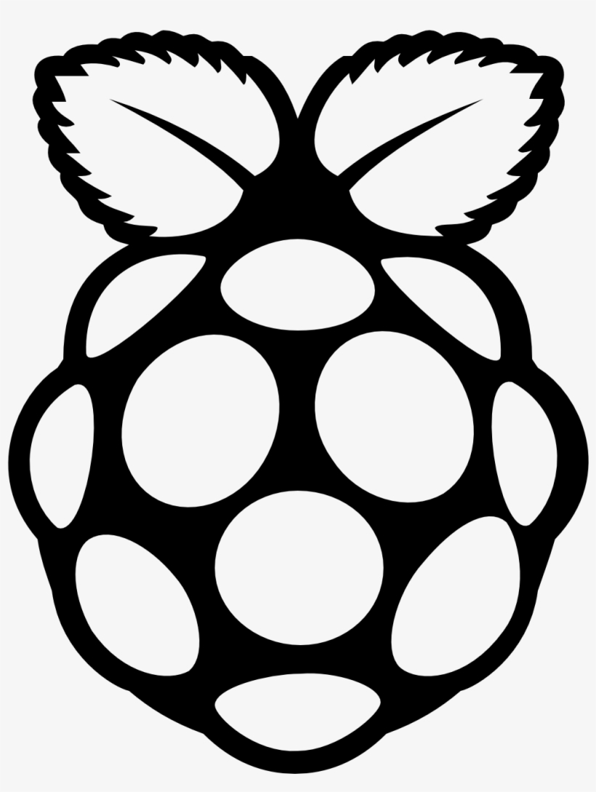▷ Shutdown… ▷ Shutdown
- Unplug your Raspberry Pi computer. | Make sure that the power cable for the Raspberry Pi is unplugged. There should be no power going into your Raspberry Pi.

Task Attach the Sense HAT
Steps | Instructions
- Carefully align the pins.   | 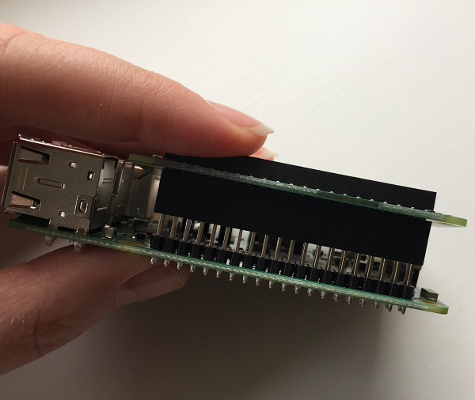
- Gently press down. | 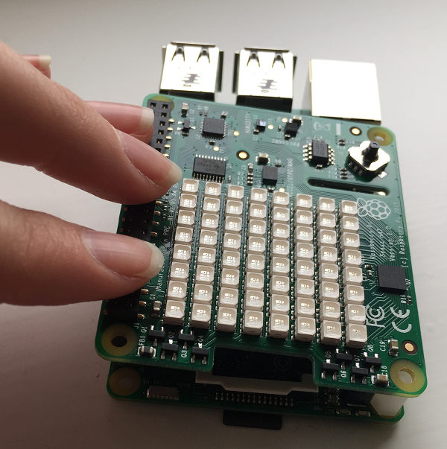

Task Power up your device
Steps | Instructions
- Attach the power cable. | Attach the power cable and all other required cables (monitor, keyboard, mouse).
- Switch on the power. | As your Raspberry Pi boots up, the Sense HAT should display a rainbow of colours on the LED matrix. The lights should last for 15 to 20 seconds before switching off.  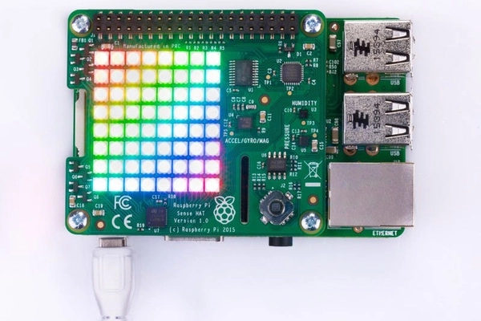  If your Sense HAT does not display a rainbow or the rainbow does not disappear, power down again and check your connections before switching the Raspberry Pi back on.

Task Testing your Sense HAT
Steps | Instructions
- Open Mu. | ▷ Programming ▷ Mu
- Import the Sense HAT library. | Enter the following code to import the library.  from sense_hat import SenseHat  sense = SenseHat()
- Show a message to test your Sense HAT. | Enter the following code after the two previous lines.  sense.show_message("Hello world!")
- Save your program. | Save the file as test.py or something similar.  Note: You must never save Sense HAT files as sense_hat.py It will not work because other programs in the same folder will not be able to access the sense_hat module.
- Run your program. | Click Run and watch your message scroll across the LED matrix.  If you receive the message  ‘ModuleNotFoundError: No module named 'sense_hat'’  make sure that you have the Sense HAT module installed by going to the command line and typing:  sudo apt-get install sense-hat

Resources are updated regularly — the latest version is available at: ncce.io/tcc.

This resource is licensed under the Open Government Licence, version 3. For more information on this licence, see ncce.io/ogl.

