Department of Electrical and Computer Engineering
The University of Alabama at Birmingham

Informal or Memorandum Report Format and Style

Memorandum style reports are usually used for small projects and industrial communications. These reports are usually shorter and less rigid in format than formal reports. However, they do contain background, results, and discussion even if not formally labeled as such.

Informal written reports should contain: 1) transmittal documentation, 2) a one to two-page summary, 3) all pertinent tables and figures that explain and present the results and conclusions, and 4) any detailed calculations.

Transmittal Documentation

In the style of a memorandum, the informal report should begin with the name of the person to whom the report is being submitted, the name of the person submitting the report, the date of submission, and a meaningful subject line describing the content of the report.

TO: Dr. Green

FROM: Elijah Rose (elirose)

DATE: 7.8.2019

SUBJECT: Project-Logger Web Application Review

Summary

The project-logger web application seeks to prove basic working knowledge of both HTML form inputs and posting as well as PHP server-side manipulation. Currently, though perhaps not the prettiest of web applications, the attached web project meets these criteria under the tab HW5. Due to the limitation of using no table in the design, as well as being locked into exact variable names, a very simple and rudimentary design was sought, as seen in Figure 1. Titles were put on top of the input fields to encourage more thoughtful, slow form-answering[1], and the related percentage fields grouped together with a fieldset; care was also taken to change the margins of the headers to be closer to their respective input fields to better serve as labels.
The only unique implementation, perhaps, is the progress bar: a dynamic div element which changes according to the values of the percentage. Javascript, of course, is used to implement this functionality, relating each value with a color. The difficult part, however, is keeping the values in-line – when one value changes, say the percent of Coding in the project, naturally all of the others should take up less of a percentage, if they are all to equal 100% combined. As such, though other methods were considered (and some tested), the solution devised was such that the four non-changed values maintain their ratios and are changed based on the difference of the new and old value of the changed input. Additionally, as nice round numbers are desired in the input field yet rounded numbers would cause gross errors in repeated calculations, a static variable progressBar.values is used to store the floating-point number that the input fields approximate.
The form view page is similarly unremarkable, as well as the all-view page. Each data entry is separated into their own div tags (due to the ambiguity of the rubric regarding if tables were disallowed everywhere or just on form input). When the user prints or “Save as..”, care was taken to remove excess elements such as the URL and time, as well as

Figures and Tables

This subsection is a demonstration subsection named “Figures and Tables”. It is intended to document how to do subsections, figures, and tables. This subsection is not meant to imply that all figures and tables should occur at this point in the memo, rather figures and tables should occur following their first reference wherever that logically occurs in the memo’s flow.

Subsections should be used to provide an organization appropriate to present the topic. Subsection titles should be in bold italics and placed on the left as shown. Figures and tables should be presented in the text near the first reference to the figure or table (Fig. 1). Lines should be straight. If possible, figures should be embedded within the document so that the electronic report document is self-contained, needs no additional pencil drawing, and needs no additional files. All figures (graphs, charts, drawings, diagrams, maps and photographs) must have captions below the figure. Figure captions must contain the figure number in the order of its reference in the text and a descriptive title. All tables must have captions above the table (Table 1). Examples are given below.

Table captions must also contain the table number in the order of its reference in the text and a descriptive title. Figures and Tables are oriented so that they are read from the bottom of the page, with the caption at the bottom of the page, unless the figure or table is very large. A large figure may be oriented so that its bottom is at the right side of the page, with the caption placed along the right edge of the page.

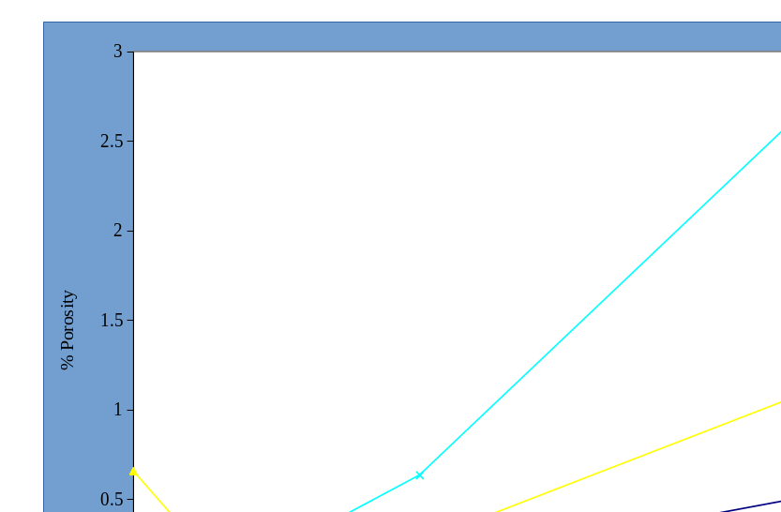

Figure 1. Percentage Porosity Versus Section Thickness

Table 1. The Sample Porosities and Uncertainties with the Average

of Three Weighings in Water

Sample | Porosity | B_{P} | P_{P} | U_{P}
1a | 1.82 % | 0.02 % | 0.42 % | 0.42 %
2a | 1.64 % | 0.02 % | 0.18 % | 0.18 %
3a | 1.58 % | 0.02 % | 0.11 % | 0.11 %
4a | 1.43 % | 0.02 % | 0.09 % | 0.09 %

Work that is not that of the report author and material such as handouts, assignments, papers, books, websites, and interviews that have been used in carrying out the activity should be referenced at the end of the report. If there is a laboratory manual or experiment assignment, then it should be referenced. Works are cited in the report should be indicated by numbers placed in brackets before punctuation. For example:

(a paper) … for determining loss coefficients [1].
(a book) … for determining loss coefficients [2].
(an interview) … for determining loss coefficients [3].
(a URL with date viewed) … for determining loss coefficients [4].

In any document there should be only one method of citation used and it should be used consistently. The IEEE reference format [5] is to be used in this course. Citations should be listed using IEEE format [5] in the references section. Citations should be numbered in order of their first appearance in the text as follows.

References

- K. L. Segwoth, C. Hang, and J. T. Barton, “Porosity malformation in modified and unmodified Fe-Si alloy castings,” AFSP Transactions, vol. 102, pp. 276-361, July, 1974.

- H. W. Dann and W. E. Steelye, Experimentation and Uncertainty Analysis for Engineers. 1st edition. New York: John Wiley & Sons, pp. 67-80, 1989.

- R. I. Peace, Informal communication, Professor, Department of Engineering, Great Midwest University, November 14, 1997.

- (Basic Book/Monograph Online Sources) J. K. Author. (year, month, day). Title (edition) [Type of medium]. Volume(issue). Available: http://www.(URL)

- (2006, May, 22) IEEE Transactions LaTeX and Microsoft Word Style Files .http://www.ieee.org/portal/pages/pubs/transactions/stylesheets.html

Calculations. Any detailed calculations used during the analysis of data, including statistical analyses performed, should be documented neatly and attached to the informal report. The reader should be able to understand the purpose and implications of the exercise by reading only the summary, but detailed calculations should be provided for further consideration.

