Democratic resilience in the age of AI (DEMRESAI)
Concept Note
2026-09-23
In brief
- Democratic resilience is a political system’s capacity to keep the citizen–information–institution loop closing under stress: citizens retain the autonomy to form and act on authentic judgments, the information they draw on retains its integrity, and the institutions that act on it remain accountable — and all three hold equitably, so resilience is not concentrated among those already best equipped to claim it (Anderson & Pro, 2026; Biddle et al., 2025; Easton, 1965).
- Three components carry that capacity: informational autonomy (citizens), informational integrity (shared environment), informational accountability (institutions).
- Three forms of AI disrupt democratic resilience, but the same three forms that erode autonomy, integrity, and accountability by default can strengthen them by design (Maerz et al., 2025).
- Studying the EU alone would show only a narrow slice of this: mature regulation, largely consolidated democracy. Australia and the EU are where this project pilots interventions — consolidated democracies with genuinely different regulatory starting points. Adding Southeast Asia and the Pacific’s hybrid and backsliding cases is what lets the project see the real scope of the problem, not just its EU-shaped corner.
- The goal of this project is to diagnose where AI is eroding each of these three information-related components and deliver the measurement/diagnostic tools, governance guidance, and citizen-facing products that let the EU, Australia, and Southeast Asia/Pacific strengthen them by design instead.

1 The Lens: Three Components
- Informational autonomy — can citizens form authentic judgments and act on them (Anderson & Pro, 2026)?
- Informational integrity — does the shared evidence base stay plural, accurate, and trustworthy?
- Informational accountability — can institutions using AI-mediated information be checked/monitored and corrected?
- This democratic resilience framework builds on classical structural-functionalism (Almond & Powell, 1966).
Three forms of AI cut across all three components at once:
- Generative AI — interpretation, drafting, summarising, and synthetic media generation (text, image, audio, video, including deepfakes) (Anderson & Pro, 2026; Kreps & Kriner, 2023).
- Ranking and recommendation — exposure, amplification, reach (Anderson & Pro, 2026).
- Administrative and advisory AI — institutional decisions, policy advice, lobbying and consultation (George & Klaus, 2026; Margetts & Dorobantu, 2019).
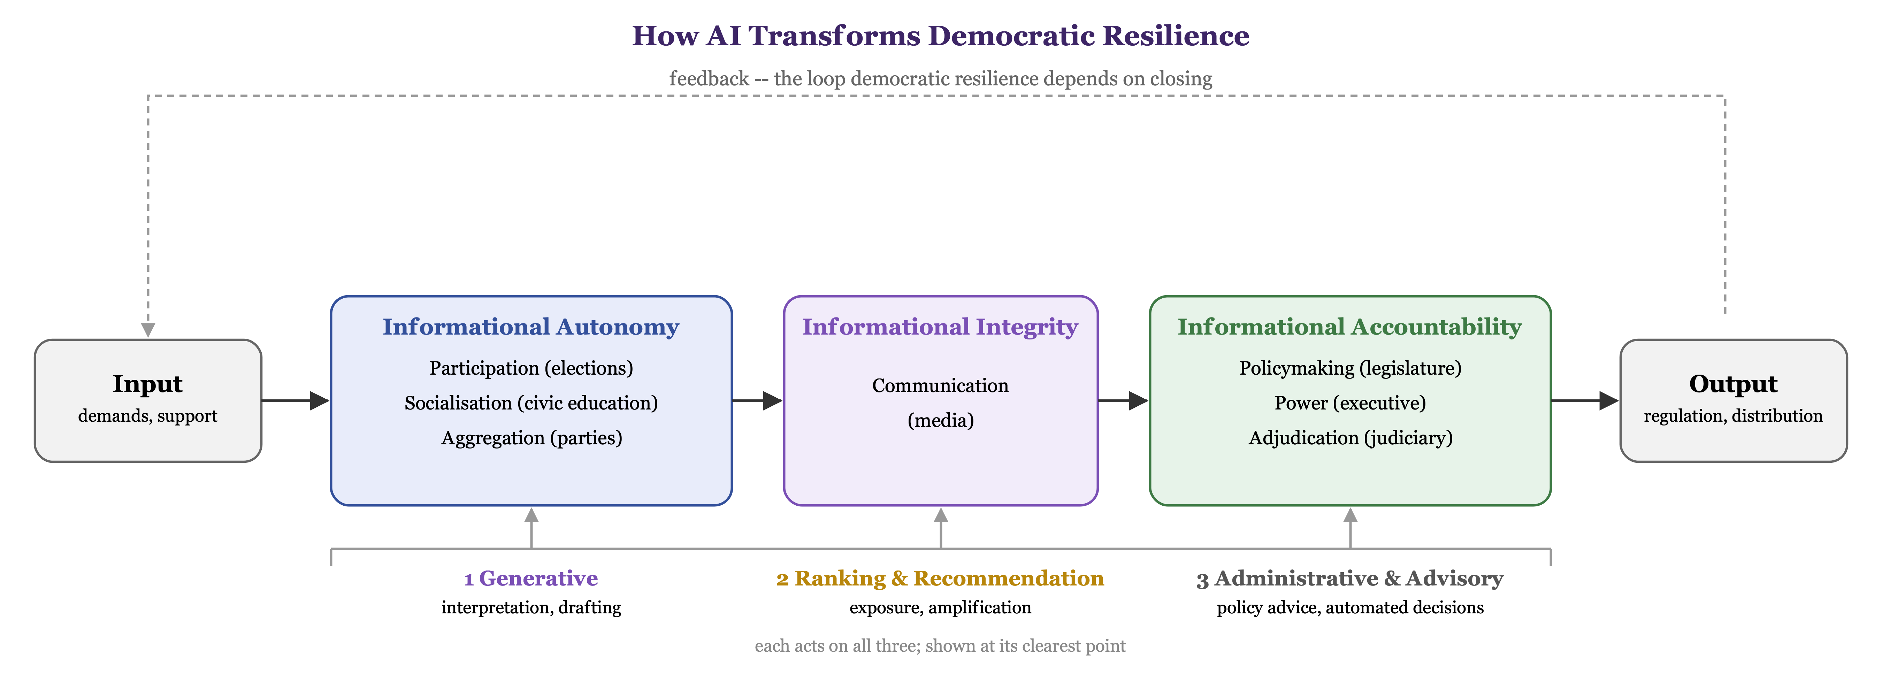
Easton’s (1965) feedback loop, regrouped into our three components in focus, with the three forms of AI that cut across all of them.
Each information component, and each form of AI, has a negative and a positive reading. The EU and Australia are where interventions are piloted and tested — consolidated democracies, one with the EU’s regulatory apparatus and one without it. Southeast Asia and the Pacific’s hybrid and backsliding cases extend the scope of analysis to contexts the other two cannot supply in their own right, so the project’s diagnosis is not scoped to the EU-conditions alone — it speaks to democratic resilience more broadly. Every work package below has been designed to deliver two things: understanding of what is eroding resilience, and recommendations of what citizens or decision-makers can do about it.

1.1 Informational Autonomy — Citizens (Constanza, 3 clearcut paragraphs plus two WPs)
- Authenticity — beliefs genuinely one’s own, formed through exposure to facts, reliable information and reflection.
- Agency — capacity to act effectively based on those beliefs.
- AI strengthens one while weakening the other: the autonomy paradox (Anderson & Pro, 2026).
- Reflective inaction (authentic, cannot act) and conditioned agency (act, but on AI-shaped beliefs) are the two failure modes. Informational breakdown is neither — the citizen-level analogue of onset/breakdown resilience (Boese et al., 2021).
- Socialisation and recruitment (Almond & Powell, 1966) set the baseline this all plays out on: how citizens acquire civic knowledge and enter political life in the first place. If that baseline is itself increasingly AI-mediated (civic content, recommender-curated education, AI tutoring), the paradox may begin earlier than participation does.
- Unevenly distributed: digital literacy and access to validated tools shift the odds (Australian Government Department of Home Affairs, Strengthening Democracy Taskforce, 2024; Biddle et al., 2025). Eroded autonomy erodes trust directly — participation feels futile, or citizens cannot tell whose judgment is doing the work.
Figure 2 also shows how equity enters the framework concretely, directly answering the call’s emphasis on inclusive digital transformation.
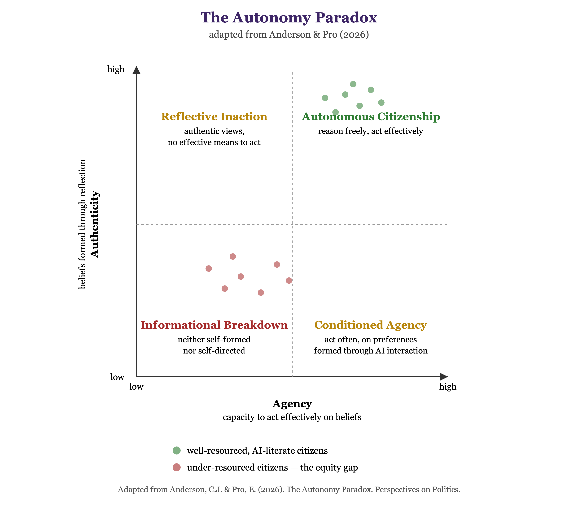
Figure 2: The autonomy paradox.

1.2 Informational Integrity — The Shared Environment (Max, 3 clearcut paragraphs plus 2 WPs)
- The media environment (Figure 1): the independent, interpretive channel that carries information between citizens and institutions — political communication in the classical sense (Almond & Powell, 1966), not information the state produces about itself.
- A second element belongs here too, though structurally it sits closer to Power: the evidentiary infrastructure democracies run on — official statistics, science, expert testimony, government reporting. Integrity and accountability overlap here: the information must be trustworthy, and because it is state-produced, whether it can be checked is an accountability question too (Section 1.3).
- Ranking and recommendation systems reward synthetic, homogenised content at scale (Bossio et al., 2022; Zuboff, 2019), i.e., the same generative tools that draft a citizen’s letter can fabricate a citation, a study, or a statistic that then enters the public record as authoritative (Summerfield et al., 2025).
- Unevenly distributed: fact-checking coverage and evidentiary infrastructure are weaker in some languages and regions than others. Eroded integrity erodes trust because the shared evidence base itself becomes unreliable.
- Restorable: provenance and certification tooling is exactly the civic-tech opportunity the call names (Noveck, 2021; OECD, 2025).

1.3 Informational Accountability — Institutions (Seraphine, 3 clearcut paragraphs plus 2 WPs)
- Draws on a different literature than the loop’s process functions: the separation of powers, plus the press as the informal fourth estate — legislature, executive, judiciary, and media watching the other three (Schultz, 1998, Luhrmann 2020). Accountability, not conversion, is the point, which is why it anchors this component rather than the loop as a whole.
- Dutton (2009) extends this to a fifth estate: networked individuals holding power accountable through the internet, alongside the institutional press. Whether AI and platforms now constitute a further, sixth estate — a new site of accountability, or a new power that itself escapes the other estates’ checks — is an open question this component investigates directly.
- Concretely: platforms, public administration, security services, and the organisations that produce policy advice. The question is not whether an institution uses AI-mediated information, but whether anyone outside it can make it account for what it does with that information (Bradford, 2020; European Parliament and Council of the European Union, 2022).
- Unchecked, this is where AI most directly serves authoritarian control (Feldstein, 2021; Garbe & Maerz, 2026).
- Unevenly distributed: well-resourced organised interests can demand accountability far more effectively than small civil-society groups. Eroded accountability erodes trust because institutions that cannot be checked cannot be believed.
- Restorable: audit and transparency tooling, plus training that builds correction into institutions by design rather than after the fact, are what convert accountability from an ideal into a habit.
The call’s second Expected Outcome — strengthened citizen engagement, increased institutional trust (European Commission, 2025) — is how democratic resilience is observed empirically. All three components feed into it, so protecting them together is how resilience is built, not a separate goal pursued alongside it.

2 From Framework to Work Packages
Each WP pairs a risk diagnosis with a strengthening response and names a deliverable that answers directly to the call’s own goals — new data/methods for decision-makers and civil society, or strengthened citizen engagement and trust. The EU and Australia anchor the project’s two pilot sites — consolidated democracies with different regulatory starting points. Southeast Asia and the Pacific extend the diagnostic scope to the hybrid and backsliding cases neither pilot site can supply. Staffing rule: every lead also collaborates on one other WP.
Table 1: Draft DEMRESAI work packages, ordered to follow Figure 1.
WP | Name | Tasks & Deliverables | Lead / co-lead
WP1 | Framework | Refine the three-component framework — informational autonomy, integrity, accountability — into a conceptual model that distinguishes where AI shields democratic resilience from where it must be reinvigorated; framework paper; policy briefs equipping EU and Australian decision-makers to tell the two apart. | Seraphine Maerz, Constanza Sanhueza Petrarca, Max Groemping
Loop, part 1: informational autonomy (all WPs deal with the autonomy paradox)
WP2 | Citizen Trust | Survey experiment measuring how AI shifts the overall level of citizens’ political trust — in parties, media, and institutions — and testing whether AI-assisted civic tools can rebuild that level where it erodes, evidencing the call’s institutional-trust outcome directly; longitudinal public-trust index; policy brief for electoral commissions. | Constanza Sanhueza Petrarca, Simon Jackman, Marta Kolczynska, some more from Europe  -Max/Ferran: Task Leaders  Task leader? Marta Kołczyńska
WP3 | Deliberative Democracy Pilot | Under what conditions can AI help humans find common groud in deliberation? (trust in AI..... perceptions of legitimacy of deliberation outcomes....) AI-assisted citizen deliberation pilot, co-designed with the JRC Competence Centre and piloted with an EU/Australian government body (which?), testing whether structured AI assistance can strengthen inclusive participation and citizen engagement; participation toolkit; paper on civic preparedness. | Marta Kołczyńska, Adele Webb, some civil society organization which uses AI to come up with nice innovative deliberation tools...?, Ed Hovy, Yoshihisa Kashima  Francesco Bailo?
WP4 | Epistemic Calibration | LLM-assisted interviews at scale asking a simple question: do citizens trust AI-generated information the right amount — more when it is actually reliable, less when it isn't — or is their trust systematically off? We also test whether AI-generated reflective prompts — brief, automatically generated nudges that ask citizens to pause and check a claim before accepting or sharing it — can help citizens correct that mismatch; large-N interview dataset; paper on the psychological microfoundations of Anderson & Pro's (2026) autonomy paradox; policy brief on practical interventions to help citizens calibrate their trust | Ed Hovy, Yoshihisa Kashima
Loop, part 2: informational integrity (Question?)
WP5 | Disinformation Monitoring | How does AI enhance or erode th eintegrity of information circulating in the public sphere? Real-time fact-checking and platform-monitoring toolkit for newsrooms, regulators, and civil society, piloted in the EU and Australia and then extended to Southeast Asian and Pacific cases where disinformation risk is most acute, testing the toolkit against the sharper end of the problem; FAIR disinformation dataset; policy brief for regulators; paper. | Andrea Carson, Sofya Glazunova, Christine de Kock, Steven Wilson
WP6 | Evidence Integrity / | How does AI enhance or erode the integrity of evidence ingested into policymaking processes?  Cross-national index of media plurality and scientific/statistical evidentiary integrity, certified to a recognised EU and Australian fact-checking standard (candidates below) and extended to Southeast Asia/Pacific via regional IFCN-verified signatories; provenance and certification toolkit for newsrooms, platforms, and public institutions — the civic-tech deliverable the call names; paper on AI and the evidentiary basis of democratic discourse. A policy-making institution as partner.  Audit AI-mediated lobbying, proxy advisory, and evidence-laundering in legislative and regulatory records; verification guidance and a lightweight public-service fact-checking tool that strengthens institutional trust directly; paper. | Max Groemping, Erin O’Brien?,  See Candidate Partner Organisations, below plus some quant scholar, maybe Simon Jackman?  European Digital Media Observatory (EDMO),
Loop, part 3: informational accountability (Question?) (all WPs adress accountability)
WP7 | Repression Monitoring,  Cross-country risk assessment | Cross-national, comparative focus. Monitor AI-enabled digital repression and surveillance threatening civil society, benchmarked against EU and Australian baselines and extended to Southeast Asian and Pacific cases where the threat is most acute; early-warning briefings and protective-countermeasure guidance for human-rights and civil-society monitors; paper. Early-warning system | Steven Wilson, Carl Henrik Knutsen, Aurel Croissant, Janjira Sombatpoonsiri, Seraphine Maerz
WP8 | How does governance and accountability change with AI, or AI regulation...? | Comparative analysis of AI regulatory and governance models — the EU’s Digital Services Act and Australia’s emerging AI governance approach as two different pilot pathways — tested against Southeast Asian and Pacific governance contexts to see which elements travel and which don’t; building on prior Horizon-funded work without duplicating it, per the call’s own condition; policy recommendations for the European Commission and DFAT; paper. | Pascal Koenig (or some regulation expert)
WP9 | AI Literacy | AI-literacy training and governance guidelines for public servants and universities, plus a citizen-facing AI-literacy programme and companion app (working name: the Resilience Companion) that helps citizens spot AI-generated content, prompts reflective judgment before sharing, and routes accountability complaints to the right body; civic-preparedness curriculum; paper. | See Candidate Partner Organisations, below, Kate Williams, Eric Fu, Tanja Notely
Scaling, synthesis, engagement, coordination
WP11 | Cross-Country Measurement, better title...? | Build and validate survey and computational indicators for informational autonomy, integrity, and accountability that flag both erosion and improvement; FAIR instrument and dataset; apply across countries; computational analysis of generative AI outputs on political topics as one input; open-source, FAIR-compliant toolkit; training workshops for partners; methods paper. | Miklos Sebok, Aurel Croissant
WP13 | Public Engagement & Impact, AI literacy | Direct citizen engagement events and panels enabling broader public debate, including the public launch and field-testing of the Resilience Companion; dissemination and impact strategy; policy-brief compendium; final report. | Tanja Notely, Ika Trijsburg, Kate Williams  Tactical Tech
WP14 | Coordination & Ethics, merge with WP1 | Consortium agreement, including onboarding the policy-making and civil-society partners the call requires; mid-term assessment by external democracy practitioners and policymakers; ethics approvals; FAIR data management plan. | Seraphine Maerz

3 Open Items
- WP9 should be led by a civic-tech partner, covering both public-sector and citizen-facing AI literacy — not yet confirmed. Current secondary contacts (International IDEA, a Brussels practitioner) are communications roles, not tool-builders.
- WP6 (Evidence Integrity) should be led by a relevant civil-society organization (see list below).
- Approach Anderson (LSE) as advisory board / co-investigator.
- Involvement of a policy-making body…?
- Mid-term assessment (required for civic-tech proposals under this call) must be performed by external practitioners/policymakers. Candidates: JRC Competence Centre, DFAT, International IDEA, Alex Reid (Inter-Parliamentary Union). WP14 names this deliverable.
- The Resilience Companion (WP9/WP13) is a new product commitment - it needs its own design/build resourcing plan beyond Tactical Tech’s own capacity. The UniMelb computer scientists (Leckie, de Kock) are candidates to extend into this if the budget allows.

4 Candidate Partner Organisations
Not yet contacted; listed here to track against WP fit and the call’s eligibility requirements.
EU and Australian civil-society / policy organisations (in the mold of EFCSN)
- European Digital Media Observatory (EDMO), Florence (EUI) — EU-funded hub coordinating fact-checkers and disinformation researchers across member states; possible WP6 co-lead alongside EFCSN.
- Democracy Reporting International (DRI), Berlin — works on AI and information integrity in democracy support, with real EU policy engagement; a candidate for the still-open policy-making-body eligibility gap.
- AlgorithmWatch, Berlin — algorithmic accountability research and advocacy; fits WP8 (AI Governance) or WP10 (Policy-Advice Audit).
- Access Now, Brussels office — digital rights and surveillance monitoring; fits WP7 (Repression Monitoring).
- European Federation of Journalists (EFJ), Brussels — journalists’ professional body across Europe; fits the media-plurality side of WP6.
- Civil Liberties Union for Europe (Liberties), Berlin — cross-EU fundamental-rights network; could help satisfy the general civil-society eligibility requirement independent of any single WP.
- RMIT FactLab, Melbourne — fact-checking research and verification training, the Australian complement to EDMO/EFCSN for WP6.
- Reset.Tech Australia, Sydney — platform-accountability and AI-governance research, the Australian arm of the international Reset network; fits WP8 (AI Governance) or WP10 (Policy-Advice Audit), complementing AlgorithmWatch/DRI.
- Digital Rights Watch, Melbourne — Australian digital-rights NGO campaigning on surveillance and government tech use; fits WP7 (Repression Monitoring), complementing Access Now.
- Media, Entertainment & Arts Alliance (MEAA) — Australia’s journalists’ union; fits the media-plurality side of WP6, complementing EFJ.
- Human Rights Law Centre, Melbourne — Australian fundamental-rights legal advocacy; could help satisfy the general civil-society eligibility requirement, complementing Liberties.
EU and Australian civic-tech / AI-literacy organisations (in the mold of Tactical Tech)
- AlgorithmWatch, Berlin — also runs public-education work alongside its accountability research; overlaps with the list above.
- European Digital Rights (EDRi), Brussels — network of digital-rights NGOs running public-awareness campaigns; a natural WP9 co-lead alongside Tactical Tech.
- Mozilla Foundation, Brussels policy office — AI-literacy and internet-health programmes at scale; could extend the Resilience Companion’s reach.
- Bits of Freedom, Amsterdam — digital-rights NGO building citizen-facing toolkits, the Dutch analogue to Tactical Tech’s Data Detox Kit.
- Access Now, Brussels — runs a Digital Security Helpline and citizen-facing digital-safety trainings.
- Digital Rights Watch, Melbourne — also runs public digital-literacy campaigns; the Australian complement to EDRi, and overlaps with the list above.
- Reset.Tech Australia, Sydney — also publishes public-facing platform-literacy resources; overlaps with the list above.
- RMIT FactLab, Melbourne — offers fact-checking and media-literacy training for the public; Australian complement to Mozilla’s AI-literacy programmes.
- CHOICE, Sydney — Australia’s consumer-advocacy organisation, publishes citizen-facing digital-safety and AI-scam guides; a lighter-touch Australian analogue to Bits of Freedom’s toolkits.

5 References
Almond, G. A., & Powell, G. B. (1966). Comparative politics: A developmental approach. Little, Brown.
Anderson, C. J., & Pro, E. (2026). The autonomy paradox: Artificial intelligence and the foundations of political behavior. Perspectives on Politics. https://doi.org/10.1017/S1537592726105775
Australian Government Department of Home Affairs, Strengthening Democracy Taskforce. (2024). Strengthening australian democracy: A practical agenda for democratic resilience. Australian Government.
Biddle, N., Fischer, A., Angus, S., Ercan, S., Grömping, M., & Gray, M. (2025). Democratic resilience: Moving from theoretical frameworks to a practical measurement agenda (Discussion Paper 5). Australian Resilient Democracy Research; Data Network, Australian National University.
Boese, V. A., Edgell, A. B., Hellmeier, S., Maerz, S. F., & Lindberg, S. I. (2021). How democracies prevail: Democratic resilience as a two-stage process. Democratization, 28(5), 885–907. https://doi.org/10.1080/13510347.2021.1891413
Bossio, D., Flew, T., Meese, J., Leaver, T., & Barnet, B. (2022). Australia’s news media bargaining code and the global turn towards platform regulation. Policy & Internet, 14(1), 136–150. https://doi.org/10.1002/poi3.284
Bradford, A. (2020). The brussels effect: How the european union rules the world. Oxford University Press.
Dutton, W. H. (2009). The fifth estate emerging through the network of networks. Prometheus, 27(1), 1–15. https://doi.org/10.1080/08109020802657453
Easton, D. (1965). A systems analysis of political life. John Wiley & Sons.
European Commission. (2025). Horizon europe work programme 2026–2027: Cluster 2 – culture, creativity and inclusive society, destination: Innovative research on democracy and governance.
European Parliament and Council of the European Union. (2022). Regulation (EU) 2022/2065 on a single market for digital services (digital services act).
Feldstein, S. (2021). The rise of digital repression: Technology, democracy, and the coming contest to the future of politics. Oxford University Press.
Garbe, L., & Maerz, S. F. (2026). The rise of authoritarian informationalism: Escalating surveillance, manipulation, and control. Democratization, 33(1). https://doi.org/10.1080/13510347.2025.2579105
George, R., & Klaus, I. (2026). AI and democracy: Mapping the intersections. Carnegie Endowment for International Peace.
Kreps, S., & Kriner, D. (2023). How AI threatens democracy. Journal of Democracy, 34, 122–131. https://doi.org/10.1353/jod.2023.a907693
Maerz, S. F., Chernykh, S., & Sanhueza Petrarca, C. (2025). Addressing the risks of generative AI for democracy. Robert Schuman Centre for Advanced Studies, European University Institute, for the European Commission. https://doi.org/10.2870/3156095
Margetts, H., & Dorobantu, C. (2019). Rethink government with AI. Nature, 568(7751). https://doi.org/10.1038/d41586-019-01099-5
Noveck, B. S. (2021). Solving public problems: A practical guide to fix our government and change our world. Yale University Press.
OECD. (2025). Governing with artificial intelligence: AI in civic participation and open government. OECD Publishing.
Schultz, J. (1998). Reviving the fourth estate: Democracy, accountability and the media. Cambridge University Press.
Summerfield, C., Argyle, L. P., Bakker, M., Collins, T., Durmus, E., Eloundou, T., Gabriel, I., Ganguli, D., Hackenburg, K., Hadfield, G. K., Hewitt, L., Huang, S., Landemore, H., Marchal, N., Ovadya, A., Procaccia, A., Risse, M., Schneier, B., Seger, E., … Botvinick, M. (2025). The impact of advanced AI systems on democracy. Nature Human Behaviour, 9(12), 2420–2430. https://doi.org/10.1038/s41562-025-02309-z
Zuboff, S. (2019). The age of surveillance capitalism: The fight for a human future at the new frontier of power. PublicAffairs.

