Democratic Resilience, Information, and AI
Working notes 17.09.2026 – Constanza

1.Information as the medium: a perception model
Fair access and accurate information is the precondition for democratic resilience: citizens can only form demands, grant or withdraw support, and hold officials to account if their picture of reality is reasonably accurate. Let reality be a true value N (example unemployment rate, GDP growth, immigration shares, effects of policy X). No citizen observes N directly; each holds a perception that differs from it by some error. Across a population these perceptions form a distribution whose mean captures systematic bias (how far the average sits from N) and whose spread captures noise and disagreement. This can be amplified by AI, eco-chambers, extremist parties and candidates, etc. A well-informed public is centred on N with modest spread.
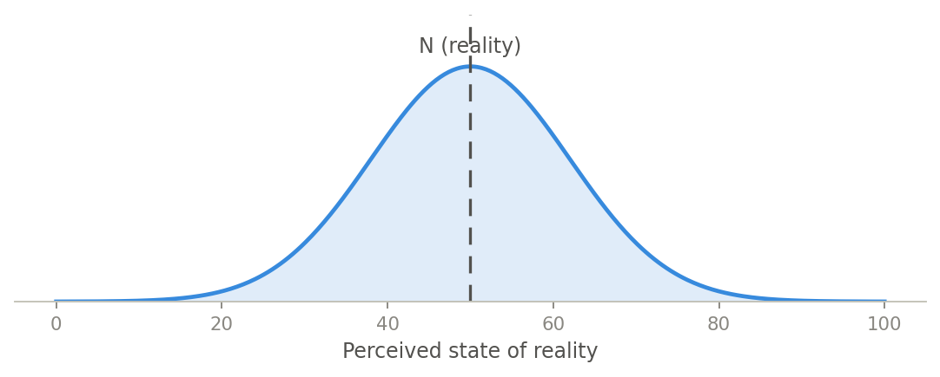
Figure 1. Baseline: citizen perceptions scatter around reality N; spread is ordinary human error.
AI acts on this whole distribution because it mediates how people acquire and summarise information, and it has two independent effects. It can move the mean — introducing bias through flattening summarisation, skewed training data, or confident wrong assessments, or removing it through fact-checking and better data. And it can reshape the spread — widening it through personalisation and confident error, or narrowing it through shared, calibrated assessments. AI is thus neither good nor bad for the information environment in the abstract: it is a transformation whose sign is empirical.
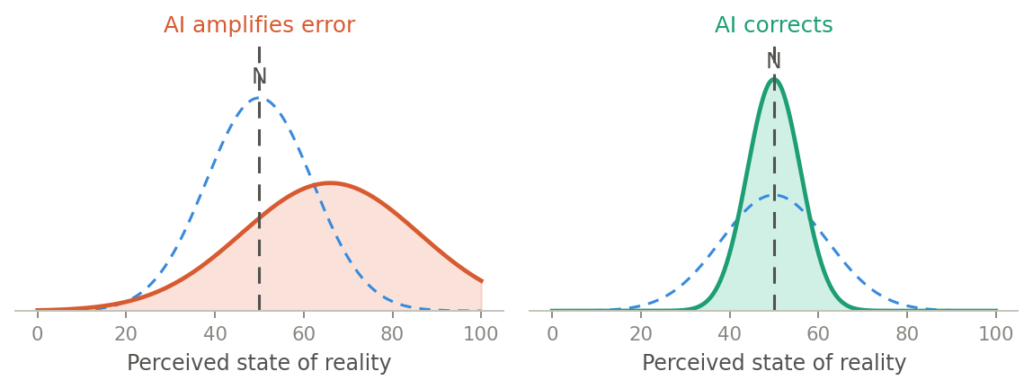
Figure 2. The same distribution under AI: amplification shifts the mean off N and widens spread (left); correction re-centres on N and narrows it (right).

2. When officials and citizens use different models
Representation and accountability assume officials and citizens share a picture of reality. If they draw on different channels — citizens through mass media and commercial platforms, officials through briefings, internal data, expert advice and “democratic AI models”— there are two distributions, and the divergence between them becomes the key quantity. As the distributions pull apart, responsiveness fails (officials optimise against a misread public), accountability weakens (citizens judge officials on a different factual baseline), and legitimacy erodes. Divergence is not automatically bad, and the official channel is not automatically closer to N: elite channels can be the more corrupted ones. A resilient system keeps the two channels cross-checkable rather than privileging either as ground truth.
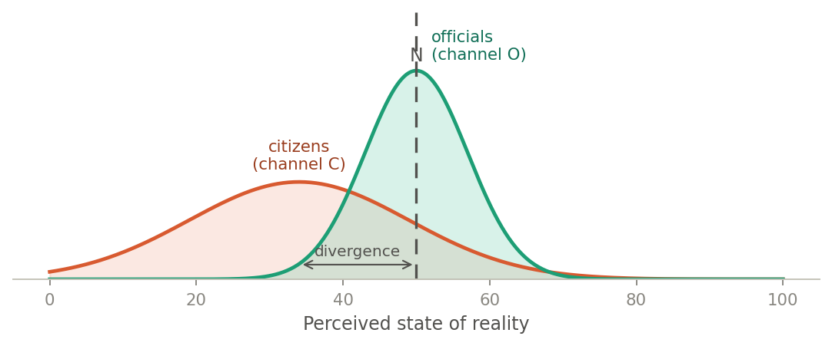
Figure 3. Two channels on one reality: officials clustered near N, citizens shifted off it and more dispersed; the gap between the peaks is the divergence.

3. Unequal access: democratic vs. commercial AI
Access to corrective AI is itself unequally distributed. Suppose a minority of citizens (say 30%) use democratic AI — public-interest models designed for shared, verifiable, deliberation-supporting outputs — while the majority of citizens (70%) use commercial models whose engagement-optimised, personalised objectives tend to bias political perception off N. The population distribution is then a weighted mixture of the two groups.
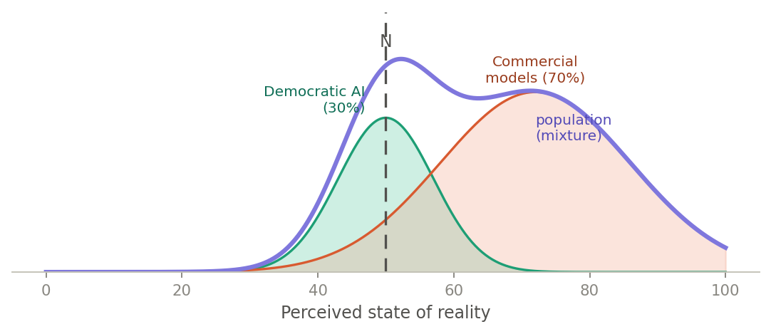
Figure 4. A 30/70 mixture. The population (purple) is dragged toward the commercial hump and becomes bimodal; the well-informed minority appears only as a shoulder, not as a shift in the mean.
Two results follow. First, the aggregate mean is a weighted average dominated by the larger group, so a single “average perception” statistic reports a mildly biased public and conceals that a large majority is badly off while a minority is accurate. Second, the mixture is typically bimodal — a divided epistemic public rather than a uniformly misinformed one. Crucially, the access share is a policy variable: widening democratic-AI provision grows the accurate hump and re-centres the population on N. If access instead tracks existing income, education or literacy, AI amplifies prior inequality and the epistemic divide lines up with the socio-economic one — connecting the information pillar directly to the material conditions in the system’s environment.

3. Implications for democratic resilience
Reading these strands together, the resilience of the information pillar is not simply “is the public’s perception accurate?” but a set of relational, distributional questions: How far is the population centred on N, and how dispersed? Is it one public or two? How wide is the citizen–official divergence, and is it growing? Who has access to corrective tools?

Figures are illustrative schematics of the model, not empirical estimates.

Notes on the reasoning:
Let reality be a true value N (the actual state of the world citizens need to grasp — say, the real level of crime, the real economic situation, the real content of a policy). No citizen observes N directly. Each holds a perception pᵢ that differs from N by some error. Across a population, those perceptions form a distribution:
pᵢ = N + bias + εᵢ, where εᵢ ~ Normal(0, σ)
Two quantities capture how well the citizenry tracks reality. Bias is how far the average perception sits from N (systematic distortion — everyone leaning the same wrong way). Spread (σ) is how dispersed perceptions are (noise, disagreement, uncertainty). A well-informed public is centred on N with low spread. This is the informational precondition for democratic resilience: citizens can only make sound decisions, and only exercise their role, if the perception distribution stays reasonably close to N and reasonably tight.
AI as a distortion operator. AI acts on the whole distribution because it mediates how people acquire and summarise information. It has two independent effects, and this is the crux of your point:
- It moves the mean — introducing or removing bias. Summarisation that flattens nuance, biased training data, or a wrong assessment shifts the average perception away from N. Correction (better data, surfacing what an individual can't see, fact-checking) pulls it back toward N.
- It reshapes the spread — amplifying or dampening σ. Personalised, confidence-inflating outputs widen dispersion and entrench divergent realities; shared, calibrated assessments narrow it.
So AI isn't good or bad for perception in the abstract — it's a transformation whose sign is empirical. The interactive lets you toggle the three regimes: baseline (perceptions scatter around N with human error only), amplify (mean shifts by AI's directional bias and σ widens — the distribution drifts off N and fattens), and correct (mean pulled back toward N and σ compressed — the distribution sharpens onto reality).

