DEMRESAI workshop
Democratic resilience in the age of AI
Wednesday 9 and Thursday 10 December 2026, Old Arts Building, University of Melbourne
Draft programme, timings and venues marked in yellow are still to be confirmed
At a glance
Dates | Wednesday 9 and Thursday 10 December 2026, both days start at 9:30
Venue | Old Arts Building, University of Melbourne, Parkville
Hotel | Best Western Plus Travel Inn Hotel, corner of Grattan and Drummond Streets, Carlton (about 12 minutes on foot, see the map)
Day 1 | Introduction, framework and how to use the two days. Introduction round. Horizon Europe input and formalities (structure of the calls) from the UniMelb Research Office. Public launch of the V-Dem Institute with drinks and finger food. Workshop dinner.
Day 2 | Group work on the work packages, a session on call 09, and a hybrid wrap-up with European partners on Zoom. Closing dinner.

What we want from the two days
- A shared picture of the project, its aims, the two calls (04 as main target, 09 as second option) and the overarching framework of informational autonomy, integrity and accountability.
- Settle the main call, and be clear how we treat the second one.
- Agree a limited number of shared empirical problems that several work packages work on together, so the project is more than a set of parallel studies.
- Identify the missing competences and partners.
- Agree a realistic division of resources, staff time and decision rights.
- Have clear expectations of what is possible and what each commitment means (funding, roles, letters of commitment).
- Decide which work packages to keep, combine or narrow.
- Make sure every work package is aligned with the outcomes the call asks for and has a clear impact.
- Notes in a form we can reuse when we write the bid.
Two checks for every work package, all through the workshop
1. Alignment with the call: does the work package deliver what the call asks for (the outcomes O1 to O4 and the call keywords)?
2. Impact: who will use the results, what changes for them, and how will we measure it?

Rooms
All rooms are in the Old Arts Building.
Room | Use | Notes
Old Arts Hall | Plenary sessions, public events (V-Dem Institute launch), meals and group work | Larger room with nice corners and sofas for small group conversations
Room 257 | Opening sessions on Day 1, group work and meetings | Directly next to the Old Arts Hall
Rooms 219 and 220 | Meeting rooms for breakout groups | Directly next to the Old Arts Hall, opposite room 257

Getting there on foot
From the Best Western Plus Travel Inn (corner of Grattan and Drummond Streets) to the Old Arts Building it is about 930 m, roughly 12 to 15 minutes. The route runs west along Grattan Street and then north through the campus. Red numbers on the map show the distance walked. The two dinner venues are marked in purple.
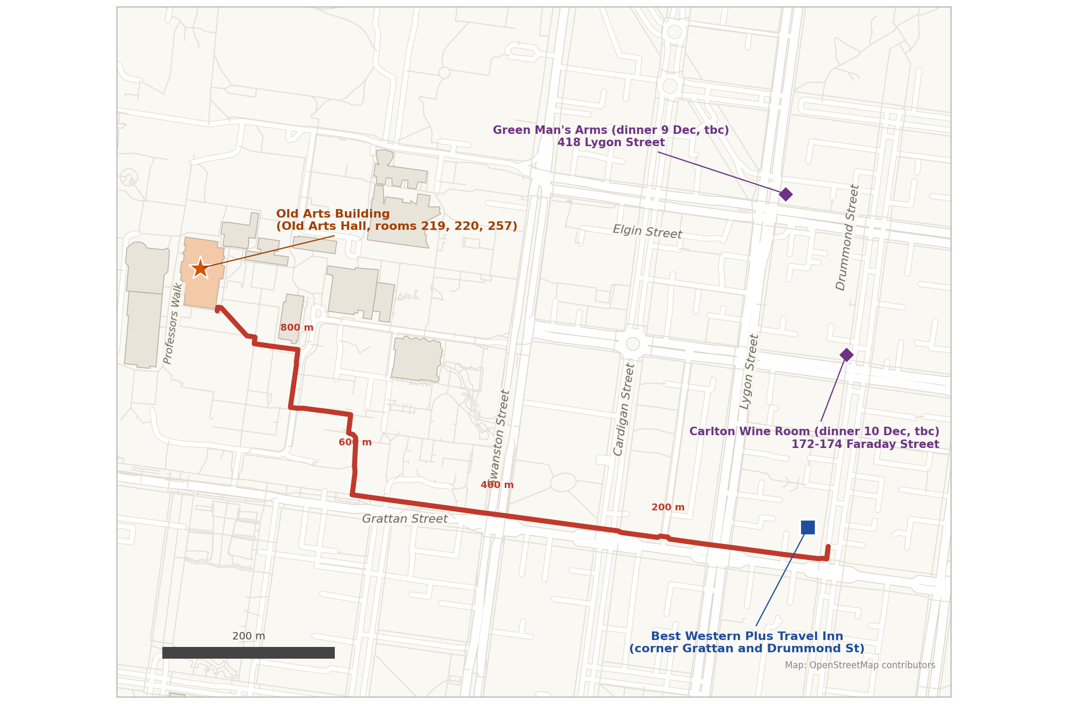

Route
- Leave the hotel and walk west along Grattan Street.
- Cross Lygon Street, Dorrit Street and Cardigan Street (about 260 m), then Swanston Street (about 390 m).
- Keep going west along Grattan Street for about 280 m, then turn right (north) into the campus at Engineering Lane (about 670 m).
- Follow the paths north past Wilson Avenue to the Old Arts Building (about 930 m in total).
The route was calculated from OpenStreetMap data. Please check it on your phone map, campus paths can be closed for building work.

Dinner venues
- Green Man's Arms, 418 Lygon Street (9 December, to be confirmed), about 400 m north of the hotel.
- Carlton Wine Room, 172 to 174 Faraday Street (10 December, to be confirmed), about 200 m from the hotel.

Day 1, Wednesday 9 December
Theme: getting started together.
Time | Session | Who and where | What happens
9:30 to 10:00 | Arrival, coffee and name tags | Room 257 | Welcoming all participants.
10:00 to 11:15 | Acknowledgement of Country and project introduction | Seraphine Maerz, Constanza Sanhueza Petrarca and Max Groemping  Room 257 | The project and its aims, targeting both calls (04 and 09).  The overarching theoretical framework: informational autonomy, integrity and accountability, and AI as disruption.  How we suggest using the next two days.
11:15 to 12:30 | Introduction round | Everyone  Room 257 | About 3 minutes each: name and institution, and the question your work package answers and what you bring.  (Optional) sharing a fun fact.
12:30 to 13:30 | Lunch | Old Arts Hall | Catering to be confirmed
13:30 to 15:00 | Horizon Europe led by Australian institutions and formalities | UniMelb Research Office  Room 257 | What it means for the project when Australian institutions take part: association, funding, coordination, lump sum rules and budget. The structure of the calls and other formalities to be aware of.  Letters of commitment: what partners are asked to sign and what each letter means. Drafts are at the end of this document.  Aim: clear expectations of what is possible and what each commitment means.  Time for questions.  Speakers and topics to be confirmed with the Research Office
15:00 to 15:45 | Break and room set-up | Old Arts Hall | Setting up the hall for the public launch.
16:00 to 17:30 | Public launch of the V-Dem Institute | Panel: Steven Wilson, Carl-Henrik Knutsen, Andrea Carson, Bec Strating  Chairs: Constanza Sanhueza Petrarca and Seraphine Maerz  Old Arts Hall, open to the public | Panel discussion with questions from the audience.
17:30 to 18:30 | Reception with drinks and finger food | Old Arts Hall | Catering to be confirmed
19:00 | Workshop dinner | Green Man's Arms, 418 Lygon Street (to be confirmed) | About 400 m north of the hotel, roughly 10 to 15 minutes on foot from the Old Arts Building.

Day 2, Thursday 10 December
Theme: working on the work packages and taking notes for the bid.
Two checks for every work package, all through the workshop
1. Alignment with the call: does the work package deliver what the call asks for (the outcomes O1 to O4 and the call keywords)?
2. Impact: who will use the results, what changes for them, and how will we measure it?

Time | Session | Who and where | What happens
9:30 to 9:45 | Arrival and coffee | Old Arts Hall
9:45 to 10:00 | Plan for the day | Seraphine Maerz  Old Arts Hall | Groups, rooms and note-taking (see the box below).
10:00 to 12:15 | Session 1: work package canvas | Groups by area: information environment (WP2, WP3, WP4), citizens (WP5, WP6), institutions (WP7, WP8), cross-cutting (WP1, WP9, WP10, WP11)  Room 257, rooms 219 and 220 and the Old Arts Hall corners | Each group fills in a one-page canvas: research question, tasks and outputs, data and methods, partners and gaps, risks, links to other work packages.  Two fixed fields on every canvas: alignment with the call outcomes (O1 to O4 and call keywords) and impact (who uses the results, what changes, how we measure it).  One note-taker per group.
12:15 to 13:15 | Lunch | Old Arts Hall | Catering to be confirmed
13:15 to 14:15 | Session 2: call 09 | Everyone  Old Arts Hall | What a bid for call 09 would need: a public body with a policy role and a civil society organisation as partners, a blind first stage, a smaller budget.  Which work packages carry over, and how we avoid two near-identical applications.  Aim: a proposal for how we proceed.
14:15 to 14:30 | Coffee break | Old Arts Hall
14:30 to 16:00 | Session 3: links between work packages and a stress test | Mixed groups  Old Arts Hall corners, rooms 219, 220 and 257 | Interface speed-dating: 10 minutes per pair of work packages on what we need from you and what we give you.  Red-team round: why Europe, why this team, why lead from Australia (how does Australian leadership improve the outcomes for Europe), what is new compared with earlier EU projects, and is the impact clear.  Milestones per work package in short periods (lump sum rules).  Gap wall: missing expertise and partners.
16:00 to 17:45 | Syntheses | Work package groups, spread across all rooms (Old Arts Hall, rooms 257, 219 and 220)  Snacks served in Old Arts Hall during this session | Each group prepares its slide (one per work package): main question, key tasks, alignment with the call outcomes, impact, open issues, what we need from others.  Time to test the slide with another group.  Written documentation for the bid (canvas and notes) is finalized and submitted to the shared folder before the hybrid session.
17:45 to 18:00 | Break and technical check | Old Arts Hall | Zoom check with the partners joining online.
18:00 to 19:30 | Hybrid session with European partners | Old Arts Hall and Zoom  Zoom link to be added | Each work package presents its slide (3 to 4 minutes).  Discussion of how the pieces fit the overall picture, open issues and next steps, including the deadlines (call 09 first stage 4 May 2027, call 04 on 23 September 2027).  18:00 in Melbourne is 08:00 in Berlin, Rome, Warsaw, Stockholm and Oslo and 07:00 in London.
20:00 | Closing dinner | Carlton Wine Room, 172 to 174 Faraday Street (to be confirmed) | About 200 m from the hotel.

Taking notes so they are useful for the bid
- Every group has a note-taker, rotating between sessions.
- One shared template with fixed headings: decisions, open questions, tasks and owners, partners to contact, alignment with the call outcomes, impact, text for the bid.
- All notes go into one shared folder at the end of each session. Folder to be set up

Draft letters of commitment
Two drafts, one for partner institutions and one for external organisations such as public bodies, civil society organisations and industry partners. Both are drafts. The Research Office checks the wording and tells us what is possible and what each letter means.

Draft A: partner institution
Letterhead of the institution
Date
To the coordinator of the DEMRESAI proposal, name and coordinating institution
Subject: Letter of commitment, proposal "Democratic resilience in the age of AI (DEMRESAI)", Horizon Europe call HORIZON-CL2-2027-01-DEMOCRACY-04
Dear name,
Institution confirms its intention to take part in the proposal as a beneficiary / affiliated entity / associated partner.
Name and position will lead / co-lead / contribute to work package number and title. Institution will contribute number person-months and the following resources: list, for example staff, data, infrastructure.
This commitment has the support of faculty / department / research office. We will work with the consortium on the consortium agreement and the lump sum budget structure.
This letter does not replace the grant agreement and the consortium agreement, which will be signed if the proposal is funded.
Yours sincerely, name, position, signature

Draft B: external organisation (public body, civil society organisation, industry partner)
Letterhead of the organisation
Date
To the coordinator of the DEMRESAI proposal, name and coordinating institution
Subject: Letter of commitment, proposal "Democratic resilience in the age of AI (DEMRESAI)", Horizon Europe call HORIZON-CL2-2027-01-DEMOCRACY-04
Dear name,
Organisation confirms its commitment to take part in the proposal as a beneficiary / affiliated entity / associated partner / user partner.
We will test / host / co-design / provide access to ... in work package number and title, with number days of staff time and the following support: list.
We intend to use the results for purpose, for example policy making, oversight, training, a product. Our contact person is name, email.
Organisation requests / does not request funding from the project.
This letter does not replace the grant agreement and the consortium agreement, which will be signed if the proposal is funded.
Yours sincerely, name, position, signature

Open points
- Research Office speaker and topics
- Booking at Green Man's Arms (9 December)
- Booking at Carlton Wine Room (10 December)
- Catering for coffee breaks, lunches, finger food and snacks, dietary needs
- Room bookings: Old Arts Hall, rooms 257, 219 and 220 on both days
- Zoom set-up for the hybrid session and the list of partners joining online
- Name tags, note-taking template and shared folder
- Letters of commitment: drafts checked by the Research Office, and who needs one

