WP structure aligned to HORIZON-CL2-2027-01-DEMOCRACY-04
This is a draft only. All suggestions are welcome, especially on the gaps highlighted in yellow, which are leads, co-leads and partners we still need. The work packages have been drafted based on keywords mentioned in the call (apparently, this is important).
Call: Addressing the impact of artificial intelligence, cyberviolence, and deepfakes on equality, democracy and inclusive societies.
The four call outcomes (columns O1 to O4):
O1 = understand the impact of AI on equality, political participation, democratic processes, public trust and social cohesion.
O2 = uptake of evidence-based policy frameworks for responsible, trustworthy and transparent AI governance (AI Act).
O3 = public awareness, media literacy and tools to prevent, detect and mitigate harms.
O4 = stronger academic capacity and academia–industry collaboration for trustworthy AI research. Projects must contribute to all four. ● = main focus of the WP, ○ = contributes.
Work Package | Framework component | Lead | Country | Co-lead(s) | Country | Runtime | O1 | O2 | O3 | O4
WP1: Framework: AI, equality and democratic resilience  - AI as exacerbating or mitigating inequality  - Malicious use and unintended consequences  - Shared coding scheme, cases in EU, Australia, Southeast Asia/Pacific | All three | Seraphine Maerz (UoM) | Australia | Max Groemping (Griffith), V-Dem centre AUS/NZ (Sanhueza Petrarca) | Australia | Months 0–12 | ●
WP2: AI-generated content, deepfakes and cyberviolence  - How AI-generated content and deepfakes manipulate opinion, campaigns and elections  - AI-driven cyberviolence and who is hit hardest  - Prevention and mitigation | Integrity (information environment) | tbc (European, gender-based violence or law) | Europe | Andrea Carson (UoM), Ken Benoit (SMU) | Australia, Singapore | Months 6–30 | ● |  | ○
WP3: Tools to prevent, detect and mitigate AI-enabled harms  - Tools to detect and mitigate deepfakes, disinformation and cyberviolence  - Human-centric AI for moderation and fact-checking  - Built with industry partners | Integrity (information environment) | tbc (European, computer science) | Europe | Ed Hovy (UoM) | Australia | Months 6–30 |  |  | ● | ○
WP4: Power in the information environment: concentration of data control and power asymmetries  - Concentration of data control and power imbalances  - Biased data and social structures  - Epistemic rights and knowledge production | Integrity (information environment) | Aurel Croissant (Heidelberg) | Europe | Andrew Walter (UoM),  Evgeny Postnikov (UoM) | Australia | Months 6–30 | ● | ○
WP5: How citizens use AI: judgment, trust and distrust in democracy, political participation and social cohesion  - How citizens’ own AI use shapes judgment and agency, elections  - Trust and distrust in democracy, participation, cohesion, how does cyberviolence affect trust  - Differences across groups | Autonomy (citizens) | Marta Kolczynska (Warsaw) | Poland | V-Dem centre AUS/NZ (Sanhueza Petrarca),  IDEA (Cecilia Hammar | Australia | Months 6–30 | ●
WP6: Public awareness and media literacy  - Awareness and media literacy on disinformation and deepfakes  - Young people and marginalised groups  - Which formats work for whom | Autonomy (citizens) | European AI-literacy CSO (tbc) | Europe | Brendan Churchill (UoM, Sociology) (tbc), Eric Fu (UoM, Education) | Australia | Months 6–30 |  |  | ●
WP7: AI-supported deliberation pilots for evidence-based policy-making  - Pilots of AI-supported deliberation (citizen assemblies)  - Inclusion of marginalised voices  - Gender gaps in who speaks and is heard  - Guidance for policymakers | Accountability (institutions) | Nicole Curato (UoB, Sociology) | UK | tbc | tbc | Months 6–30 | ○ | ●
WP8: Evidence-based policy frameworks for trustworthy and transparent AI governance  - Policy frameworks for trustworthy, transparent AI (AI Act, DSA)  - AI in policy and judicial decisions  - EU, Australia and Southeast Asia compared | Accountability (institutions) | Pascal Koenig (VUA), Kristina Weissmueller (VUA) | Netherlands | Max Groemping (Griffith) | Australia | Months 6–30 |  | ●
WP9: Academic capacity: higher education for societally relevant, trustworthy AI research  - Capacity of higher education for societally relevant AI research  - Training, computing, datasets, tools  - Academia–industry collaboration | Cross-cutting | tbc (European, higher education) | Europe | Kate Williams (UoM) | Australia | Months 6–30 |  |  |  | ●
WP10: Resilience Radar: indicators of AI’s impact on democracy and equality  - Indicators of AI’s effects on autonomy, integrity, accountability  - Cross-national, split by group | All three | V-Dem Institute, Steven Wilson (Gothenburg) | Sweden | Carl-Henrik Knutsen (Oslo) | Norway | Months 18–36 | ● | ○
WP11: Project management, synthesis and dissemination  - Coordination and mid-term review  - Synthesis, policy briefs, uptake  - Public awareness, links to EU projects | All three | Seraphine Maerz (UoM) | Australia | Project Manager (UoM), IDEA (Cecilia Hammar, for dissemination in Europe and across) | Australia, Belgium | Months 0–36 |  | ○ | ○
WPs per call outcome (main focus / contributing) |  |  |  |  |  |  | 5 / 1 | 2 / 3 | 2 / 2 | 1 / 1

Balance between Europe and Australia
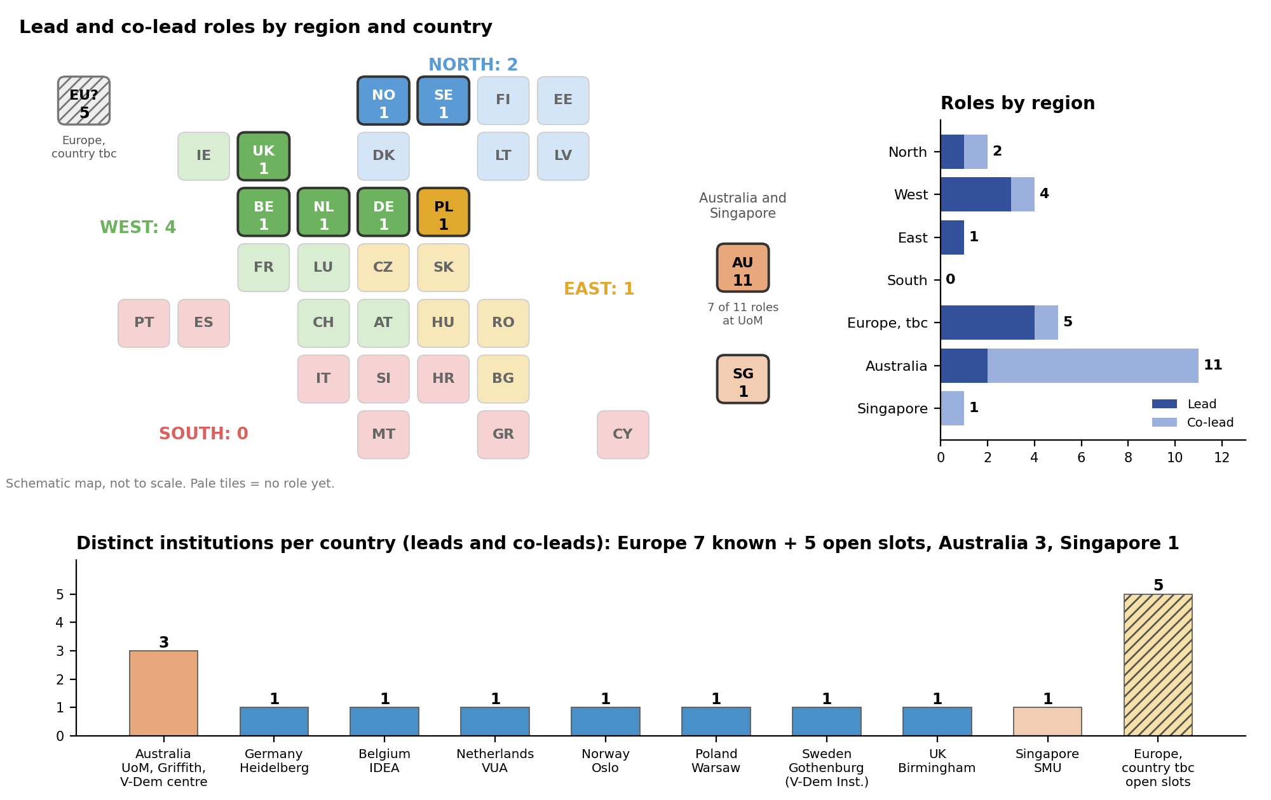
Counts are lead and co-lead roles per WP. North = Nordic and Baltic countries, West = UK, Ireland, Benelux, Germany, France, Austria, Switzerland, East = Poland, Czechia, Slovakia, Hungary, Romania, Bulgaria, South = Iberia, Italy, Greece, Malta, Cyprus, Balkans. The V-Dem centre is counted under Australia and IDEA under Belgium. Roles and institutions with a European country still tbc are shown separately.

How the work packages relate to the framework
