Dear Seraphine,

Thanks for sharing this. There has been incredible progress, and the proposition, particularly the Australia–EU dimension, is really starting to take shape and amazing work.

I know Cat is working through her feedback, and I don't want to cut across her review. However, given the timelines, I wanted to send through a few early thoughts that you could start considering now, rather than holding up development. I’d treat these as prompts rather than definitive feedback.

Happy to talk you through this as it’s a bit long and hope you take this with the good intentions of supporting you to make this as strong as possible, so your efforts pay off! Let me know if it would be best to call and explain?

Alignment to the call
Given how tightly we will ultimately need to align with the call language, if the focus is moving towards 04, I think you could start sharpening the concept explicitly – if 04 is the direction, I think the next step is to bring the problem, solution and intended impact even closer to the call, particularly around reducing the harms/impacts of AI and strengthening equality, democratic and inclusive societies.
I pulled out some of the key language from 04 through a fairly literal read of the call- Cat will share to include/share this when she sends through her feedback so that you have everything together.
It may be worth maintaining two working versions for each call,

But kudos to you, the language has already become much simpler and more direct, which is fantastic!

Why Australia + Europe?
I think this argument is becoming much stronger. I would perhaps be even more direct about the value to Europe: what Australia enables Europe to understand/test that it cannot readily do alone that only Australia or Australia as a partner can do.
I’ll come back to leading, but perhaps something to test with collaborators is what is Australia's strongest leadership proposition -is it that Australia offers a materially different regulatory, enforcement and victim-centred environment from which Europe can learn-or what is the leading differentiator. What about the aspect on the regional node to complete VDEM?

Ie Australia potentially provides a compelling test bed because of the combination of:
- a comparable democratic and multicultural society exposed to many of the same global online platforms and information environments;
- a fast-moving and enactable regulatory and enforcement environment;
- Australia's social media minimum-age legislation;
- the Criminal Code Amendment (Sharing of Abhorrent Violent Material) Act 2019;
- the Criminal Code Amendment (Deepfake Sexual Material) Act 2024, including its victim-centred context;
- the eSafety Commissioner and Australia's broader online-safety environment; and
- truth-in-political-advertising legislation
I also wonder whether your point about language and the Australian information environment can be developed further. Could Australia provide a sufficiently coherent environment in which to identify effects cleanly and generate evidence that can then be tested or translated across different European contexts? I wouldn't overclaim this yet, but I think there may be something worth exploring.

A few things I would keep in view for the full proposal
These may already be planned for later stages, but eventually I think reviewers will need to see very clearly:
- explicit alignment with the call objectives;
- the state of the art and competitive landscape, particularly existing EU-funded activity and comparable work, what it has achieved, and precisely what remains unresolved;
- existing national/international activities and assets/work that the consortium can leverage; and
- a clear pathway to impact: target groups and beneficiaries, tangible outcomes, how those outcomes will be measured, and, where possible, measurable indicators.

One challenge I think is worth stress-testing early
I am raising it now because I suspect reviewers or potential partners may ask it later, but looking at the current work packages, what do you think will be the perception of Australian centrality in a program ultimately intended to generate evidence relevant to European policy and practice, on the way Europeans are affected by information/AI and the impacts on their society?

Australia may be an excellent test bed and there may be very strong grounds for Australian leadership of particular work packages. But if I am the devil’s advocate, some might ask, why should so much of the work be undertaken in Australia rather than Europe, and how does that demonstrably improve the European outcomes more than if the work was done by European organisations. Can it not be done in Europe to fund European Researchers?

That is the risk with many work packages run out of Australia, it just lends itself to being, if you image a pie chart, very Australian looking. In no way is this meant to question your capacity or suitability to lead, more, people may wonder, why are you better or more suited to delivering and being awarded than a European dominant application. So how do you prepare yourself or pre-empt thoughts, quell push back and still come out on top?

I wonder if it is worth clarifying with the partners or a Horizons specialist, what Australian leadership of the consortium is intended to mean in practice. Is the expectation primarily that Australia provides strong coordination and some intellectual leadership across the consortium, or that it should also lead a significant proportion of the work and expected to be the best organisation reputationally, or execution wise? If the latter, I think we need to be particularly clear about why Australian leadership or conducting the work in Australia improves the outcomes for Europe, rather than simply demonstrating that Australia has the capability to lead those work packages.

I don't have a predetermined answer here, but I wonder whether it is worth considering:
- whether some Australian activities could be packaged together into a smaller number of clearly differentiated work packages;
- whether European partners should lead more of the Europe-facing testing, validation or translation; and
- whether the structure could make the reciprocity more visible, with Australia and Europe each contributing capabilities, environments and evidence that the other cannot provide alone.

I mostly wanted to get these questions to you now so they can sit in the back of your mind as you continue developing the concept and in preparation for what you can ask of your partners.

There is a lot here that is really starting to come together and amazing work!

Best,
Amabel

DRAFT only but birds eye of the proposal content
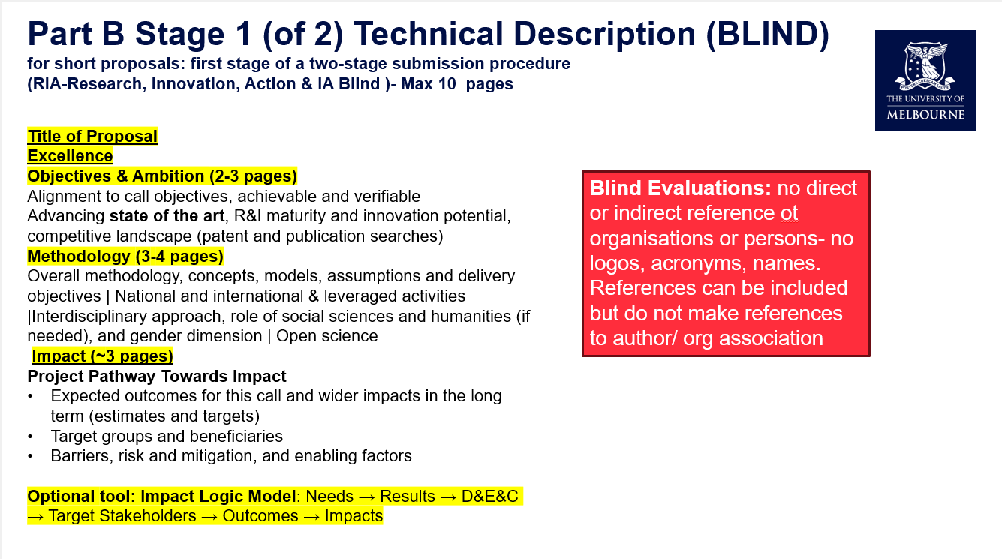
Amabel Tan, PhD | Manager, Strategic Research Initiatives
Innovation & Enterprise | Melbourne Research and Enterprise

HI Seraphine,

While Amabel and Cat focus on alignment of the project with the scope of the DEMOCRACY-04 call, my feedback at this stage is around budget - which will impact WP design.

DEMOCRACY-04 is a lump sum call and this means that you get funding upon the completion of milestones which in this case is Work Packages. To ensure we don’t have to wait until the end of the project to receive cash – many orgs, especially smaller ones, cannot operate this way – The way most people address this is by breaking up work packages into smaller periods. The attached slide deck by the EU provides more information on this.

I believe the Administration work package (divided up into 12 month periods for lump sum) must be separate from the dissemination work package. It does make sense though that Admin is led by UoM, and Dissemination by a European org.

I’ll be looking at the Horizon budget template in more detail in coming weeks. A note that our current UoM Research Costing and Pricing Tool does not really accommodate Horizon budget structure: I am internal talks about this. I understand you might not have decided yet who will be beneficiary and who will be involved in other capacities.

Thanks for your patience as we work through the requirements and our understanding of them evolves. Some of Amabel’s questions, perhaps you can bounce them off your European collaborators to see what they think.

Best regards,
Trish

Patricia Gigliuto | Team Manager, International Research Grants
Research Grants and Contracts | Office of Research Management

Hi Seraphine,

I’m just adding to the reviews you’ve now recently received. Please see a few comments in your attached concept note from me.

I know it’s just a concept note at this stage but to me, it is still sitting somewhere between the Strengthening Democracy Call and this one, which places a strong emphasis on the malicious use of AI, particularly cyberviolence and deepfakes. If the intention is to target Call 04, I think it would strengthen the proposal to engage more consistently with this theme. My reading of the call is that it is particularly concerned with cyberviolence, foreign interference, extremist or populist movements etc., and at the moment I don't think those elements come through as strongly as they could in the concept note.

I can see the importance of the theoretical and conceptual framing underpinning the project and it’ll be vital for the ‘enhanced understanding’ objective. However, the call then asks for practical recommendations, concrete interventions, and approaches that can be adopted more broadly so suggesting where these might come from will be key. As the proposal develops, it will be important to clearly articulate the pathway from the theoretical framework and research questions through to tangible outcomes and impact.

Also, just focusing in on the state of play currently with EU’s broader AI strategy and EU legislative frameworks, what are the gaps, who is doing what and how it makes sense for you to fill them. I’ve put some questions in there around the Australia question. You say that you’ll ‘yield evidence and instruments robust across regulatory regimes rather than one’, but it would be useful to articulate more clearly why that is particularly valuable from an EU perspective. Why do they care what Australia does.

As Amabel noted, I'm sure many of these considerations are already front of mind as the proposal moves from concept note to full application, but we’re just making sure!

Looking forward to seeing further iterations,
Cat

Catherine Nobes | Major Bid Coordinator
Melbourne Research and Enterprise

