Proiect SGBD

-Șerban Andrei, 242-

Proiectul ales de mine este o bază de date pentru o firmă de agricultură, proiectat pentru a eficientiza operațiunile afacerilor agricole moderne. Acesta pune împreună datele legate de managementul departamentelor, activitățile angajaților, interacțiuni cu clienți, procesare comenzi, inventarul produselor si echipamentelor agricole. Baza de date oferă perspective in timp real asupra fiecărui aspect al operațiunilor firmei, ajutând la procesul decizional, eficienta operațională si satisfacția clienților.

Următoarele diagrame prezinta funcționalitatea bazei de date.

Diagrama entitate-relație:

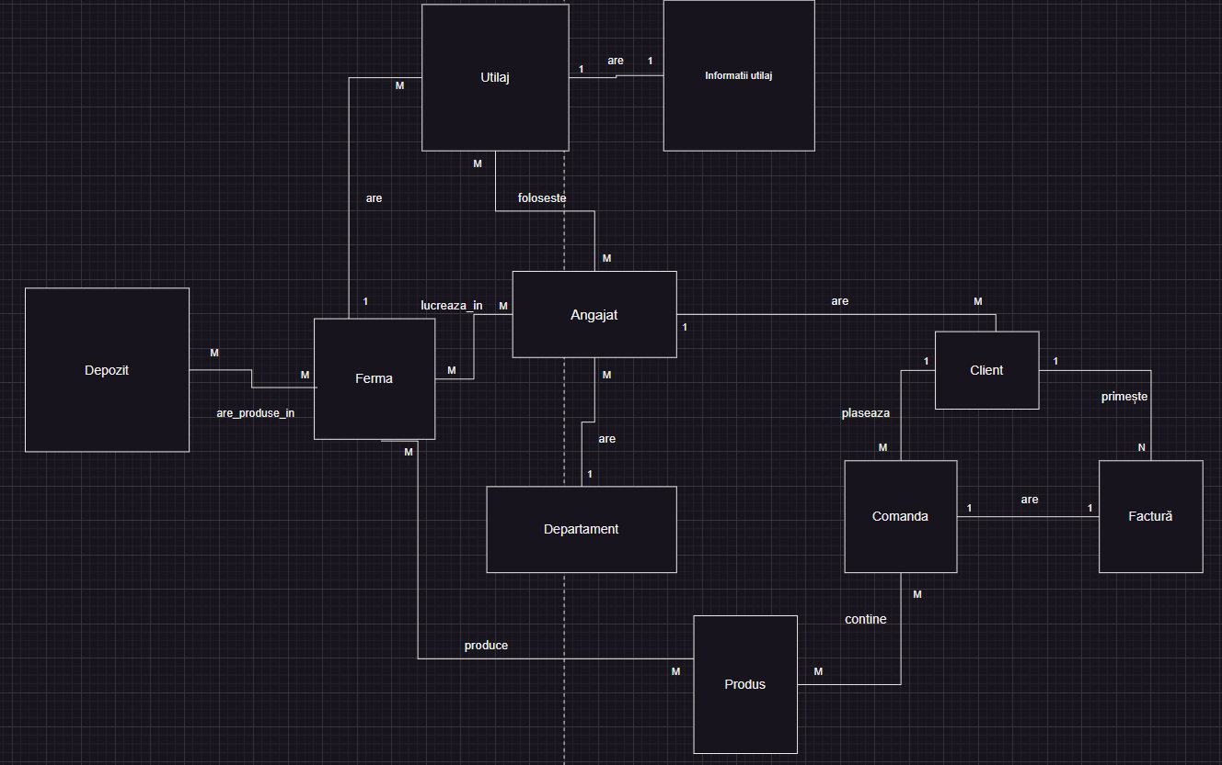

Diagrama conceptuală:

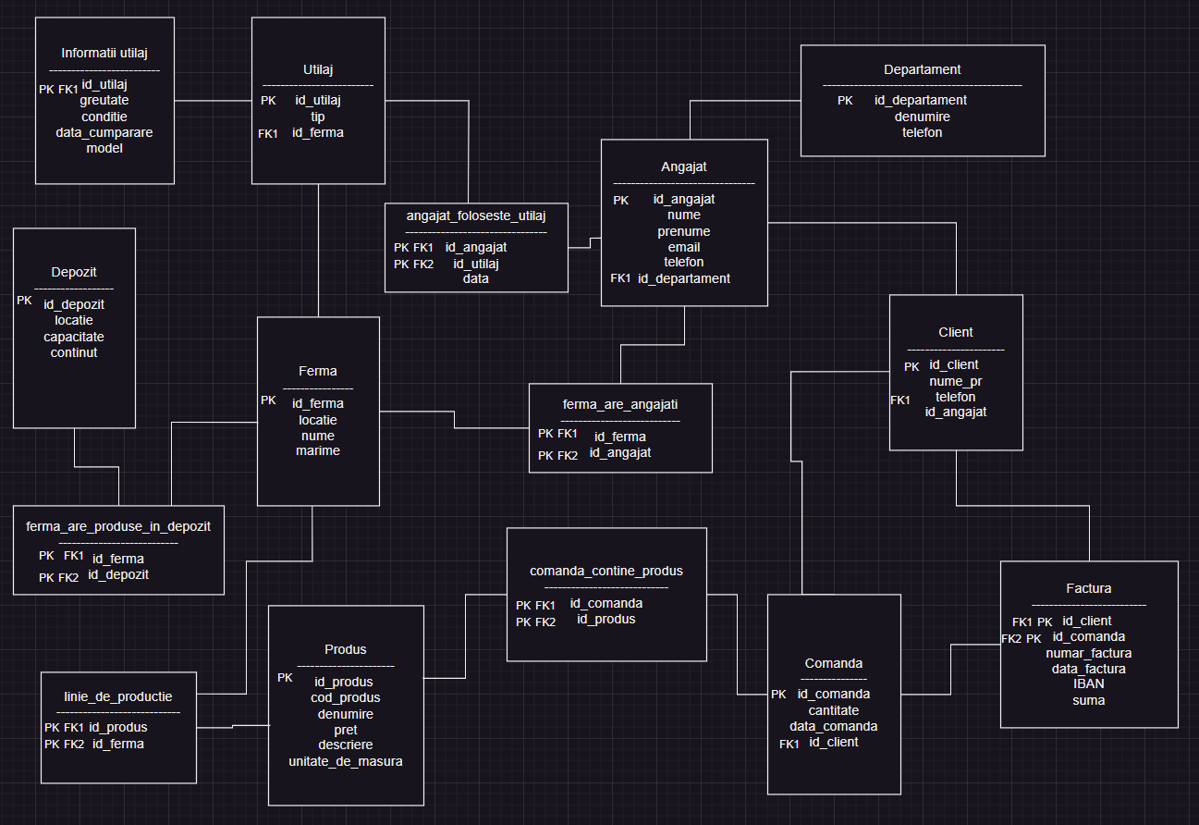

Codul folosit pentru crearea bazei de date:

CREATE TABLE Departament (

id_departament NUMBER PRIMARY KEY,

denumire VARCHAR2(100) NOT NULL,

telefon VARCHAR2(15)

);

CREATE TABLE Angajat (

id_angajat NUMBER PRIMARY KEY,

nume VARCHAR2(50) NOT NULL,

prenume VARCHAR2(50) NOT NULL,

email VARCHAR2(100),

telefon VARCHAR2(15),

id_departament NUMBER,

CONSTRAINT fk_angajat_departament FOREIGN KEY (id_departament)

REFERENCES Departament (id_departament)

);

CREATE TABLE Client (

id_client NUMBER PRIMARY KEY,

nume_pr VARCHAR2(100) NOT NULL,

telefon VARCHAR2(15),

id_angajat NUMBER,

CONSTRAINT fk_client_angajat FOREIGN KEY (id_angajat)

REFERENCES Angajat (id_angajat)

);

CREATE TABLE Comanda (

id_comanda NUMBER PRIMARY KEY,

cantitate NUMBER NOT NULL,

data_comanda DATE NOT NULL,

id_client NUMBER,

CONSTRAINT fk_comanda_client FOREIGN KEY (id_client)

REFERENCES Client (id_client)

);

CREATE TABLE Factura (

id_comanda NUMBER ,

id_client NUMBER ,

PRIMARY KEY (id_comanda,id_client),

numar_factura VARCHAR2(50) NOT NULL,

data_factura DATE NOT NULL,

IBAN VARCHAR2(24),

suma NUMBER NOT NULL,

CONSTRAINT fk_factura_client FOREIGN KEY (id_client)

REFERENCES Client (id_client),

CONSTRAINT fk_factura_client_2 FOREIGN KEY (id_comanda)

REFERENCES Comanda (id_comanda)

);

CREATE TABLE Produs (

id_produs NUMBER PRIMARY KEY,

cod_produs VARCHAR2(50) NOT NULL,

denumire VARCHAR2(100) NOT NULL,

pret NUMBER NOT NULL,

descriere VARCHAR2(255),

unitate_de_masura VARCHAR2(50)

);

CREATE TABLE Depozit (

id_depozit NUMBER PRIMARY KEY,

locatie VARCHAR2(100) NOT NULL,

capacitate NUMBER NOT NULL,

continut VARCHAR2(255)

);

CREATE TABLE Ferma (

id_ferma NUMBER PRIMARY KEY,

locatie VARCHAR2(100) NOT NULL,

nume VARCHAR2(100) NOT NULL,

marime NUMBER NOT NULL

);

CREATE TABLE Utilaj (

id_utilaj NUMBER PRIMARY KEY,

tip VARCHAR2(100) NOT NULL,

id_ferma NUMBER,

CONSTRAINT fk_utilaj_ferma FOREIGN KEY (id_ferma)

REFERENCES Ferma (id_ferma)

);

CREATE TABLE Informatii_Utilaj (

id_utilaj NUMBER PRIMARY KEY,

greutate NUMBER NOT NULL,

conditie VARCHAR2(100),

data_cumparare DATE,

model VARCHAR2(100),

CONSTRAINT fk_utilaj_informatii FOREIGN KEY (id_utilaj)

REFERENCES Utilaj (id_utilaj)

);

CREATE TABLE Angajat_Foloseste_Utilaj (

id_angajat NUMBER,

id_utilaj NUMBER,

data DATE NOT NULL,

PRIMARY KEY (id_angajat, id_utilaj),

CONSTRAINT fk_afu_angajat FOREIGN KEY (id_angajat)

REFERENCES Angajat (id_angajat),

CONSTRAINT fk_afu_utilaj FOREIGN KEY (id_utilaj)

REFERENCES Utilaj (id_utilaj)

);

CREATE TABLE Ferma_Are_Angajati (

id_ferma NUMBER,

id_angajat NUMBER,

PRIMARY KEY (id_ferma, id_angajat),

CONSTRAINT fk_faa_ferma FOREIGN KEY (id_ferma)

REFERENCES Ferma (id_ferma),

CONSTRAINT fk_faa_angajat FOREIGN KEY (id_angajat)

REFERENCES Angajat (id_angajat)

);

CREATE TABLE Ferma_Are_Produse_In_Depozit (

id_ferma NUMBER,

id_depozit NUMBER,

PRIMARY KEY (id_ferma, id_depozit),

CONSTRAINT fk_fapd_ferma FOREIGN KEY (id_ferma)

REFERENCES Ferma (id_ferma),

CONSTRAINT fk_fapd_depozit FOREIGN KEY (id_depozit)

REFERENCES Depozit (id_depozit)

);

CREATE TABLE Linie_De_Productie (

id_produs NUMBER,

id_ferma NUMBER,

PRIMARY KEY (id_produs, id_ferma),

CONSTRAINT fk_ldp_produs FOREIGN KEY (id_produs)

REFERENCES Produs (id_produs),

CONSTRAINT fk_ldp_ferma FOREIGN KEY (id_ferma)

REFERENCES Ferma (id_ferma)

);

CREATE TABLE Comanda_Contine_Produs (

id_comanda NUMBER,

id_produs NUMBER,

PRIMARY KEY (id_comanda, id_produs),

CONSTRAINT fk_ccp_comanda FOREIGN KEY (id_comanda)

REFERENCES Comanda (id_comanda),

CONSTRAINT fk_ccp_produs FOREIGN KEY (id_produs)

REFERENCES Produs (id_produs)

);

commit;

Datele introduse la inceput in baza de date sunt:

INSERT INTO Departament VALUES (1, 'Contabilitate', '0312345679');

INSERT INTO Departament VALUES (2, 'Vanzari', '0312345681');

INSERT INTO Departament VALUES (3, 'IT', '0312345682');

INSERT INTO Departament VALUES (4, 'Intretinere si Reparatii', '0312345683');

INSERT INTO Departament VALUES (5, 'Intretinere Culturi Agricole', '0312345684');

INSERT INTO Angajat VALUES (1, 'Popescu', 'Ion', 'ion.popescu@example.com', '0722345678', 5);

INSERT INTO Angajat VALUES (2, 'Ionescu', 'Maria', 'maria.ionescu@example.com', '0722345679', 1);

INSERT INTO Angajat VALUES (3, 'Georgescu', 'Andrei', 'andrei.georgescu@example.com', '0722345680', 4);

INSERT INTO Angajat VALUES (4, 'Dumitrescu', 'Elena', 'elena.dumitrescu@example.com', '0722345681', 1);

INSERT INTO Angajat VALUES (5, 'Stanescu', 'Mihai', 'mihai.stanescu@example.com', '0722345682', 5);

INSERT INTO Angajat VALUES (6, 'Ilie', 'Andrei', 'andrei.ilie@example.com', '0723000011', 2);

INSERT INTO Angajat VALUES (7, 'Popa', 'Ioana', 'ioana.popa@example.com', '0723000012', 4);

INSERT INTO Angajat VALUES (8, 'Nicolae', 'Raluca', 'raluca.nicolae@example.com', '0723000013', 3);

INSERT INTO Angajat VALUES (9, 'Marin', 'Dan', 'dan.marin@example.com', '0723000014', 2);

INSERT INTO Angajat VALUES (10, 'Dobre', 'Elena', 'elena.dobre@example.com', '0723000015', 3);

INSERT INTO Ferma VALUES (1, 'Craiova', 'Ferma legumicola din Craiova', '3');

INSERT INTO Ferma VALUES (2, 'Iasi', 'Ferma viticola din Iasi', '150');

INSERT INTO Ferma VALUES (3, 'Vaslui', 'Ferma de cereale de la Vaslui', '500');

INSERT INTO Ferma VALUES (4, 'Sibiu', 'Ferma pomicola din Sibiu', '60');

INSERT INTO Ferma VALUES (5, 'Galati', 'Ferma de cereale din Galati ', '1000');

INSERT INTO Produs VALUES (1, 'P001', 'Struguri', 2.99, 'Struguri rosii', 'kg');

INSERT INTO Produs VALUES (2, 'P002', 'Castraveti', 2.83, 'Castraveti cornison', 'kg');

INSERT INTO Produs VALUES (3, 'P003', 'Porumb', 850.00, 'Porumb', 't');

INSERT INTO Produs VALUES (4, 'P004', 'Orz', 800.00, 'Orz', 't');

INSERT INTO Produs VALUES (5, 'P005', 'Mere', 30.00, 'Mere verzi', 'lada');

INSERT INTO Produs VALUES (6, 'I001', 'Ingrasamant NPK', 17.60, 'Ingrasamant lichid', 'l');

INSERT INTO Produs VALUES (7, 'P001', 'Struguri', 3.50, 'Struguri albi', 'kg');

INSERT INTO Produs VALUES (8, 'P006', 'Pere', 35.99, 'Pere', 'lada');

INSERT INTO Produs VALUES (9, 'P007', 'Rosii', 3.50, 'Rosii Roma', 'kg');

INSERT INTO linie_de_productie VALUES (2, 1);

INSERT INTO linie_de_productie VALUES (1, 2);

INSERT INTO linie_de_productie VALUES (7, 2);

INSERT INTO linie_de_productie VALUES (3, 3);

INSERT INTO linie_de_productie VALUES (4, 3);

INSERT INTO linie_de_productie VALUES (5, 4);

INSERT INTO linie_de_productie VALUES (3, 5);

INSERT INTO linie_de_productie VALUES (4, 5);

INSERT INTO linie_de_productie VALUES (8, 4);

INSERT INTO linie_de_productie VALUES (9, 1);

INSERT INTO Client VALUES (1, 'Ion Ionescu', '0722000001', 1);

INSERT INTO Client VALUES (2, 'Maria Popescu', '0722000002', 2);

INSERT INTO Client VALUES (3, 'George Vasile', '0722000003', 3);

INSERT INTO Client VALUES (4, 'Elena Radu', '0722000004', 4);

INSERT INTO Client VALUES (5, 'Mihai Zaharia', '0722000005', 5);

INSERT INTO Utilaj VALUES (1, 'Tractor', 1);

INSERT INTO Utilaj VALUES (6, 'Tractor', 2);

INSERT INTO Utilaj VALUES (10, 'Tractor', 4);

INSERT INTO Utilaj VALUES (7, 'Tractor', 3);

INSERT INTO Utilaj VALUES (8, 'Tractor', 5);

INSERT INTO Utilaj VALUES (9, 'Tractor', 5);

INSERT INTO Utilaj VALUES (2, 'Combinator', 1);

INSERT INTO Utilaj VALUES (11, 'Semantoare', 3);

INSERT INTO Utilaj VALUES (3, 'Semantoare', 5);

INSERT INTO Utilaj VALUES (4, 'Cultivator', 2);

INSERT INTO Utilaj VALUES (5, 'Irigator', 1);

INSERT INTO angajat_foloseste_utilaj VALUES (1, 1, TO_DATE('2022-04-24', 'YYYY-MM-DD'));

INSERT INTO angajat_foloseste_utilaj VALUES (3, 2, TO_DATE('2023-08-16', 'YYYY-MM-DD'));

INSERT INTO angajat_foloseste_utilaj VALUES (5, 3, TO_DATE('2023-05-08', 'YYYY-MM-DD'));

INSERT INTO angajat_foloseste_utilaj VALUES (1, 4, TO_DATE('2022-08-26', 'YYYY-MM-DD'));

INSERT INTO angajat_foloseste_utilaj VALUES (3, 5, TO_DATE('2021-06-25', 'YYYY-MM-DD'));

INSERT INTO angajat_foloseste_utilaj VALUES (5, 2, TO_DATE('2021-10-31', 'YYYY-MM-DD'));

INSERT INTO angajat_foloseste_utilaj VALUES (7, 3, TO_DATE('2022-11-18', 'YYYY-MM-DD'));

INSERT INTO angajat_foloseste_utilaj VALUES (7, 4, TO_DATE('2023-04-04', 'YYYY-MM-DD'));

INSERT INTO angajat_foloseste_utilaj VALUES (1, 5, TO_DATE('2023-11-01', 'YYYY-MM-DD'));

INSERT INTO angajat_foloseste_utilaj VALUES (5, 1, TO_DATE('2022-04-21', 'YYYY-MM-DD'));

INSERT INTO ferma_are_angajati VALUES (1, 1);

INSERT INTO ferma_are_angajati VALUES (2, 3);

INSERT INTO ferma_are_angajati VALUES (3, 5);

INSERT INTO ferma_are_angajati VALUES (4, 7);

INSERT INTO ferma_are_angajati VALUES (5, 1);

INSERT INTO ferma_are_angajati VALUES (1, 2);

INSERT INTO ferma_are_angajati VALUES (2, 3);

INSERT INTO ferma_are_angajati VALUES (3, 4);

INSERT INTO ferma_are_angajati VALUES (4, 5);

INSERT INTO ferma_are_angajati VALUES (5, 2);

INSERT INTO Depozit VALUES (1, 'Onesti', 100, 'Depozit de cereale');

INSERT INTO Depozit VALUES (2, 'Adjud', 200, 'Depozit de legume');

INSERT INTO Depozit VALUES (3, 'Ploiesti', 150, 'Depozit de fructe');

INSERT INTO Depozit VALUES (4, 'Focsani', 250, 'Depozit universal');

INSERT INTO Depozit VALUES (5, 'Bacau', 300, 'Depozit de cereale');

INSERT INTO ferma_are_produse_in_depozit VALUES (3, 2);

INSERT INTO ferma_are_produse_in_depozit VALUES (5, 2);

INSERT INTO ferma_are_produse_in_depozit VALUES (3, 3);

INSERT INTO ferma_are_produse_in_depozit VALUES (4, 4);

INSERT INTO ferma_are_produse_in_depozit VALUES (5, 5);

INSERT INTO ferma_are_produse_in_depozit VALUES (1, 2);

INSERT INTO ferma_are_produse_in_depozit VALUES (2, 3);

INSERT INTO ferma_are_produse_in_depozit VALUES (3, 4);

INSERT INTO ferma_are_produse_in_depozit VALUES (4, 5);

INSERT INTO ferma_are_produse_in_depozit VALUES (5, 1);

INSERT INTO comanda VALUES (1, 10, TO_DATE('2021-01-23', 'YYYY-MM-DD'), 1);

INSERT INTO comanda VALUES (2, 15, TO_DATE('2021-04-01', 'YYYY-MM-DD'), 2);

INSERT INTO comanda VALUES (3, 20, TO_DATE('2023-03-24', 'YYYY-MM-DD'), 3);

INSERT INTO comanda VALUES (4, 25, TO_DATE('2021-11-30', 'YYYY-MM-DD'), 4);

INSERT INTO comanda VALUES (5, 30, TO_DATE('2023-10-06', 'YYYY-MM-DD'), 5);

INSERT INTO comanda_contine_produs VALUES (1, 1);

INSERT INTO comanda_contine_produs VALUES (2, 2);

INSERT INTO comanda_contine_produs VALUES (3, 3);

INSERT INTO comanda_contine_produs VALUES (4, 4);

INSERT INTO comanda_contine_produs VALUES (5, 5);

INSERT INTO comanda_contine_produs VALUES (1, 2);

INSERT INTO comanda_contine_produs VALUES (2, 3);

INSERT INTO comanda_contine_produs VALUES (3, 4);

INSERT INTO comanda_contine_produs VALUES (4, 5);

INSERT INTO comanda_contine_produs VALUES (5, 1);

INSERT INTO factura VALUES (1, 1, 'FAC001', TO_DATE('2021-01-30', 'YYYY-MM-DD'), 'RO49AAAA1B31007593840000', 123.45);

INSERT INTO factura VALUES (2, 2, 'FAC002', TO_DATE('2021-04-02', 'YYYY-MM-DD'), 'RO49AAAA1B31007593840001', 678.90);

INSERT INTO factura VALUES (3, 3, 'FAC003', TO_DATE('2023-03-28', 'YYYY-MM-DD'), 'RO49AAAA1B31007593840002', 234.56);

INSERT INTO factura VALUES (4, 4, 'FAC004', TO_DATE('2021-10-10', 'YYYY-MM-DD'), 'RO49AAAA1B31007593840003', 789.01);

INSERT INTO factura VALUES (5, 5, 'FAC005', TO_DATE('2023-10-30', 'YYYY-MM-DD'), 'RO49AAAA1B31007593840004', 345.67);

INSERT INTO Informatii_utilaj VALUES (1, 1500, 'Excelenta', TO_DATE('2019-04-08', 'YYYY-MM-DD'), 'John Deere 5075E');

INSERT INTO Informatii_utilaj VALUES (2, 1800, 'Buna', TO_DATE('2019-12-19', 'YYYY-MM-DD'), 'Case IH Maxxum 110');

INSERT INTO Informatii_utilaj VALUES (3, 900, 'Nou', TO_DATE('2019-03-07', 'YYYY-MM-DD'), 'Kverneland Miniair Nova');

INSERT INTO Informatii_utilaj VALUES (4, 1200, 'Uzura Medie', TO_DATE('2019-08-16', 'YYYY-MM-DD'), 'Amazone KE 3000 Super');

INSERT INTO Informatii_utilaj VALUES (5, 2000, 'Buna', TO_DATE('2019-02-22', 'YYYY-MM-DD'), 'Valley 8000 series');

INSERT INTO Informatii_utilaj VALUES (6, 1600, 'Foarte Buna', TO_DATE('2019-11-15', 'YYYY-MM-DD'), 'Massey Ferguson 6713');

INSERT INTO Informatii_utilaj VALUES (7, 1400, 'Excelenta', TO_DATE('2019-07-21', 'YYYY-MM-DD'), 'New Holland T5.105');

INSERT INTO Informatii_utilaj VALUES (8, 1550, 'Nou', TO_DATE('2019-06-30', 'YYYY-MM-DD'), 'Fendt 500 Vario');

INSERT INTO Informatii_utilaj VALUES (9, 1700, 'Uzura Redusa', TO_DATE('2019-10-12', 'YYYY-MM-DD'), 'CLAAS Arion 630');

INSERT INTO Informatii_utilaj VALUES (10, 1300, 'Buna', TO_DATE('2019-05-24', 'YYYY-MM-DD'), 'Kubota M5-091');

INSERT INTO Informatii_utilaj VALUES (11, 950, 'Uzura Medie', TO_DATE('2019-09-17', 'YYYY-MM-DD'), 'Accord Optima');

commit;

6.Sa se creeze o procedura RaportFerma care va primi prin id o ferma si va retine in 3 colectii diferite utilajele si modelele utilajelor prezente in ferma, angajatii care lucreaza in ferma si produsele cultivate/facute in ferma.

CREATE OR REPLACE PROCEDURE RaportFerma(p_id_ferma IN number) IS

TYPE tablou_indexat IS TABLE OF NUMBER INDEX BY PLS_INTEGER;

t_angajati_id tablou_indexat;

TYPE tablou_imbricat IS TABLE OF NUMBER;

t_produse_id tablou_imbricat := tablou_imbricat();

v_index PLS_INTEGER := 1;

TYPE vector IS VARRAY(105) OF VARCHAR2(255);

t_utilaje vector := vector();

BEGIN

FOR rec IN (SELECT id_angajat FROM ferma_are_angajati WHERE id_ferma = p_id_ferma) LOOP

t_angajati_id(v_index) := rec.id_angajat;

v_index := v_index + 1;

END LOOP;

v_index := 1;

FOR rec IN (SELECT id_produs FROM linie_de_productie WHERE id_ferma = p_id_ferma) LOOP

t_produse_id.EXTEND;

t_produse_id(v_index) := rec.id_produs;

v_index := v_index + 1;

END LOOP;

FOR rec IN (SELECT u.tip, iu.model

FROM Utilaj u

JOIN Informatii_utilaj iu ON u.id_utilaj = iu.id_utilaj

WHERE u.id_ferma = p_id_ferma) LOOP

t_utilaje.EXTEND;

t_utilaje(t_utilaje.LAST) := 'Tip: ' || rec.tip || ', Model: ' || rec.model;

END LOOP;

FOR i IN 1..t_angajati_id.COUNT LOOP

FOR rec IN (SELECT nume, prenume, email, telefon FROM Angajat WHERE id_angajat = t_angajati_id(i)) LOOP

DBMS_OUTPUT.PUT_LINE('Nume: ' || rec.nume || ' Prenume: ' || rec.prenume ||

' Email: ' || rec.email || ' Telefon: ' || rec.telefon);

END LOOP;

END LOOP;

FOR i IN 1..t_produse_id.COUNT LOOP

FOR rec IN (SELECT cod_produs, denumire, pret, descriere FROM Produs WHERE id_produs = t_produse_id(i)) LOOP

DBMS_OUTPUT.PUT_LINE('Produs - Cod: ' || rec.cod_produs || ', Denumire: ' || rec.denumire ||

', Pret: ' || rec.pret || ', Descriere: ' || rec.descriere);

END LOOP;

END LOOP;

FOR i IN 1..t_utilaje.COUNT LOOP

DBMS_OUTPUT.PUT_LINE('Utilaj ' || i || ': ' || t_utilaje(i));

END LOOP;

END RaportFerma;

