CSE 3323 Lab3

Inverting Summer, Difference Amps

* This lab requires 2 supplies, so op amp can have + and – supply. **Pay particular attention to supply wiring and color coding.** Color code for power supply wiring and jumpers: Red for positive (+5), white for ground, black for minus (-5). This will help you avoid mistakes, and help instructors also.
* Check your supply wiring and levels before connecting positive and negative supplies to the op-amp. With the DVM common lead connected to ground, verify +5V positive supply, and -5V negative supply.
* “Ground” in the schematic is indicated by the triangular ground symbol. The concept “ground” makes more sense on a real pc layout. With our white breadboards you will have to make your own ground. Use a common rail that to which you can connect a number of jumpers. For these op amp circuits, the function generator’s ground and both scope probe ground clips will connect to this ground, as does the white supply lead.
* Look up datasheet for op amp. Pay particular attention to pin-out. Know how to determine which is pin 1, and how the pins are numbered around the package. This lab will use only one of the two amplifiers in the package. The other amp should be configured in a safe manner for an unused op amp (wire pin 6 to pin 7 absent other instructions).
* For this lab “frequency response” means a number of dB gain measurements at different frequencies, where GdB=10*log10|(V0/Vin)|2. Vo and Vin are measured with the oscilloscope, usually ppk. Start by making a table, with columns for frequency, Vo, and Vin, and GdB, where GdB is calculated from Vo and Vin).

Inverting Summer Amp

The ckt below has 3 inputs, which have different gains, but all are inverting. **The op-amp is the LM358.**

The inputs are 1) Function generator, 2) wiper of 5K potentiometer, 3) jumper to gnd or open.

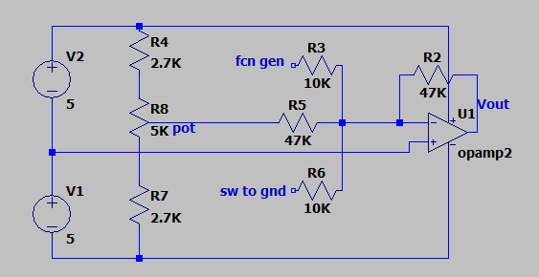

With resistor values above, the potentiometer will be able to source voltages -2.4 to +2.4 V with source impedance of approximately 2.5 K.

If 5K potentiometer not available, a 10K pot may be substituted. The voltage range with a 10K pot will be larger, -3.2 to +3.2V approximately, and the pot adjustment will be more “sensitive”.

If we were analyzing this circuit as in class, Vo = -4.7*(fcn gen_out) + -1 * (Pot_out).

1. Verify voltage at wiper on pot (Pot_out) variable between -2.4 and +2.4V.
2. Verify small signal gain is -5 for the fcn gen input. Do this by calculating the ratio of Vout to V_fcn_gen. The function generator output should be small signal and low frequency, say .1Vpp and 1 KHz. For step 2, the pot adjustment is not critical, but pot should be adjusted mid-range, such that op-amp Vout at DC approximately zero.

Vo/Vin = -Rf/Rs = 47k/10k = -4.7 ~ -5

1. Verify small signal gain is -1 for pot input. Again measure the ratio of Vout to Vpot_out with the function generator off.

Vo/Vpot_out = 47k/47k = -1

Value Measured =

1. Verify that pot output *offsets* the function generator output at op amp output. With function generator set as in step 2, adjust the pot to low, near center, and high outputs. Draw sketches to show that the math equation above is satisfied.
2. Verify that connecting 3rd input to ground (vs open ckt) does not significantly affect gains for other two inputs at low frequency (say 1 KHz). This demonstrates the independence between inputs for the inverting summer. Explain why there is no significant gain change for inputs 1 and 2 when the third input is grounded. Certainly, the voltage divider relationship would suggest a different result.
3. Verify the low frequency (1 KHz) large signal response with pot set for minimal output offset. How much peak to peak output swing do you see at the onset of clipping? Now offset the output +2V by adjusting the pot. Now how much pk-pk swing can you get at clip onset?

Difference Amp

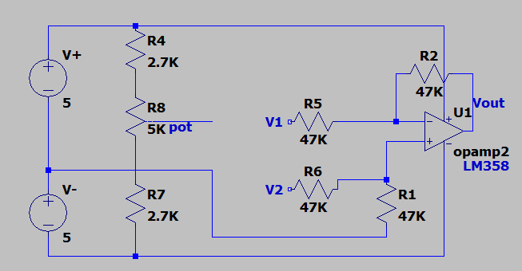

The math we do for this circuit in class gives that Vo=V2-V1, with common mode inputs rejected.

We do not have a differential source, so connect the pot output to one input and the fcn generator output to the other as described below. For 1 and 2 below, fill out a table with enough points to show what is requested.

1. Demonstrate small signal inverting operation over frequency (G=-1) w V1 as input from fcn_gen, V2 connected to pot. Determine bandwidth. What did you expect?
2. Verify small signal noninverting operation (G = 1) with V2 as input from fcn gen and V1 connected to the pot. Measure bandwidth. What did you expect?
3. Measure common mode gain with fcn generator driving both V1 AND V2 (V1=V2). Measure at a few of the same freqs used in step 1. Common mode gain is small, so function generator output can be increased for this measurement without clipping. Note that common mode rejection degrades as frequency increases.
4. **CALCULATE** CMRR (common mode rejection ratio) = 20log(diff gain/CM gain) from the CM and diff gain measurements at a few frequencies across the bandwidth.
5. Measure large signal low frequency (1KHz) clip threshold with no offset, driving either V1 or V2.
6. Estimate the op-amp’s slew rate limit in V/us starting with low freq output = 6V ppk. Then increase frequency until output resembles a triangle wave. Measure the ppk amplitude of the triangle wave and the half period time, then calculate the slew rate limit in V/sec or V/us.