THE UNIVERSITY OF TEXAS AT ARLINGTON

COMPUTER SCIENCE AND ENGINEERIG

LABORATORY 7 REPORT

**ELECTRONICS LABORATORY**

Submitted toward the partial completion of the requirements for CSE 3323-002

**Submitted by,**

Servando Olvera

1001909287

Date 11/25/2023

**Lab 7: Solar Tracker**

**Part 1:**

**Set Up**

Circuit Diagram:

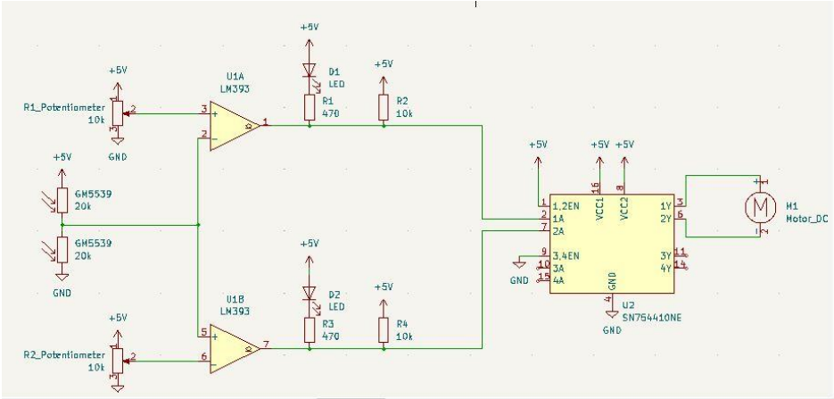

Findings:

First, when talking about the photoresistors, a common perspective is needed. We will be viewing the solar tracker from the front where the front is where the banana jacks are facing towards you. Thus, there are a left and a right photoresistor on the solar tracker.

Second, it goes to note that the photoresistors of the circuit form a voltage divider where shining the light on the left(upper) photoresistor will decrease the resistance from the voltage source to the common and shining the light on the right(lower) photoresistor will decrease the resistance from the common to the ground.

Next, hookup a 5V voltage source to the red socket and the ground to the black socket.

• Record the voltage from the yellow socket to ground with no light shining on the photoresistors.

2.5 V

• Then, shine light on the left photoresistor and record the voltage from the yellow socket to ground.

0.8 V

• Then, shine light on the right photoresistor and record the voltage from the yellow socket to ground.

3.9 V

• Do these voltages make sense? Why? Think back to part 1, question 2(hint: look at the voltage divider formula).

Yes, the light is inversely proportional to resistance so there is less of a voltage drop so the LED goes off.

• Based on what was learned, what condition should cause the solar tracker to go counterclockwise? Clockwise?

Shine light on left makes it go clockwise. Shining light on right makes it go counter.

**Part 2:**

**Comparators**

Circuit:

Findings:

Look back at the solar tracker schematic and hook up the comparators EXCEPT for the SN754410NE H-Bridge. Set both the potentiometers to output 2.5V. Here are some specifics on the comparators FOR THIS CIRCUIT(not all comparators work this way, read the datasheet for any comparator you get).

When the positive input terminal(Vin+) has a higher voltage than the negative input terminal(Vin-), the comparator output is seen as a high impedance:

When Vin- has a higher voltage than the Vin+, the comparator output is seen as a short to the negative voltage supply.

Now, based on this logic, the comparator naturally has no voltage on the output of the comparator when Vin+ > Vin-. To make it such that this condition does have an output voltage, there needs be pullup resistor which is your R2 for the upper comparator and R4 for the lower comparator.

Shine the light again on the left resistor and measure and record both comparator output voltages to ground. Do the same measurements after shining light on the right resistor. Compare the voltages on the outputs to the effects on their respective LEDS. What are the purpose of the LEDs?

|  |  |
| --- | --- |
| Left  COMP A = 5 V  LED OFF  COMP B = 0.25  LED ON | Right  COMP A = 0.28 V  LED ON  COMP B = 5.01V  LED OFF |

The LEDs serve as a debug feature to make sure that the comparators are working correctly.

Knowing the output voltages from the comparators and what was found on number 3, what is the purpose of the upper comparator? The lower comparator?

The upper comparator is a pull up.

The lower comparator is a pull down.

Next, remove resistors R1 and R2 from output 1 of the upper comparator. Measure and record the voltage on output 1 with reference to ground after shining light on the left photoresistor. Record the same while shining light on the right photoresistor. What happens and why? This effect showcases what the pullup resistor does.

|  |  |
| --- | --- |
| Left  COMP A = 0 V  LED OFF | Right  COMP A = 0 V  LED OFF |

This happens because the pull-up resistor was removed from the circuit, thus, the voltage cannot be pulled up and stays low.

**Part 3:**

**H-Bridge**

Circuit:

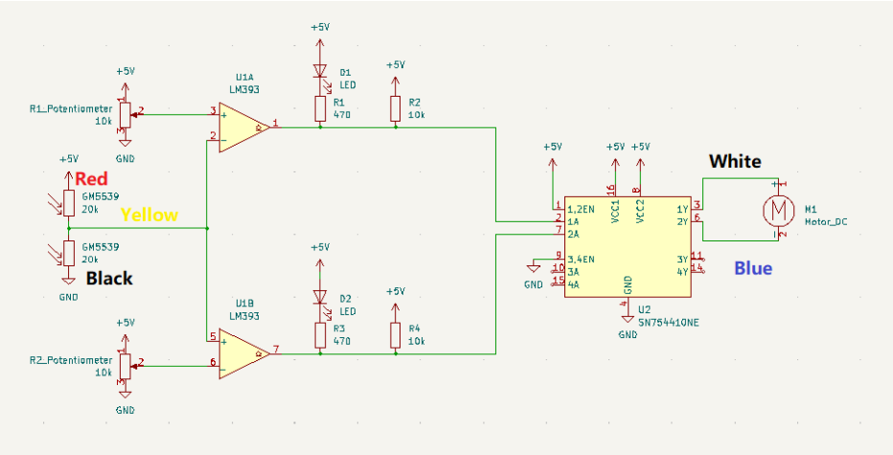

Findings:

Now, hookup the rest of the circuit. Experiment and document what occurs when you shine the left and right photoresistors. Again, the solar tracker should rotate to follow the light source.

Once the circuit is completed if there is a light source on the left photoresistor, solar tracker moves to the left; it follows the light source. Same idea with a light source on right.

A final issue should be occurring in our current setup with the solar tracker. Notice when the solar tracker is idling, the voltage source is still outputting current only that it is not enough overcome the torque needed to rotate the motor. Based on the voltage and current outputted by the voltage source, how much power is being wasted? Note, this is not only a waste of power, but it will also destroy the motor overtime.

Vs = 5 V

Is = 0.1 A

P = V * I

P = 0.5 W

To solve this, there needs to be a deadzone voltage that the yellow socket can safely output without activating either of the comparators, or a deadzone that activates both comparators. There are two ways to solve this, and you only need to figure out one of the ways:

• Create a condition where both comparators are on.

• Create a condition where both comparators are off.

To do either of these conditions, the voltages outputted the potentiometers should be adjusted. Pick and note down which method you decide to use, and record what voltages you observed on the R1_potentionmeter and R2_potentionmeter to get this effect.

Both comparators are off

Upper Potentiometer = 5 V

Lower Potentiometer = 2.5 V