THE UNIVERSITY OF TEXAS AT ARLINGTON

COMPUTER SCIENCE AND ENGINEERIG

LABORATORY 4 REPORT

**ELECTRONICS LABORATORY**

Submitted toward the partial completion of the requirements for CSE 3323-002

**Submitted by,**

Servando Olvera

1001909287

Date 10/05/2023

**Lab 4: Rectifiers**

**Part 1: Half-Wave Rectifier**

Circuit Diagram:

Built Circuit & Output:

Findings:

1. Set DVM on AC volts and measure transformer output.

Vout = 13.82 V

1. With oscilloscope ground clip connected to the minus supply output, measure the transformer output. Calculate the ratio of the peak transformer amplitude to the value measured with DVM in step 1. What did you expect?

Vout = 39.4 V

Output is expected to be higher since Oscilloscope is not measuring in VRMS, unlike the voltmeter.

Ration =

1. Now probe the positive supply output. How does the peak voltage on the rectifier output compare to transformer peak amplitude. What did you expect?

Vout = 17.17 V

The rectifier has a lower voltage than that of the transformer, this was expected.

1. Measure the ppk ripple voltage on the supply output.

Vpp-pk = 2.8 V (*from image above*)

1. Double the load current by adding a second 1K resistor paralleling the other 1K load resistor. Re-measure the ppk ripple voltage. What is the ratio of the ripple voltage to the ripple in step 4.

Vpk-pk = 4.92

Ratio =

**Part 2: Full-Wave Rectifier**

Circuit Diagram:

Built Circuit:

Findings:

1. Now probe the positive supply output. How does the peak voltage on the full wave rectifier output compare to transformer peak amplitude measured previously. What did you expect?

Vpeak = 16.8 V

Peak voltage is about the same. Expected since we measuring voltage at around the same spot.

1. Measure the ppk ripple voltage on the supply output. How does the full-wave ripple compare to the half-wave ripple measured previously.

Vpk-pk = 1.36 V (*from image above*)

1. How does the measured ripple in step 2 compare to the calculated value using the eqn I=DV/Ddt, with I = load current, C = filter capacitance, DV = ripple voltage, Dt = time interval between peaks?

D

Values are nearly the same!

**Part 3: Linear Regulators**

Circuit Diagram:

Built Circuit:

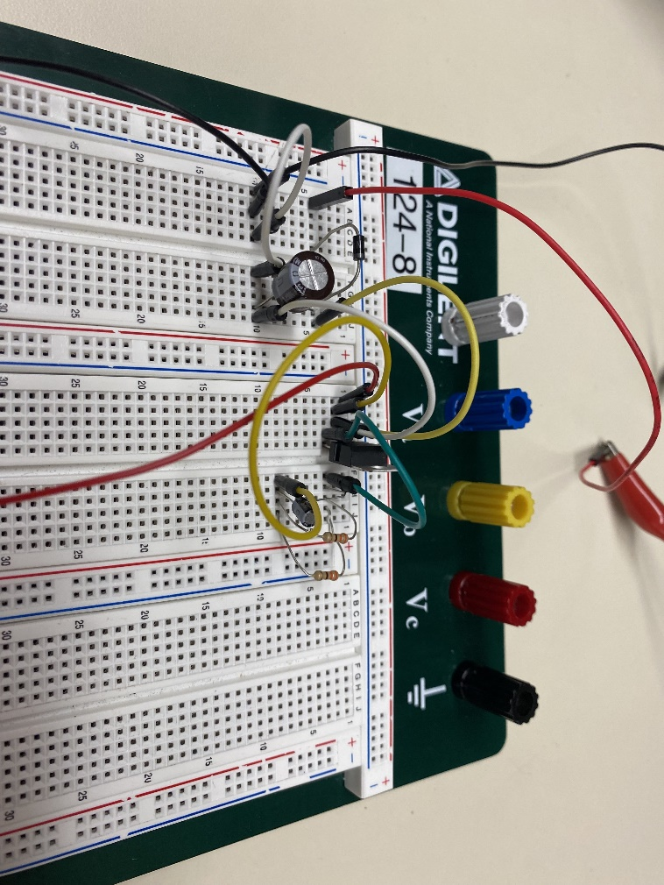

Findings:

1. Note the ripple voltage on the input and output of the regulator. Note: ripple voltage being low is a GOOD thing!

VRegIn = 5.32 V

VRegOut = 0.64 V

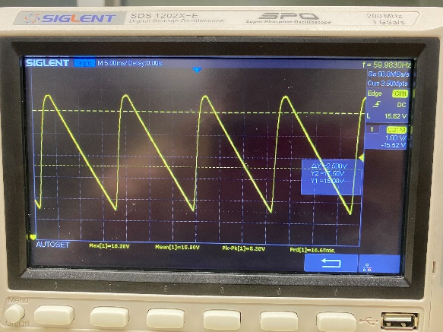

1. Calculate the power dissipation in the regulator, and resistive load. Note: First estimate input power - you may assume regulator input current approximately equal to load current.

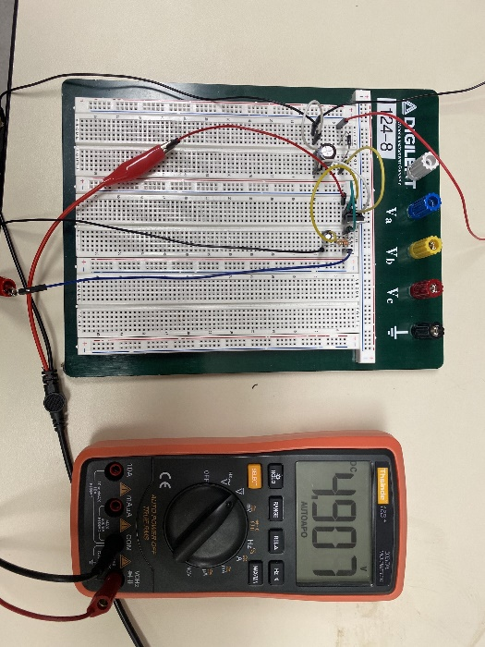

PinMean = 15.8

Reqv = 165

Vload = 4.9 V

Iload =

Pin = 15.8 * 0.0296 = 0.468 W

Pload = 4.9 * 0.0296 = 0.145 W

1. Calculate the efficiency of this regulator (Pload/ Pin).

Efficiency =

**Part 4: Simulation**

Circuit Diagram:

Findings:

“Measure” the current in the 18V supply and calculate the input power. Use the output voltage to calculate output power. Calculate efficiency as the ratio Pout/Pin.

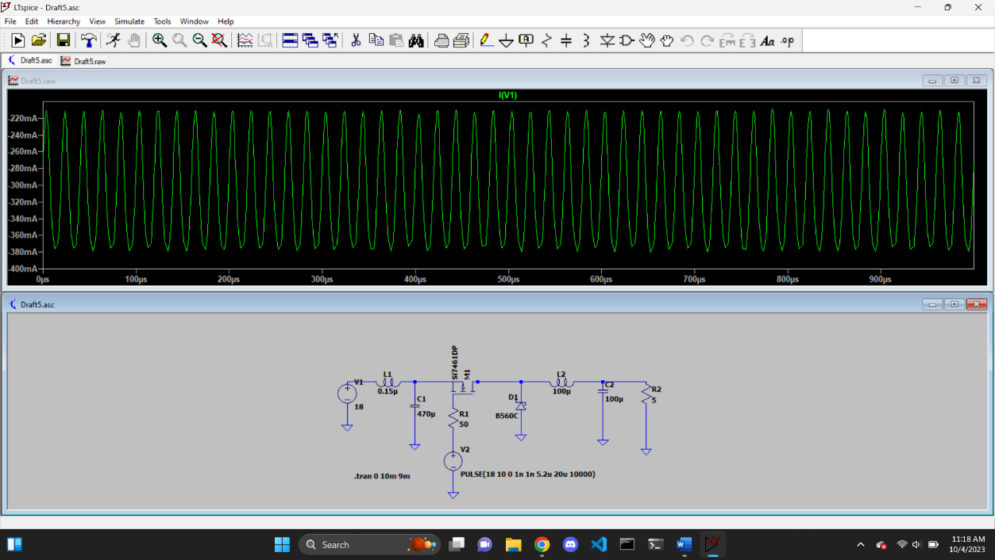

Iin = 300 mA

Pin = 18 * 0.3 = 5.4 W

Iout = 1 A

Pout = 5 * 1 = 5W

Efficiency =

Compare to the LM7805 – which is simpler / cheaper?

LM7805 is much simpler than the simulated circuit, and since it requires less components, it just might be cheaper.

Which is more efficient?

Simulation is a lot more efficient. But then again, it is a simulation and might not take into account some real-world problems that could make it less efficient.

Do you really even have a choice if you have a high power load?

Yes, there’s always a choice. A different rearrangement of the circuit with different components might yield different power outputs.