CSE3323 Lab 4: Rectifiers

Wire half-wave rectifier as shown below. Use “rectifier” diode (1N4004) diode or equivalent.

Note that the 100uF electrolytic capacitor is polarized, hence polarity is important for both diode and capacitor.

The transformer steps the 120V AC power to 12V approximately. Coupling from primary to secondary is magnetic, so no ohmic

connection exists between either secondary output and either primary input. This primary/secondary isolation provided by the

transformer is a requirement for this lab for safety reasons.

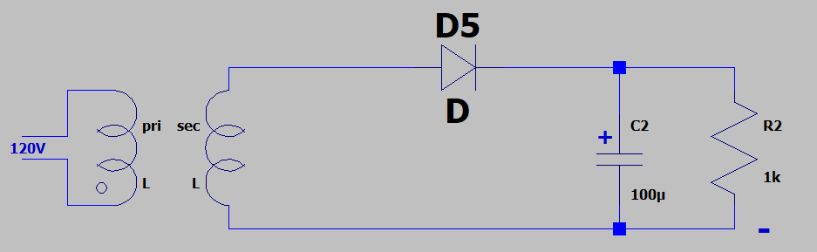

1. Set DVM on AC volts and measure transformer output.

Vo(RMS) = 13.82

1. With oscilloscope ground clip connected to the minus supply output, measure the transformer output. Calculate the ratio

of the peak transformer amplitude to the value measured with DVM in step 1. What did you expect?

Vo = 39.6

Ration = (39.6/13.82)

1. Now probe the positive supply output. How does the peak voltage on the rectifier output compare to transformer peak

amplitude. What did you expect?

Vo = 17.2

1. Measure the ppk ripple voltage on the supply output.

Vo(p-pk) = 2.8

1. Double the load current by adding a second 1K resistor paralleling the other 1K load resistor. Re-measure the ppk ripple

voltage. What is the ratio of the ripple voltage to the ripple in step 4.

Vo(p-pk) = 4.92

4.92/2.8 = 1.75

Now wire the full wave bridge rectifier as shown below. Use same transformer and diodes. Pay careful attention to diode orientation. Reversal of just one of the four diodes effectively shorts the transformer output. Polarity is important for the 100 uF filter capacitor also.

Note that you CANNOT simultaneously monitor both the AC input and DC output with two separate scope probes (as you did for the half wave rectifier). Connecting the second ground clip shorts one of the four diodes (D3) and causes D2 failure.

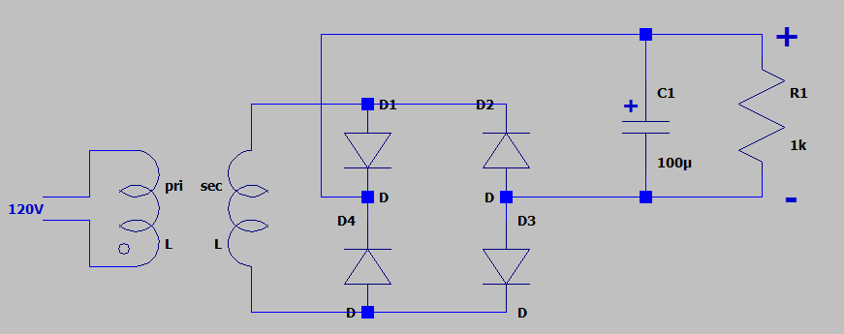

1. Now probe the positive supply output. How does the peak voltage on the full wave rectifier output compare to transformer

peak amplitude measured previously. What did you expect?

Vo = 17

1. Measure the ppk ripple voltage on the supply output. How does the full-wave ripple compare to the half-wave ripple

measured previously.

Vo(p-pk) = 1.36

1. How does the measured ripple in step 2 compare to the calculated value using the eqn I=DV/Ddt, with I = load current,

C = filter capacitance, DV = ripple voltage, Dt = time interval between peaks?

I = V/R = 17/1000 = 17 mA

C = 100u

Dt = 8.34 ms

DV = (Dt \* I )/C = 1.441

After the above, the difficulty in removing ripple from a power supply output should be apparent. Passive filtering can be utilized

(R, L, C), but these filters are large, especially with 60 Hz AC power input. One filtering approach that is simple and effective uses

active filtering or “linear” regulation. Linear regulators are readily available, and packaged into a single part except for external

capacitors. You will use one below to build a 5V supply.

Start with your worst case from a ripple perspective, the half-wave rectifier. Add the LM7805 3 terminal regulator as shown below.

Load resistors are smaller such that the load current will be similar, at the much lower voltage.

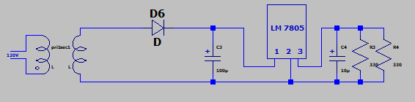

1. Note the ripple voltage on the input and output of the regulator. Note:ripple voltage being low is a GOOD thing!

Input V = 5.32 V , Output V = 0.64 V

1. Calculate the power dissipation in the regulator, and resistive load. Note: First estimate input power - you may

assume regulator input current approximately equal to load current.

Reqv = 165

Vload = 4.9

Iload = 4.9/165 = 0.0297 A

Pin = (15.8)(0.0297) = 0.4752 W

Pload = (4.9)(0.0297) = 0.146 W

1. Calculate the efficiency of this regulator (Pload/ Pin).

0.307

Lastly, re-run the switcher simulation you built for lab 1. You may notice that this circuit also “converts” 18V to 5V.

“Measure” the current in the 18V supply and calculate the input power. Use the output voltage to calculate output power.

Calculate efficiency as the ratio Pout/Pin.

Compare to the LM7805 – which is simpler / cheaper? Which is more efficient? Do you really even have a choice if you have

a high power load?

Iin  = 300 mA

Pin = (18)(0.3) = 5.4 W

Iout = 1 A

Pout = (5)(1) = 5 W

Pout/Pin = 0.93