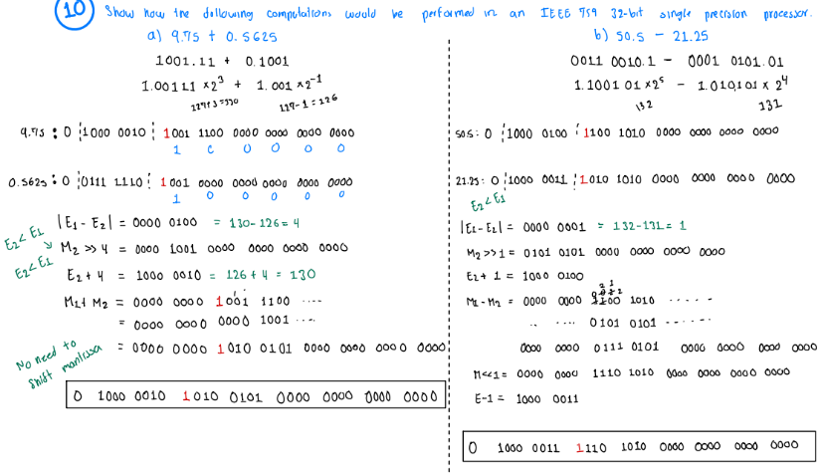

**Make an 8x8 Multiplier:** Control path no change. Modify data path to accommodate for 8-bit inputs; register Q & M. Also, accommodate Reg A to 9 bits and the counter to 3 bits.

**Make it faster:** Recoding could be used. Booth’s encoding could be implemented; this would decrease the number of partial products to be added.

**Allow it to handle signed numbers:** Extend Reg M and A to 8 & 9 bits. Check if M and Q are neg by checking MSB. If M is neg, extended signs bits are set, upper half; else they are not set; do Multiplication. If Q is neg, on last add operation of process add the 2’s comp of M to reg A; else regular M us added. If both M and Q are neg, both operations are performed.

**Combinational**: No clock needed to operate logic. Output is computer based entirely on current inputs. Multiplication operations can be performed in a parallel manner: fast but not precise.

Pros: Fast and efficient

Cons: Scalability is an issue.

**Sequential**: Clock dependent. Output is computed based entirely on previous and current inputs. Memory units are introduced to keep history of previous inputs. Multiplication operations are computed in a sequential manner; slow but precise.

Pros: Tackle Scalability

Cons: Slower and more complex

**Data path width** Number of bito processed simultaneously in multiplication operation. Increasing the width would allow for more bits to be processed -simultaneously.

Pros: Faster computation of data

Cons: Higher Complexity

**Recoding** Used in high-speed Multipliers to reduce the number of partial products that must be computed and added to produce the product of 2 numbers.

Pros: Reduces number of addition operations required; faster.

Cons: Introduces higher complexity to the overall process.

**Pipelining** Multiplication is broken down into Sequential stages, allowing for overlapping of such. Each stage performs an operation of the multiplication, and the result is passed onto the next step without waiting for previous operations to be done.

Pros: More efficient: throughput increases.

Cons: Slower; Latency is introduced

**Floating-Point Range**

Neg #s: $-2\left(2-2^{-23}\right)*2^{128} to 2^{-127}$

Pos #s: $2^{-127} to \left(2-2^{-23}\right)*2^{128}$

**Normalization:** this entails formatting the mantissa with the implicit 1 to the left of the decimal point.

**Exponent Overflow/Underflow:** the exponent can be represented in only 8-bits, and thus there is a limited range of numbers that can be represented. Going over max val = overflow. Going below min val = underflow.

**Significand overflow/underflow:** 23-bits used to represent mantissa. Limited range. If number magnitude exceeds max val = overflow. If number magnitude is too close to zero = underflow.

+ infinity = 0 | 1111 1111 | 000 0000 0000 0000 0000 0000

- infinity = 1 | 1111 1111 | 000 0000 0000 0000 0000 0000

**Binary Array Mult vs Wallace Mult**

Binary Array Mult: algo based on hand-written multiplication process, where each bit of multiplicand is multiplied w each bit of multiplier, and the partial products are then added to compute result.

Wallace Mult; uses Wallace tree reduction to group partial products into smaller groups and perform parallel reduction to minimize number of addition operations.

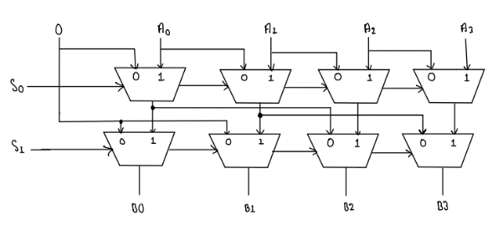

**Shift Barrel can perform a shift in one clock cycle.**

Advantages: Much faster than regular Shifter

Same time of execution regardless of # bits shifted.

Disadvantages: Much more complex to implement logic

Limited Shift Distance

The purpose of the modular exponent subtractor is to find the absolute value of the difference of the two exponent values. This absolute is used in the processing of addition or subtraction of two floating point numbers.

