|  |
| --- |
| Name: _____Servando_Olvera________ ID# ________1001909287_______    Date Submitted: _____02-06-2024____ Time Submitted _____9:00_pm______    CSE 3341 Digital Logic Design II    CSE 5357 Advanced Digital Logic Design    Spring Semester 2024    **Lab 2 –Multiplexed Seven-Segment Displays**  Due Date – February 6, 2024, 11:59 PM    Submit on Canvas Assignments |

**DESIGN REQUIREMENTS**

Design a decoder/controller for the *HexBoard* four-digit multiplexed seven segment display. Capture your design using SystemVerilog. Realize your design on the DE10-Lite + HexBoard devices found in your ADL Lab Kit. In Part A, you will test your decoder/controller by displaying, in hexadecimal, the output of a 16-bit binary counter as shown in Figure 1. In Part B, you will use the *HexBoard* to display a crawling message. This can be realized by replacing the 16-bit counter with a circular buffer as shown in Figure 2.

* SystemVerilog must be used for coding the solutions.
* Structured design must be used and documented by a hierarchy diagram.
* Code must be commented.

## **Part A – Multiplexed seven-segment decoder/controller**

1. Design and implement the circuit in Figure 1.
2. Demonstrate that the counter counts and displays properly from 0000 to FFFF and repeats.
3. Demonstrate that the On/Off and Reset features work.
4. Mathematically derive the count rate and mux rate for the clock ladder settings in Figure 1.
5. Add a feature that allows the mux rate to be controlled from the DE10-Lite+HexBoard switches and pushbuttons.
6. Experimenally determine the slowest mux rate that does not produce flicker on the display.
7. Does speeding up the mux rate from this minimum improve the display?

## **Part B – Crawling message display**

1. Design and implement the circuit in Figure 2.
2. Demonstrate that it can continuously display the message *0123456789AbCdEF* in hex.
3. Increase the crawl rate by a factor of 4 and observe the effect on the display.
4. Reprogram your circular buffer to display the message HELLO 2 YOU.

**HIRERARCHY DIAGRAMS**

**Part A**

**Part B**

**SYSTEM-VERILOG CODE**

**Part A Top Module**

**Part B Top Module**

**ON & OFF Toggle Module**

**Clock Ladder Module [Part A]**

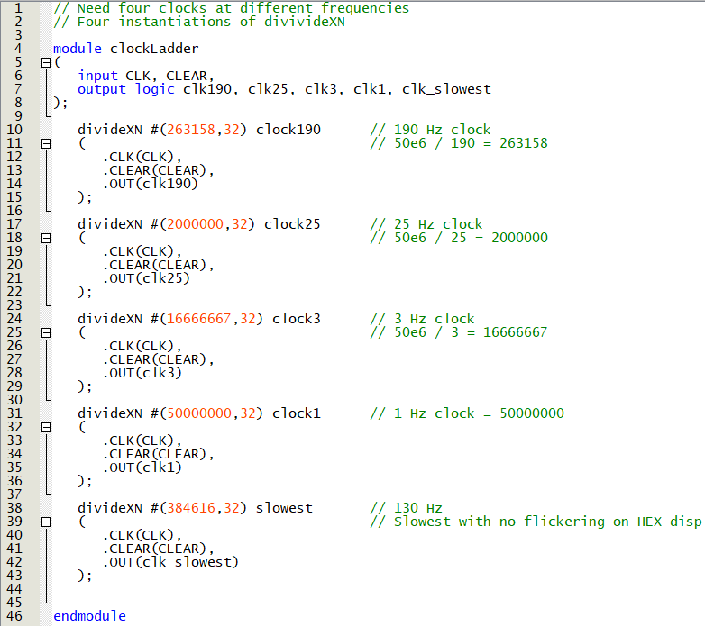

**Clock Ladder Module [Part B]**

**Clock Rates Module**

**16-bit Binary Counter Module [Part A]**

**Circular Buffer Module [Part B]**

**MUX Module**

**Four To One Module**

**Finite State Machine Module**

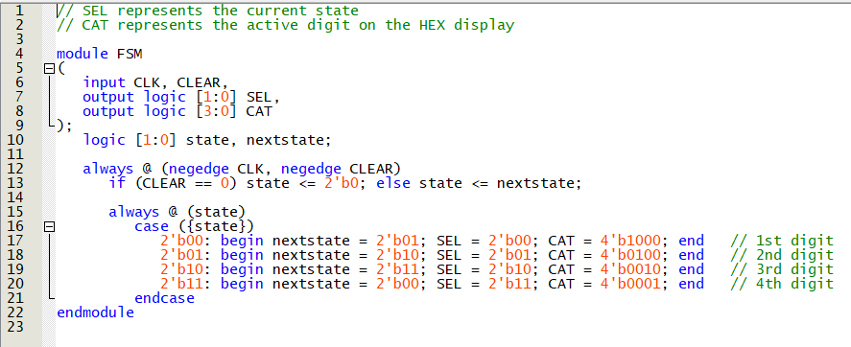

**Binary To 7-Hex & To Message Decoder**

**PIN ASSIGMENTS**

**SW9 is for part B (I implemented A & B similarly)**

**DEMOED IN PERSON**

**Demoed on 02/05/2024**

**To: TA (Madison)**