|  |
| --- |
| Name: _____Servando_Olvera________ ID# ________1001909287_______    Date Submitted: _____01-25-2024____ Time Submitted _____4:16_pm______    CSE 3341 Digital Logic Design II    CSE 5357 Advanced Digital Logic Design    Spring Semester 2024    **Lab Assignment #1 – Knight Rider Flasher**    Due Date – January 25, 2024 (11:59 PM)    Submit on Canvas Assignments |

**DESIGN REQUIREMENTS**

Design in SystemVerilog, implement on the DE10-Lite, and demonstrate a sequential machine that flashes the red LEDs on the DE10-Lite in a continuous back and forth pattern reminiscent of the action lights on the Knight Rider’s Firebird Trans Am, KITT. Once you complete this assignment, you will have demonstrated an ability to design and model sequential logic circuits in SystemVerilog that meet specified requirements and to implement the design using a Field Programmable Gate Array (FPGA) employing the following features.

* Clock_50 50-MHz clock
* On/Off toggle
* Clock divider
* Up/Down counter
* Binary to 7-segment decoder
* Module instantiation
* Pin assignment

The DE10-Lite board provides a 50-MHz clock (CLOCK_50) that can be used as the time-based for the Flasher. You will need to design a clock divider to provide an appropriate frequency for the machine. The LEDs should flash in a continuous back and forth pattern, reversing direction about once per second, twice per second, and once every two seconds. An up/down counter can be used to realize the LED output pattern. Employ an on/off toggle for your On/Off switch.

Design, implement, and demonstrate the sequential machine described above. Your design must employ a top-down approach and include the following modules.

* Top level
* On/off toggle
* Clock divider
* Up/down counter
* Seven-segment decoder

Lower-level modules should be instantiated in the top-level module.

**HIERARCHY DIAGRAM**

**SYSTEM VERILOG CODE FOR ALL MODULE**

* Top Module

* On and Off Toggle Module

* Divide By Counter Module

* Reverse Logic

* Up Down Counter Module

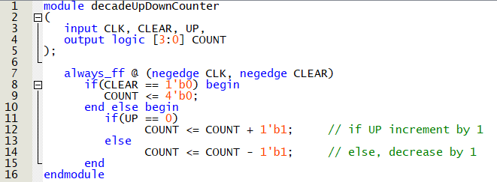

* Decoder (4-10) Module

* Decoder (10-7 seg) Module

**DE-10 PIN ASSIGMENT**

**DEMOED IN PERSON**

Demoed on 01/24/2024

To: TA (Madison)