|  |
| --- |
| Name: _____Servando_Olvera________ ID# ________1001909287_______    Date Submitted: _____04-18-2024____ Time Submitted _____9:00_pm______    CSE 3341 Digital Logic Design II    CSE 5357 Advanced Digital Logic Design    Spring Semester 2024    **Lab 6 – Keypad Encoder and Scanner**  **100 points**  Due Date – May 18, 2024, 11:59 PM    Submit on Canvas Assignments |

**DESIGN REQUIREMENTS**

***PURPOSE/OUTCOMES***  
To design, implement using the DE10-Lite + KeyPad + FlipBoard + HexBoard a keypad scanner and  
encoder to display keystrokes on a multiplexed seven-segment display. By successfully completing this lab you will be able to use the KeyPad and HexBoard for input and output units for the term project.

***BACKGROUND***  
A basic calculator can be partitioned in to four functional units. The arithmetic unit (AU) receives two eight-bit operands, with the left-most bit being a sign-bit, encoded in two’s complement and produces an output in two’s complement. For the four-function term-project calculator, data will be entered in hexadecimal on the KeyPad and displayed in hexadecimal on the HexBoard. Hence, the KeyPad must be configured to output key strokes in hexadecimal characters. Note, the KeyPad (4x4 keypad) must be plugged in to the Arduino port on the DE 10-Lite.

***DESIGN REQUIREMENTS***  
Your assignment is to configure and test the KeyPad Scanner and Encoder to capture four key strokes and display the hex code on the HexBoard.

1. Implement the BCD KeyPad Scanner and Encoder and display the outputs on the HexBoard.

2. Demonstrate your implementation with an appropriate test.

3. Modify the code to capture hexadecimal characters.

4. Implement the HEX KeyPad Scanner and Encoder and display the outputs on the HexBoard.

5. Demonstrate your implementation with an appropriate test.

**ORGANIZATION DIAGRAM**

**HIRERARCHY DIAGRAM**

**SYSTEM-VERILOG CODE**

**Part Top Module**

**Keypad Input**

**Keypad Base Module**

**Clock Divider Module**

**Keypad FSM Module**

**Keypad Key Decoder Module**

**Shift Register Module**

**Controller/MUX Module**

**Clock Ladder Module**

**Four to One Decoder Module**

**Finite State Machine Module**

**Four to One Decoder Module**

**PIN ASSIGMENTS**

**RTL DIAGRAMS**

**Top Module**

**Keypad Input**

**Keypad Base**

**Clock Divider**

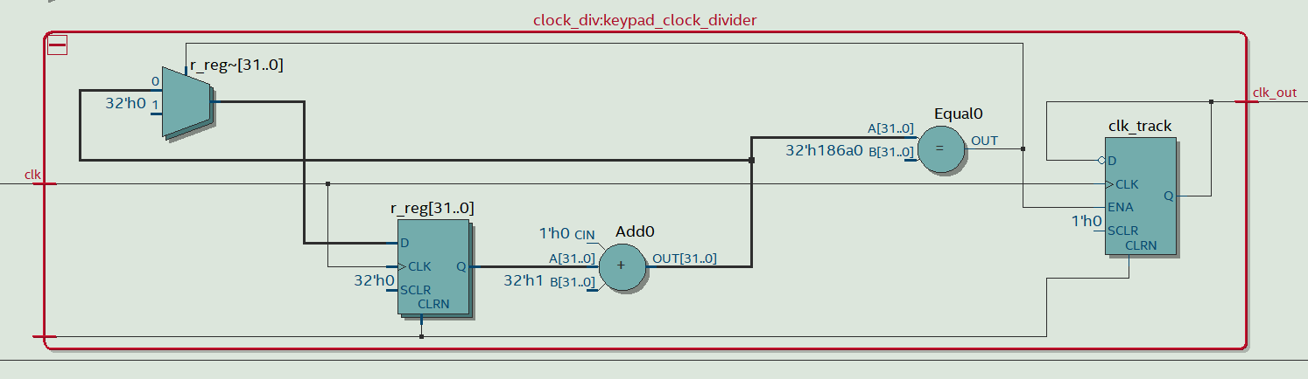

**Keypad Finite State Machine**

**Keypad Key Decoder**

**Shift Register**

**Controller/MUX**

**Four to One Decoder**

**Clock Ladder**

**Finite State Machine**

**Binary To Seven Hex Decoder**

**Compilation Summary**

**DEMOSTRATION OF DCB KEYPAD SCANNER**

Demoed In person to TA.

**DEMOSTRATION OF HEX KEYPAD SCANNER**

Demoed In person to TA.