IRIDE CYBERITALY — OPERATING PROCEDURE
Creating and Managing Groups in Awareness

1. Purpose
This procedure describes how to create a group on the IRIDE CyberItaly Awareness platform, how to add members to it, and how to modify or delete it afterwards.
Group creation is not restricted to administrators: any authenticated user can create a group. The distinction between a standard user and an administrator lies in visibility, not in permission to create — see Section 3.

2. Prerequisites
- An active Awareness account. No specific role is required in order to create a group.
- The list of users to be added as members, identified by their platform username.
- An agreed name for the group (see Section 6 on naming).

3. Visibility
The content of the My Groups screen depends on the role of the account in use:
- Administrator — all groups existing on the platform are listed.
- Standard user — only the groups associated with the account in use are listed.
This difference affects what is displayed only. The creation workflow described in Section 4 is identical for both roles.

4. Creating a group
- Sign in to Awareness with the account that will own the group.
- Navigate to Manage my account, then open the My Groups section.
- Review the existing groups shown in the list, in order to confirm that an equivalent group has not already been created.
- Click + Add group to start the creation of a new group.
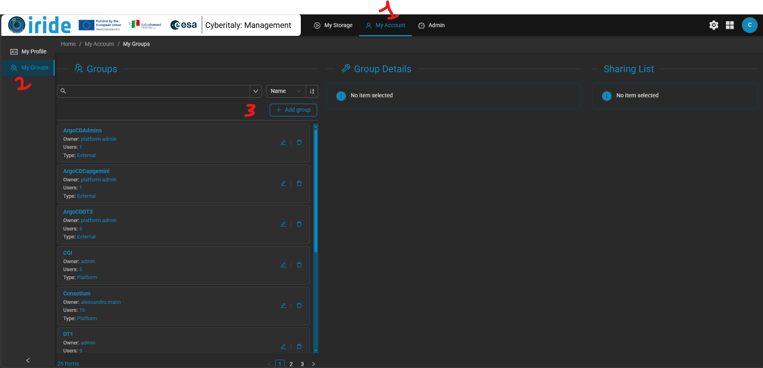

- Assign a name to the group. The name is how the group will be identified in every subsequent screen, so it should be descriptive and unambiguous.
- Select the group type: choose Platform.
- Add the members using the button marked with the user icon, and select each user to be included in the group.
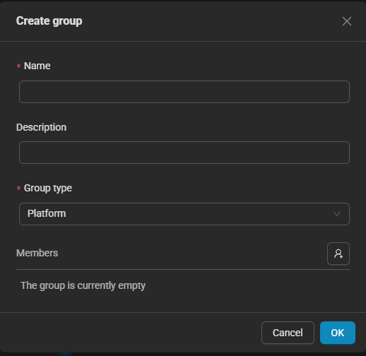

- Confirm the creation. Once created, the group appears in the list on the My Groups screen.

5. Modifying or deleting a group
Once a group appears in the list, two operations are available from the same screen:
- Editing the membership — members can be added to or removed from an existing group without recreating it.
- Deleting the group — the group can be removed from the platform.
Deletion should be treated as a deliberate action rather than a routine clean-up step: any permission, sharing arrangement or workflow that references the group will be affected. Confirm that the group is genuinely unused before removing it.

