Sereda Andrei
Task:
Установить приложение ‘Hollister So Cal Style’ либо с App Store: https://itunes.apple.com/us/app/hollister-so-cal-style/id383915209?mt=8 либо с Play Store https://play.google.com/store/apps/details?id=com.abercrombie.hollister
Написать тест-кейсы на экраны:
1. Account: Create Account
2. My Saves

Software environment – BlueStacks client ver.3.55.70.1783
ID | Date | Title | Test case procedure | Expected result | Actual result | Note
001 | 05.16.2018 | Install and open  Screen: main, Create Account | 1.Install and open Hollister So Cal Style.  2.Push create account button.  3.Click back button. | 1.The app Install and open.  2.Open create account form.  3.Go to the main screen. | Pass  Pass  Pass
ID | Date | Title | Test case procedure | Expected result | Actual result | Note
002 | 05.16.2018 | Check for requirements  Screen: Create Account | 1.Push “First name” field.  2.Push “Last name” field.  3.Push “Email” field.  4.Push “Password” field. | 1.Requirement to fill out a “First name” field.  2. Requirement to fill out a “Last name” field.  3. Requirement to fill out a “Email” field.  4. Requirement to fill out a “Password” field. | Pass  Pass  Pass  Pass | Attachment: picture
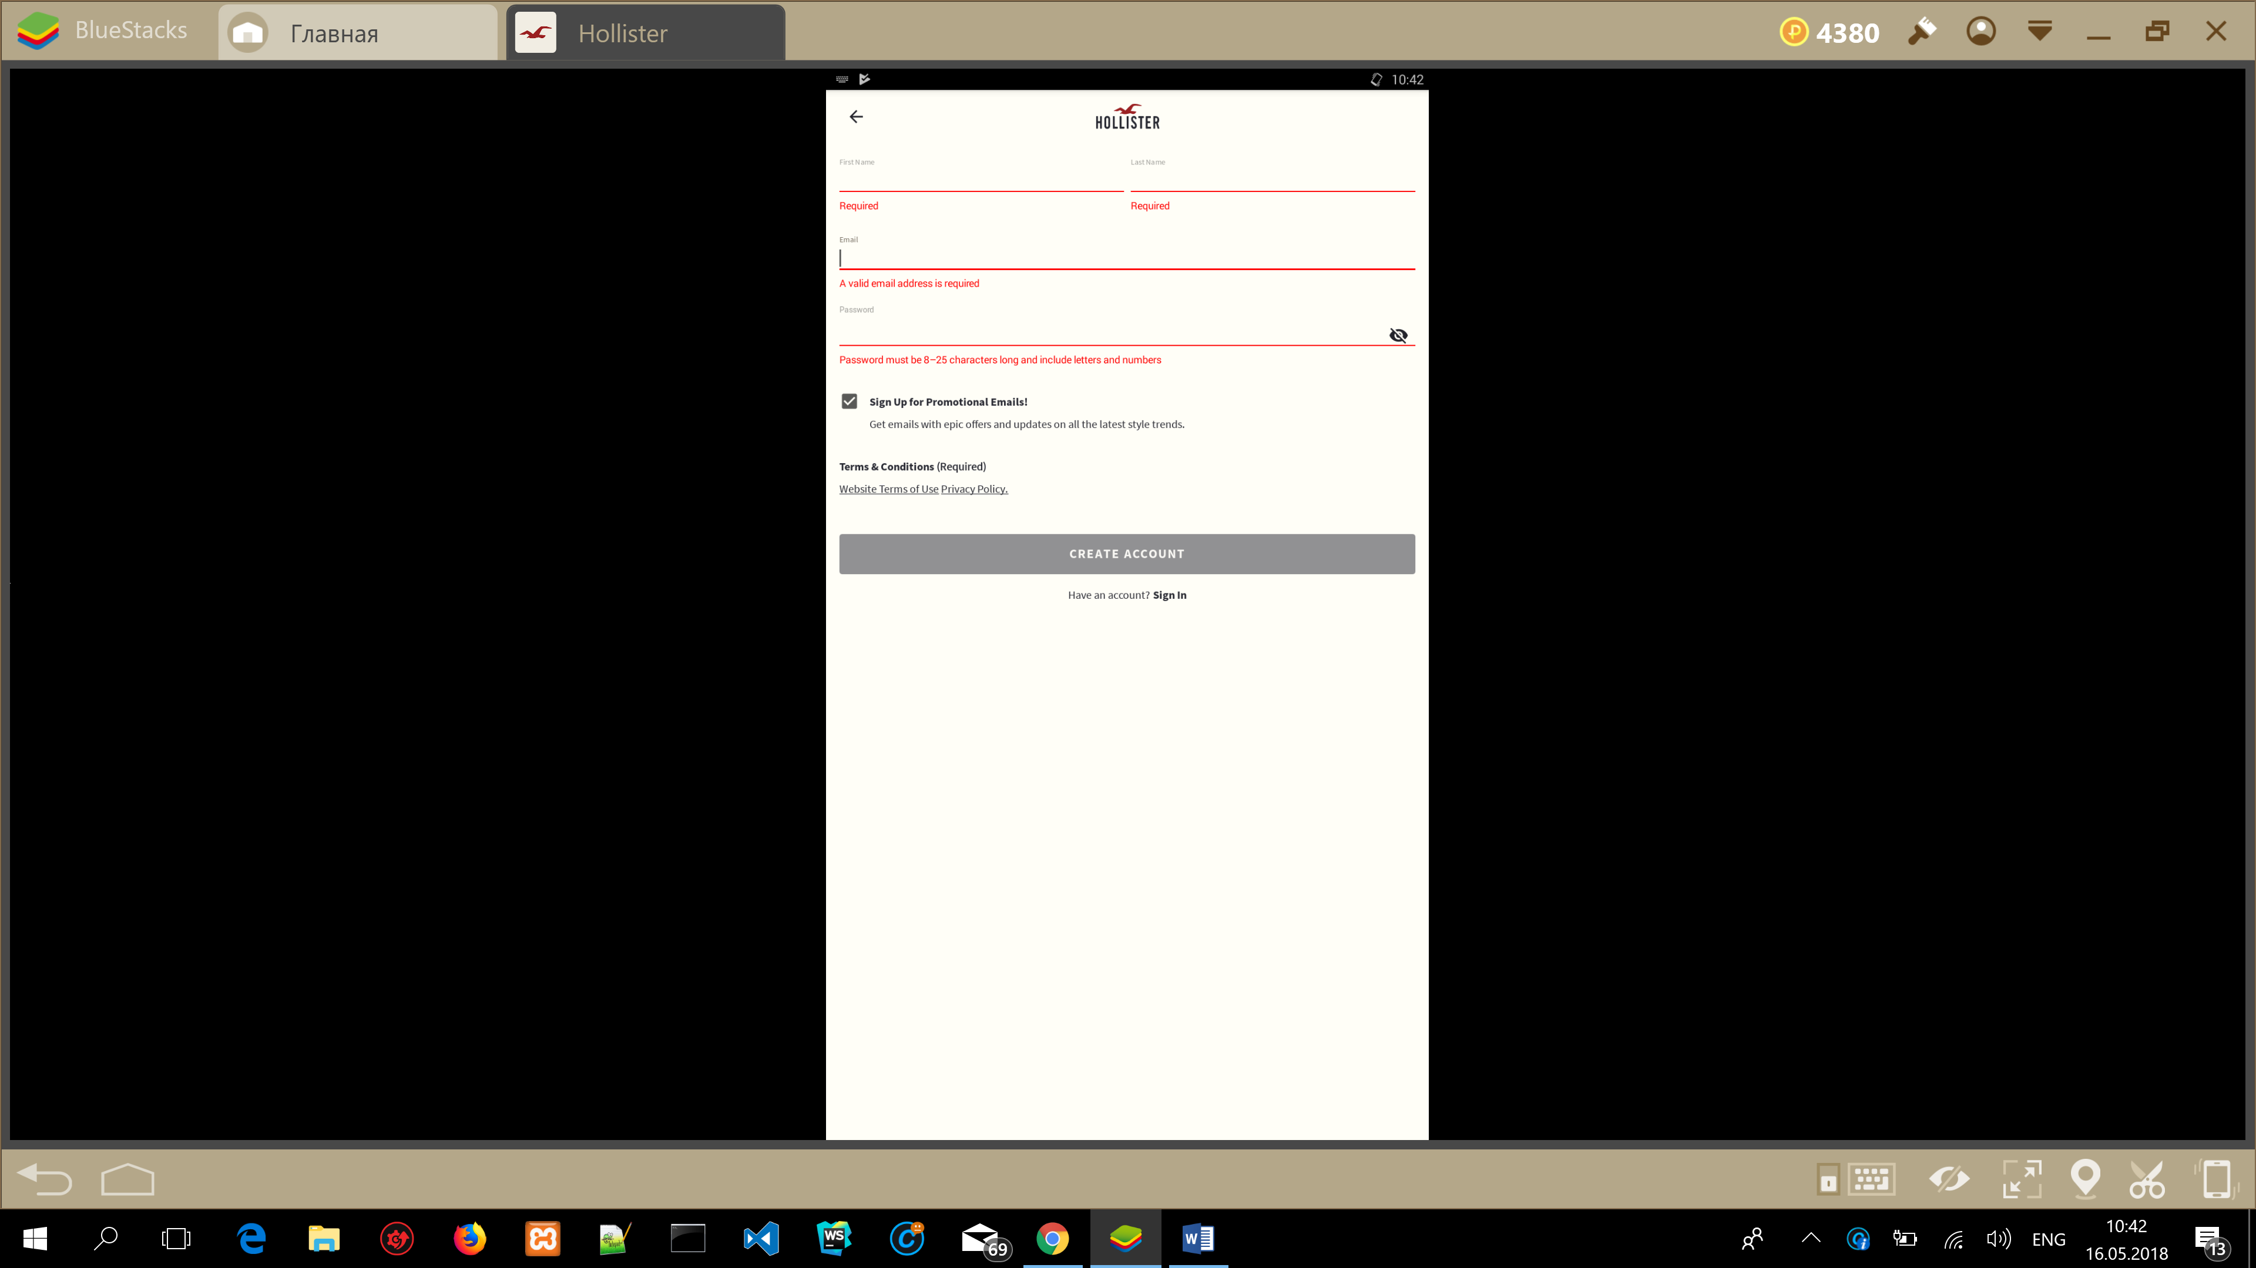

ID | Date | Title | Test case procedure | Expected result | Actual result | Note
003 | 05.16.2018 | Check the check box “Sign Up for Promotional Emails!”  Screen: Create Account | 1.Push the check box button.  2.Push the check box button. | 1.Disable the check box.  2.Enable the check box. | Pass  Pass
ID | Date | Title | Test case procedure | Expected result | Actual result | Note
004 | 05.16.2018 | Check “Terms & Conditions (Required)”  Links  Screen: Create Account | 1.Push “Website Terms of Use” link.  2.Close “Website Terms of Use” link.  3.Push “Privacy Policy” link.  4.Close “Privacy Policy” link. | 1.View next page.  2.Close Website Terms of Use page.  3.View next page.  4. Close “Privacy Policy” page. | Pass  Pass  Pass  Pass
ID | Date | Title | Test case procedure | Expected result | Actual result | Note
005 | 05.16.2018 | Check “Terms & Conditions (Required)”  Links  Screen: Create Account | 1.Push “Website Terms of Use” link.  2.Close “Website Terms of Use” link.  3.Push “Privacy Policy” link.  4.Close “Privacy Policy” link. | 1.View next page.  2.Close Website Terms of Use page.  3.View next page.  4. Close “Privacy Policy” page. | Pass  Pass  Pass  Pass
ID | Date | Title | Test case procedure | Expected result | Actual result | Note
006 | 05.16.2018 | Enter valid First name, Last name,  Email & password data  Screen: Create Account | 1.Enter valid first name.  2.Enter valid last name.  3.Enter valid email name.  4.Enter valid password(8-25 characters long include letters and numbers).  5.Create account.  6.Sign out. | 1.Accept valid first name.  2.Accept valid last name.  3.Accept valid email name.  4.Accept valid password.  5.Accept data.  6.Accept sign out. | Pass  Pass  Pass  Pass  Pass  Fail | Attachment:  1.Close window after step 5.  2.Tap sign out.  3.Still don’t sign out.  4.Tap “Categories” after “sign out”  5.Tap “New Arrivals after “sign out”  6.Filter is works after “sign out”  7.Sort is works after “sign out”  8.Add item in bag  9.Must sign in to buy item  10. After sign in item is still in bag.  For successful sign out need tap drop-down menu & tap my account

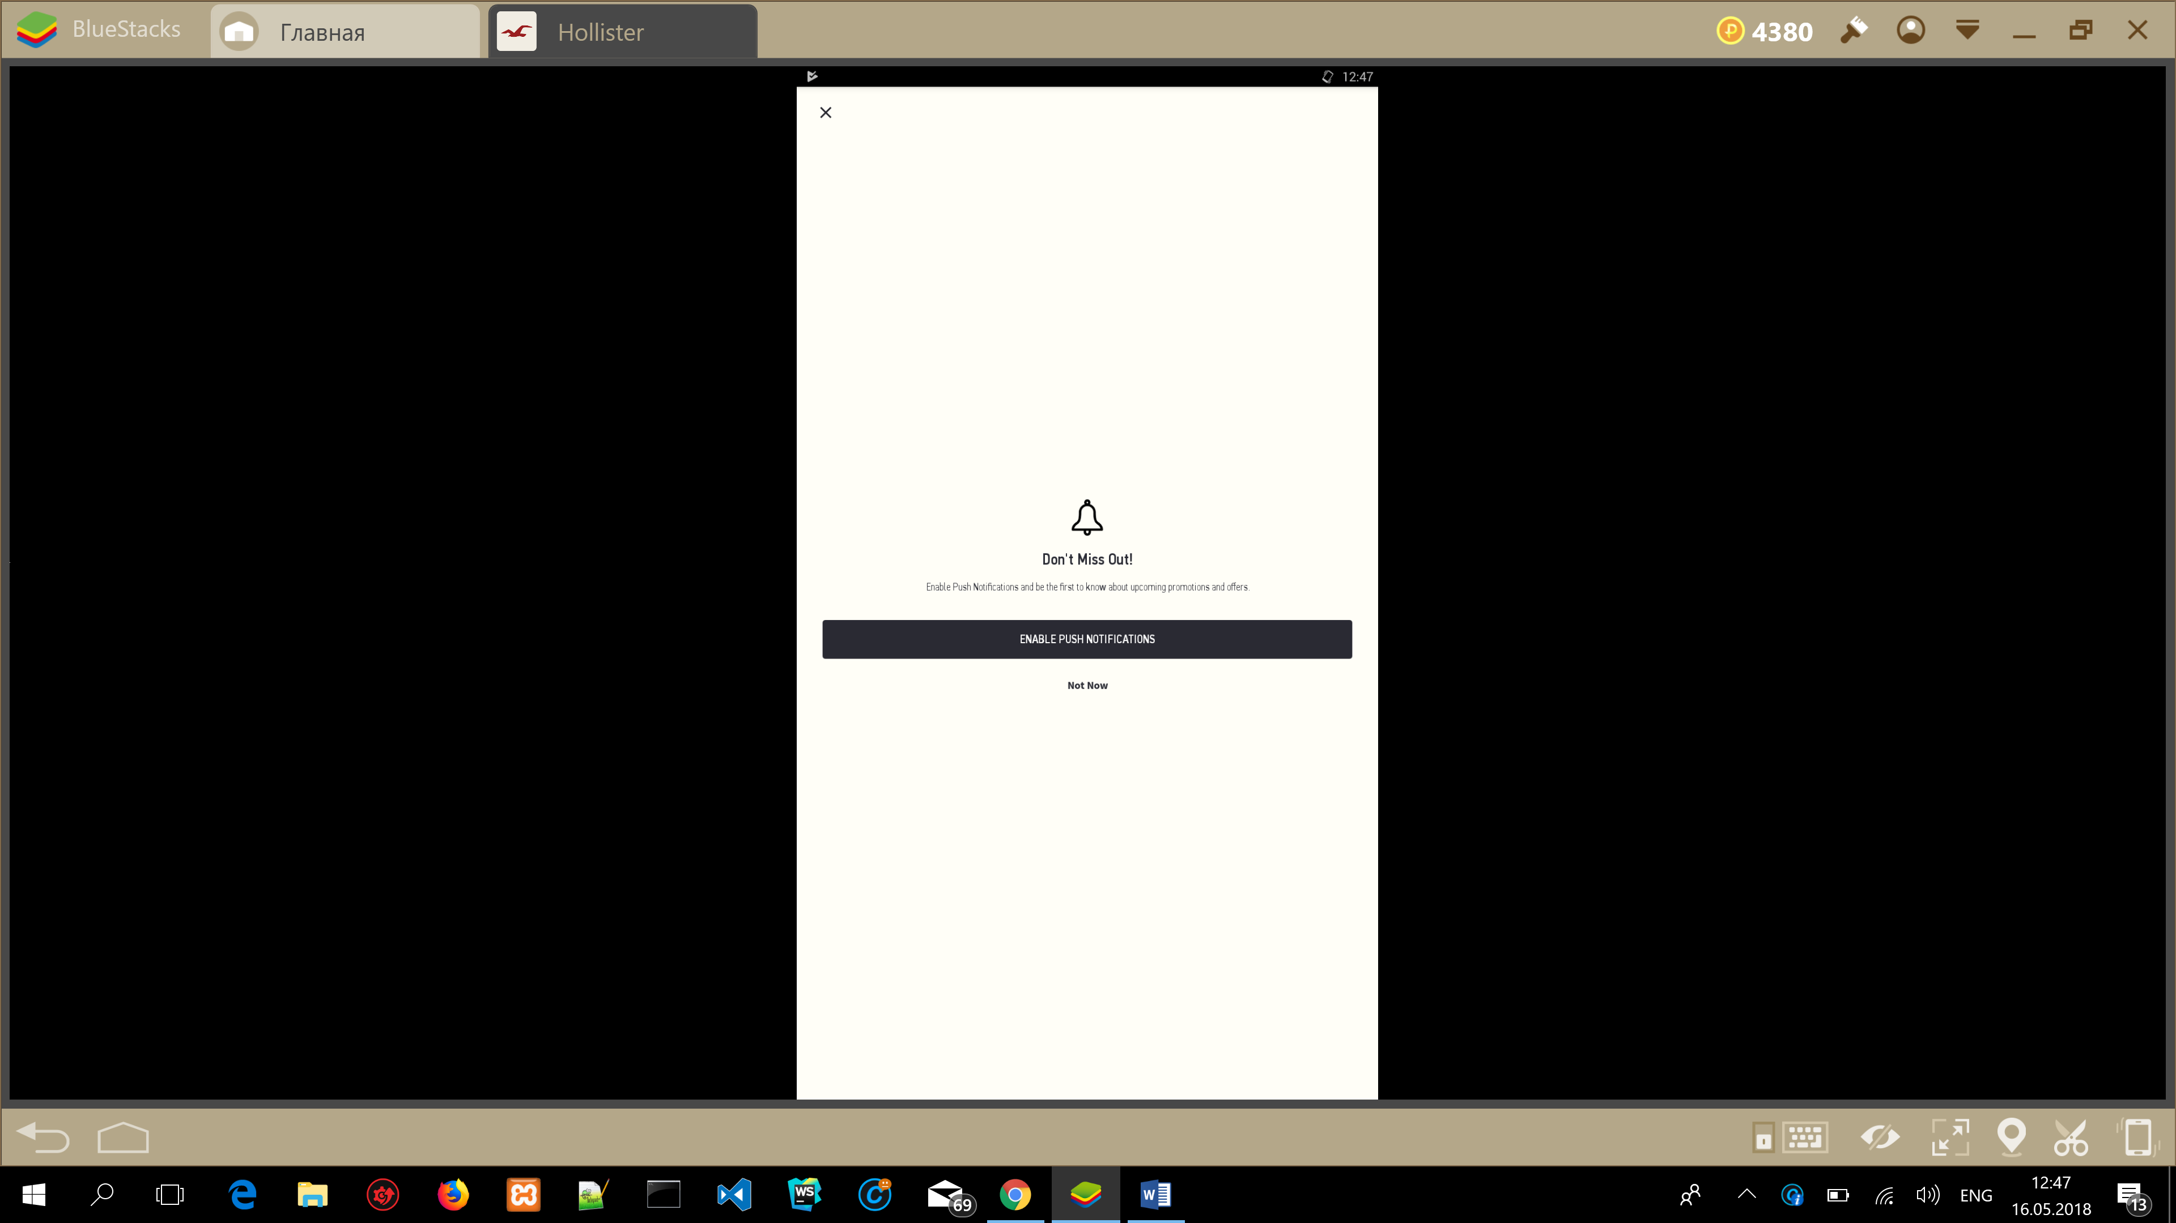







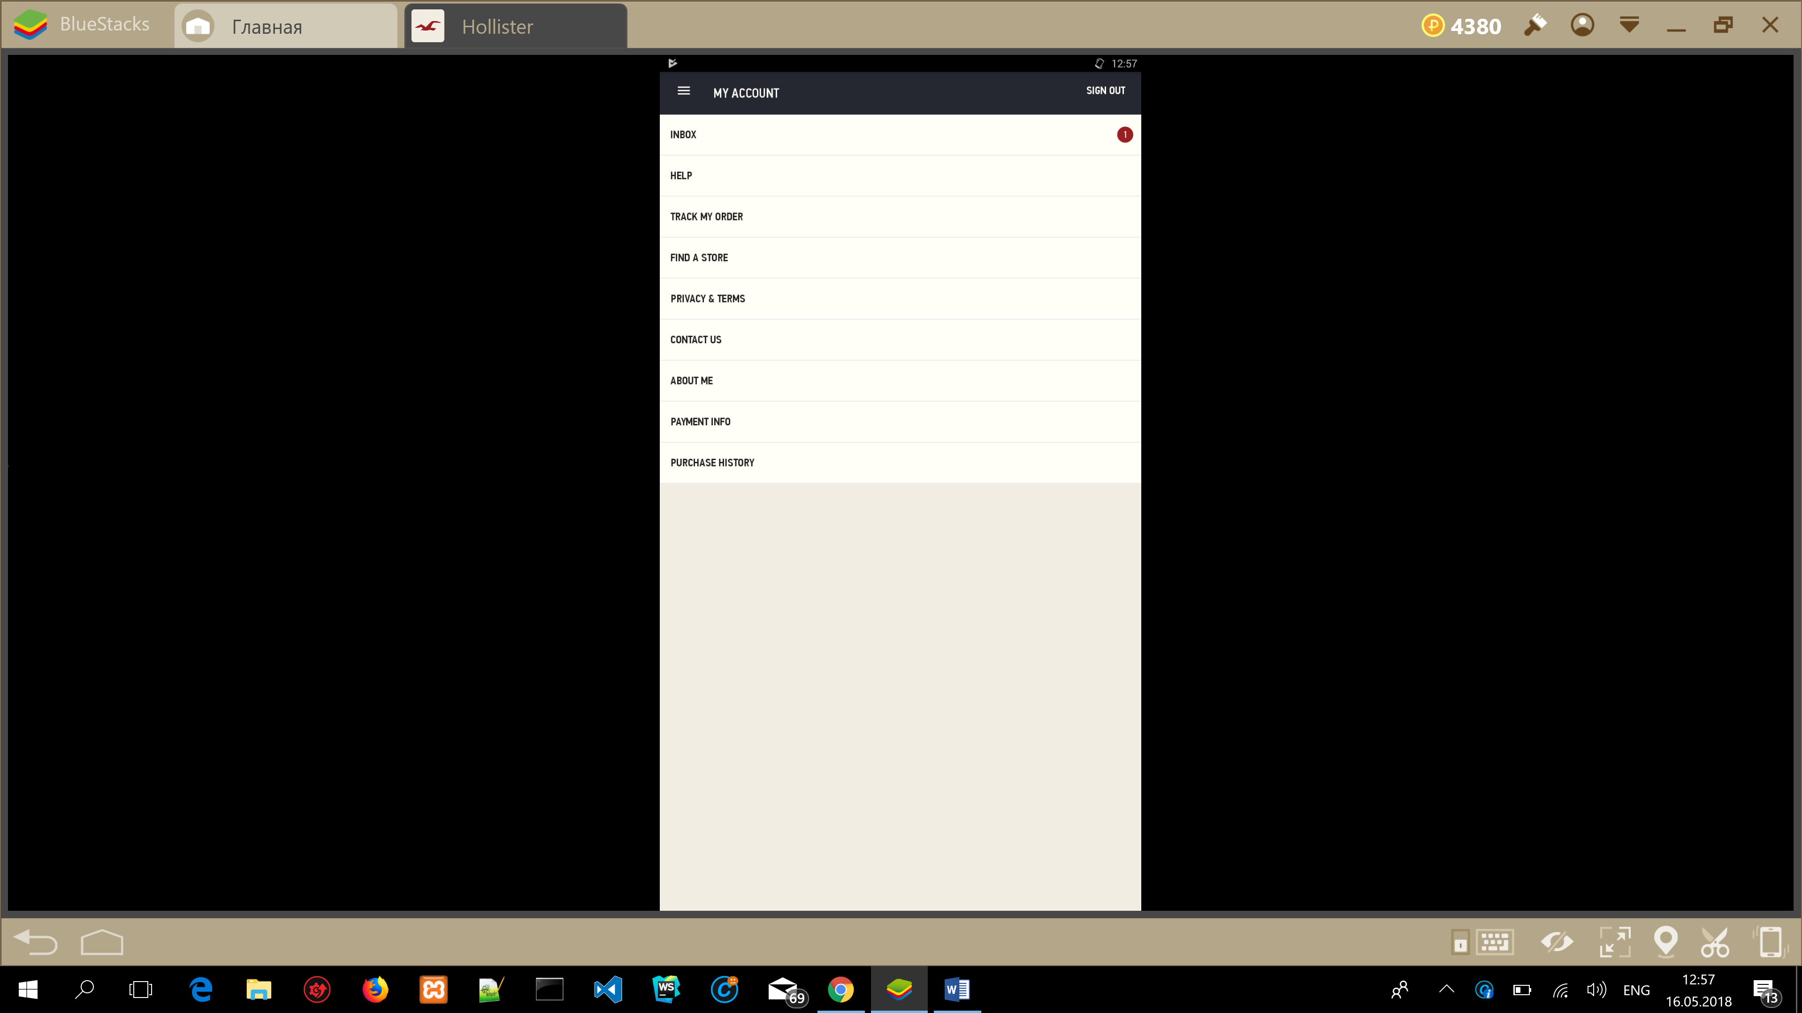

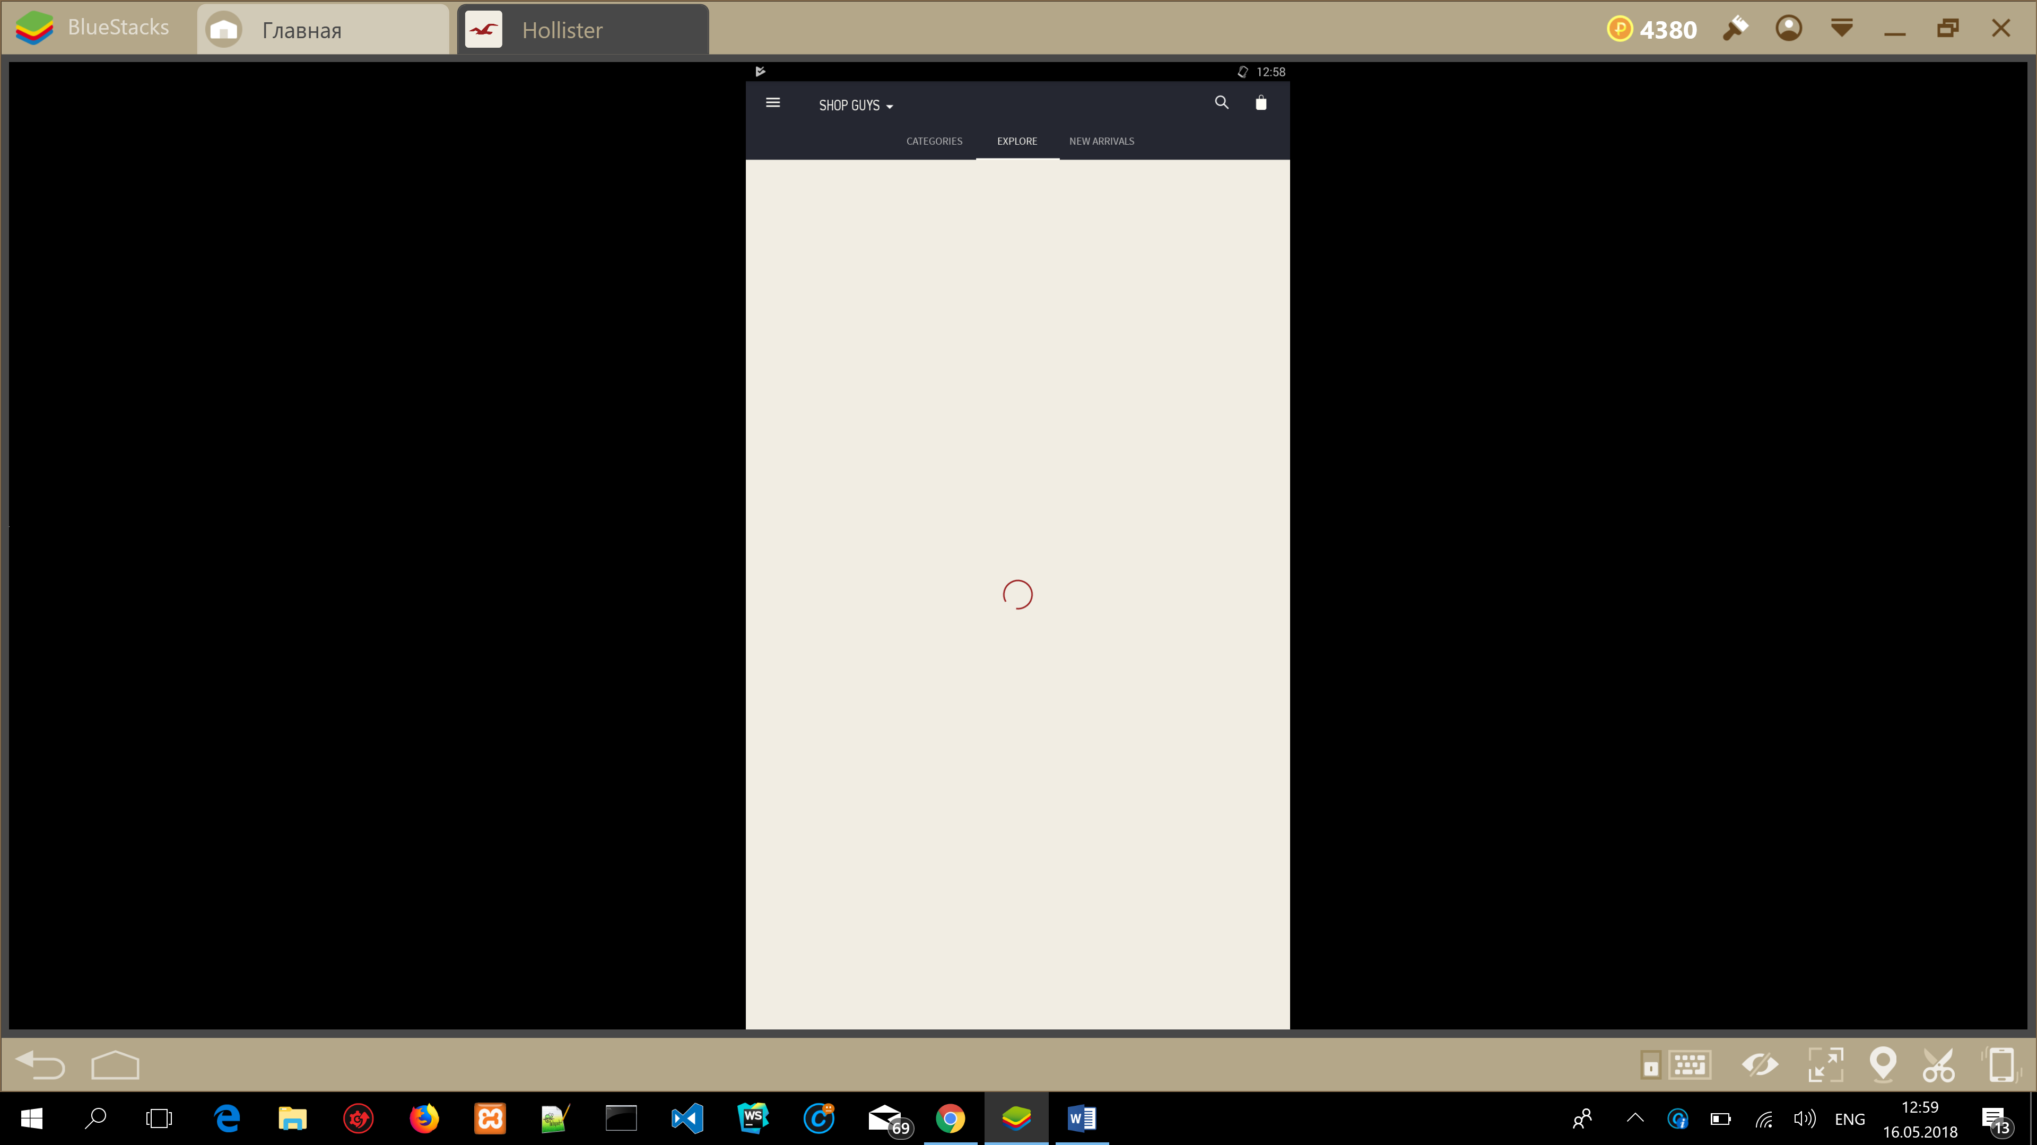

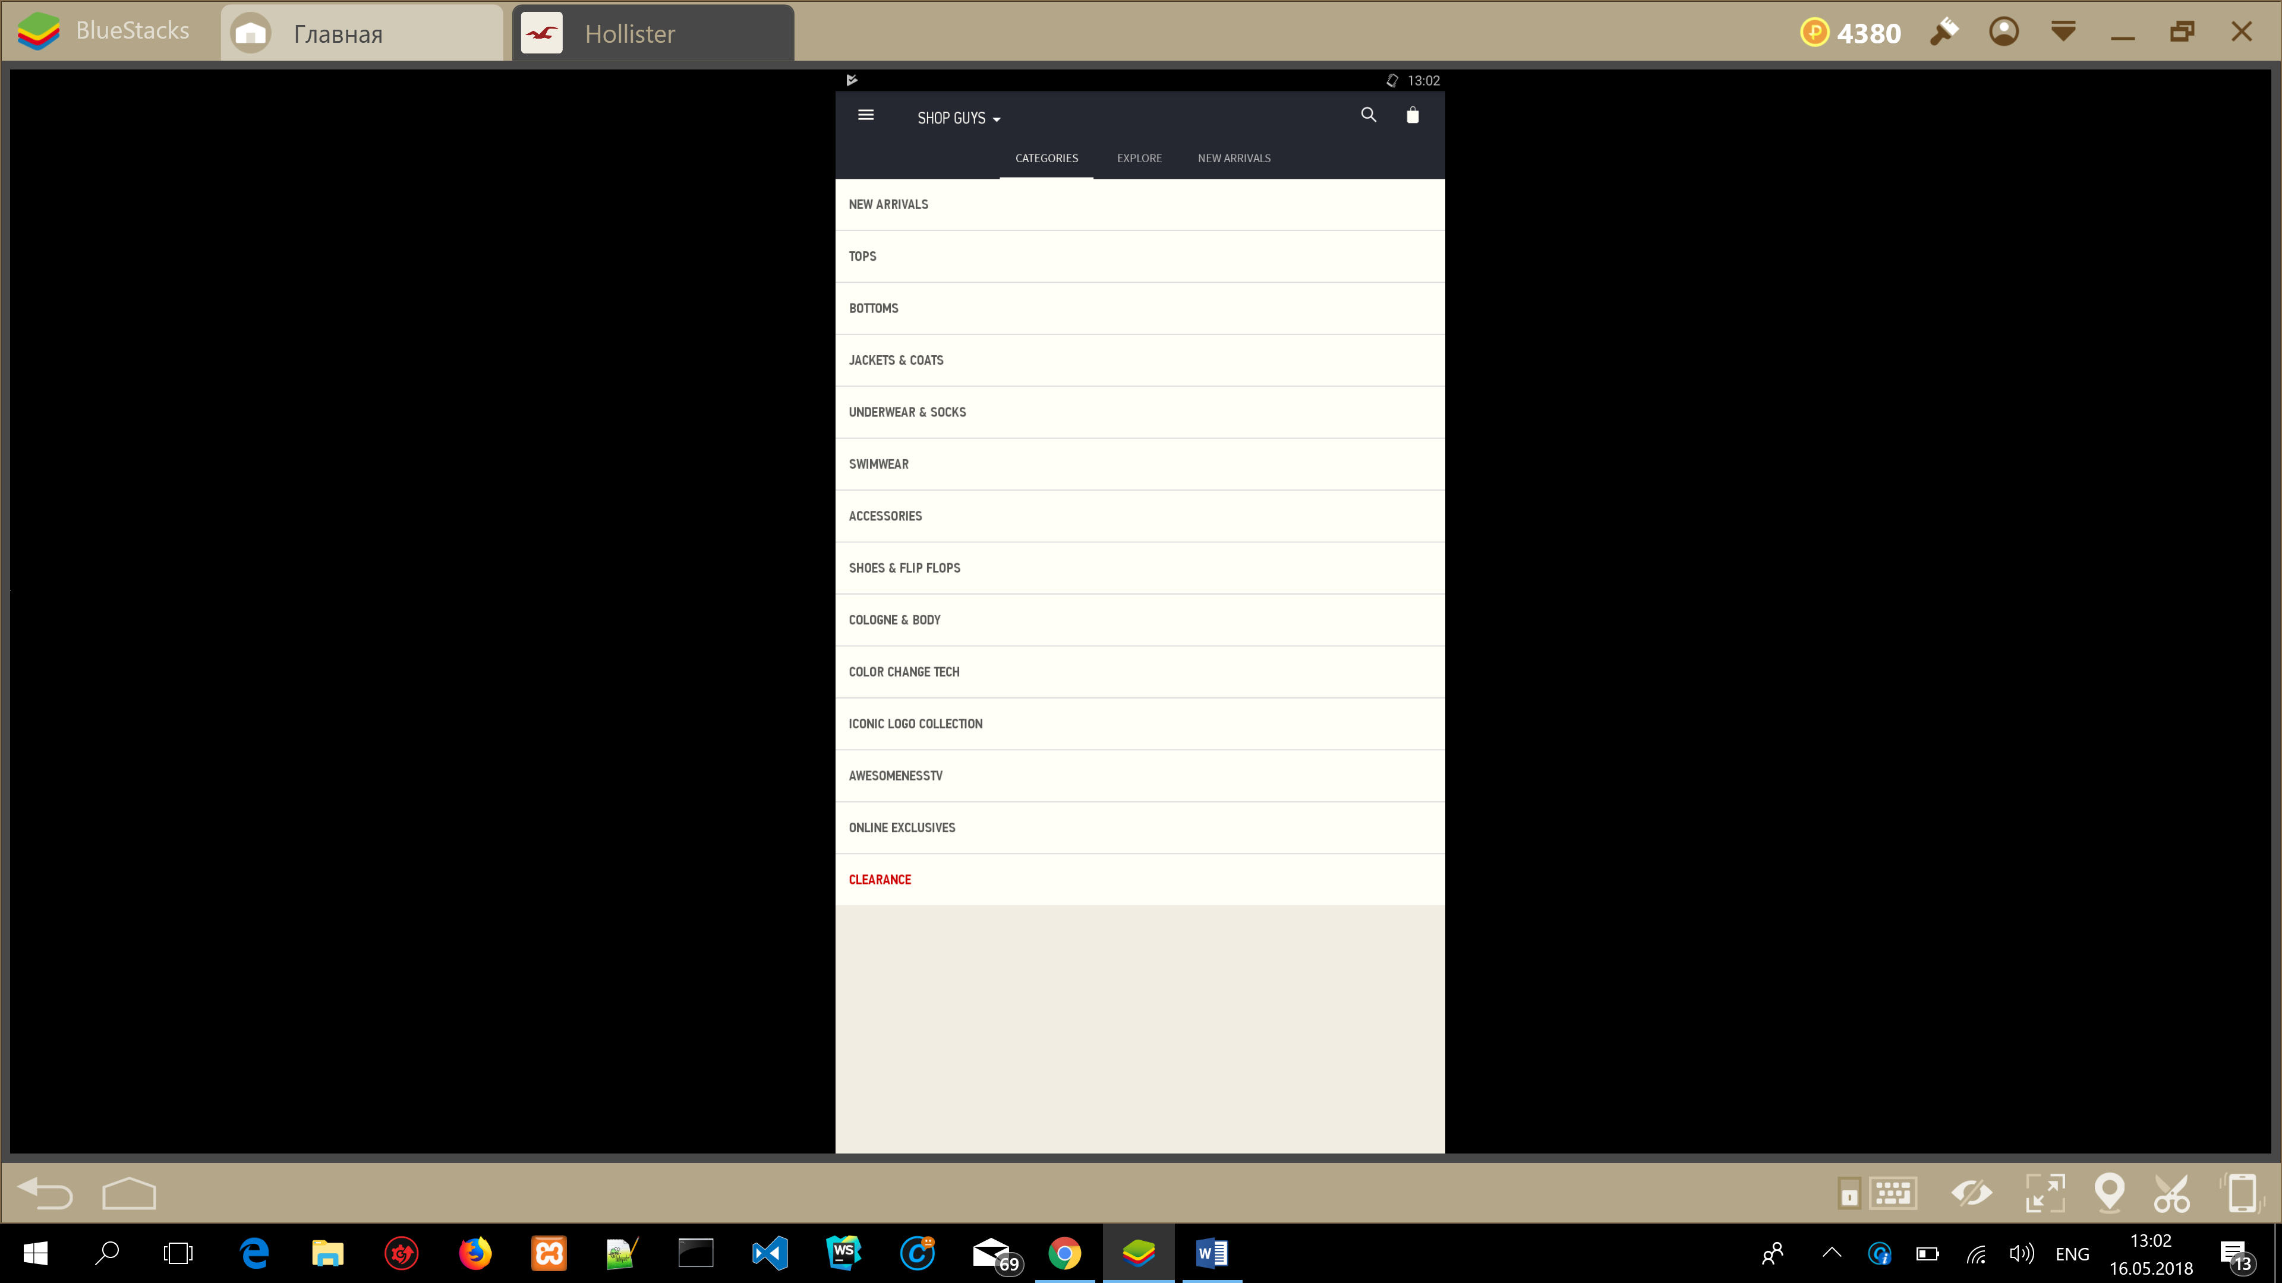

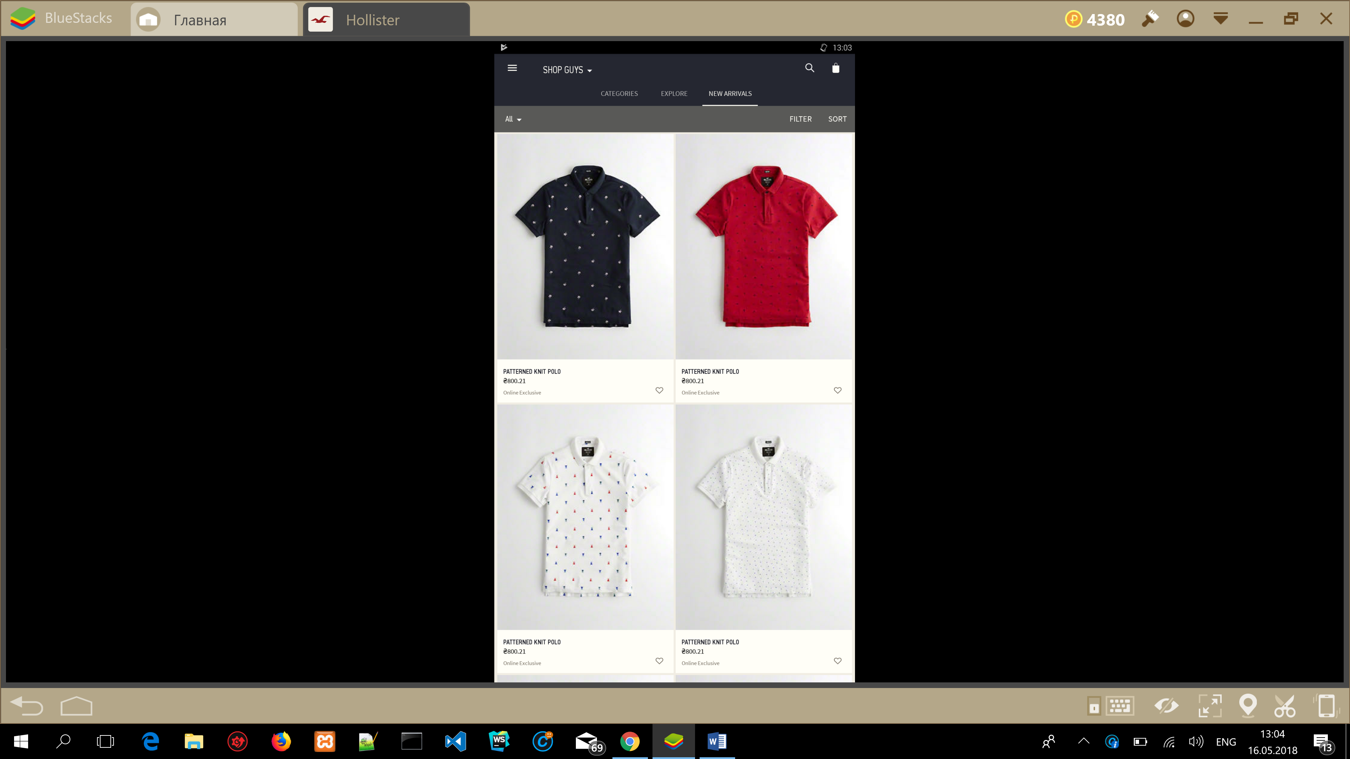

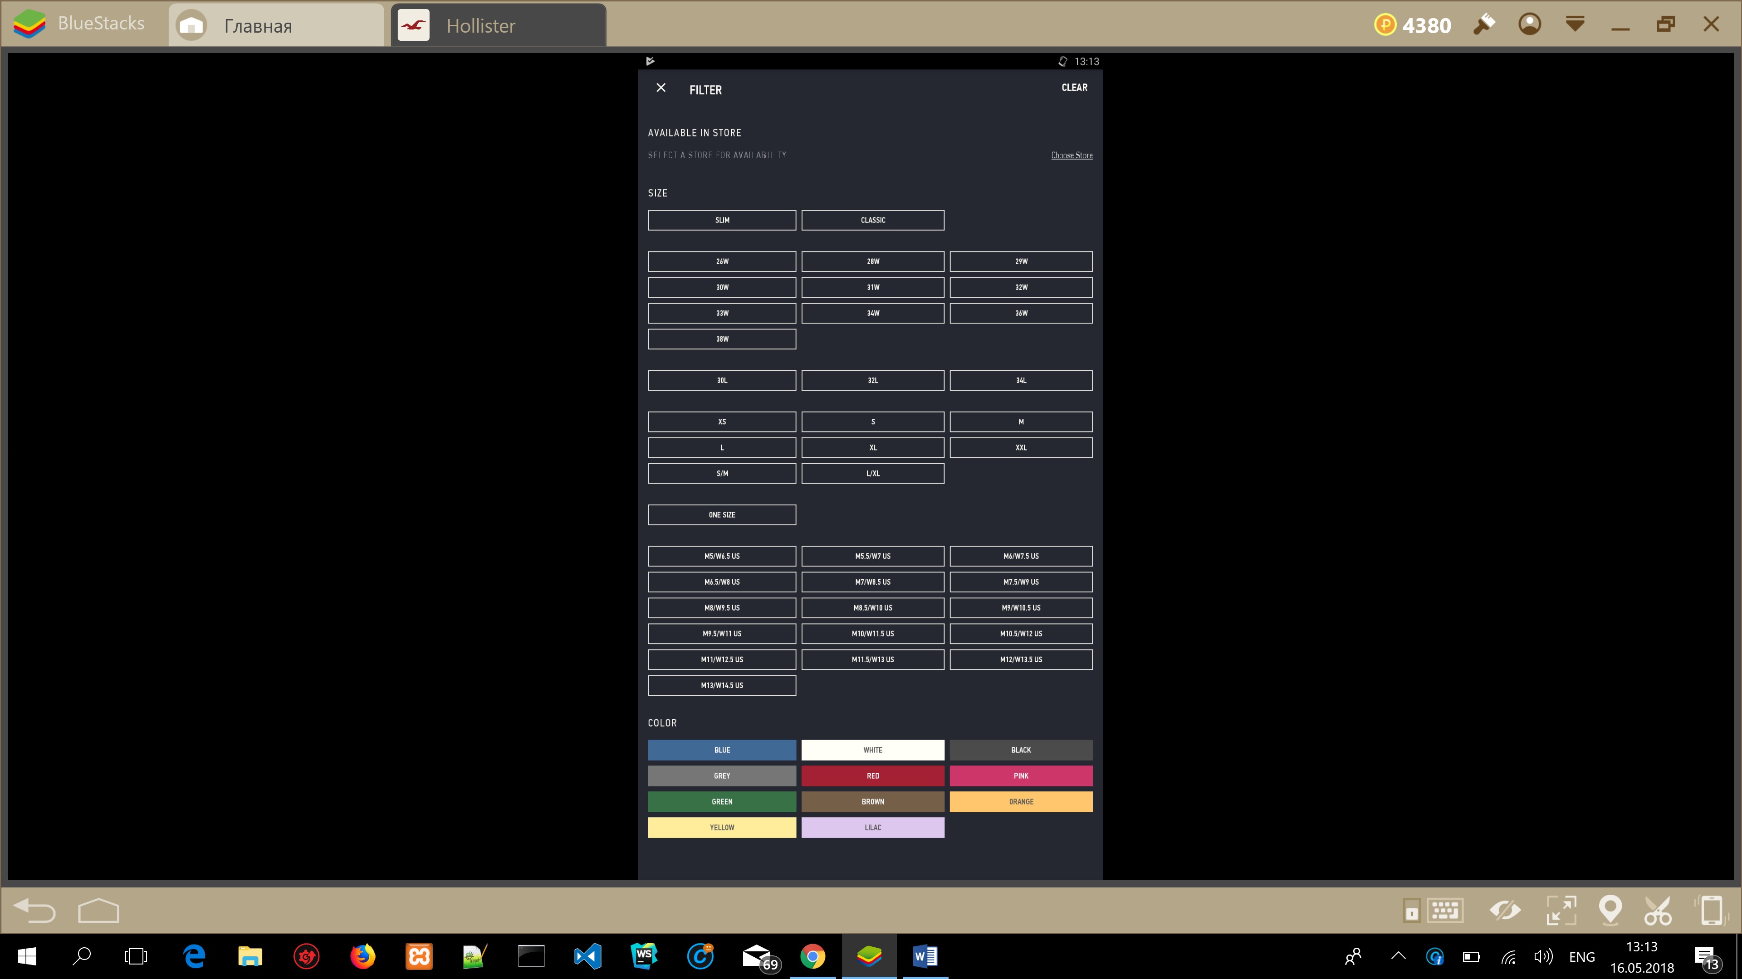

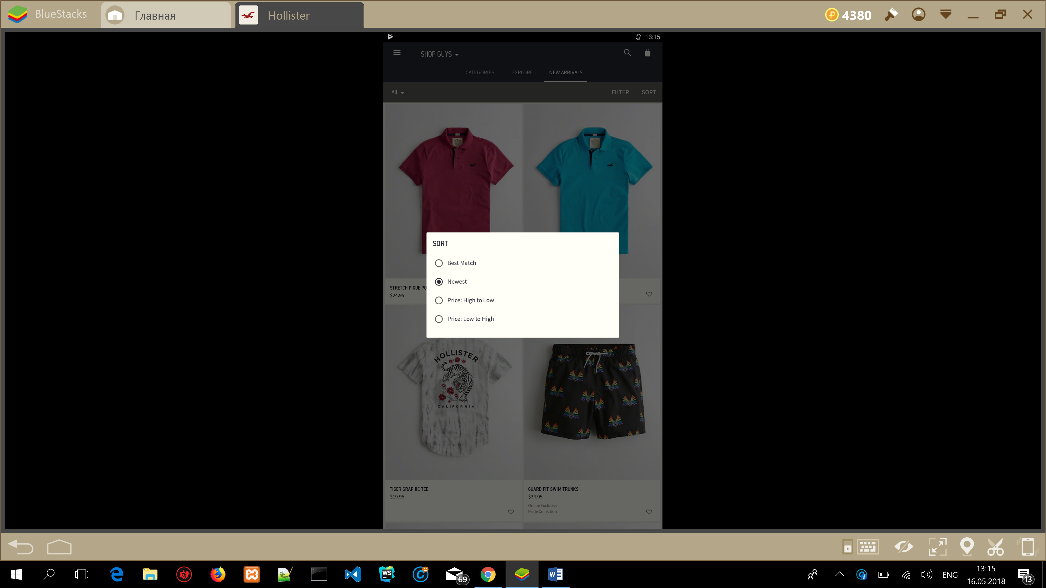

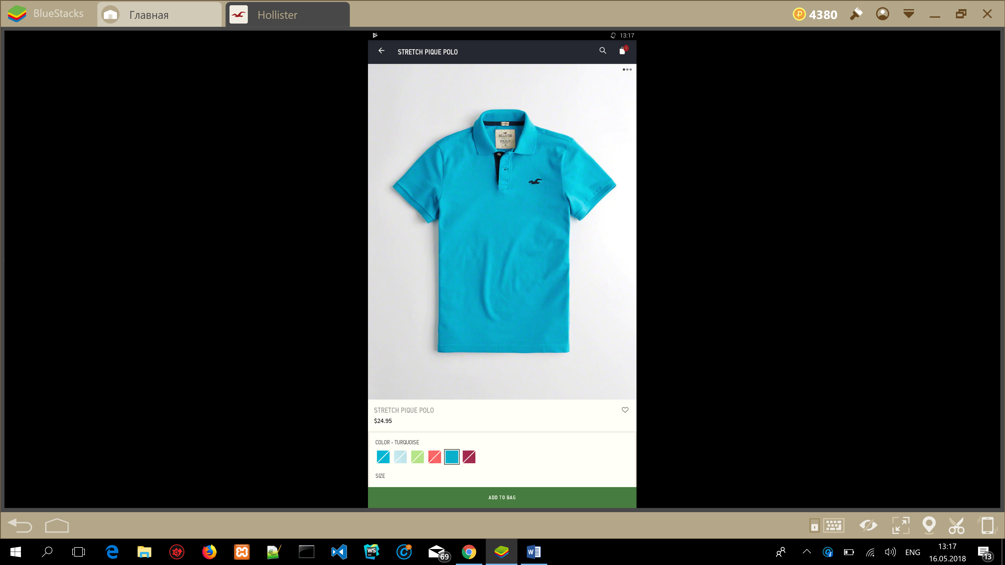

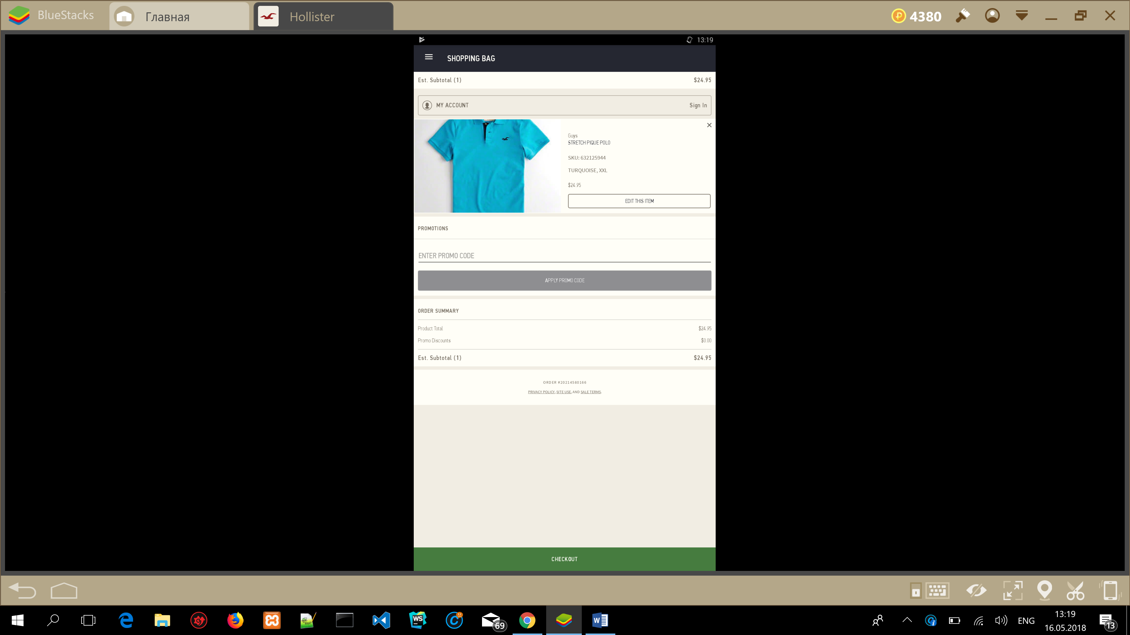


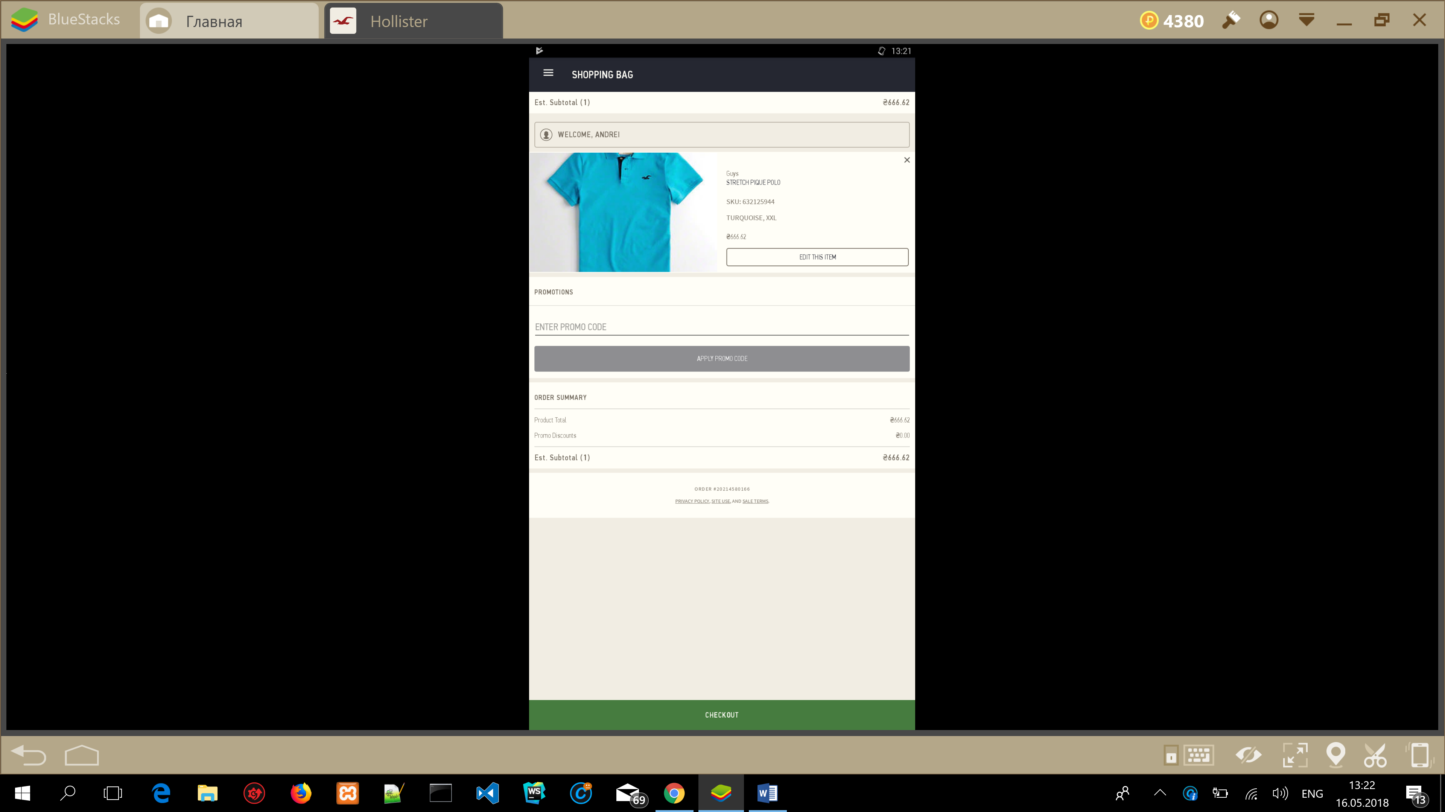

ID | Date | Title | Test case procedure | Expected result | Actual result | Note
007 | 05.16.2018 | Log in by link “Have an account? Sign in”  Screen: Sign In | 1.Enter valid email name.  2.Enter valid password(8-25 characters long include letters and numbers). | Sign in | Pass
ID | Date | Title | Test case procedure | Expected result | Actual result | Note
008 | 05.16.2018 | Check for hidden requirements for “First name” field  Screen: Create Account | 1.Use numbers in “First name” field | Accept | Pass
ID | Date | Title | Test case procedure | Expected result | Actual result | Note
009 | 05.16.2018 | Check for hidden requirements for “First name” field  Screen: Create Account | 1.Use special characters in “First name” field | Accept | Pass
ID | Date | Title | Test case procedure | Expected result | Actual result | Note
010 | 05.16.2018 | Check for hidden requirements for “First name” field  Screen: Create Account | 1.Use 1 symbol in “First name” field | Accept | Pass
ID | Date | Title | Test case procedure | Expected result | Actual result | Note
011 | 05.16.2018 | Check for hidden requirements for “First name” field  Screen: Create Account | 1.Use more than 41 symbol in “First name” field | Accept | Fail | Attachment: picture.  Add Requirement for “First name” field– less than 41 symbol
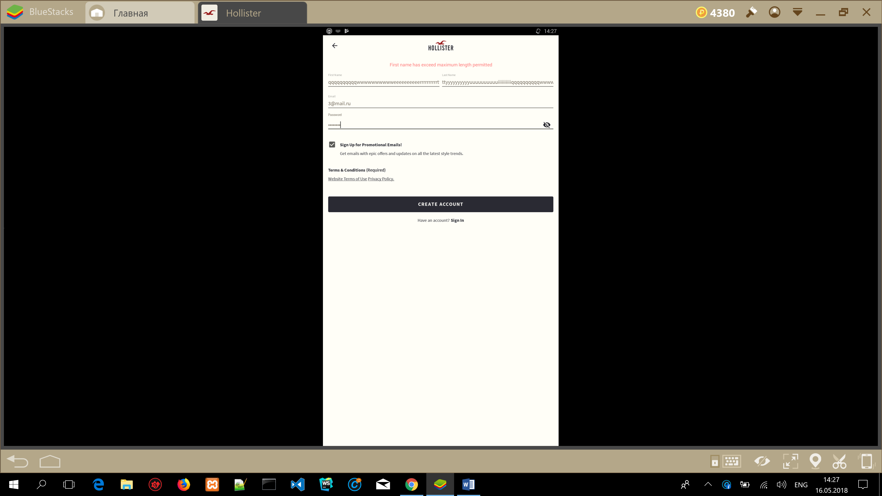
ID | Date | Title | Test case procedure | Expected result | Actual result | Note
012 | 05.16.2018 | Check for hidden requirements for “First name” field | 1.Use Unicode char in “First name” field | Accept | Fail | Add Requirement for “First name” field
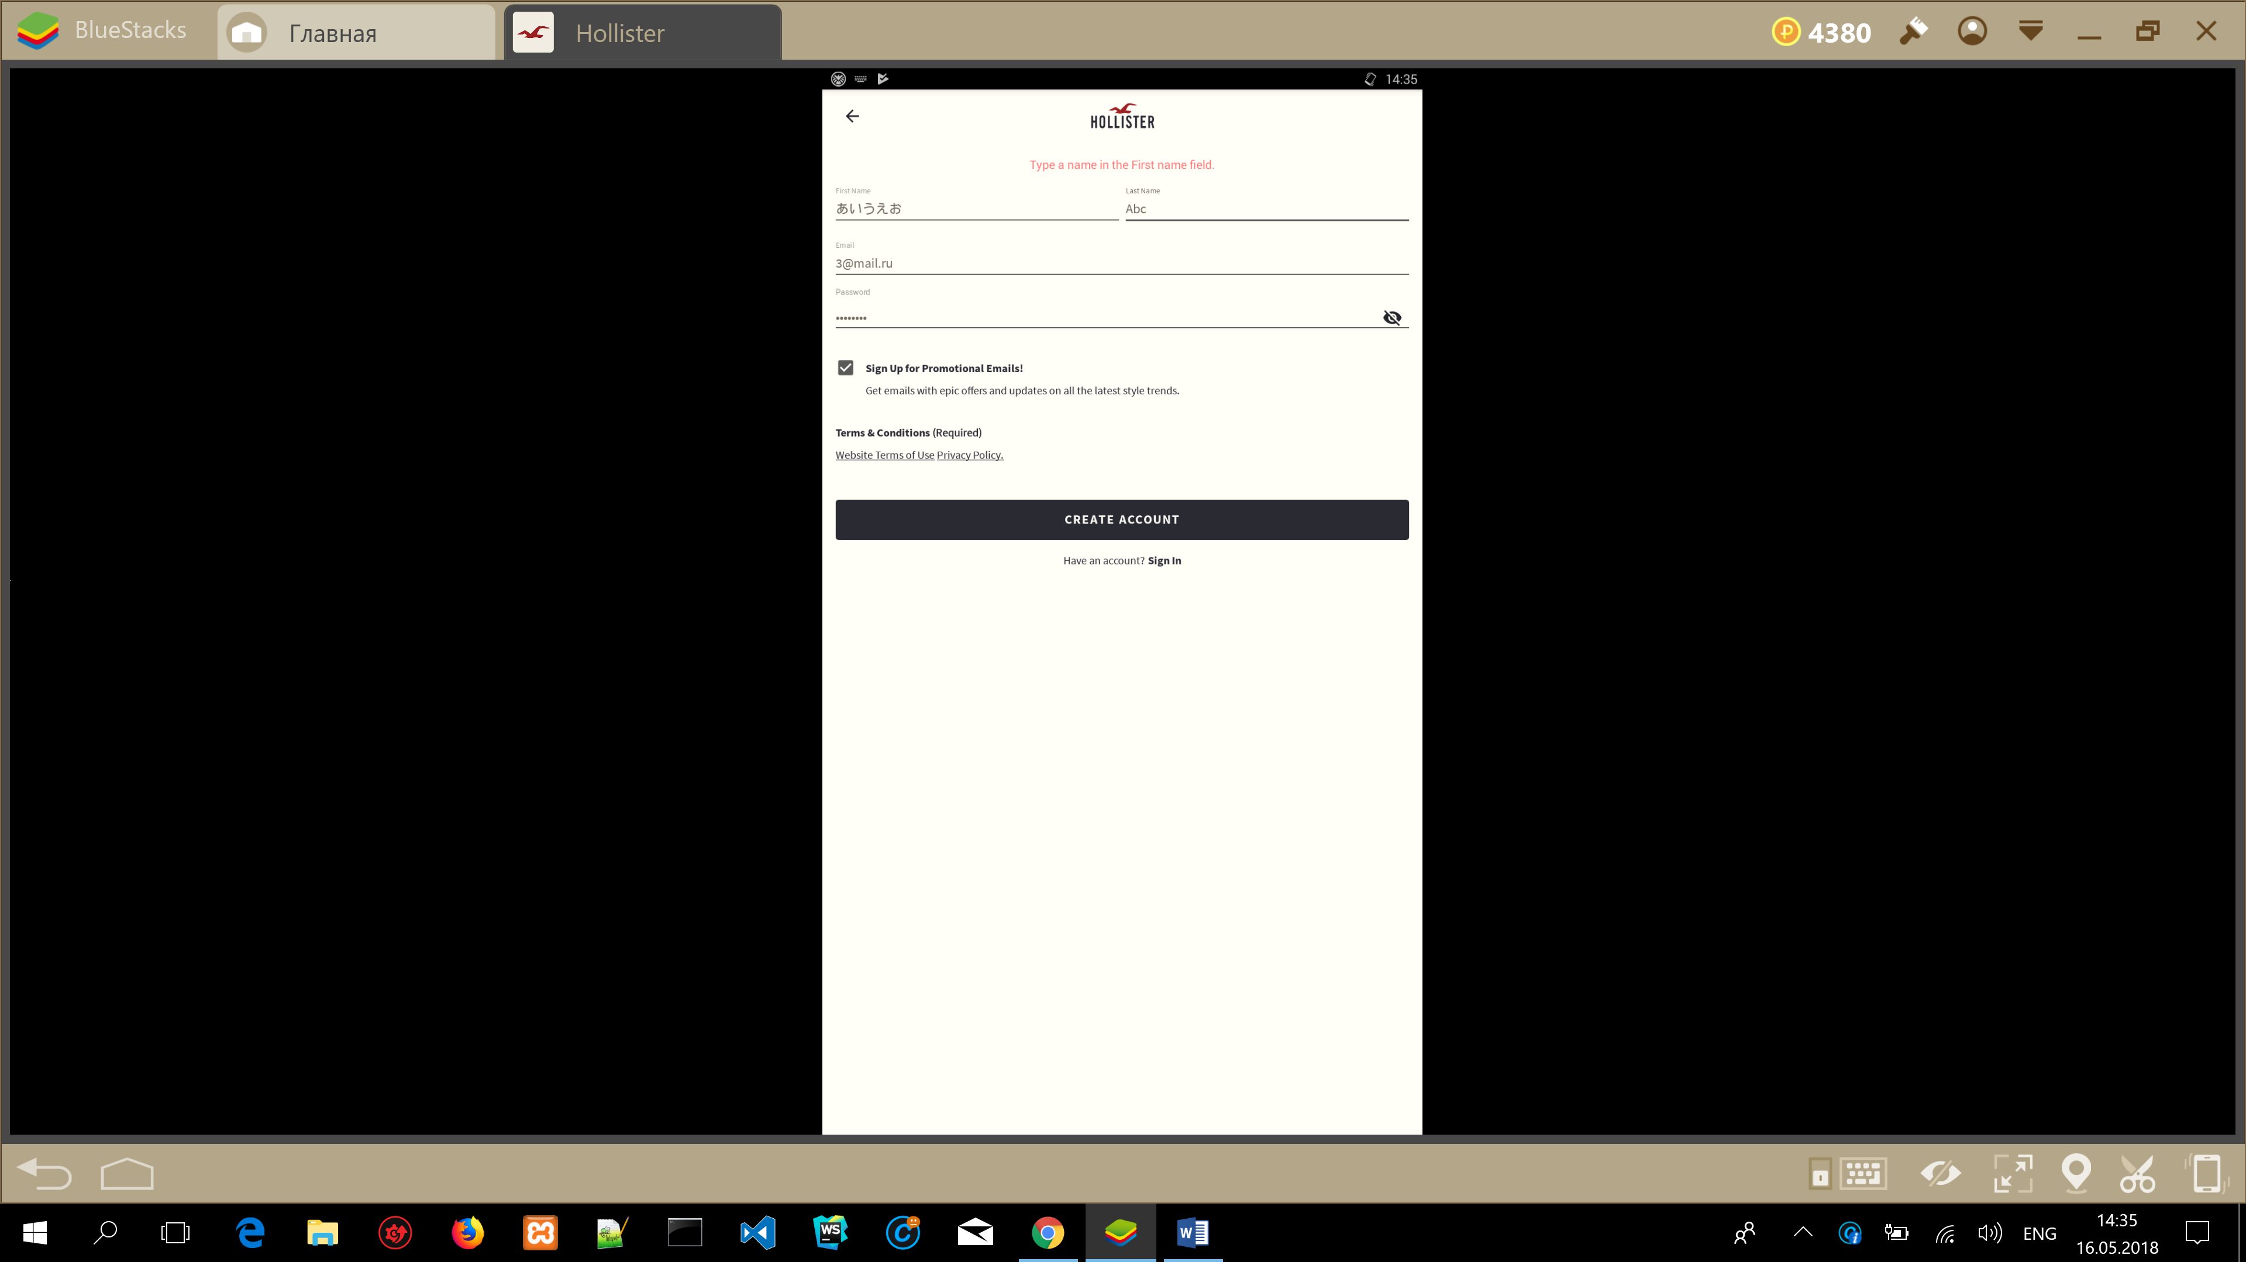
ID | Date | Title | Test case procedure | Expected result | Actual result | Note
013 | 05.16.2018 | Check for hidden requirements for “First name” field  Screen: Create Account | 1.Copy “First name” field  2.Delete  3.Paste | Accept  Accept  Accept | Pass  Pass  Pass
ID | Date | Title | Test case procedure | Expected result | Actual result | Note
014 | 05.16.2018 | Check for hidden requirements for “First name” field  Screen: Create Account | 1.Use lower case in “First name” field  2.Use upper case in “First name” field | Accept  Accept | Pass  Pass
ID | Date | Title | Test case procedure | Expected result | Actual result | Note
015 | 05.16.2018 | Check for hidden requirements for “Last name” field  Screen: Create Account | 1.Use numbers in “Last name” field | Accept | Pass
ID | Date | Title | Test case procedure | Expected result | Actual result | Note
016 | 05.16.2018 | Check for hidden requirements for “Last name” field  Screen: Create Account | 1.Use special characters in “Last name” field | Accept | Pass
ID | Date | Title | Test case procedure | Expected result | Actual result | Note
017 | 05.16.2018 | Check for hidden requirements for “Last name” field  Screen: Create Account | 1.Use 1 symbol in “Last name” field | Accept | Pass
ID | Date | Title | Test case procedure | Expected result | Actual result | Note
018 | 05.16.2018 | Check for hidden requirements for “Last name” field  Screen: Create Account | 1.Use more than 41 symbol in “Last name” field | Accept | Fail | Attachment: picture.  Add Requirement for “Last name” field – less than 41 symbol
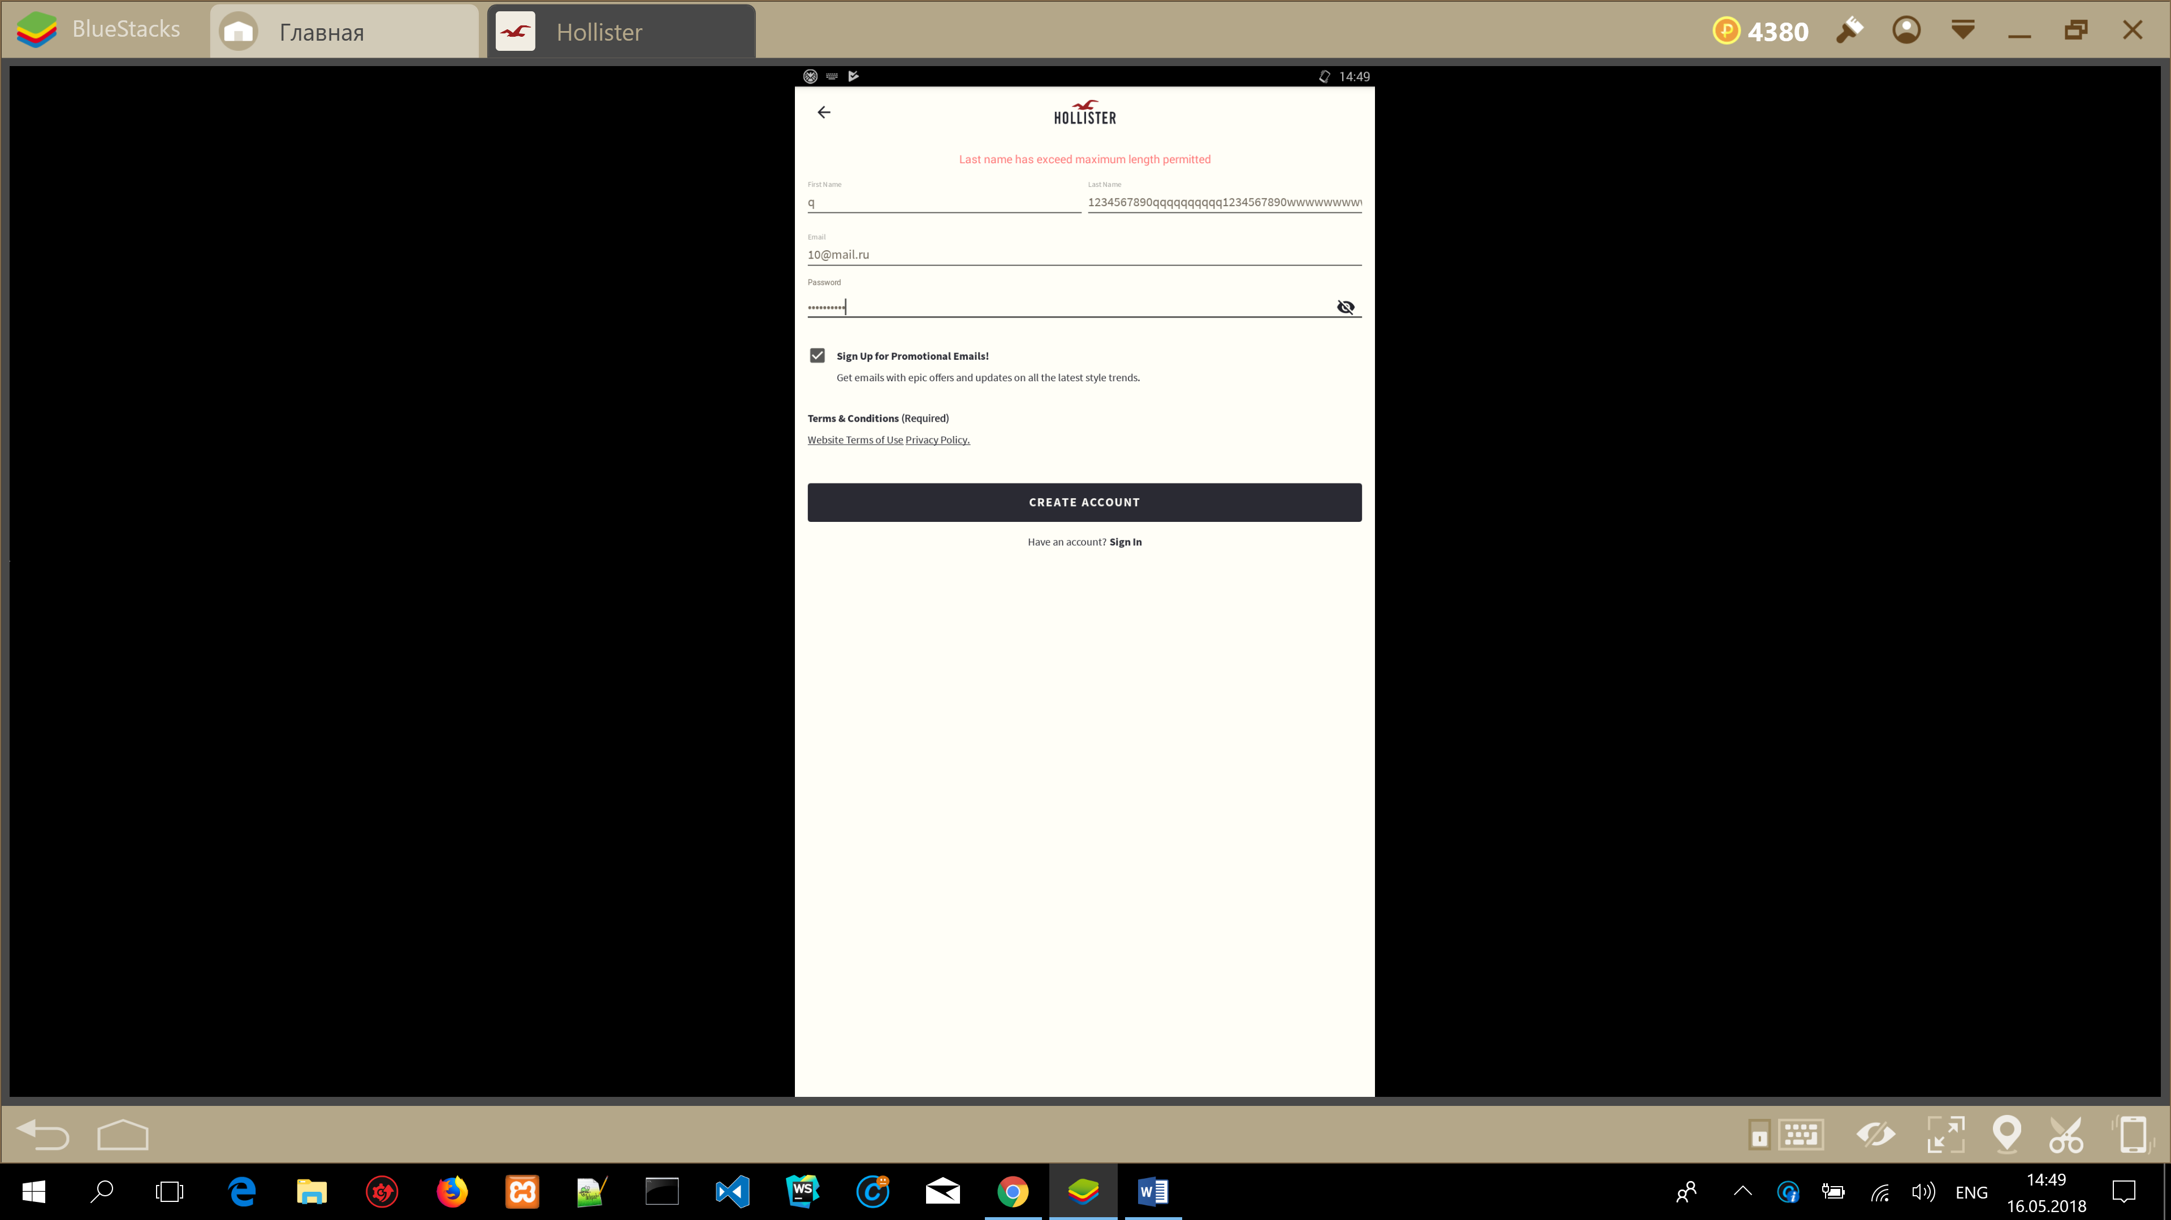
ID | Date | Title | Test case procedure | Expected result | Actual result | Note
019 | 05.16.2018 | Check for hidden requirements for “Last name” field Screen: Create Account | 1.Use Unicode char in “Last name” field | Accept | Fail | Add Requirement for “Last name” field
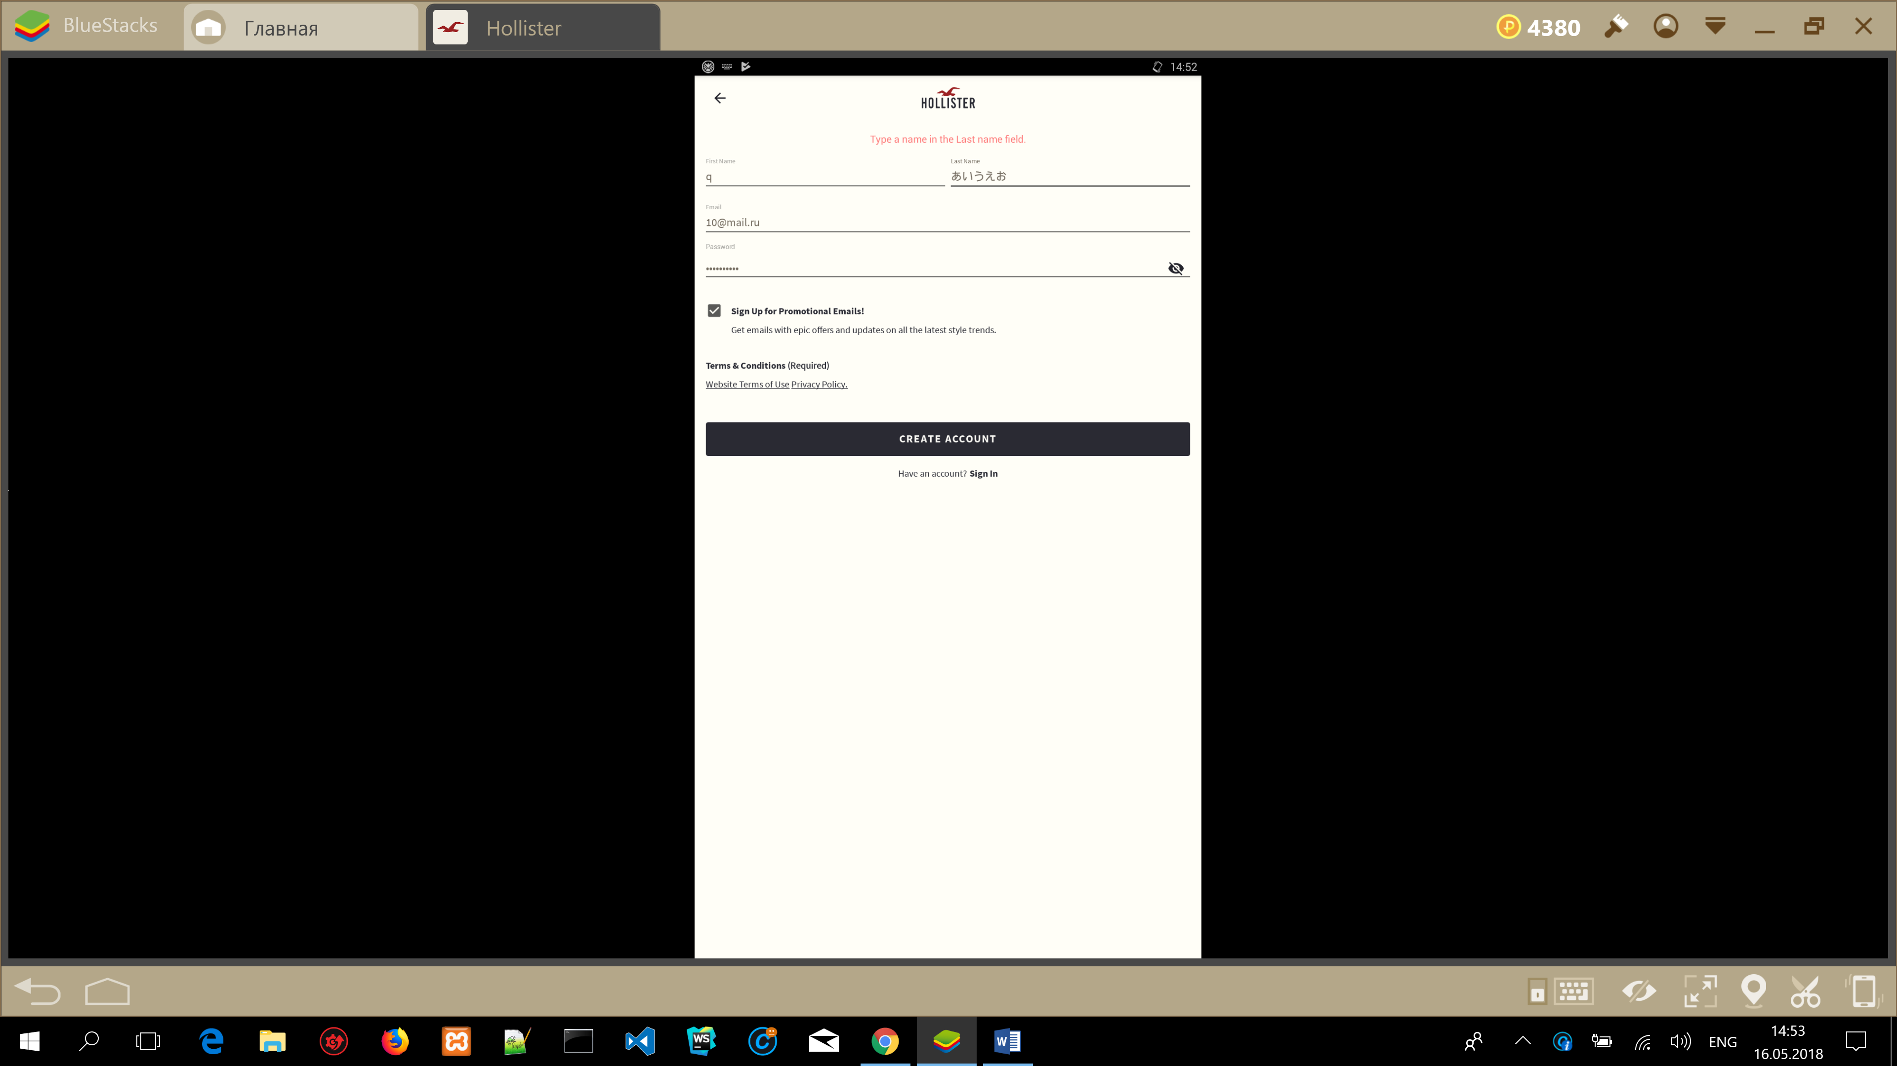
ID | Date | Title | Test case procedure | Expected result | Actual result | Note
020 | 05.16.2018 | Check for hidden requirements for “Last name” field  Screen: Create Account | 1.Copy “Last name” field  2.Delete  3.Paste | Accept  Accept  Accept | Pass  Pass  Pass
ID | Date | Title | Test case procedure | Expected result | Actual result | Note
021 | 05.16.2018 | Check for hidden requirements for “Last name” field  Screen: Create Account | 1.Use lower case in “First name” field  2.Use upper case in “First name” field | Accept  Accept | Pass  Pass
ID | Date | Title | Test case procedure | Expected result | Actual result | Note
022 | 05.16.2018 | Check for hidden requirements for “Email” field  Screen: Create Account | 1.Use email address without @ symbol before domain | Fail | Fail
ID | Date | Title | Test case procedure | Expected result | Actual result | Note
023 | 05.16.2018 | Check for hidden requirements for “Email” field  Screen: Create Account | 1.Use email address with empty field before “@domain.com” | Fail | Fail
ID | Date | Title | Test case procedure | Expected result | Actual result | Note
024 | 05.16.2018 | Check for hidden requirements for “Email” field  Screen: Create Account | 1.Use email address 64 symbols before “@domain.com”  2.Use email address 43 symbols before “@domain.com”  3.Use email address 42 symbols before “@domain.com” | Accept  Accept  Accept | Fail  Fail  Pass | https://tools.ietf.org/html/rfc5321#section-4.5.3.1  Add Requirement for “Email address” field – less than 43 symbols
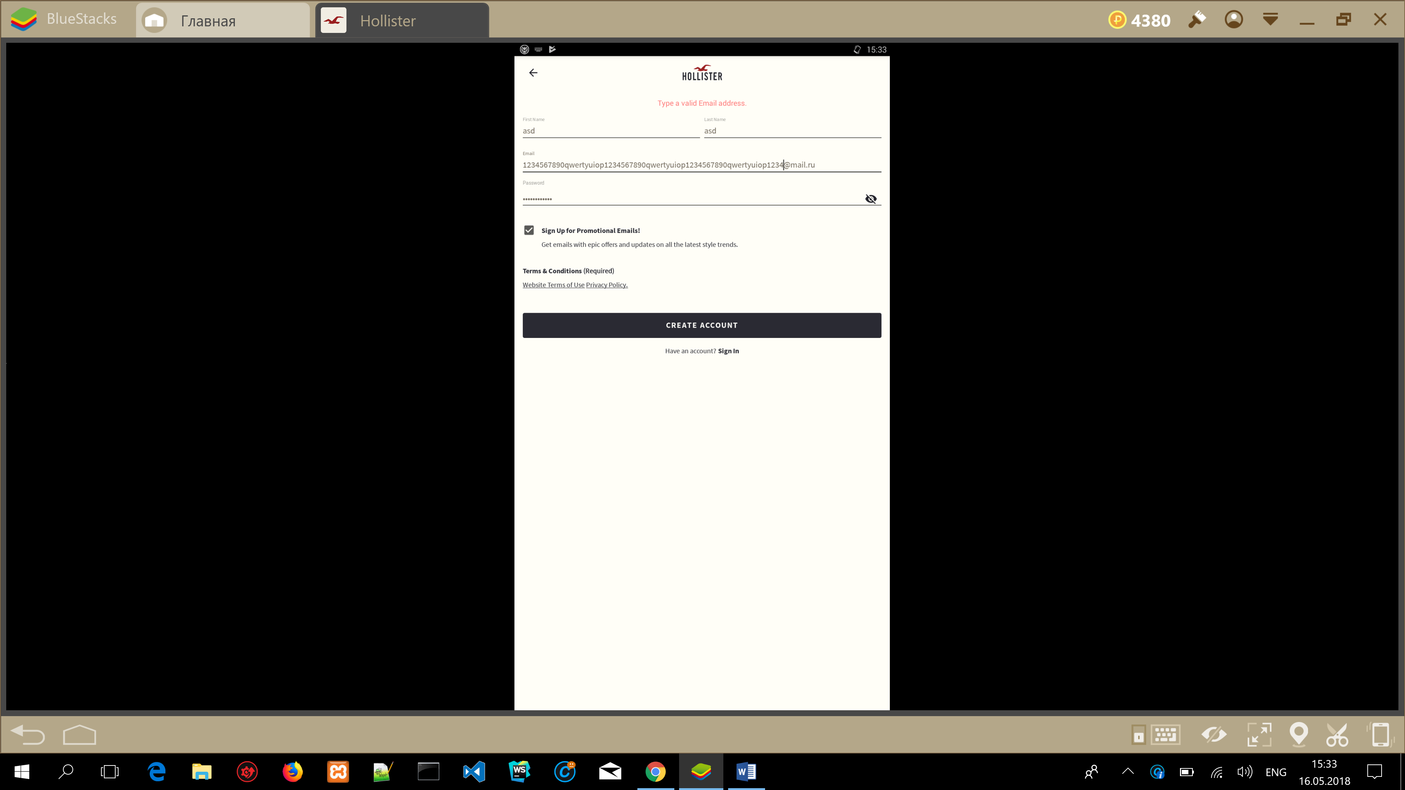
ID | Date | Title | Test case procedure | Expected result | Actual result | Note
025 | 05.16.2018 | Check for hidden requirements for “Email” field  Screen: Create Account | 1.Use email special characters !#$%&'*+-/=?^_`{|}~ before “@domain.com” | Pass | Fail | https://en.wikipedia.org/wiki/Email_address  https://en.wikipedia.org/wiki/ASCII
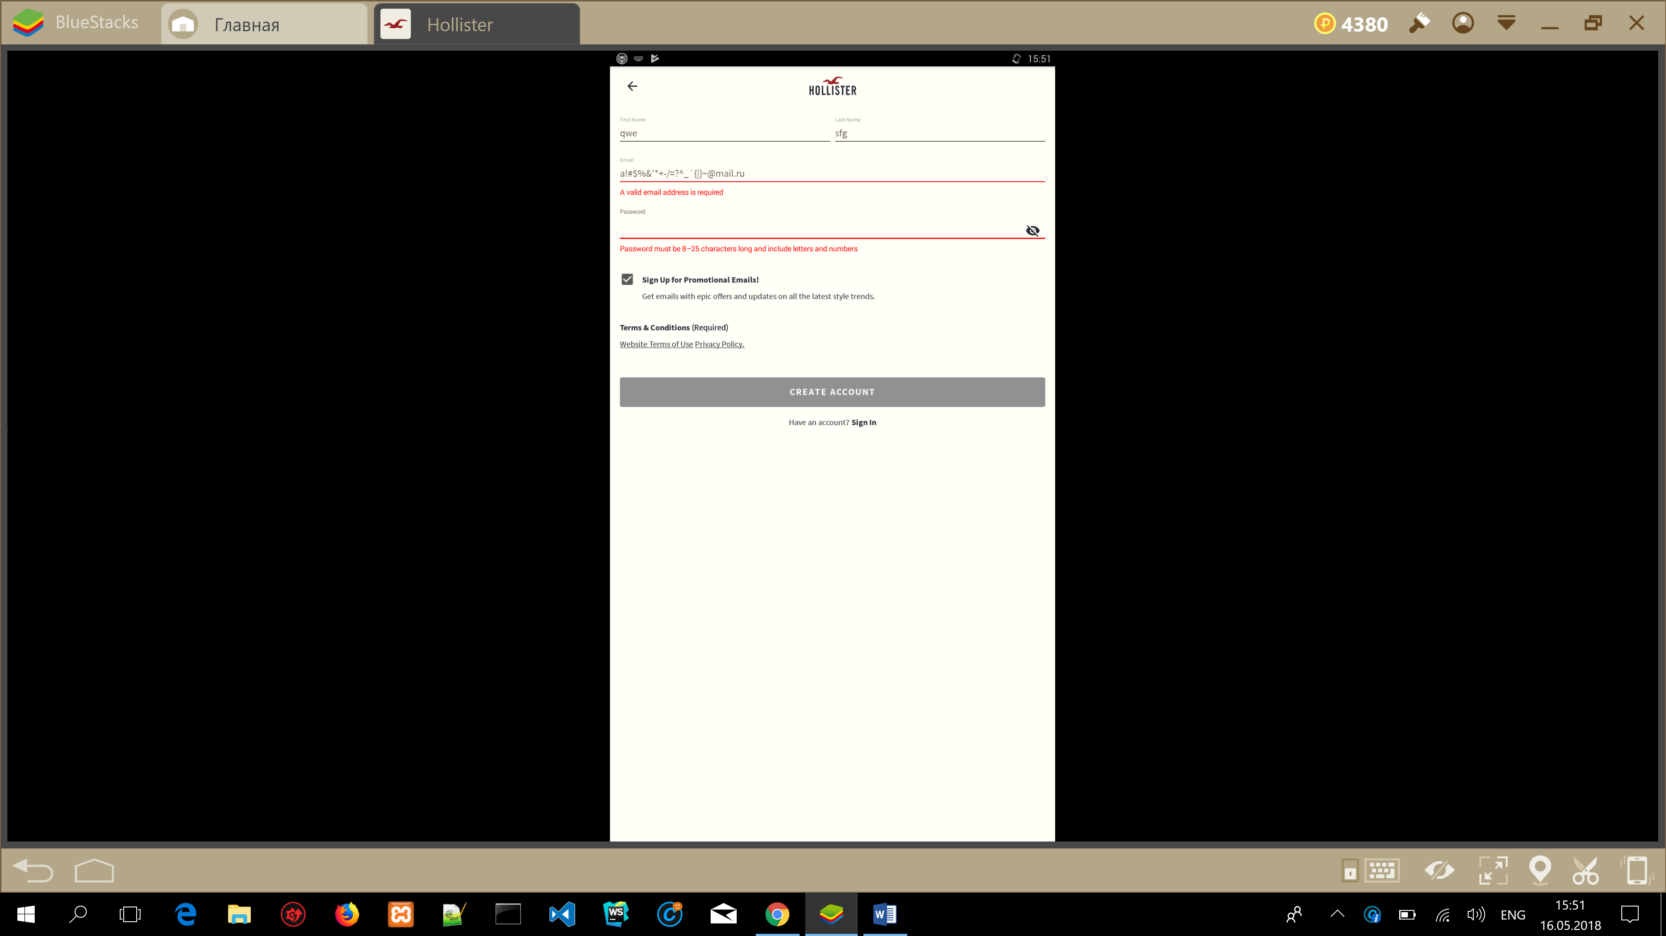
ID | Date | Title | Test case procedure | Expected result | Actual result | Note
026 | 05.16.2018 | Check for hidden requirements for “Email” field  Screen: Create Account | 1.Use invalid email address with dot before address.  2.Use invalid email address with dot address before @  3. Use invalid email address with double dot - my..ad@mail.com  4. Use invalid email address with space my ad@mail.com  5.Use invalid email with special characters("(),:;<>@[\]) inside (example my”ad@mail.com) | Fail  Fail  Fail  Fail  Fail | Fail  Fail  Fail  Fail  Fail

ID | Date | Title | Test case procedure | Expected result | Actual result | Note
027 | 05.16.2018 | Check for hidden requirements for “Email” field  Screen: Create Account | 1.Copy email address  2.Delete  3.Paste | Accept  Accept  Accept | Pass  Pass  Pass
ID | Date | Title | Test case procedure | Expected result | Actual result | Note
028 | 05.16.2018 | Check for requirements in “password” field  Screen: Create Account | 1.Use less than 8 characters in password field  2.Use more than 25 characters in password field  3.Use only letters  4.Use only numbers  5.Use uppercase letters  6.Use lowercase letters | Fail  Fail  Fail  Fail  Accept  Accept | Fail  Fail  Fail  Fail  Pass  Pass
ID | Date | Title | Test case procedure | Expected result | Actual result | Note
028 | 05.16.2018 | Check for requirements in “password” field  Screen: Create Account | 1.Use Unicode symbols (あいうえお)  2.Special characters | Fail  Fail | Pass  Pass | Attachment: pictures  Requirements don’t correspond reality.  Users can use special characters and Unicode symbols
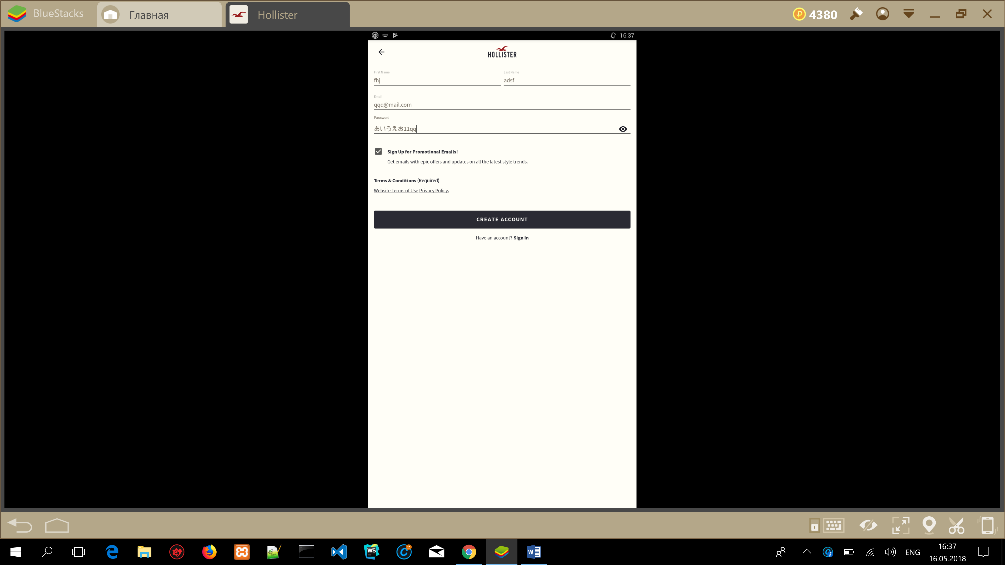
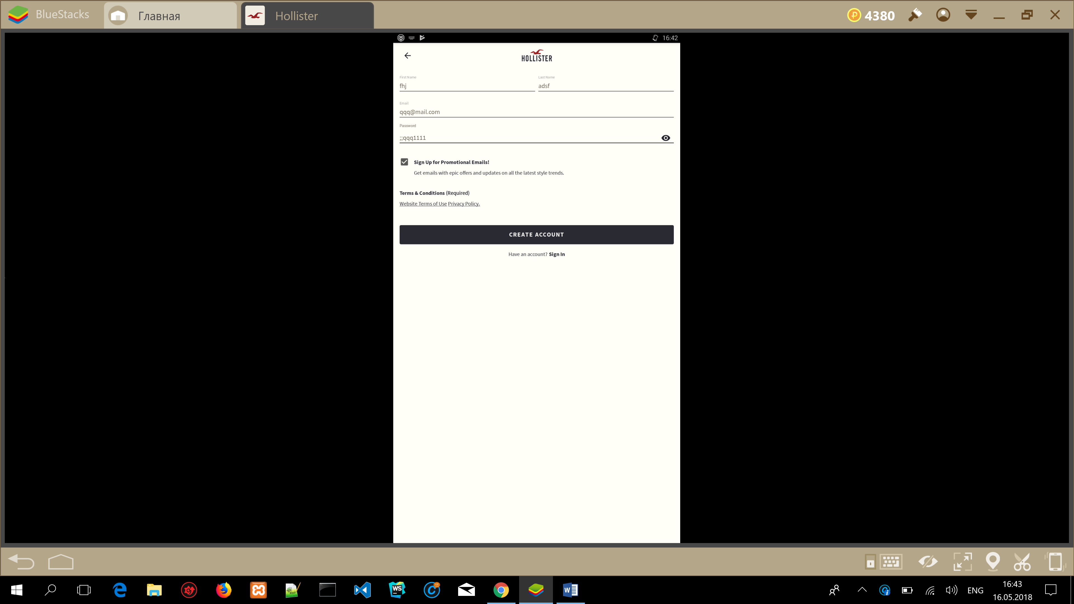
ID | Date | Title | Test case procedure | Expected result | Actual result | Note
029 | 05.16.2018 | Check for masking password  Screen: Create Account | 1.Show password in bullets  2.Copy password in bullets  3.Paste password in bullets  4.Non masking password  5.Copy password  6.Paste password | Accept  Fail  Fail  Accept  Accept  Accept | Pass  Fail  Fail  Pass  Pass  Pass

My saves

ID | Date | Title | Test case procedure | Expected result | Actual result | Note
001 | 05.16.2018 | Add and delete items in my saves  Screen: Sign in  Shop Guys  My Saves | 1.Open Hollister So Cal Style.  2.Add item from new arrivals – shop guys.  3.Add accessory item.  4.Add item from new arrivals – shop guys.  5.Check “My saves” for added items  6.Delete all items  7.Check “My saves” for added items | 1.The app Install and open.  2.Item is added  3.Item is added  4.Item is added  5.Items added in “my saves”  6.All items deleted  7.No added items | Pass  Pass  Pass  Pass  Pass  Pass  Pass | Too small button.  Too often misscklick & open description of item
ID | Date | Title | Test case procedure | Expected result | Actual result | Note
002 | 05.16.2018 | Quit and sign in the app. Check items in my saves  Screen: My Account  Sign in  My Saves | 1.Quit the app.  2.Sign in app.  3.Check items in my saves | 1.Accept  2.Accept  3.All items is added | Pass  Pass  Pass
ID | Date | Title | Test case procedure | Expected result | Actual result | Note
003 | 05.16.2018 | Add item after log out.  Screen: My Account  Main screen(Explore)  Shop Guys  Shop  My Saves | 1.Quit the app.  2.Add few item in “My saves”  3.Check items in my saves  4.Sign in the app.  5. Check for new items in my saves | 1.Accept  2.Fail. Must sign in.  3.Fail. All items isn’t added  4.Accept  5.Fail. All items isn’t added | Pass  Pass  Pass  Pass  Pass | User can add item in “My Saves” after sign out & check it in “My saves”

