SereGlowy
Final Project - Phase 1 Documentation
Personalized Skincare Web Application
Prepared by: Sereen
2026

1. Project Overview

Project Idea
SereGlowy is a skincare web application designed to help users build a personalized skincare experience based on their skin profile, preferences, and skincare goals. When a user creates an account, they complete a short onboarding questionnaire about their skin type, sensitivity, skincare goals, routine experience, and makeup usage. Based on the provided information, the system creates a personalized Skin Profile and provides suitable skincare routine suggestions and product recommendations.
The platform also provides educational information about common skincare ingredients, supports general makeup matching guidance, and helps users organize the products they already use. SereGlowy is not intended to diagnose or treat medical skin conditions; it focuses on skincare organization, product guidance, and general cosmetic preferences.

Purpose of the System
The purpose of SereGlowy is to make skincare easier and more organized by providing users with a personalized experience instead of showing the same information and products to everyone.
- Understand their general skin profile.
- Build a simple skincare routine.
- Discover products based on their preferences.
- Learn about common skincare ingredients.
- Find makeup products that match their skincare preferences.
- Save and manage products they currently use.
- Keep skincare information organized in one place.

Target Users
- People interested in skincare.
- Beginners who want help organizing a skincare routine.
- Users who want product suggestions based on their preferences.
- Users who want to learn more about skincare ingredients.
- Users who want to track and organize the skincare products they use.

2. Main Features

Authentication
- Create a new account.
- Login and logout.
- Access and update a personal profile.
- Role-based access for User and Admin.

Onboarding Questionnaire
After registration, the user completes a short skincare questionnaire. The answers are stored in the user's Skin Profile.
Question | Options
Skin Type | Dry / Oily / Combination / Normal
Skin Sensitivity | Sensitive / Not Sensitive / Not Sure
Main Skincare Goal | Hydration / Glow / Oil Control / Smoother-looking skin
Routine Experience | Beginner / Simple Routine / Full Routine
Makeup Usage | Often / Sometimes / Rarely

Skin Profile
- View the generated skin profile.
- Update skin type, sensitivity, goals, and preferences.
- Update onboarding answers when needed.

Personalized Skincare Routine
The system provides Morning and Evening routine suggestions using predefined matching rules based on the user's Skin Profile.
Morning Routine | Evening Routine
1. Cleanser | 1. Cleanser
2. Moisturizer | 2. Treatment / Product
3. Sunscreen | 3. Moisturizer

Products
- Browse skincare products and product details.
- Search and filter products by category or skin type.
- View related ingredients.
- View recommended products according to the Skin Profile.

Ingredients Guide
- Browse and search skincare ingredients.
- View ingredient details and common cosmetic purpose.
- View suitable skin profiles and related products.

Makeup Match Guide
Users can browse makeup products and receive general suggestions based on skincare preferences and Skin Profile. The guide may include category, product information, suitable skin type, finish type, and related skincare considerations.

My Products
- Add a product to My Products.
- View saved products.
- Remove products.
- Manage products currently in use.

3. Admin Functionalities
- Login to the Admin Dashboard.
- View dashboard statistics.
- Manage users and user accounts.
- Create, read, update, and delete/deactivate skincare products.
- Manage product categories.
- Create, update, and delete skincare ingredients.
- Manage makeup products.
- Manage routine recommendation rules or content.

4. Functional Requirements

Authentication & Authorization
FR-01: The system shall allow users to register.
FR-02: The system shall allow registered users to login.
FR-03: The system shall allow users to logout.
FR-04: The system shall provide role-based authorization.
FR-05: The system shall differentiate between User and Admin permissions.
FR-06: Users shall not be able to access Admin pages.
FR-07: Only authenticated users shall access personal features such as Skin Profile and My Products.

Skin Profile Requirements
FR-08: The system shall allow users to complete an onboarding questionnaire.
FR-09: The system shall save questionnaire answers.
FR-10: The system shall generate a Skin Profile based on the answers.
FR-11: The system shall allow users to view their Skin Profile.
FR-12: The system shall allow users to update their Skin Profile.

Routine Requirements
FR-13: The system shall display skincare routine suggestions.
FR-14: Routine suggestions shall be based on the user's Skin Profile.
FR-15: The system shall support Morning and Evening routines.

Product Requirements
FR-16: The system shall display available products.
FR-17: Users shall be able to view product details.
FR-18: Users shall be able to search for products.
FR-19: Users shall be able to filter products.
FR-20: The system shall provide product recommendations based on the user's Skin Profile.

Ingredients Requirements
FR-21: The system shall display skincare ingredients.
FR-22: Users shall be able to view ingredient information.
FR-23: Users shall be able to search for ingredients.
FR-24: The system shall display related products where available.

Makeup Match Requirements
FR-25: The system shall display makeup products.
FR-26: Users shall be able to view makeup product information.
FR-27: The system shall provide general makeup suggestions based on the user's Skin Profile.

My Products Requirements
FR-28: Users shall be able to add products to My Products.
FR-29: Users shall be able to view products saved in My Products.
FR-30: Users shall be able to remove products from My Products.

Admin Requirements
FR-31: Admin shall be able to manage products.
FR-32: Admin shall be able to create products.
FR-33: Admin shall be able to update products.
FR-34: Admin shall be able to delete or deactivate products.
FR-35: Admin shall be able to manage ingredients.
FR-36: Admin shall be able to manage product categories.
FR-37: Admin shall be able to manage makeup products.
FR-38: Admin shall be able to view and manage user accounts.

5. Non-Functional Requirements

Performance
NFR-01: The system should load pages within a reasonable response time.
NFR-02: Database queries should be optimized to avoid unnecessary delays.
NFR-03: Images should be optimized for web usage.

Security
NFR-04: User passwords must not be stored as plain text.
NFR-05: Authentication must be implemented securely.
NFR-06: Authorization must prevent users from accessing Admin functionality.
NFR-07: User input must be validated.
NFR-08: Sensitive user information must be protected.

Usability
NFR-09: The interface should be simple and easy to understand.
NFR-10: Navigation should be consistent throughout the website.
NFR-11: Forms should provide clear validation messages.
NFR-12: The onboarding questionnaire should be short and easy to complete.

Responsiveness
NFR-13: The website shall support desktop, tablet, and mobile screen sizes.
NFR-14: Bootstrap responsive components and grid system shall be used where appropriate.

Reliability
NFR-15: The system should handle invalid user input without crashing.
NFR-16: Database operations should maintain data consistency.
NFR-17: Errors should be handled appropriately.

Scalability
NFR-18: The system architecture should allow additional products, users, ingredients, and categories to be added in the future.
NFR-19: The system should use a structured database design that supports future features.

6. Database Design
The project will use SQL Server with Entity Framework Core, the Code First approach, and Migrations. The database will be created and updated through Entity Framework migrations.
Table | Main Fields | Purpose
Users | UserId (PK), FirstName, LastName, Email, PasswordHash, Role, CreatedAt | Authentication and user account data. ASP.NET Core Identity may replace this custom table.
SkinProfiles | SkinProfileId (PK), UserId (FK), SkinType, IsSensitive, SkinGoal, RoutineExperience, MakeupUsage, CreatedAt, UpdatedAt | Stores questionnaire results and personalization data.
Categories | CategoryId (PK), CategoryName, Description | Organizes skincare products.
Products | ProductId (PK), CategoryId (FK), ProductName, Brand, Description, ImageUrl, Price, SuitableSkinType, IsActive, CreatedAt | Stores skincare products.
Ingredients | IngredientId (PK), IngredientName, Description, Purpose, SuitableSkinType | Stores ingredient guide content.
ProductIngredients | ProductIngredientId (PK), ProductId (FK), IngredientId (FK) | Bridge table for Product-Ingredient many-to-many relationship.
MyProducts | MyProductId (PK), UserId (FK), ProductId (FK), AddedAt | Stores products saved by each user.
MakeupProducts | MakeupProductId (PK), ProductName, Brand, Category, Description, SuitableSkinType, FinishType, ImageUrl, IsActive | Stores makeup guide products.
RoutineRecommendations | RoutineRecommendationId (PK), SkinType, SkinGoal, RoutineTime, StepOrder, StepName, Description | Stores rule-based routine recommendation content.

Entity Relationship Diagram (ERD)
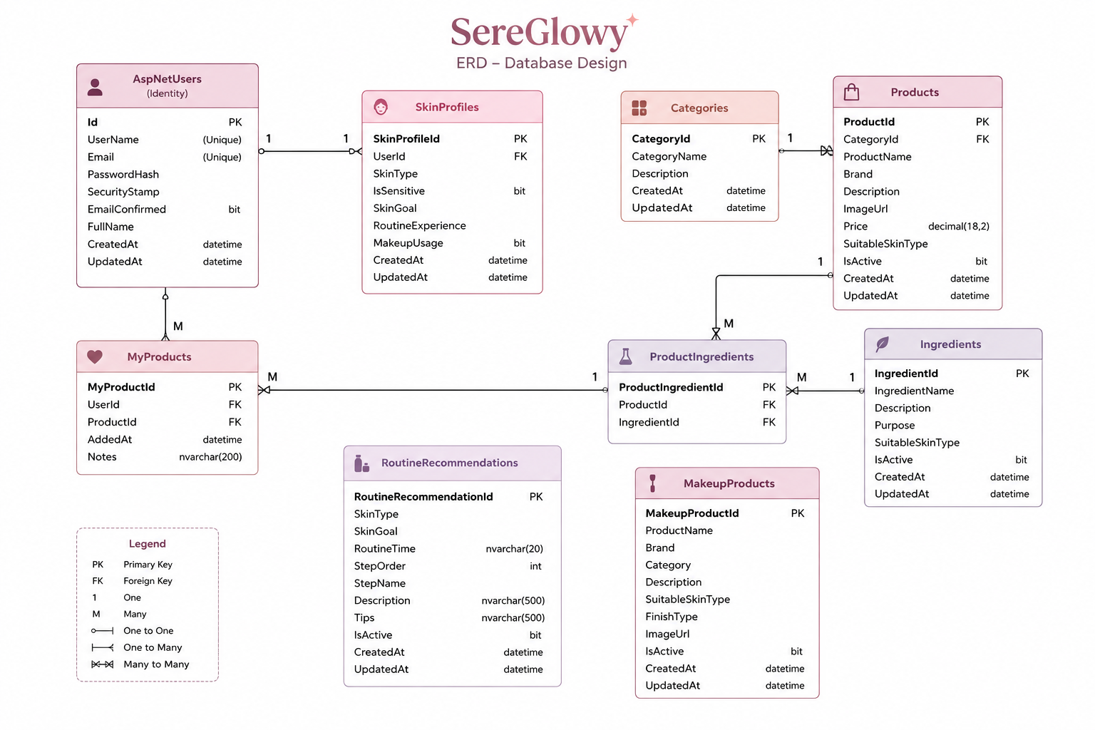

Main Database Relationships
- User -> SkinProfile: One-to-One
- User -> MyProducts: One-to-Many
- Category -> Products: One-to-Many
- Product -> Ingredients: Many-to-Many through ProductIngredients
- Product -> MyProducts: One-to-Many
- Skin Profile information -> Routine Recommendation: rule-based matching
ERD: The Entity Relationship Diagram will be added to the Documentation folder after the final database structure is confirmed and implemented.

7. Front-End Pages
Public Pages | User Pages | Admin Pages
Landing / Home Page | Onboarding Questionnaire | Admin Dashboard
About SereGlowy | Skin Profile | Manage Products
Products | Personalized Routine | Add Product
Product Details | Recommended Products | Edit Product
Ingredients Guide | Makeup Match | Manage Categories
Ingredient Details | My Products | Manage Ingredients
Login | User Profile | Add / Edit Ingredient
Register |  | Manage Makeup Products
 |  | Manage Users

Front-End Requirements
- HTML5
- CSS3
- JavaScript
- Bootstrap
- Responsive design for desktop, tablet, and mobile
- Complete design for both User and Admin roles

8. Technologies
Area | Technology
Front-End | HTML5, CSS3, JavaScript, Bootstrap
Back-End | ASP.NET Core MVC, C#
Database | SQL Server
ORM | Entity Framework Core
Database Approach | Code First + Entity Framework Migrations
Version Control | Git + GitHub

9. Project Roles

User
- Register and login.
- Complete onboarding questionnaire.
- Manage Skin Profile.
- View personalized routine.
- Browse products and recommendations.
- View ingredients.
- Use Makeup Match Guide.
- Manage My Products.

Admin
- Manage users.
- Manage products.
- Manage categories.
- Manage ingredients.
- Manage makeup products.
- Manage routine recommendation content.
- Control content displayed in the system.

10. Phase 1 Submission Checklist
- Separate and organized GitHub repository for the Final Project.
- Project Overview completed.
- Functional Requirements completed.
- Non-Functional Requirements completed.
- Database schema, keys, and relationships documented.
- SQL Server database connected using Entity Framework Core, Code First, and Migrations.
- ERD added when finalized.
- All required Front-End pages completed using HTML, CSS, JavaScript, and Bootstrap.
- User and Admin designs included.
- Repository updated before submission.
- GitHub repository link sent by email before the deadline.

