**1. What did challenge you the most during the process?**

Most challenging part was detecting collision direction, because sometimes player passes by a ball, but take the ball anyway. So I used ray casting to detect collision and direction.

Second one making hole look like a hole. I did two different approaches. First simple one is I just made a circle and hollow cylinder in blender then import it to unity. Secon one I made a stencil buffer and combine with blender hole and use it. With Stencil buffer, the hole really look like a hole, but not looking good as plane blender one in artistic way. So the challange was not making them but deciding which one should I use. So I put the stencil hole in the level 4. Other levels have just a blender hole.

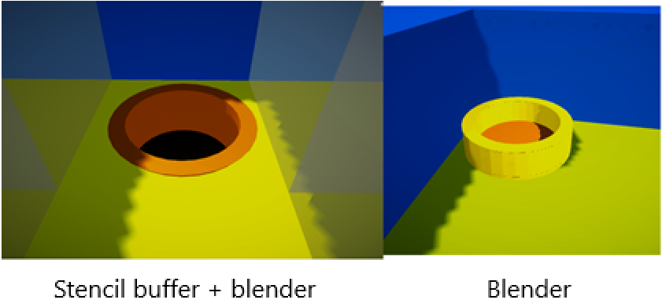

**2. What are the easiest parts of the development for you?**

Creating different obtacles is easy, level design.

**3. What would you do to make the users play this game longer? Please give detailed reasons.**

I could add a level system for player gameobject. For example when it is level five via collecting collectables, then you have a skill like a fancy fire shield for 10 seconds, but it consumes mana so they need to come up with a plan to solve problems. I think gaining different skills, adds game more variety and make it more enjoyable. And so on.

Another thing could be skins for player. For example, we can create flags, then players want to use them in game. Acquiring these flags via collecting some collectables. So this makes a challange for player to go further.

We can make a max score so with that way, we create a challange for players. Because they want to get more scores than before, so they play longer. Even we can make a global score table, country base like, a league maybe. Therefore players want to to be top.

We can make this game multiplayer.

We should not builld too long levels. At least, at beginning of game.

We should avoid unneccesary game mechanics. In a nutshell, the game should be easy to play, but hard to master. I think that’s the motto of all hyper-casual games.

Balance in difficulty. Making games goes to difficult too quickly, makes players exhausted and quit game. The reverse is bad as well, making games goes monoton in diffuculity for a long time, makes player bored and quits. The solution is make a balance in difficulity progression.

In summary, we should always avoid boredom and frustration.

**4. What theme would you pick for this game?**

Minimalistic hyper casual could be reasonable choice I guess.