Config map and secrets
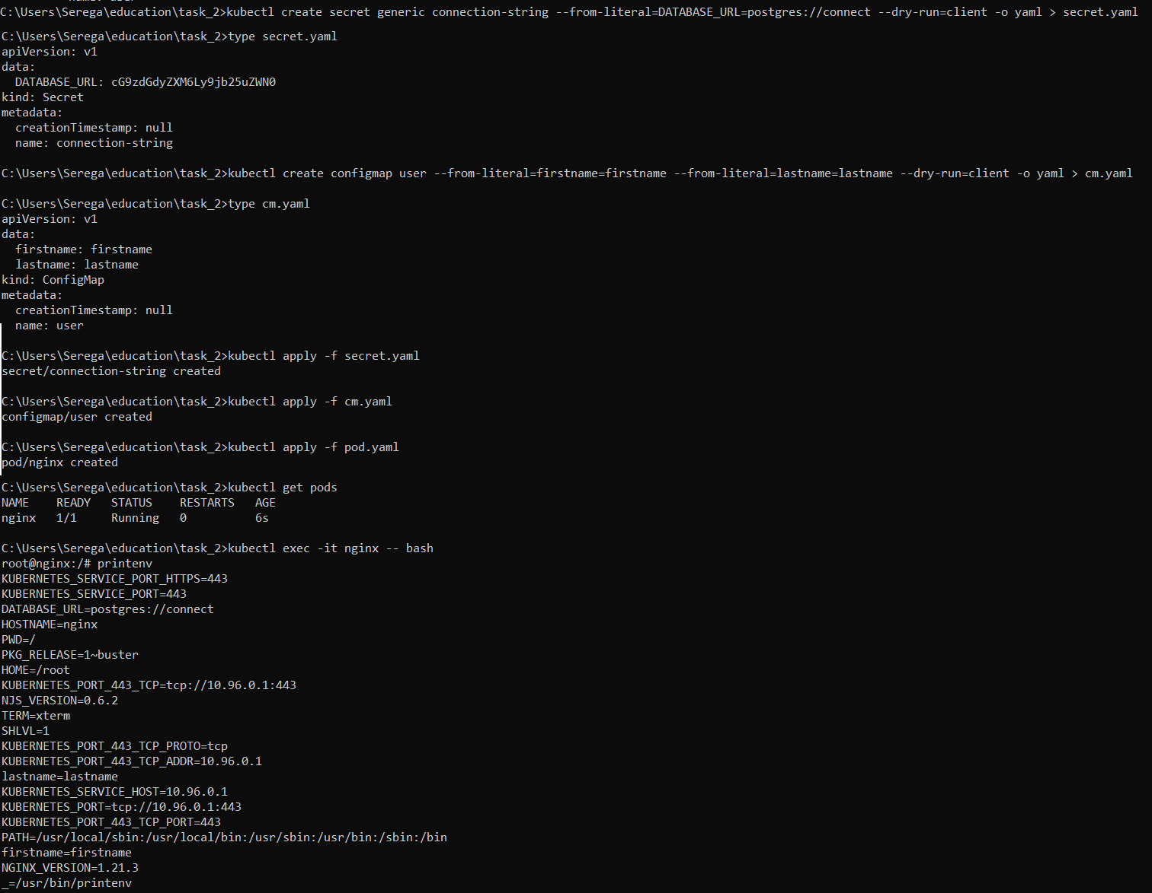
Connect to pods ip
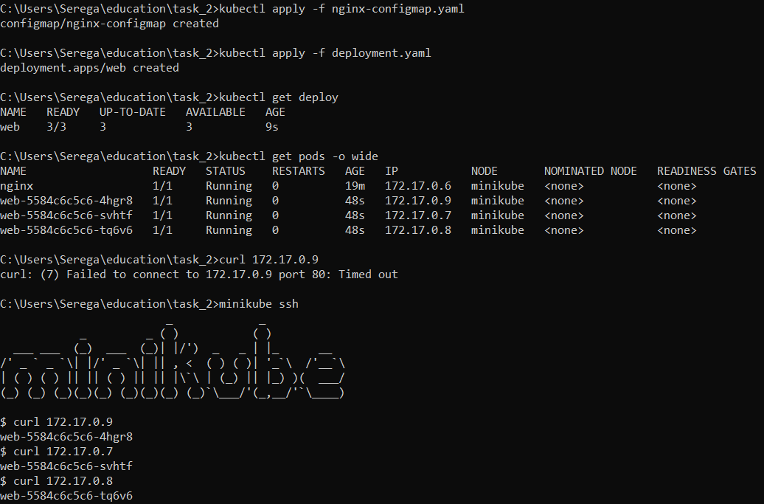
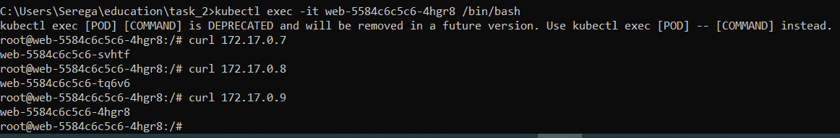
Connect to ClusterIP
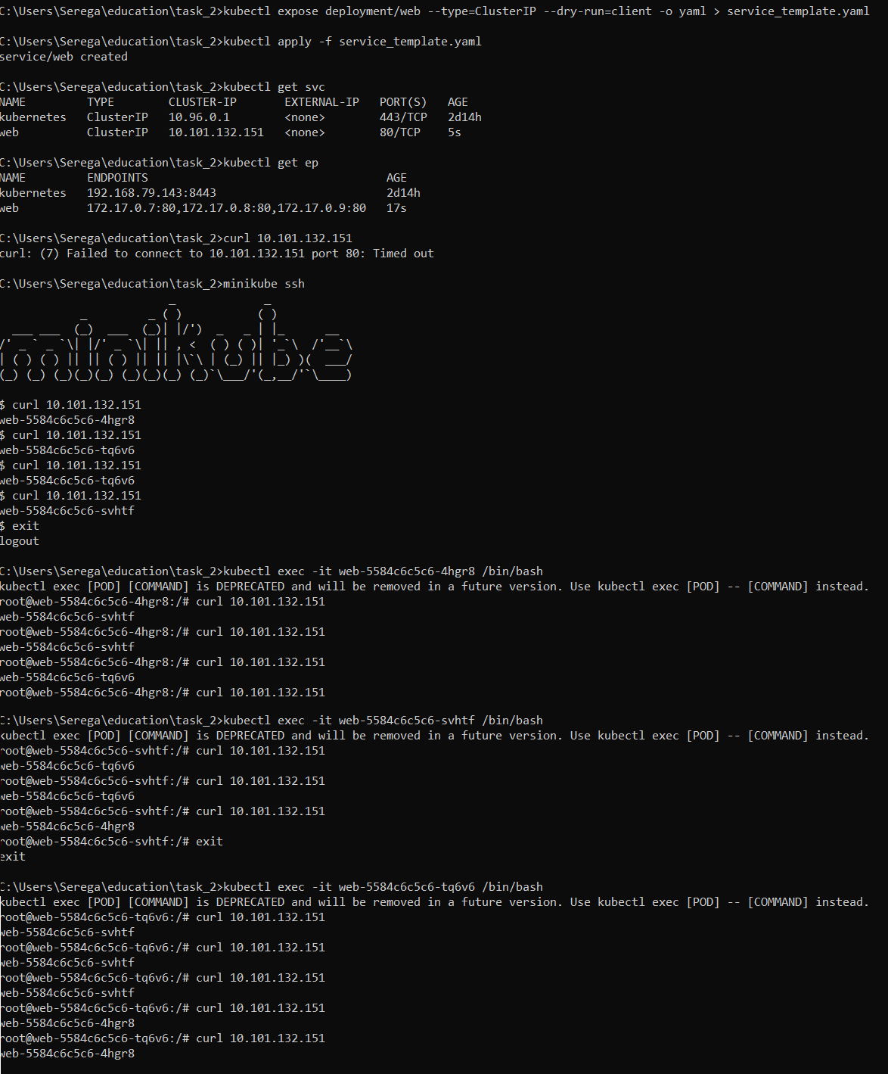

Connect to NodePort
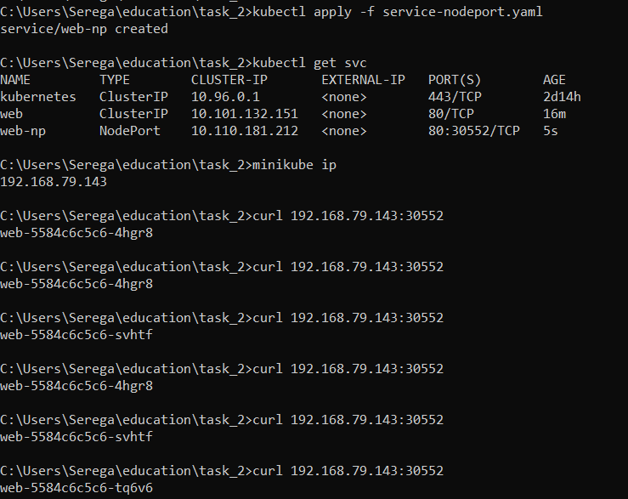

Setup headless and nslookup
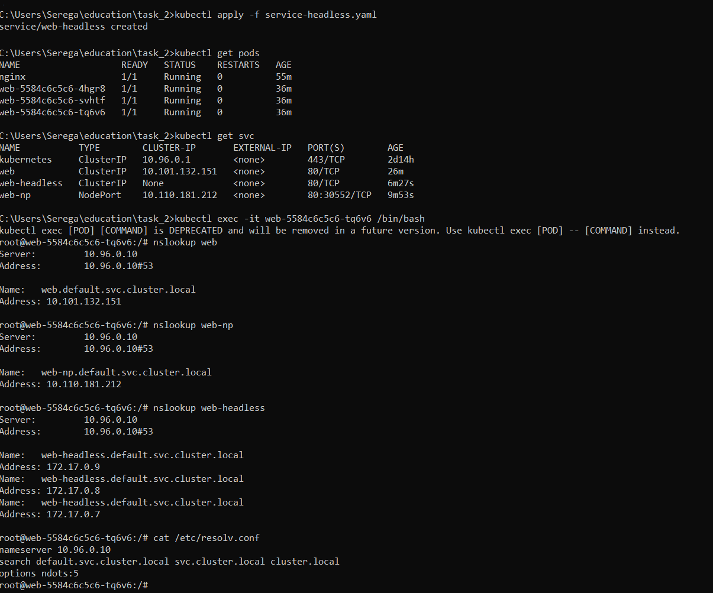
Ingress
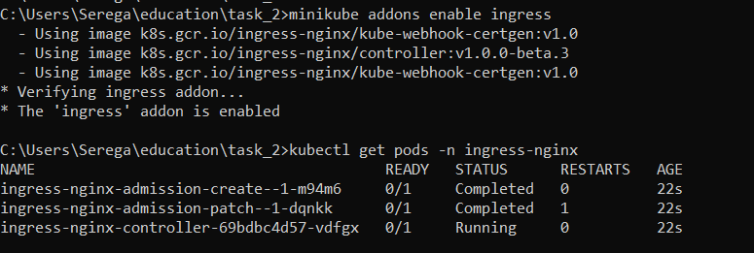
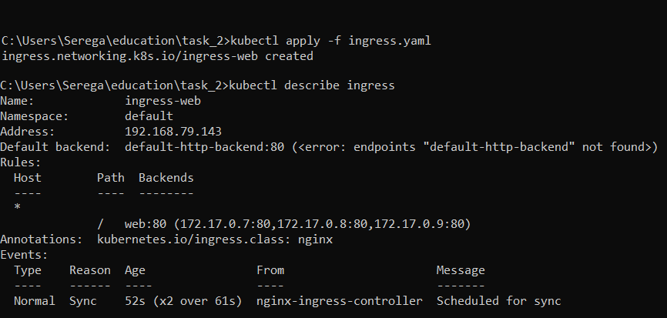
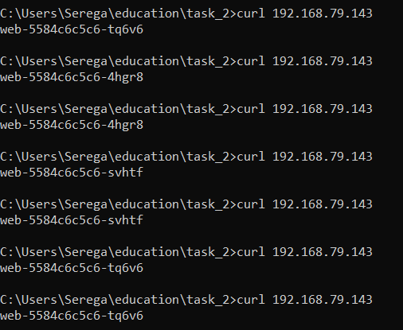
Homework
- In Minikube in namespace kube-system, there are many different pods running. Your task is to figure out who creates them, and who makes sure they are running (restores them after deletion).
For each pod can do this and get required information:
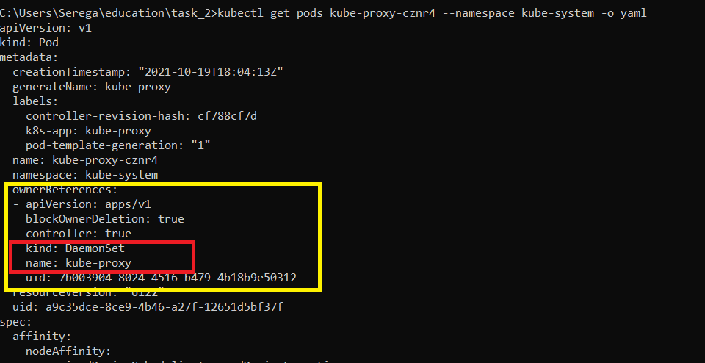
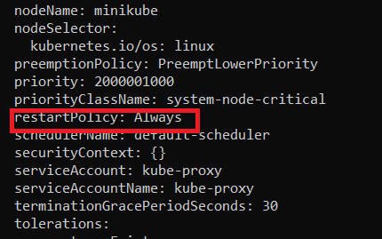

Additional we can check higher level object (daemonset in this case)
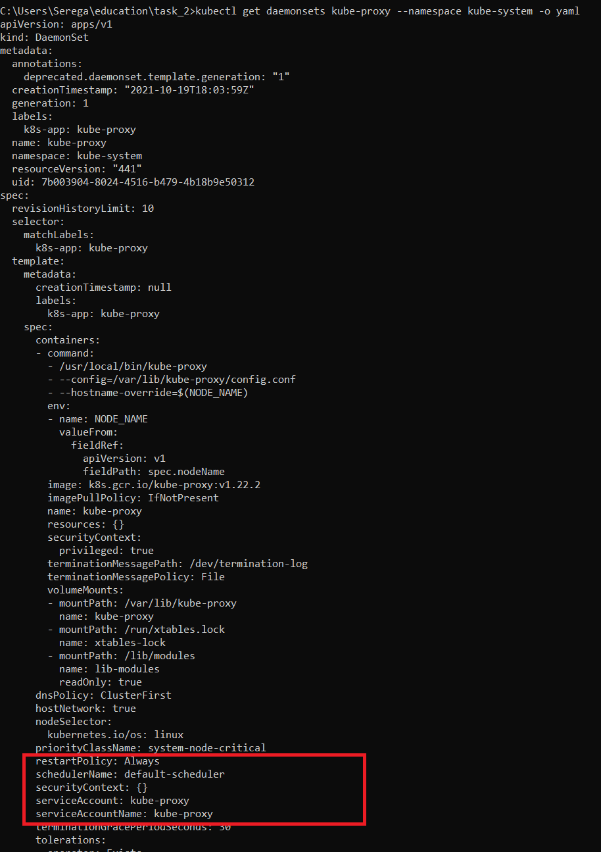

- Implement Canary deployment of an application via Ingress. Traffic to canary deployment should be redirected if you add "canary:always" in the header, otherwise it should go to regular deployment. Set to redirect a percentage of traffic to canary deployment.

Create identical env in canary namespace(deployments, services)

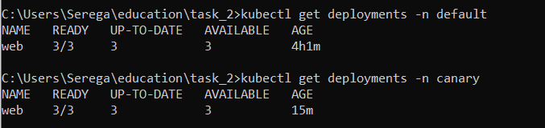
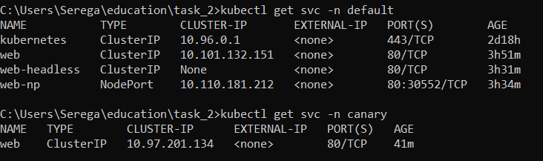
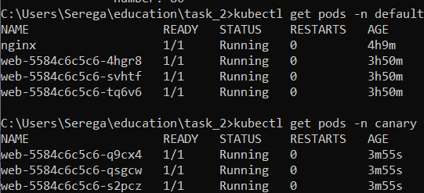

Edit default ingress and deploy in canary namespace

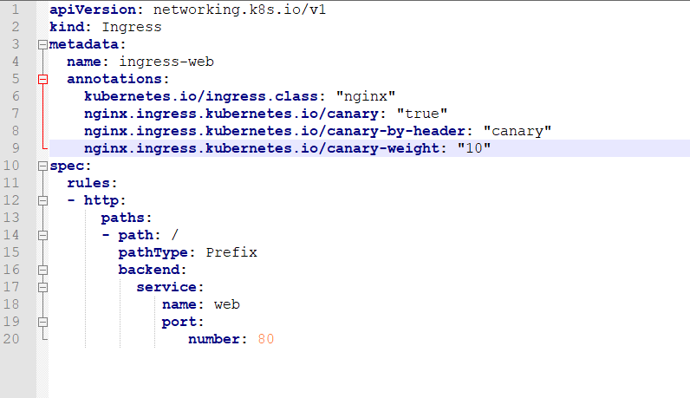
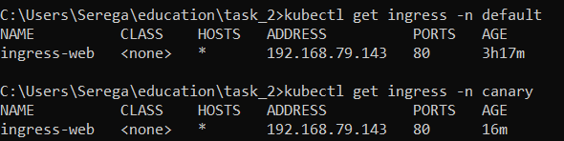

Check requests without header canary:always
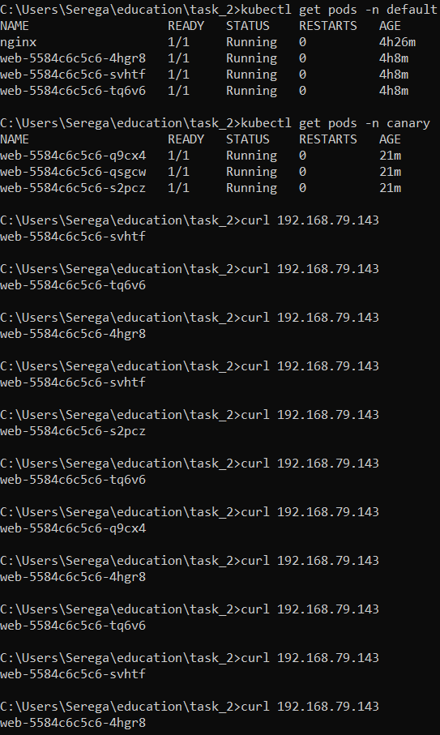
11 replies
9 from default namespace pods (main) and 2 from canary namespace pods

Check requests with header canary:always
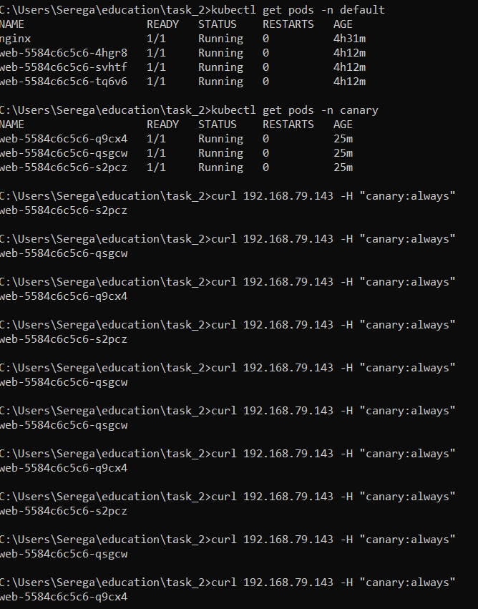
10 replies
10 from canary pods

