**Validator design.**

1. **Class diagram.**

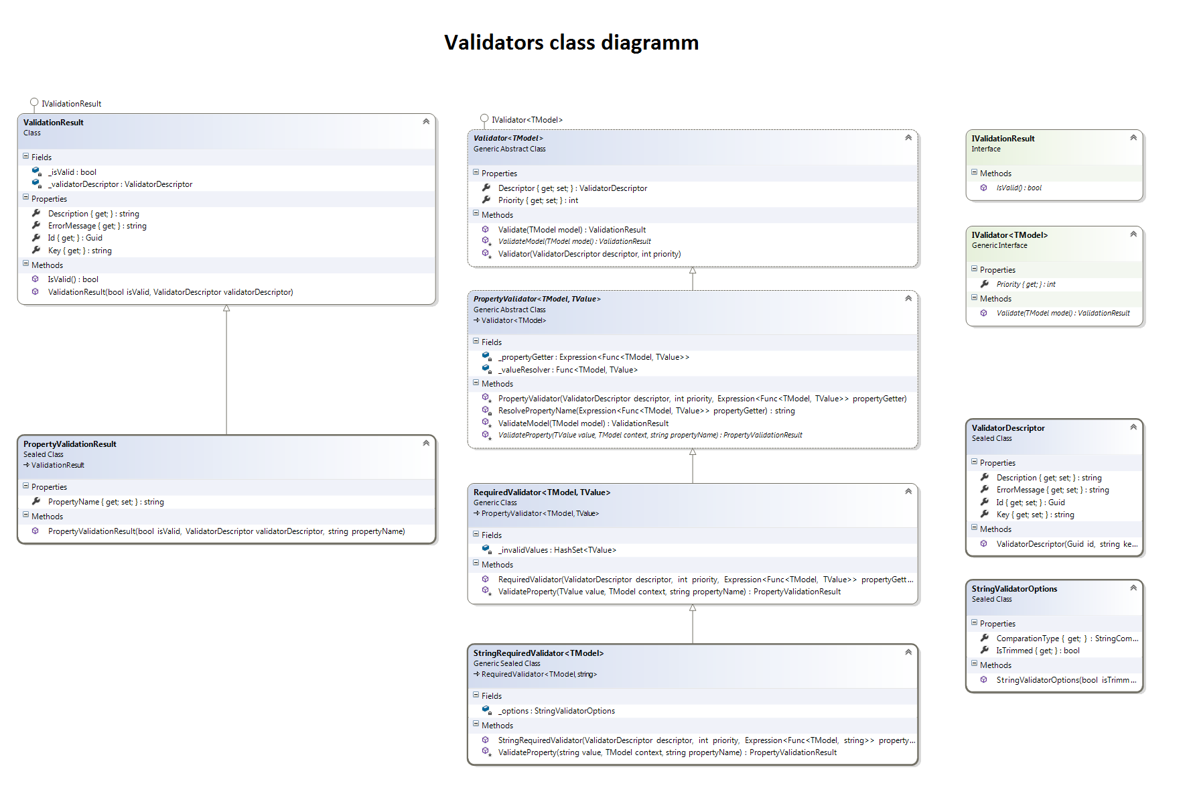

1. **Glossary.**

* **Validator - the core entity.**