**Fully-automatic defects classification and restoration for STM images**

Xianguang Fana,b, Yi Wua, YuLiang Zhia, HongXiaa, XinWanga,b,*

a Department of Instrumental and Electrical Engineering, Xiamen University, Xiamen, Fujian 361005, P. R. China

b Fujian Key Laboratory of Universities and Colleges for Transducer Technology, Xiamen Key laboratory of Optoelectronic Transducer Technology, Xiamen, Fujian 361005, P. R. China

**Abstract**

Scanning tunneling microscope(STM) is a micro instrument for surface morphology with nanometer precision. While the restoration of the STM images’ defects usually need manual judgement and manual positioning because of the diversity of the morphology and the randomness of the defects. This paper provided a new fully-automatic method combined with deep convolutional neural classification network and unique restoration algorithms corresponding different defects. Aimed at automatically processing compound defects in STM images, the method first predicted what kinds of defects a raw STM image have by a series of parallel binary classification network and then decide the process order according to the predicted label and finally restore the defects by corresponding global restoration algorithms in order. Experiment results prove the provided method can restore the STM images by self-judging, self-positioning, self-processing without any manual intervention.

**Keywords:** STM; image processing; DCNN; classification; restoration; RPCA

1. **Introduction**

Scanning tunneling microscope(STM),which has the ability of direct atomic-precise surface structure determination of objects, was introduced by J. Tersoff in 1984[1]. As a mighty imaging tool, STM has been widely applied in surface science[2, 3], material science[4], chemistry[5], biology[6] and nanotechnology[7], etc. Whereas on account of the STM system needs very high stability to generate high quality image, just slight outside vibration, motor periodic vibration or control system hysteresis may cause defects in morphologies. Hence, image post-processing of STM morphology is a very significant issue for STM application. The common defects of STM images are image damages, periodic noise, blur, low-contrast and so on. Three typical types of STM images’ common defects to be processed are long stripe, short sparse stripe and periodic noise, as presented in Fig.1.

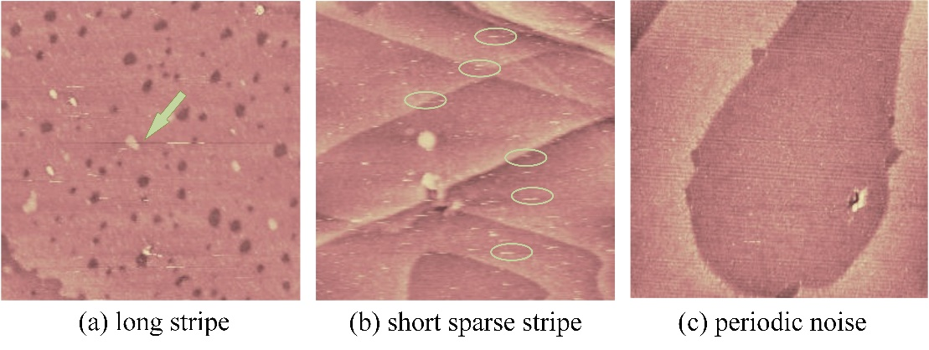

**Fig.1.** Three typical kinds of defects of STM topography: (a) long stripe defects (pointed by arrow). (b) Short sparse stripe (circled by ellipses). (c) periodic noise(global).

Long stripe and short sparse stripe are both local noise. Long stripe is usually caused by the pinpoint tinny shake when the whole precise mechanical system having outside disturbance. On account of the pinpoint scanning direction is horizontal, almost all long stripe defects present as horizontal linear stripes occupying the whole row or at least quarter. Short stripe is usually generated by system hysteresis before and after the pinpoint scanning to a raised surface topography. Short stripes appear abundantly and sparsely in an image. The randomness and quantity of these two defects make identification and positioning a very time-consuming and inefficient work.

Periodic noise usually appears globally in an image, because of the periodic mechanical vibration causing by motor or refrigerant fan rotation. Several researchers have introduced some methods of restoring strict periodic noise. T.Y. Ji[8] used patial filter called optimal soft morphological filter (OSMF) to remove the sinusoidal noise in images. Hongtao Li[9] used adaptive mathematical morphological filter to remove periodic narrow bandwidth noise. However, the methods in time domain can only perform well in strict periodic noise, the methods in frequency domain are more suitable for the generic periodic noise on the contrary. Payman Moallem[10] introduced a novel adaptive Gaussian notch filter to remove striping or local periodic noise. Fr´ed´eric Sur [11] introduced an automated notch filter based on the expected power spectrum of images to remove the pseudo periodic noise. While on account of the diversity of the periodic noise, positioning the frequency content in the frequency map becomes a difficulty and complexity task.

Many image processing methods have been introduced in STM image restoration and [de-noising](javascript:;), such as, Sparse Coding[12], TV and Criminisi algorithms[13] and so on. While all these algorithms relied on manual classification and manual positioning of defects. Moreover, the complexity and time consumption can be added along with the defects amount [increasement](javascript:;) and position randomness augment. Therefore, in this study, a novel method for STM image post-processing is provided. It combines with defects classification network which using DCNN and unique image processing algorithms. Using this method, STM images can be fast restored automatically by defects self-positioning and self-processing and the entire process minimize the manual intervention.

The rest of the paper is organized as follows. Section 2 provides the flow path and the theory of the whole automatic processing method including the classification work and the restoration work. Section 3 discusses the effectiveness of the whole processing method. Finally, section 4 summarizes the conclusions.

**2. Methods**

**2.1 Image processing strategy**

As observed in Fig.1, each kind of defect has its unique feature which has no relationship with the morphology presented. The valid restoration methods become diverse because of the specificity of each kind of defect which makes distinguishing defect separate necessary. Furthermore, on account of the independence between defect features and the content presented, classifying defects by computer without manual works are possible. Therefore, the central idea of the developed algorithm consists of two parts:(1) classifying defects and marking all defect types. (2) self-positioning and self-processing of each marked defect type by different means according to appointed priority. The flowchart of the developed algorithm is shown in Fig.2, and the various detailed steps involved in the algorithm are discussed in subsequent chapters.



Fig.2: Flowchart which showing the whole provided processing method. The left part is the flow of the defects classification and marking, the right part shows the details of the restoration of each kind of defects.

**2.2 Defects classification and marking**

A STM image may contain more than one type defects which makes defects recognizing a multi-label learning problem. The key challenge of multi-label learning problems is the large size of output space. As the types of label increases, the size of label sets grows exponentially[14]. Thus, a solving method called cross-training which transform the defects classification problem into three independent binary classification problems is to be used[15]. Because of the irrelevance between the different defect labels on each image, the coexistence of other labels can be ignored when training one label[16]. Then, how to set up and train the unique classification network for the three defects become the core problem.

On account of the difficulty in features extraction, traditional supervised machine-based learning methods, such as k-NN, SVM, need some extraction techniques (e.g., SIFT, HOG, GIST)[17]. Hence, the deep convolutional neural network (DCNN) which can extract features automatically and does not need hand designed features [18] is be chosen. The base structure of the proposed DCNN network contains 5 convolution layers and 2 fully connected layers as Fig.3 presented. Because of that the features of the defects are tinny and unimpressive, the dimensionality of the whole image is too large by contrast. Thus, one pooling layer is added after each convolution layer to descend dimension of output features[19]. The pooling layer can reduce the trained parameters and can automatically judge which features play key roles in the defects classification. The detailed parameters are different according to the diverse features the three defects have.

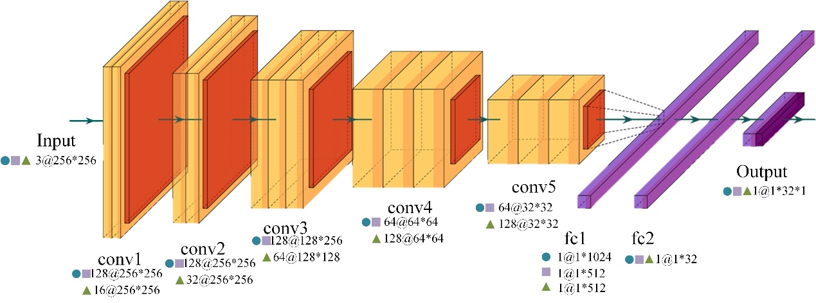

Fig.3: The base structure of proposed DCNN binary network(conv represent the convolution layer, fc represent the connection layer). The detailed parameters are presented in the figure:  represent the concrete parameters of the periodic noise binary network,  represent the concrete parameters of the long stripe binary network,  represent the concrete parameters of the short stripe binary network. Expect for the conv1, each convolution layer is combined with a max-pooling layer. Expect for the output layer which activated by Sigmoid function, the result of each layer is activated by Relu.

**2.2.1 Periodic noise classification network**

Although the periodic noise is global, the features of it are weak relative to the diverse background morphologies. So the kernel size of each five convolution layers are set to 3*3 to ensure the effect that features of periodic noise can be learned by the network. All stride of each five convolution layers are set to 1 and filters number are 128,128,128,64,64 respectively. All pooling layers are use max-pooling method and 2*2 kernel size. The nodes number of followed 2 fully connected layers are 1024 and 32. In the hidden layer section, each output will be nonlinearized by the Relu activation function which can reduce the calculation and improve convergence. The Relu activation can also reduce the interdependence of parameters which can prevent overfitting[20]. The output layer is a 1 node full-connected layer and activation function is Sigmoid. Thus, the output 1 represent pending image has periodic noise and 0 represent it does not have.

**2.2.2 Long stripe classification network**

Long stripe is local noise, so the evidence of its features are weaker than periodic noise. If using the same parameters of periodic noise classification network, the overfitting phenomenon, that the accuracy of training set rocket to nearly 100% while the accuracy of validation set rises slowly or even declines, may appear in training. Thus, in order to avoid the network being trained to remember all the samples, the size of the first full connected layer are reduced to 512 as shown in Fig.3.

**2.2.3 Short sparse stripe classification network**

Short sparse stripe is also local noise, and the sparsity and randomness are higher than long stripe. Furthermore, on account of the tinny size of each stripe, the feature of short sparse stripe is the weakest among three defects. In order to make the weeny feature can be retained during convolution, the stride of first three convolution layers are increased and the filters number change to 16, 32 and 64 as demonstrated in Fig.3.

**2.3 Defects restoration methods**

What defects a pending image contained has been marked by the classification network in section 2.2. Thus, the following work is restoring the image in what way and in what priorities. Because of the restoring methods of three defects have different slight side effects which may affect other defects restoration of pending images, the order of each process is important to ensure the restoration effect. The priority level of three defects is defined as Eq.1:

(1)

The reason of the rank is according to the prior experience in experiments and the details of each restoration algorithm will be mentioned in the following sections.

**2.3.1 Long stripe restoration**

Long stripe defect is a kind of image damage whose main causes are pinpoint tinny shaking. Some studies have proposed some effective algorithms of image damages restoration for different types of damages.

Total Variation(TV) algorithm was proposed by Rudin & Osher in 1992[21],and was amended and used for image inpainting by Chan in 2002[22]. The principle of TV is mentioned in the Supporting Information Part 1. Because of TV using the outside boundary information, this restoring method are effective only when the damage size is relatively small. Otherwise the restoration result will become blur in center section of marked pending region as Fig.4 shown.

Criminisi algorithm is a global searching algorithm used widely in texture repairing. The principle of Criminisi is mentioned in the Supporting Information Part 2. Because of the globality of the searching and matching, when the pending area is smaller than the template, the restoring result may have some pseudo texture, as Fig.4.

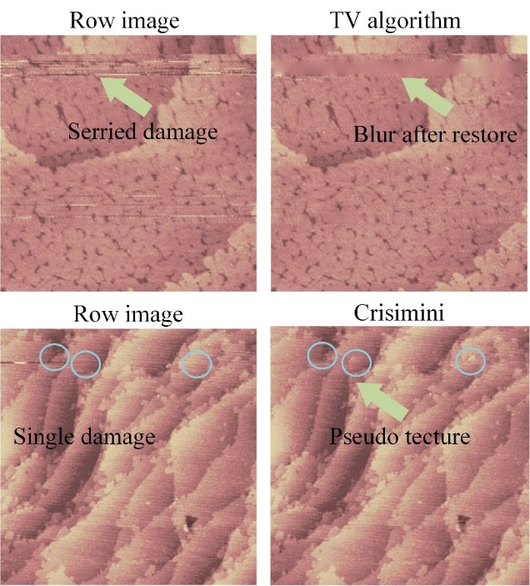

Fig.4: Weaknesses of the TV and Criminisi algorithm. Image becomes blur when use TV to restore large area damage. Criminisi algorithm may make image have some pseudo texture when the damage area is small.

To solve the shortcoming of the two algorithm and make the best of the two method, [13]proposed a method which combines the two in restoring STM image damages. While this method need manual positioning and judging of the defects. Hence, a self-positioning, self-judging and self-restoring algorithm is proposed.

Through the analysis of the long stripe defects, a phenomenon is found that the texture difference between damaged rows and adjacent lines are much larger than that between undamaged rows. Thus, we proposed a novel index parameter called ‘row gradient’ (denoted by RG) which present the sharpness of transition between two rows. The formula of RG is Eq.2:

 （2）

where x is the row of the image; n is the width of the image; p is the image matrix. As the Fig.5 shown, the RG value of the damaged rows are prominently higher than others, and RG value of the rows above and under the damaged line are about half of damaged rows’.

E:\研究生阶段\STM+TERS课题\stmLitterPapper\STM-Image-Porcess-Little-Papper\image origin\fig6\Graph2.tif

Fig.5: Demonstration of how to use the RG value to locate the damaged line. The purple line represents the mean of RG plus the standard deviation of RG. The rows (16th & 237th) whose RG value surpass the threshold correspond the damaged lines.

Then, the kernel work is finding the suitable threshold value of RG to divide the damaged rows and undamaged rows. In one pending image, the majority of the rows are undamaged, thus the average of the RG is nearly represent the datum RG value of undamaged rows. Also, the standard deviation of the RG can represent the extent of the RG augment of the damaged rows. Thus, the threshold value is defined as Eq.3:

 （3）

Expect for the rows that adjoin the damaged row, the pending rows can be marked as fig.6.

Then, choose the restoring method automatically through whether the damaged rows are intensive, the judge formula is Eq.4:

(4)

To sum up, after the algorithm mentioned above, the pending image marked having long stripe defects can be restored automatically without any manual intervention.

**2.3.2 Short sparse stripe restoration**

Short stripe defects can be viewed as global sparse outliers, although they are separately looked as local damages. Beside the sparse defects, the undamaged area of the pending image is identified as low-rank matrix. On this assumption, the restoring process is become a work that recover the low-rank section of the pending image, namely separating M= L0+ S0 into the terms L0 and S0[23]. Although the problem is N-P hard, a super-duper solution to those low-rank and sparse decomposition problem was introduced by Emmanuel Cand´es et al in 2010 called Robust Principal Component Analysis (RPCA). In this method, the low-rank L0 and sparse S0 which generated data can be exactly recovers by solving a simple convex program[23]:

 (5)

where ,. This principle has been widely used in image processing and video processing[24], and inspire applied work in image video analysis. On account of that the short sparse stripe defects can be viewed as the S matrix, restoring this kind of defects can be solved by RPCA as Fig.6 present.

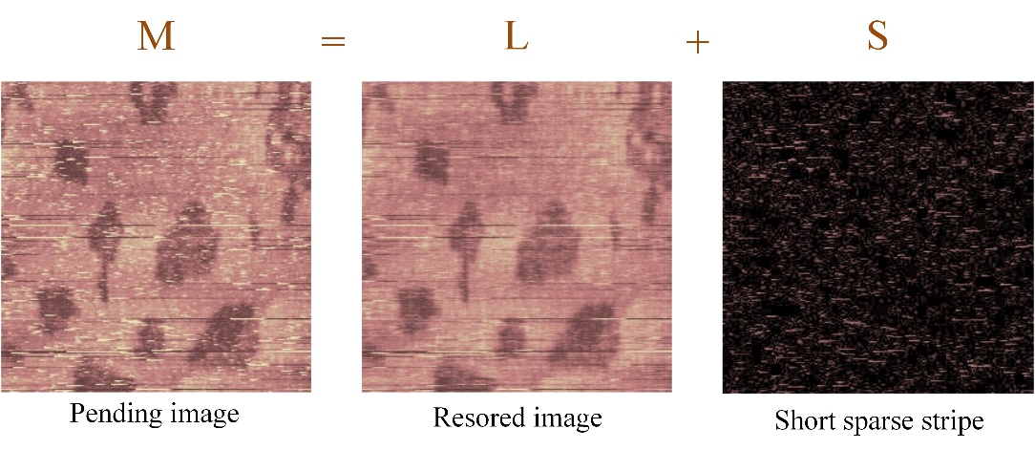

Fig.6: the figure present how the RPCA restore the Short sparse stripe restoration. The RPCA algorithm divides the row image into two matrixes, the S matrix includes the sparse outliers (short stripe) of the image, and the L matrix includes the remain low rank section. The L matrix is the image that restored by RPCA.

**2.3.3 Periodic noise restoration**

Periodic noise is usually hard processed directly in time domain although it has obvious periodic feature. Because of the ability of Fourier transform that converting complex convolution operation in spatial domain into simple product operation in frequency domain, frequency domain filtering has been widely used in periodic de-noising of images. While, the shape and location of the filter determine the effect of de-noising, thus positioning the frequency domain that to be removed is a very important task. The Fourier transform of two-dimensional image is Eq.6:

 （6）

The frequency of periodic noise is two light vertical lines centrosymmetric distributing around the center of the spectrogram as the Fig.7 presented. Also, analytically the distance between the light line and the center column is range from 1pixels to 6 pixels. The light lines’ position can be ensured by an index parameter called ‘column gradient’ (denoted by CG) which is defined like the way mentioned in 2.3.1, as the Eq.7.

 （7）

So, the column which has the highest CG value is the light line which contain the spectrogram of the periodic noise, as shown in Fig.7.

E:\研究生阶段\STM+TERS课题\stmLitterPapper\STM-Image-Porcess-Little-Papper\image origin\fig8\Graph1.tif

Fig.7: Demonstration of how to use the CG value to locate the spectrum of the periodic noise. The marked centrosymmetric light lines (124th column & 134th column) are the periodic noise section of the spectrum which correspond the marked highest CG value from 123rd to 135th. Thus, the location of the periodic noise spectrum can be ensured by the CG value. As the left two image shown, after removing the located section of spectrum, the periodic noise is restrained well.

After ensuring the light lines’ position, the next task is to estimate whether the light lines are distributing as ‘left high right low’ mode or ‘left low right high’ mode. Through analyzing the pixels’ values in the left light line in Fig.8, when the distribution mode is ‘left high right low, the average of the 1~128 pixels is obvious higher than that of the 129-256 pixels, vice versa.

Then, after ensuring the distribution of the light line, choosing corresponding filter can restore the periodic noise of the pending image.



Fig.8： Demonstrates of how to choose the corresponding filter to remove the periodic noise spectrum. When most of the pixels which are above the mean is distribute on the left, the filter mode is defined as ‘left high right low’(above). On the contrary, when most of the pixels which are above the mean is distribute on the right, the filter mode is defined as ‘left low right high’(below).

**3.Results and discussion**

The processed STM images were generated from 2007 to 2015 by the STM module of NanoScope®E produced by Digital Instruments department which total number is around ten thousand. The image size is 256*256 which has RGB three channels. It is analyzed and found that long stripe, short sparse stripe, periodic noise which are approximately occupy 33%, 28%,22% respectively is the top three main defects of scanning images in spite of the various morphologies these images present.

**3.1 Classification results**

Through manual recognition and tagging, we collect three original data sets as table 1 shown. The positive samples and negative samples are roughly equally distributed. Distinguishingly, in the long stripe defect data set, we collect 126 positive samples and 126 negative samples which have totally same morphology except for long stripes in order to help the network study the characteristics of long stripes. Then, after shuffling the data set, respectively divide the three dataset into three set for training, validating and testing.

Table 1: The amount and distribution of the data set of three types of defects. The original part presents the PN/NE samples distribution, the * mark represents the samples are comparative (have totally same morphology except for defects). The divided part present how the original data randomly divided into three sets (train set, valid set, test set).

|  |  |  |  |  |  |
| --- | --- | --- | --- | --- | --- |
| **Data Set Size** | **Original** | | **Divided** | | |
| PN | NE | Train | Valid | Test |
| **Periodic Noise** | 170 | 174 | 281 | 23 | 40 |
| **Long Stripe** | 126**\***+76 | 126**\***+60 | 300 | 44 | 44 |
| **Short Stripe** | 233 | 204 | 300 | 69 | 68 |

Then, in order to get good classification performance, we make some minor alterations such as flips, zooming and rotations to the existing training data sets as table 2 shown[25]. Because of the periodic noise is global noise and the characteristics of it are sensitive to direction, we randomly rotate the data in the range of and zoom the data in the range of 0.2% and flip the data both horizontally and vertically. While, to the short stripe and long stripe, on account of the locality and the sensibility of direction, we only use the horizontal flip and only zoom the short stripe data in the range of 0.1%. Through these minor changes, the training data amount of each set are increased to around 5500 which is more proportional to the parameters of the net.

Table 2: Augment method and augmented set size of three types of defects.

|  |  |  |  |  |  |
| --- | --- | --- | --- | --- | --- |
| **Data Augment** | **Train Set** | **Augment Method** | | | **Augmented**  **Set** |
| Rotate | Zoom | Flip |
| **Periodic Noise** | 281 |  | 0.2% | H/V | 5708 |
| **Long Stripe** | 300 | ╳ | ╳ | H | 5216 |
| **Short Stripe** | 300 | ╳ | 0.1% | H | 5216 |

After the training data preparation, we use the augmented training data sets to train the correspondent binary network. And the accuracy of the validating data set indicates the degree of the training. We test each binary network in correspondent testing data set, and the resulting confusion matrix of each binary network is shown in table 3. The accuracies of the three binary networks are respectively 92.500%, 91.489% and 92.063%. We also use the precision value, recall value and f-measure(a=1) to evaluate the binary network. Fig.9 present the three binary networks’ ROC (receiver operating characteristic) curve and the AUC (area under ROC curve). Putting all the evaluation indexes together, the three binary networks work well separately in each classifying work.

Table 3: The confusion matrix and the evaluation of three binary network .ACC represents accuracy defined as (TP+TN)/Total, Precision defined as TP/(TP+FP), Recall defined as TP/(TP+FN), (TP: true positive, TN: true negative, FP: false positive, FN: false negative ). F-1 represents the value of F-measure (when ) which defined as .

|  |  |  |  |  |  |  |  |  |
| --- | --- | --- | --- | --- | --- | --- | --- | --- |
| **Periodic Noise** | **Predicted** | | | | **Evaluation Criterion** | | | |
|  | PN | NE | TOTAL | ACC | Precision | Recall | F-1 |
| **Actual** | PN | 20 | 2 | 22 | 92.500% | 95.238% | 90.909% | 93.023% |
| NE | 1 | 17 | 18 |
| TOTAL | 21 | 19 | 40 |
| **Long**  **Stripe** | **Predicted** | | | | **Evaluation Criterion** | | | |
|  | PN | NE | TOTAL | ACC | Precision | Recall | F-1 |
| **Actual** | PN | 23 | 2 | 25 | 91.489% | 92.000% | 92.000% | 92.000% |
| NE | 2 | 20 | 22 |
| TOTAL | 25 | 22 | 47 |
| **Short Stripe** | **Predicted** | | | | **Evaluation Criterion** | | | |
|  | PN | NE | TOTAL | ACC | Precision | Recall | F-1 |
| **Actual** | PN | 37 | 4 | 41 | 92.063% | 97.374% | 90.244% | 93.674% |
| NE | 1 | 21 | 22 |
| TOTAL | 38 | 25 | 63 |



Fig.9: ROC (receiver operating characteristic) curve and AUC (area under ROC curve) of three types of defects.

In order to verify the universality of the classification net, we choose 15 image samples which are newly generated by the STM to validate the accuracy of the classification. As the Fig.10 shown, the true label which were tagged manually is attached in the ▉rectangle at the top of each image, and the predict label is attached in the ▉rectangle. The color of the rectangle at the top left corner represent the correctness of the classification (▉green represent correct, ▉red represent incorrect). Among the 15 test samples, 13 images are classified correctly, 2 images have little deviation on the prediction, which are the 9th and 15th respectively. Through analyzing, the periodic noise of the 9th image is very sharp and the single stripe of the noise is similar as a long stripe defect which may cause the mistake of the prediction. The periodic noise of the 15th image is slightly blurred which may lead to the mistake.

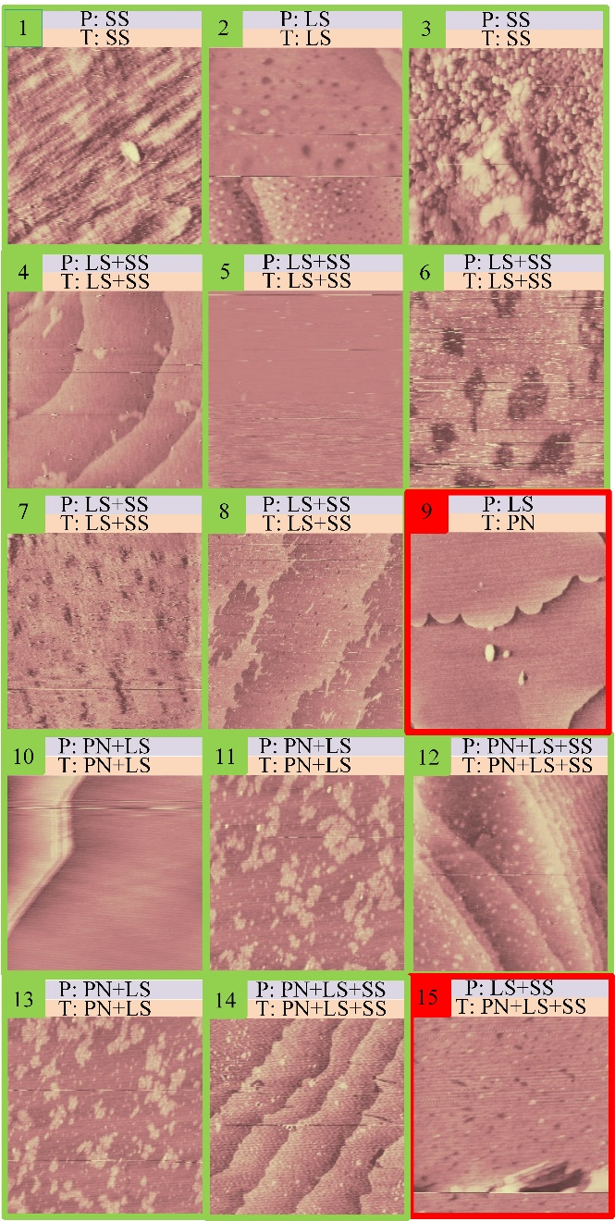

Fig.10: The prediction on 15 new generated STM image by the trained classification. ▉label of each image is the predicted label tagged manually and ▉label of each image is the true label by the classification (P: predicted, T: true, LS: long stripe, SS: short stripe, PN: periodic noise). The accuracy is shown by the rectangle on the top left corner. (▉green represent correct, ▉red represent incorrect).

The overall results indicated that the deep convolutional neural network provided above have a quite well performance in the defects classification and prediction work.

**3.2 Restoration result**

Table 4 indicates the effectiveness of the provided restoration methods mentioned before. Three provided algorithms respectively process 50 images which have typical corresponding defects, and only a few of images are not restored good remaining some defects. The integral success rate of restoration is around 95%().

Table 4: the effectiveness of three restoration algorithms. The judgement ‘good’ represent the defects are restored visually well with little residue and pseudo stripe. The judgement ‘bad’ represent the defects partly remain or some side effects are introduced. Part of the samples are shown in the Supporting Information Part 3.

|  |  |  |  |  |
| --- | --- | --- | --- | --- |
| **Image Restoration** | **Restoration Result** | | | **Success**  **Rate** |
| total | good | bad |
| **Periodic Noise** | 50 | 48 | 2 | 96% |
| **Long Stripe** | 50 | 46 | 4 | 92% |
| **Short Stripe** | 50 | 49 | 1 | 98% |

Fig.11 vividly presents the entire restoring process without any manual intervention. The No.1 topography (CPI/Pd（monolayer）/Au) is correctly predicted by the network as LS and SS. It is restored automatically by the long stripe restoration algorithm (self-locating TV&CRISMINI) and short stripe restoration algorithm (RPCA) successively. No.2 (Autip1/Pd/Au (111)) and No.3 (Pd(monolayer)/Au) are both predicted as NP and LS. After the process, the long stripes are restored well and the periodic noise are repressed obviously not entirely (remain little slight grains). No.4 (4CPI/Pd(monolayer)/Au) are predicted as NP, and the periodic noise is removed well.

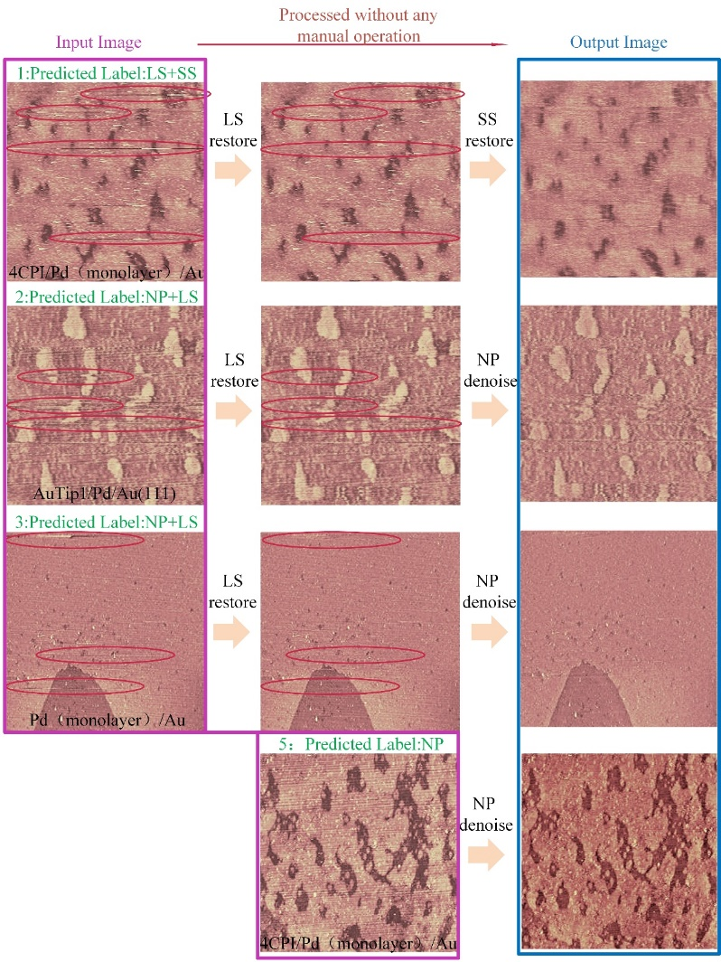

4

Fig.11: This figure demonstrates visually the process and effectiveness of the whole restoration method. The processed image is the morphology of CPI/Pd（monolayer）/Au(no.1), Autip1/Pd/Au(111)(no.2), Pd(monolayer)/Au(no.3), 4CPI/Pd(monolayer)/Au(no.4).

**4 Conclusion**

We have proposed a new full-automatic method for STM post-processing combing CNN classification network and three specific restoring algorithms. In the traditional post-processing for STM, the complexity of the morphologies and the defects makes the restoration a complex and time-consuming things which need a lot of human intervention. The method proposed a new idea that combing deep learning classification network and traditional image processing algorithms. This combination provides a model that combine several algorithms for specific defects into a universal restore method. It not only overcomes the limitation of restoring algorithms for specific defects but also reduce the manual intervention during the restoring. The processed results demonstrate the effectiveness of the method adequately. The proposed new method has been written in the software and can process one image in seconds automatically without any manual intervention, the print screen of the software is in the part 6 of the supporting information.

Further research should be focus on expanding the kinds of defects that can be handled and on how to change the process order adaptively to get the best process result. The new process model can make further work focus on particular defects’ positioning and restoring instead of focusing on finding a universal restoring method. And also, on the current method, the order of process is determined by prior experience and can’t be changed in different conditions. The further work can weight each label of defects and train a network to determine the order of the restore process dynamically.

**Acknowledgement**

This work was supported by the National Nature Science Foundation of China (Nos: 21874133, Nos: 21874133), the National Nature Science Foundation of China (Major Program, Nos:21790354) and State Key Laboratory of Physical Chemistry of Solid Surfaces, Xiamen University.

**References**

[1] Tersoff, J. and D.R. Hamann, *Theory of the scanning tunneling microscope.* Physical Review B, 1985. **31**(2): p. 805-813.

[2] Motin, A.M., et al., *Surface science approach to Pt/carbon model catalysts: XPS, STM and microreactor studies.* Applied Surface Science, 2018. **440**: p. 680-687.

[3] Nguyen, H.A., et al., *STM Imaging of Localized Surface Plasmons on Individual Gold Nanoislands.* J Phys Chem Lett, 2018. **9**(8): p. 1970-1976.

[4] Kumar, A., et al., *STM study of exfoliated few layer black phosphorus annealed in ultrahigh vacuum.* 2D Materials, 2018. **6**(1).

[5] Zhao, A., et al., *STM tip-assisted single molecule chemistry.* Phys Chem Chem Phys, 2013. **15**(30): p. 12428-41.

[6] Tempe, D., et al., *Multisite protein kinase A and glycogen synthase kinase 3beta phosphorylation leads to Gli3 ubiquitination by SCFbetaTrCP.* Mol Cell Biol, 2006. **26**(11): p. 4316-26.

[7] Tapaszto, L., et al., *Tailoring the atomic structure of graphene nanoribbons by scanning tunnelling microscope lithography.* Nat Nanotechnol, 2008. **3**(7): p. 397-401.

[8] Ji, T.Y., Z. Lu, and Q.H. Wu, *Optimal soft morphological filter for periodic noise removal using a particle swarm optimiser with passive congregation.* Signal Processing, 2007. **87**(11): p. 2799-2809.

[9] Li, H., P. Hui, and N. Shu. *Study on Suppressing White Noises and Periodic Narrow Bandwidth Noise of PD by Vertically Invariant Gray-Level Morphological Filter*. in *International Conference on E-product E-service & E-entertainment*. 2010.

[10] Moallem, P., M. Masoumzadeh, and M. Habibi, *A novel adaptive Gaussian restoration filter for reducing periodic noises in digital image.* Signal, Image and Video Processing, 2013. **9**(5): p. 1179-1191.

[11] Sur, F. and M.J.J.o.E.I. Grédiac, *Automated removal of quasiperiodic noise using frequency domain statistics.* Journal of Electronic Imaging, 2015. **24**(1): p. 013003-013003.

[12] Oliveira, J.P., et al., *Restoring STM images via Sparse Coding: noise and artifact removal.* 2016.

[13] Xian-guang, F., et al., *Image processing for three defects of topography images by SPM.* Chemometrics and Intelligent Laboratory Systems, 2019. **185**: p. 12-17.

[14] Zhang, M.-L. and Z.-H. Zhou, *A Review on Multi-Label Learning Algorithms.* IEEE Transactions on Knowledge and Data Engineering, 2014. **26**(8): p. 1819-1837.

[15] Boutell, M.R., et al., *Learning multi-label scene classification.* Pattern Recognition, 2004. **37**(9): p. 1757-1771.

[16] Zhang, M.-L. and Z.-H. Zhou, *ML-KNN: A lazy learning approach to multi-label learning.* Pattern Recognition, 2007. **40**(7): p. 2038-2048.

[17] Zhang, M., W. Li, and Q. Du, *Diverse Region-Based CNN for Hyperspectral Image Classification.* IEEE Trans Image Process, 2018. **27**(6): p. 2623-2634.

[18] Liu, X.L., et al., *On fusing the latent deep CNN feature for image classification.* World Wide Web-Internet and Web Information Systems, 2019. **22**(2): p. 423-436.

[19] Hu, W., et al., *Deep Convolutional Neural Networks for Hyperspectral Image Classification.* Journal of Sensors, 2015. **2015**: p. 1-12.

[20] Yarotsky, D., *Error bounds for approximations with deep ReLU networks.* Neural Netw, 2017. **94**: p. 103-114.

[21] Rudin, L.I., S. Osher, and E.J.P.D.N.P. Fatemi, *Nonlinear total variation based noise removal algorithms* Physica D, 1992. **60**(1–4): p. 259-268.

[22] Chan, T.F. and H.M. Zhou. *Total variation improved wavelet thresholding in image compression*. in *International Conference on Image Processing*. 2002.

[23] Candès, E.J., et al., *Robust principal component analysis?* Journal of the ACM, 2011. **58**(3): p. 1-37.

[24] Bouwmans, T., et al., *On the Applications of Robust PCA in Image and Video Processing.* Proceedings of the IEEE 2018. **106**(8): p. 1427-1457.

[25] Teramoto, A., et al., *Automated Classification of Lung Cancer Types from Cytological Images Using Deep Convolutional Neural Networks.* Biomed Res Int, 2017. **2017**: p. 4067832.