
Serendib Learn
Brand Guide
Keeping languages alive.

Logo & Mark
The primary mark is the Araliya flower -- five white petals with an amber centre, set on a forest-green circle. It pairs with the lowercase serif wordmark "serendib.learn" and the tagline "Keeping languages alive."
The mark alone

Horizontal lockup

Vertical lockup
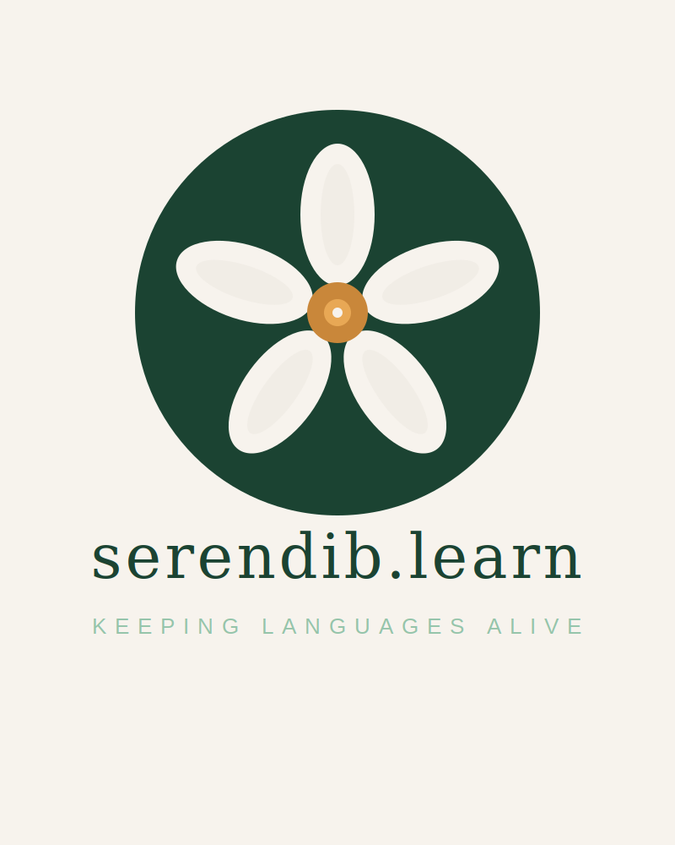
Usage notes
• Minimum clear space: keep the mark's own height as breathing room on every side.
• Backgrounds: the mark reads best on Cream (#F7F3ED) or Forest (#1B4332).
• Avoid placing the mark over busy photography or low-contrast backgrounds.
• Don't recolour the flower, stretch the lockup, or rotate the mark.

Colour Palette
Forest green is Sri Lankan jungle -- depth and trust. Spice amber is cinnamon -- warmth and heritage. Cream is calm, premium, unhurried. Never use corporate blue: this should feel like a boutique Colombo cafe, not a tech startup.
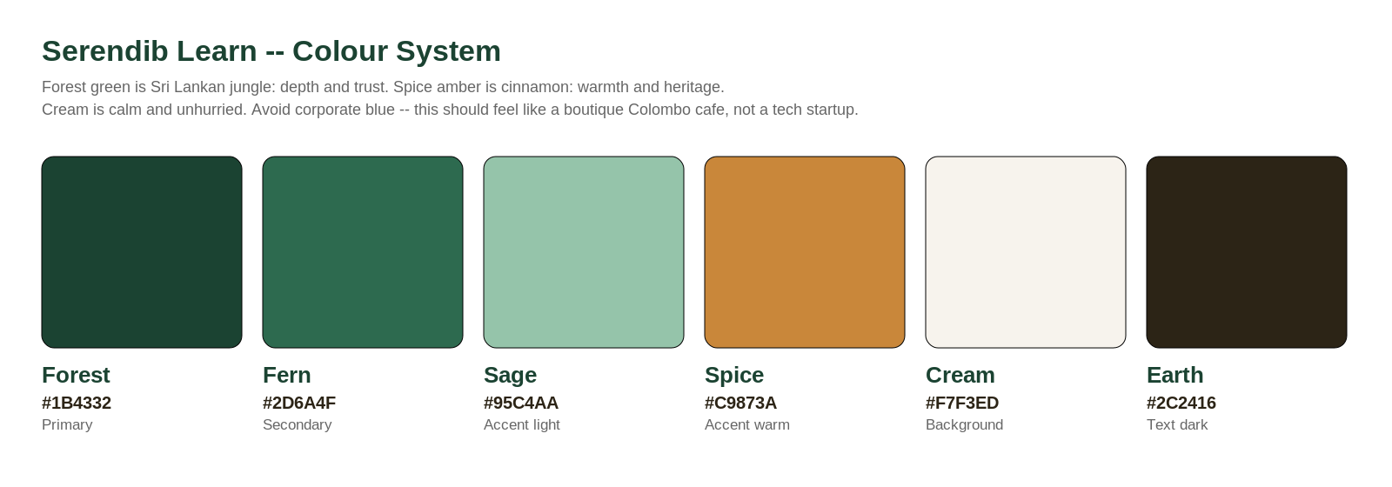
Where each colour lives
• Forest #1B4332 -- primary; headers, navigation, dark sections
• Fern #2D6A4F -- secondary green; supporting text and accents
• Spice #C9873A -- primary call-to-action colour (buttons, links)
• Cream #F7F3ED -- primary background
• Sage #95C4AA -- muted text on dark backgrounds
• Earth #2C2416 -- body text on light backgrounds

Typography
Headings -- Georgia
The quick brown fox jumps over the lazy dog
Warm and editorial. Used for all headlines and display text.
Body & UI -- Inter
The quick brown fox jumps over the lazy dog
Clean and highly legible. Used for paragraphs, navigation, and buttons.
Tone note
Serif headlines carry the emotional, editorial weight. Sans-serif body copy keeps things practical and readable.

Voice & Tone
Warm, personal, editorial -- never corporate or salesy.
“The language your child speaks with their grandmother is worth fighting for.”
Mission line: keeping Sinhala and Tamil alive for the next generation, one family at a time.
Favour
• Specific, sensory, human details over abstract claims
• Direct, warm language that speaks to families, not "users"
Avoid
• Jargon and hard-sell language
• Generic edtech phrasing
• Corporate blue, corporate tone, corporate anything

