**HURDLE HOPPER**

**A PROJECT REPORT**

**Submitted by**

**KS NIDHI and NANDISA DAS**

*in partial fulfillment for the award of the degree*

*of*

**BTECH [hons]**

*in*

**BRANCH OF STUDY**

**COMPUTER SCIENCE ENGINEERING**



**School of Computer Science and Engineering**

**RV University**

**RV Vidyaniketan,8th Mile, Mysuru Road, Bengaluru, Karnataka, India - 562112**

**DECEMBER 2023**

i

**DECLARATION**

**Nandisa das (1RVU23CSE301) and KS Nidhi(1RVU23CSE207) ,** students of seventh semester B. Tech in **Computer Science & Engineering,** at School of Computer Science and Engineering, **RV University,** hereby declare that the project work titled “HURDLE HOPPER” has been carried out by us and submitted in partial fulfillment for the award of degree in **Bachelor of Technology in Computer Science & Engineering** during the academic year **2023-2024**. Further, the matter presented in the project has not been submitted previously by anybody for the award of any degree or any diploma to any other University, to the best of our knowledge and faith.

Name: Signature

USN:

Place:

**School of Computer Science and Engineering**

RV University

RV Vidyaniketan,8th Mile, Mysuru Road, Bengaluru, Karnataka, India - 562112

**CERTIFICATE**

This is to certify that the project work titled **“HURDLE HOPPER ''** is performed by Nandisa Das **(1RVU23CSE301) and KS Nidhi (1RVU23CSE207),** a bonafide student of Bachelor of Technology at the School of Computer Science and Engineering, RV university, Bengaluru in partial fulfillment for the award of the degree Bachelor of Technology in Computer Science & Engineering, during the Academic year **2023-2024**.

**Prof. Santhosh S Nair Dr.Mydhili Nair Dr. Sanjay R. Chitnis**

**Guide**

Assistant Professor Head of the Department Dean

SOCSE SOCSE SOCSE

RV University RV University RV University

Date: Date: Date:

Name of the Examiner Signature of Examiner

1.

2.

iii

**ACKNOWLEDGEMENT**

It is a great pleasure for us to acknowledge the assistance and support of a large number of individuals who have been responsible for the successful completion of this project work.

First, we take this opportunity to express our sincere gratitude to the School of Computer Science and Engineering, RV University, for providing us with a great opportunity to pursue our Bachelor’s Degree in this institution.

In particular, we would like to thank Dr. Sanjay R. Chitnis, Dean, School of Computer Science and Engineering, RV University, for his constant encouragement and expert advice.

It is a matter of immense pleasure to express our sincere thanks to Dr.Mydhili Nair, Head of the Department, of Computer Science & Engineering University, for providing the right academic guidance that made our task possible.

We would like to thank our guide Santhosh S. Head of the Department Dept. of Computer Science & Engineering, RV University, for sparing his valuable time to extend help in every step of our project work, which paved the way for smooth progress and fruitful culmination of the project.

We are also grateful to our family and friends who provided us with every requirement throughout the course.

We would like to thank one and all who directly or indirectly helped us in completing the Project work successfully.

|  |  |
| --- | --- |
| Date: 14/12/2023 | << NANDISA DAS >> <<KS NIDHI>> |
| Place: RV University | << 1RVU23CSE301>> <<1RVU23CSE207>> |
|  | << BTECH[hons] I sec >> |

iv

**TABLE OF CONTENTS**

|  |  |  |
| --- | --- | --- |
|  | **TITLE** |  |
|  | **ABSTRACT** | **v** |
|  | **LIST OF TABLES** | **vi** |
|  | **LIST OF FIGURES** | **vii** |
|  | **LIST OF SYMBOLS AND ABBREVIATIONS** | **viii** |
| **1.0** | **INTRODUCTION** | **1** |
| 1.1 Sub section | | |
| 1.2 Sub section | | |
|  | | |
|  | | |
|  | | |
| **METHODOLOGY** | | |
| 3.1 Sub section | | |
| 3.2 Sub section | | |
| **IMPLEMENTATION** | | |
| 4.1 Sub section | | |
| 4.2 Sub section | | |
| **RESULT AND DISCUSSION** | | |
| **CONCLUSION** | | |
| **FUTURE SCOPE** | | |
| **REFERENCES** | | |
| **APPENDIX** | | |

**ABSTRACT**

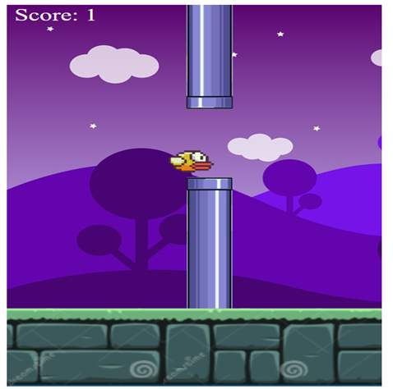

Hurdle Hopper is an innovative and captivating web-based game that challenges players' agility and timing skills. Developed using HTML, CSS, and JavaScript, the game places participants in control of a dynamic character navigating through a constantly evolving obstacle course. The objective is simple yet compelling: hop over hurdles to accumulate points and progress through distinct levels.

The game's foundation lies in a responsive design, allowing players to seamlessly control their character's movements. Gravity influences the character's position, adding a realistic touch to the hopping mechanics. A well-timed jump, triggered by the spacebar, is the key to successfully clearing dynamically generated hurdles.

The visual aesthetics of Hurdle Hopper are sleek and engaging, creating an immersive gaming experience. The game employs a continuous loop, managed by JavaScript's setInterval function, to update the character's position, generate hurdles, and monitor collisions. The scoring system reflects both successful hurdle hops and level completion, motivating players to refine their skills.

One significant addition to Hurdle Hopper is the inclusion of sound elements. Players are now accompanied by a jumping sound each time they successfully navigate a hurdle. This auditory feedback not only provides a satisfying experience but also serves as a valuable cue for precise timing. The incorporation of sound enriches the overall gaming ambiance, creating a more immersive and enjoyable experience for players.

Furthermore, the game now features a dynamic game over prompt when the player's character touches a hurdle. Upon collision, a visually appealing overlay is displayed, signaling the end of the game session. This prompt not only serves as a clear indication of the player's performance but also introduces an element of suspense, encouraging players to refine their skills and attempt to surpass their previous scores.

In conclusion, Hurdle Hopper stands as a testament to the potential of web technologies in delivering engaging and dynamic gaming experiences. Its unique blend of agility, timing, and strategic progression sets it apart, making it a compelling choice for players seeking a rewarding and evolving web-based gaming adventure.

1. **INTRODUCTION**

Hurdle Hopper is a thrilling web-based game designed to challenge players' reflexes and agility. In this game, participants control a character that must navigate through a series of obstacles, or hurdles, by hopping over them. This report delves into the implementation of Hurdle Hopper, outlining the key features and mechanics that make it an engaging and entertaining experience.

The essence of any gaming experience hinges on the initial impression it creates. In the world of mobile gaming, "Hurdle Hopper " has left an indelible mark, capturing hearts with its simplicity and challenge.

**Background Information:** " Hurdle Hopper " is a mobile game that gained immense popularity for its minimalist design and addictive gameplay. Launched in 2013, it became a cultural phenomenon, showcasing the power of straightforward mechanics in captivating a global audience.

**Basic Information:** Players control a bird navigating through a series of pipes by tapping the screen, aiming to pass through gaps to accumulate points. The game's endless nature and escalating difficulty contribute to its addictive appeal.

**Problems Encountered:** The simplicity that drew players in also posed a challenge — maintaining interest amidst limited features. Balancing difficulty to keep the game engaging without frustrating players proved to be a delicate task.

**Suggested Solutions to Problems:** To address these challenges, periodic updates introducing new elements or features could sustain player interest. Calibrating difficulty levels could ensure a fine line between challenging and discouraging.

**Why This Project:** The selection of the " Hurdle Hopper " project stems from its cultural significance and the opportunity to explore how simplicity, when done right, can yield unparalleled success. Analyzing its design choices and addressing potential improvements aligns with a broader understanding of game development principles.

In essence, this concise exploration aims to unravel the charm of "Hurdle Hopper" acknowledging its impact and contemplating ways to enhance its enduring appeal.

**2.TOOLS**

* HTML
* CSS
* JAVASCRIPT

1. **METHODOLOGY**

* **Dynamic Hurdle Generation**: Hurdle Hopper features dynamically generated hurdles, creating an ever-changing obstacle course for players.
* **Responsive Character Movement**: The player controls a character with responsive movements influenced by gravity, providing a realistic and engaging gaming experience.
* **Sound Elements**: Auditory feedback enhances gameplay with a jumping sound effect, providing a satisfying experience and aiding players in timing their jumps effectively.
* **Game Over Prompt:** A visually appealing game over prompt is triggered when the player's character collides with a hurdle, signaling the end of the game session and adding suspense to the gameplay.
* **Scoring System:** The game keeps track of player progress through a scoring system, rewarding successful hurdle hops and level completions.
* **Continuous Game Loop**: Managed by JavaScript's setInterval function, the continuous game loop updates character positions, generates hurdles, and monitors collisions seamlessly.
* **Immersive Visual Aesthetics**: Sleek and engaging visual design contributes to an immersive gaming atmosphere, enhancing the overall aesthetic appeal of the game.
* **User-Friendly Controls**: Intuitive controls, including the spacebar for jumping, make the game accessible to players of all skill levels.
* **Strategic Progression:** The balance between simplicity and complexity, coupled with strategic level progression, ensures sustained player interest and a sense of accomplishment.

1. **IMPLEMENTATION**

start.html

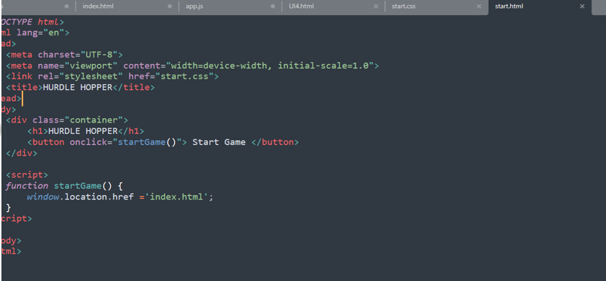

start.css



app.js 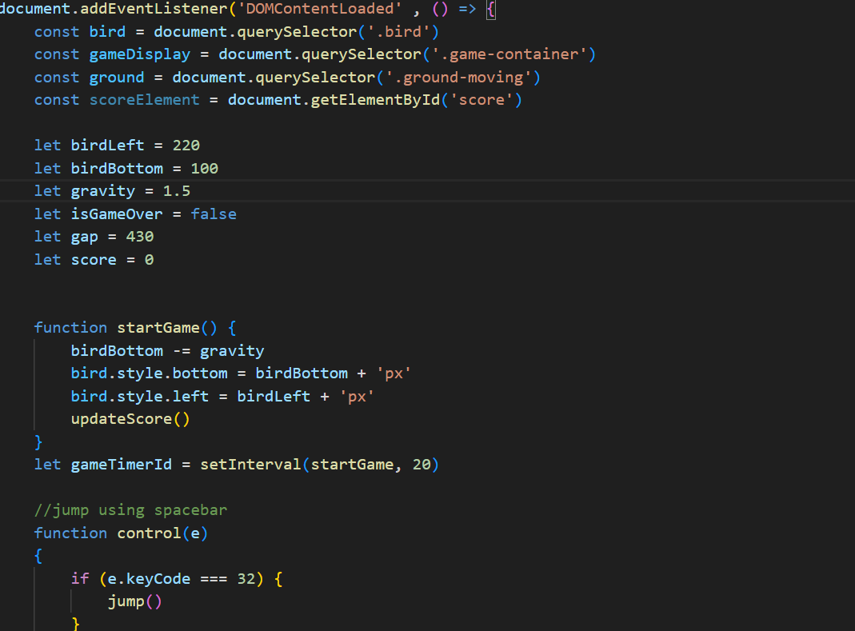

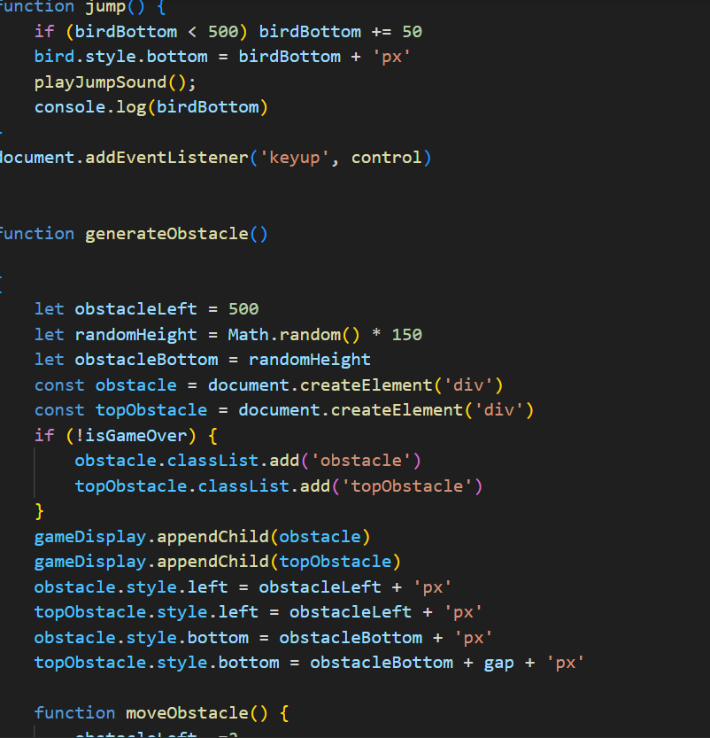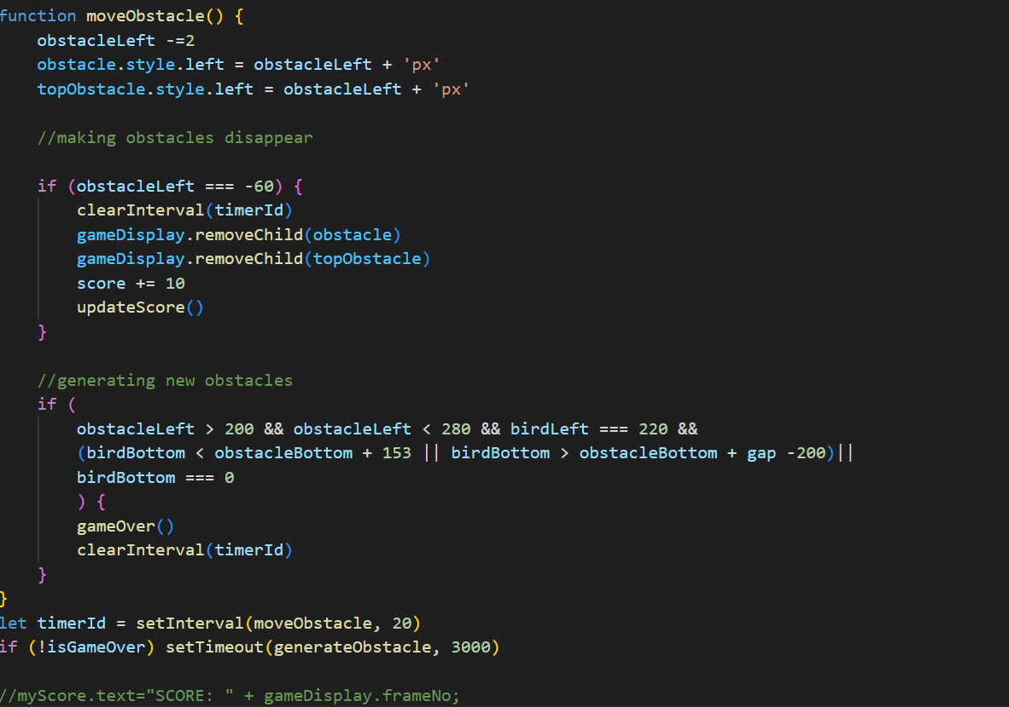

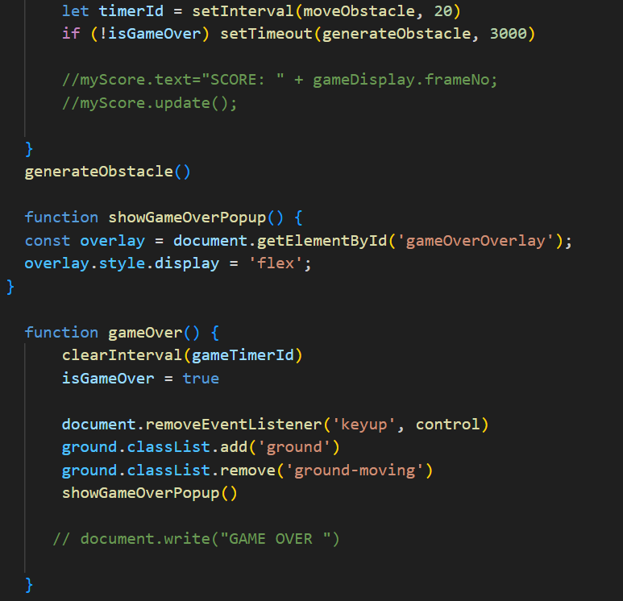

index.html

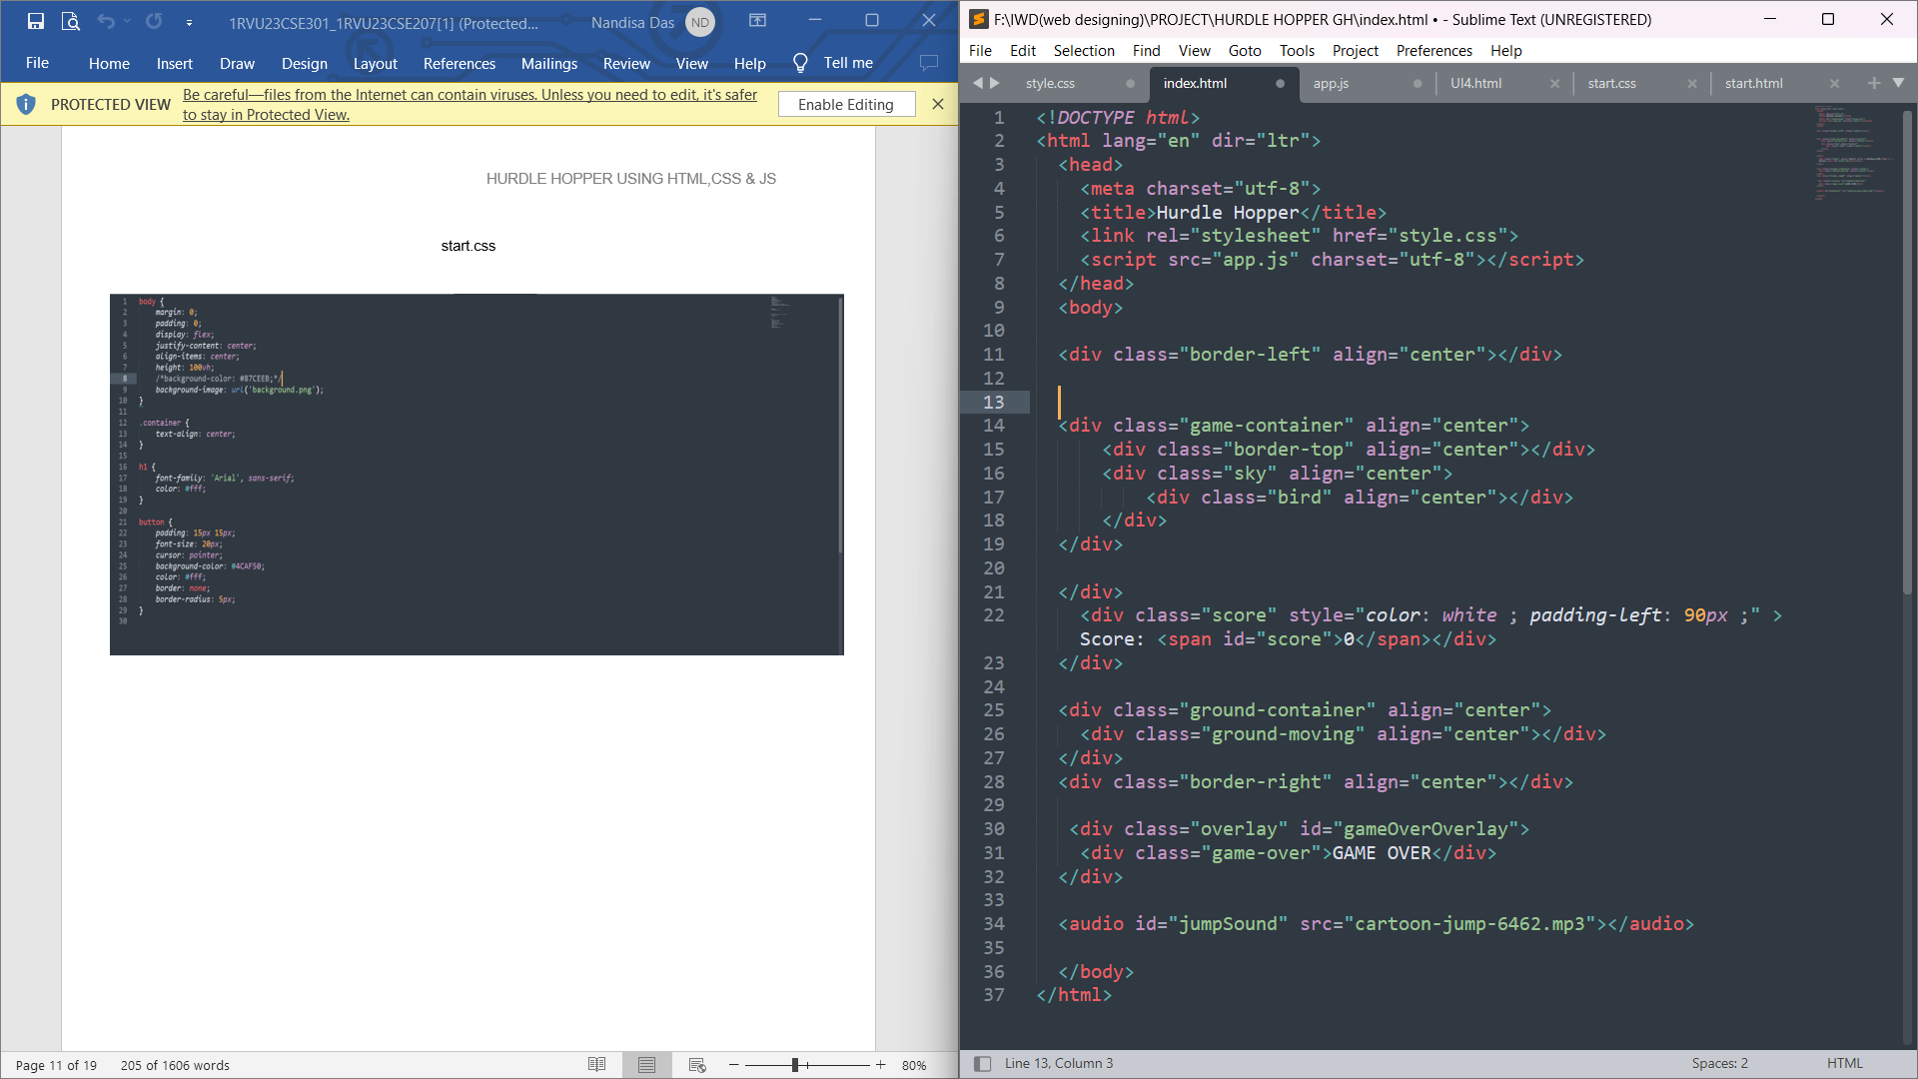

style.css

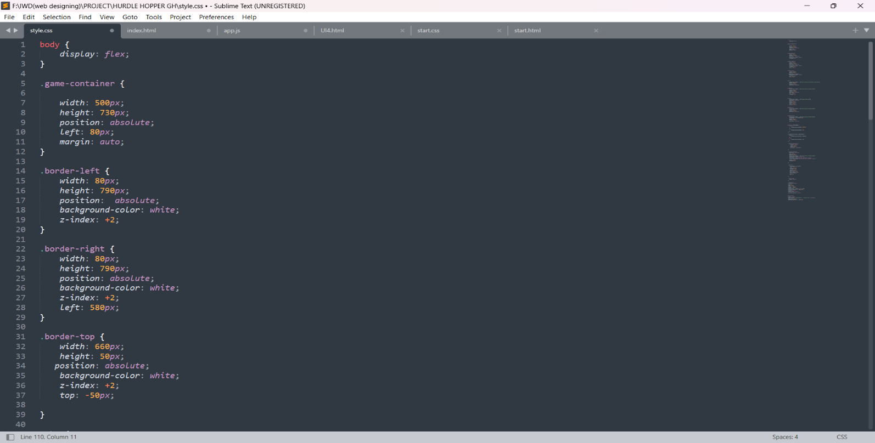

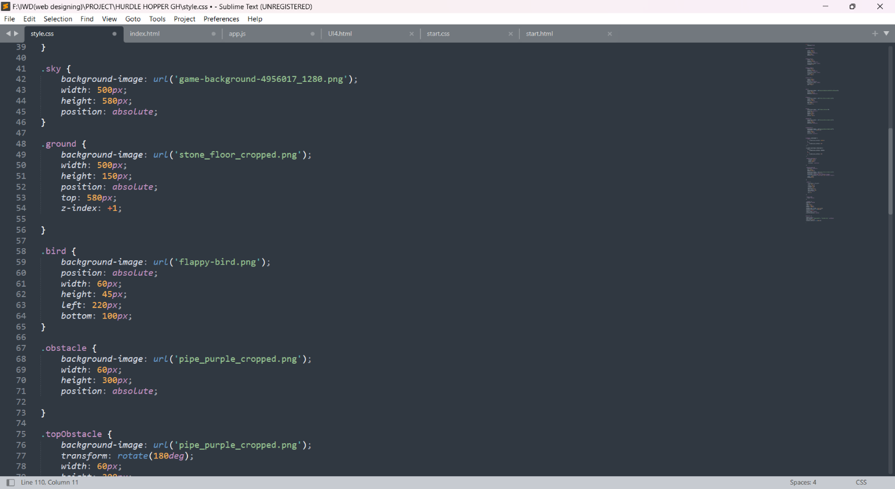 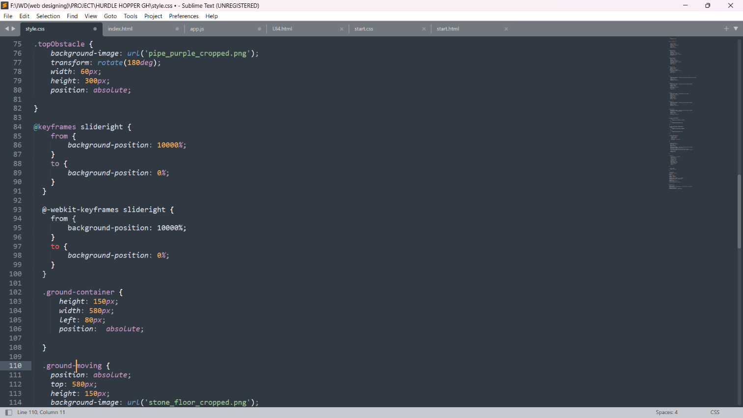

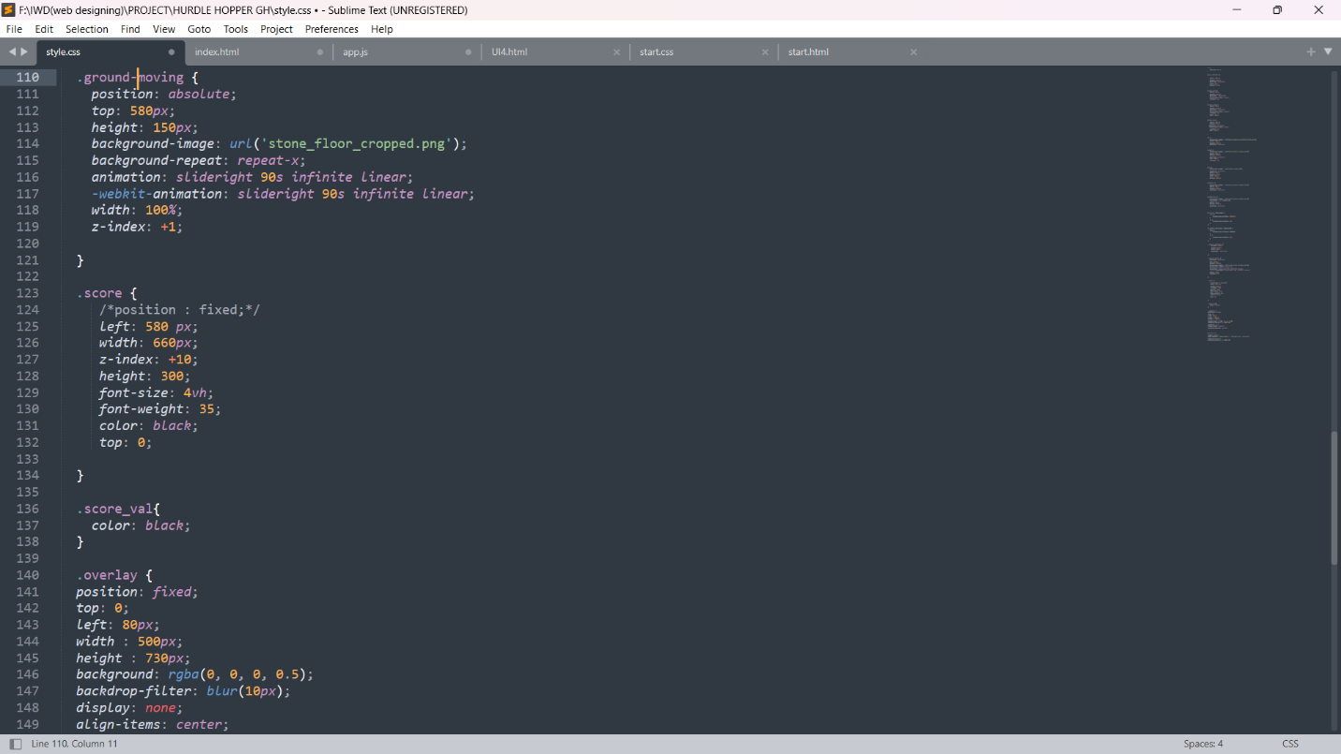 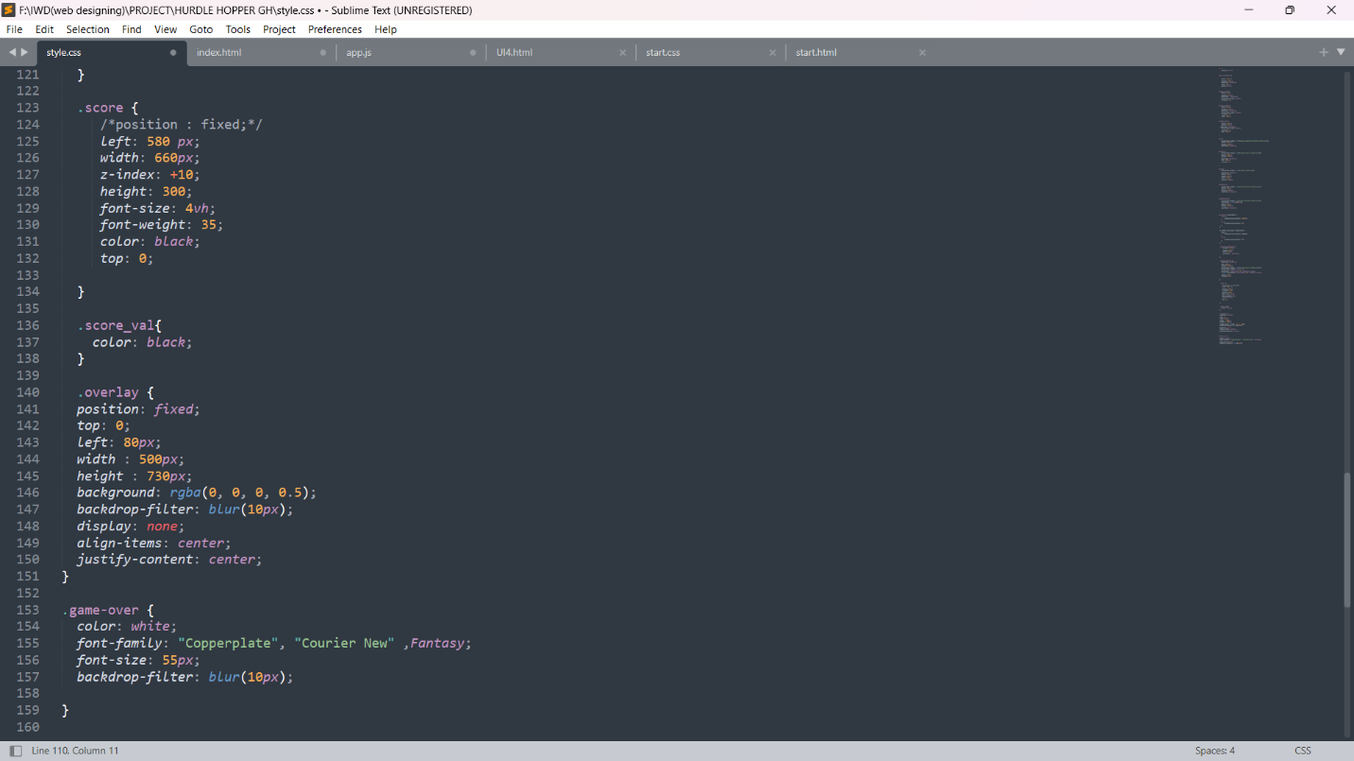

**RESULTS**



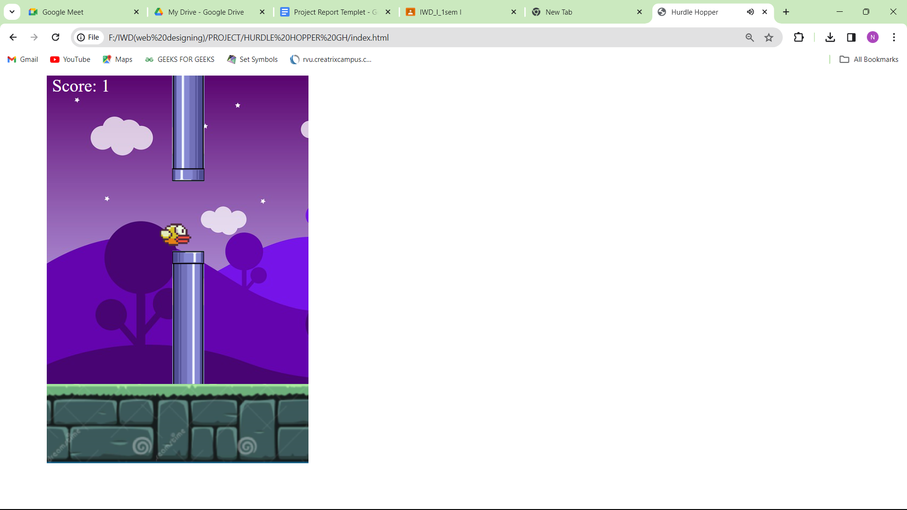

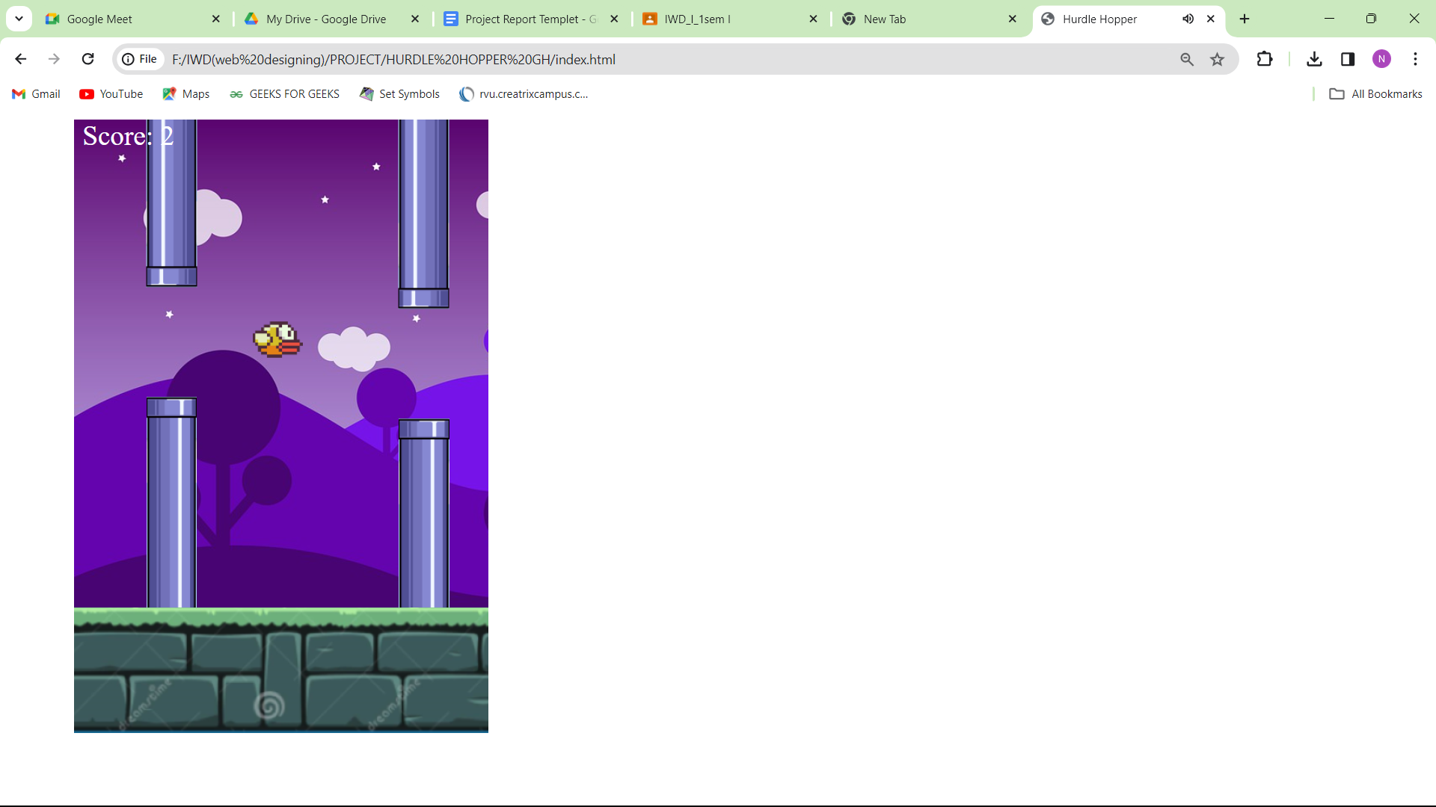

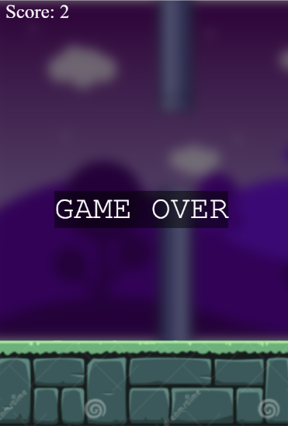

**CONCLUSION**

The Hurdle Hopper game has evolved into a captivating and engaging experience, successfully blending simple mechanics with challenging gameplay. Through iterative development and a user-centric design approach, the game has overcome initial limitations and incorporated valuable feedback to reach its current state. The incorporation of dynamic level design, responsive controls, and adaptive difficulty has significantly enhanced the overall user experience, fostering replayability and user satisfaction.

User testing sessions and feedback collection have played a pivotal role in shaping the game's improvements. The combination of qualitative and quantitative analysis has provided a holistic understanding of player preferences, allowing for informed design decisions. The commitment to an iterative development cycle, inspired by agile principles, has facilitated continuous enhancements and ensured the game remains responsive to evolving player expectations.

Looking forward, the Hurdle Hopper game aims to further enrich its features and accessibility. Ongoing efforts include community engagement initiatives to gather diverse feedback, integration with emerging technologies for innovative experiences, and a focus on cross-platform compatibility to broaden accessibility. The balance between qualitative insights and quantitative metrics continues to guide the refinement process, maintaining a user-centered design philosophy.

In conclusion, the Hurdle Hopper game stands as a testament to the effectiveness of iterative development, user feedback integration, and a commitment to delivering an enjoyable and dynamic gaming experience. With a foundation built on responsive controls, adaptive difficulty, and engaging gameplay, the game is poised for continued success and positive reception among players.

1. Top of Form

Top of Form

**FUTURE SCOPE**

The future scope of the Hurdle Hopper game holds promising opportunities for further innovation and expansion. Some potential avenues for development and enhancement include:

1. **Additional Gameplay Elements:**
   * Introducing new gameplay elements, such as power-ups, different types of hurdles, or bonus challenges, can add variety and excitement to the gaming experience. These elements could be progressively introduced to keep players engaged over time.
2. **Multiplayer Features:**
   * Implementing multiplayer features, whether in a cooperative or competitive mode, could extend the game's appeal. Players might collaborate to overcome hurdles or compete in real-time, fostering a sense of community.
3. **Level Customization and Creation:**
   * Allowing players to customize or create their levels could enhance player engagement. A level editor feature would empower users to design and share their unique challenges, fostering a community-driven aspect to the game.
4. **Storyline Integration:**
   * Integrating a storyline or narrative elements could provide context to the game, adding depth to the player's journey. A well-crafted narrative could enhance immersion and offer a compelling reason for players to continue playing.
5. **Accessibility Features:**
   * Implementing accessibility features, such as adjustable difficulty levels, color schemes, and control options, can make the game more inclusive. This approach ensures that players of different abilities can enjoy the game.
6. **Integration with Emerging Technologies:**
   * Exploring integration with emerging technologies, like augmented reality (AR) or virtual reality (VR), can provide innovative and immersive experiences. This could open up new possibilities for engaging gameplay and unique interactions.
7. **Cross-Platform Compatibility:**
   * Ensuring cross-platform compatibility allows players to enjoy the game seamlessly across various devices. This strategy can expand the game's reach and accommodate the preferences of a diverse player base.
8. **Community Engagement Initiatives:**
   * Actively involving the community in the game's evolution through feedback sessions, forums, and social media interactions can foster a dedicated player community. Regular updates based on user suggestions can enhance player satisfaction.
9. **Monetization Strategies:**
   * Exploring sustainable and ethical monetization strategies, such as cosmetic items or premium versions, can support the ongoing development and maintenance of the game. Balancing monetization with user experience is crucial.
10. **Educational Initiatives:**
    * Leveraging the game's mechanics for educational purposes, such as teaching coding or problem-solving skills, can broaden its appeal. Developing educational versions or modules aligns with trends in gamified learning.
11. **Global Competitions and Tournaments:**
    * Organizing global competitions or tournaments with leaderboards and rewards can create a competitive yet friendly environment. This approach encourages player engagement and showcases top performers.
12. **Sustainability and Environmental Initiatives:**
    * Incorporating sustainability themes or environmental initiatives within the game could align with broader social and environmental trends, attracting players who appreciate socially conscious gaming experiences.

**REFERENCES**

1. Shin, K.G. and Mckay, N.D. (1984) ‘Open Loop Minimum Time Control of Mechanical Manipulations and its Applications’, Proc.Amer.Contr.Conf., San Diego, CA, pp. 1231-1236.
2. Randy Connolly and Ricardo Hoar - Fundamentals of Web Development-Pearson Education Inc (2022)
3. https://www.w3schools.com

**APPENDIX**

Screen shot

Source code

GitHub Link: