LED Button and control processing

<https://www.instructables.com/id/Arduino-LED-Button-Pad-Driving-Processing-Animatio/>

Use Arduino to play a cat

<https://www.digitaltrends.com/cool-tech/cool-arduino-projects/>

SENSOR

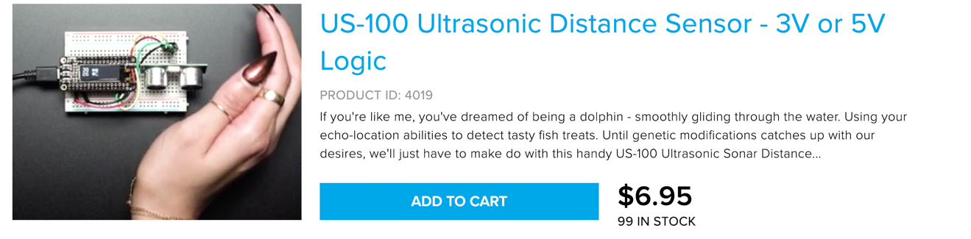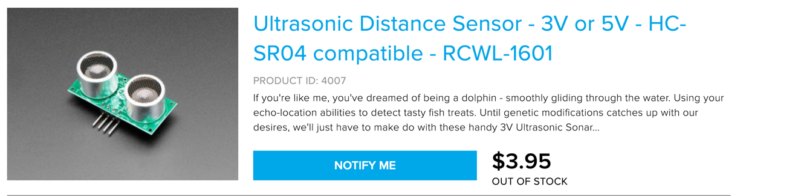

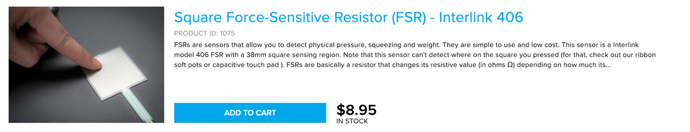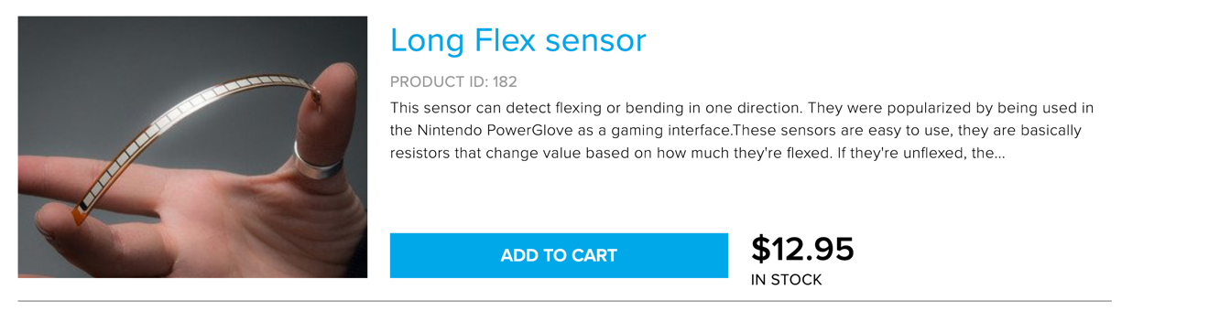

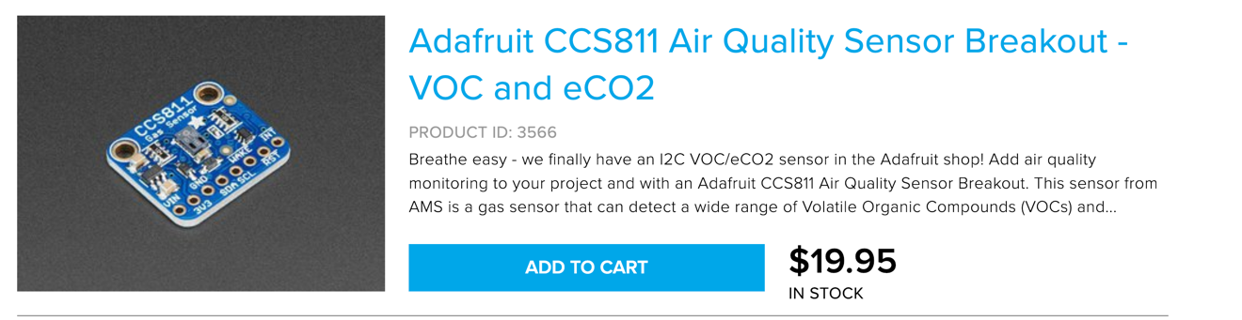

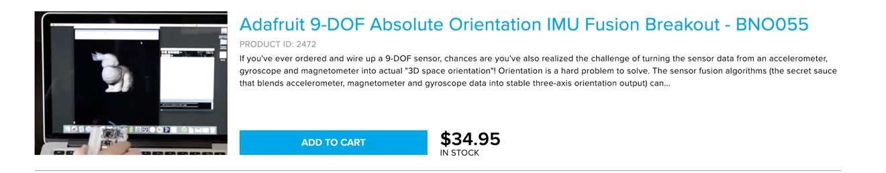

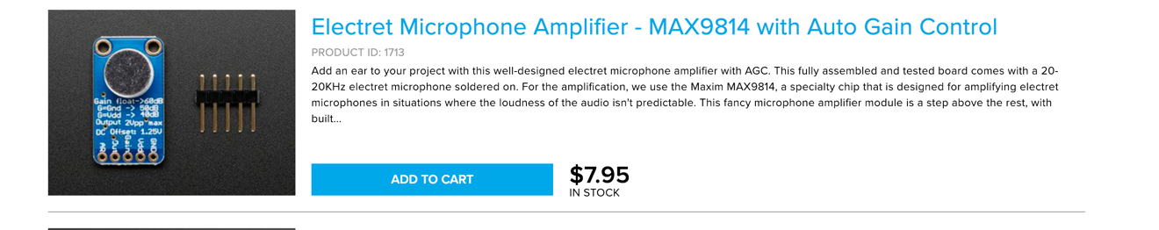

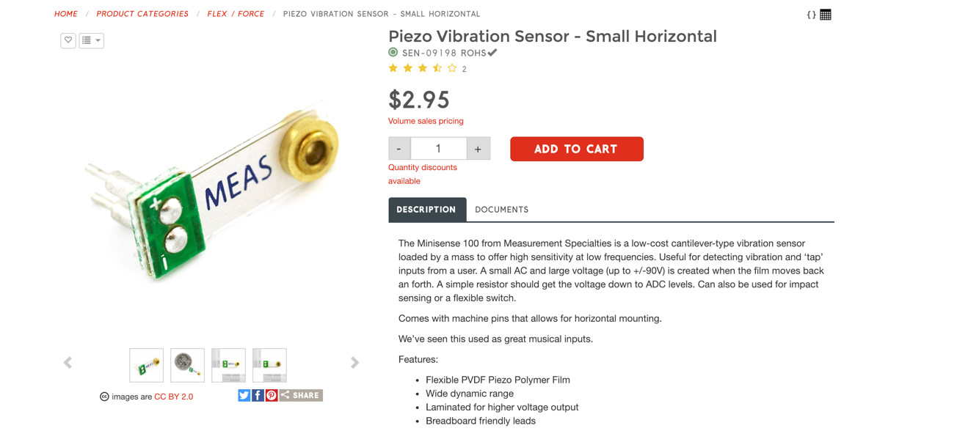

PROJECT1: An Air Quality character.

When the air quality turns into bad, the character‘s face would change into red(led). When quality turns into good, the face turns into blue.

Project2: A release pressure toy

When you tap the toy, the toy will scream.

Matrixes

Charlieplexing

Vibration motor.

