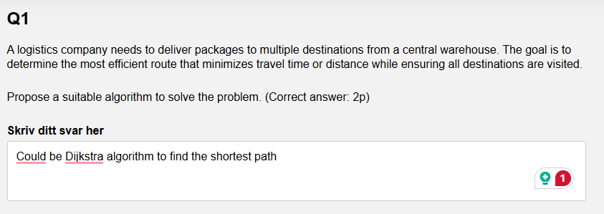

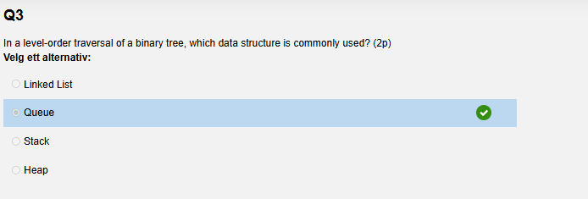
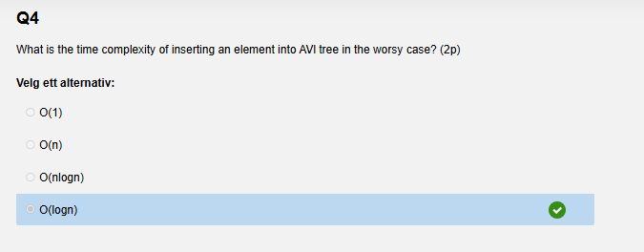
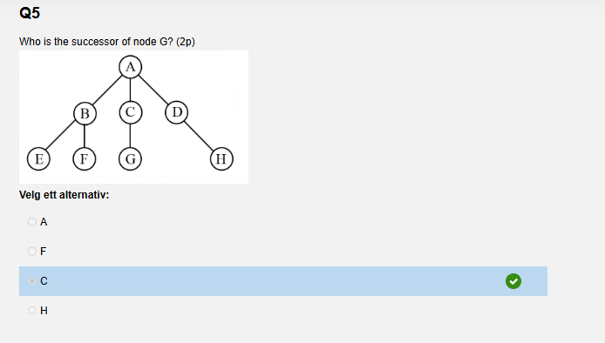
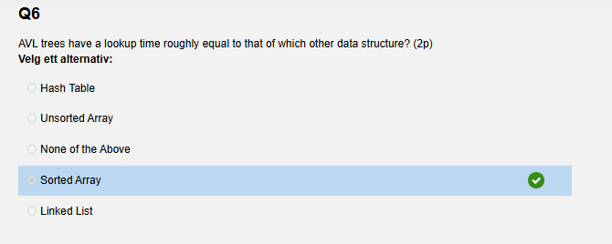
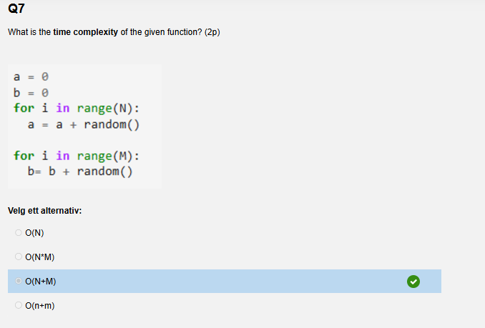
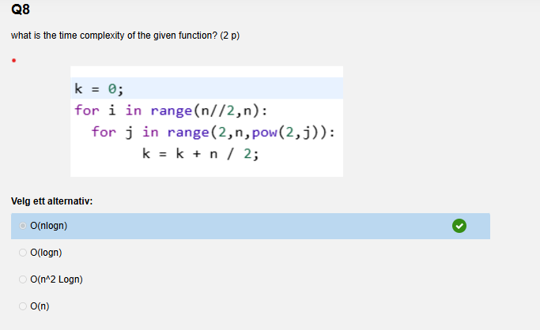
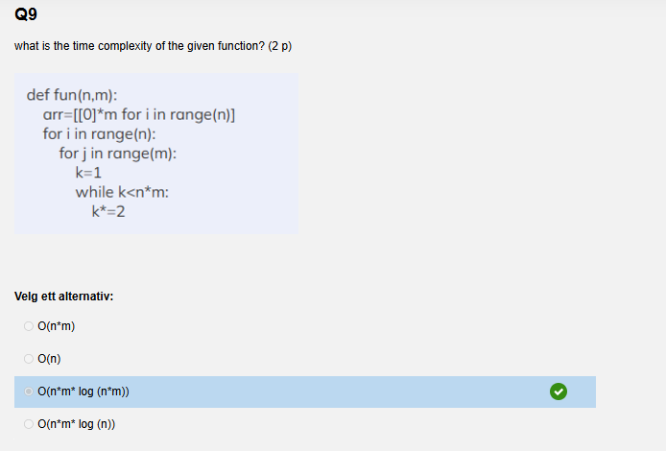
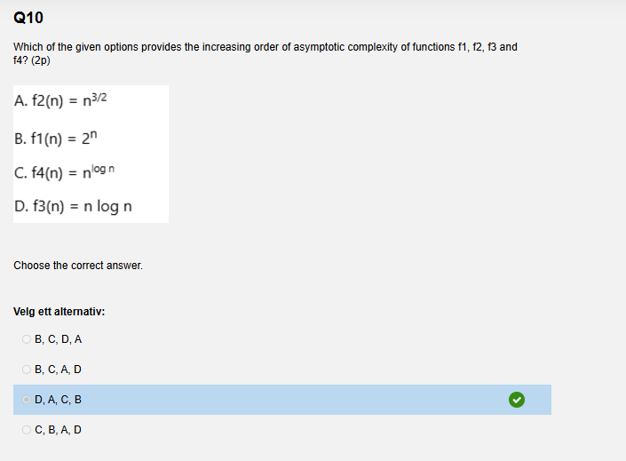
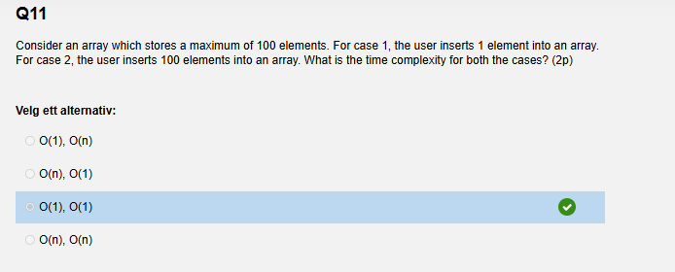
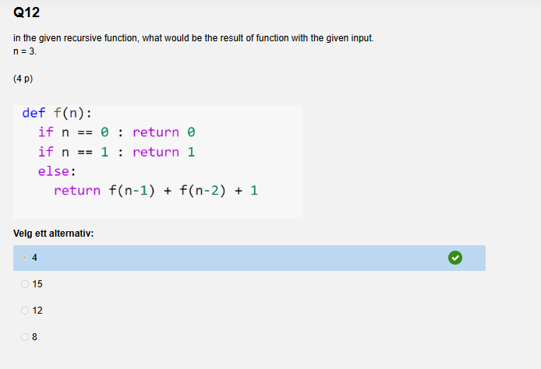
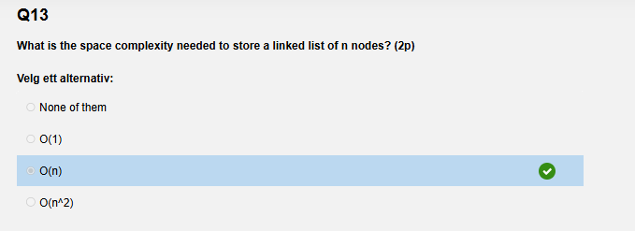
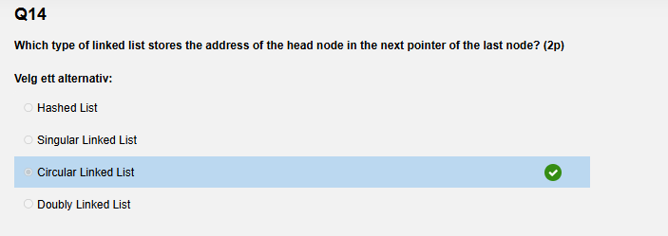
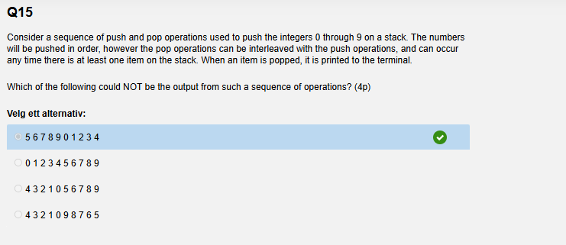
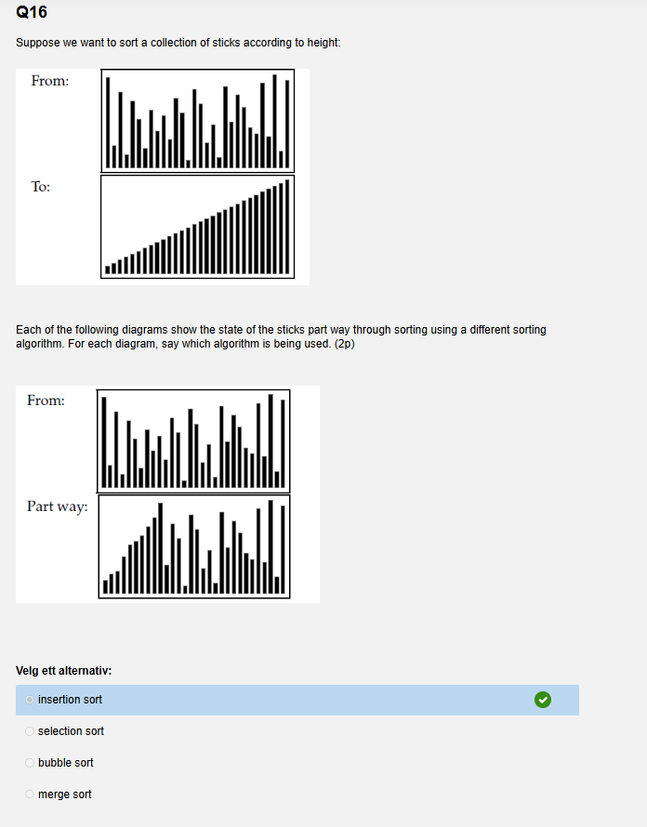
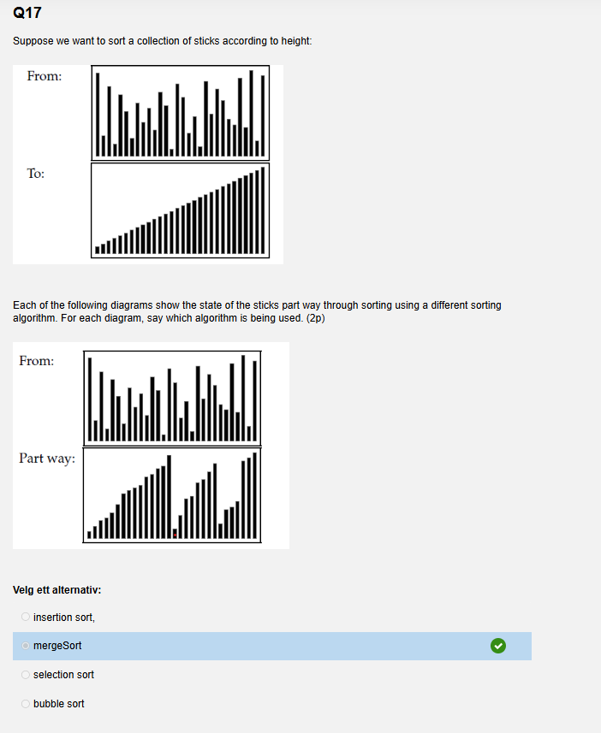
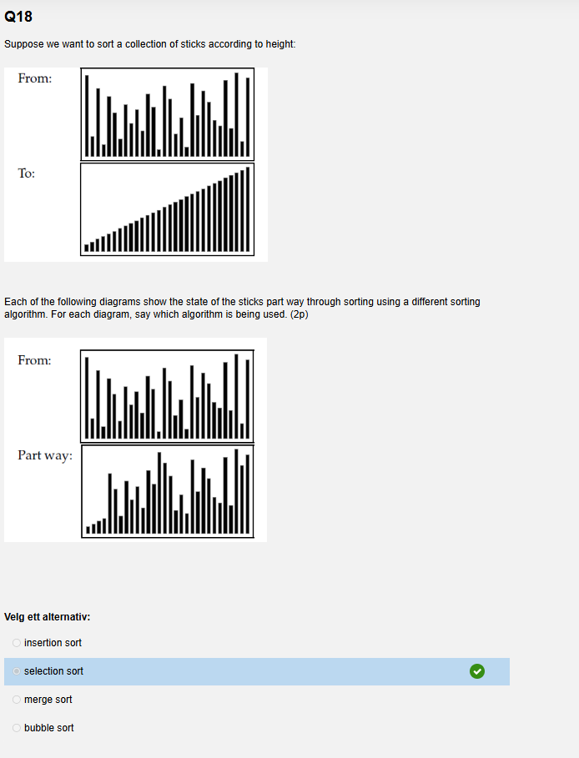
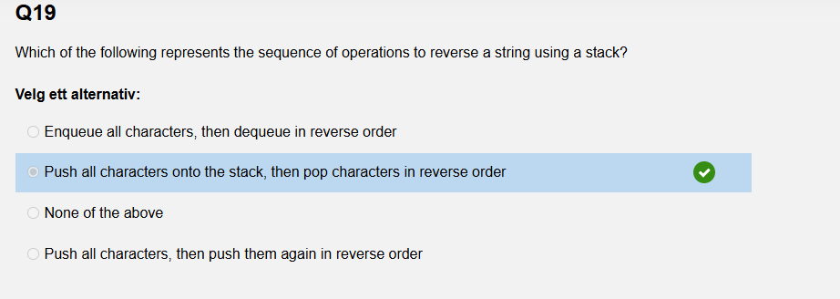

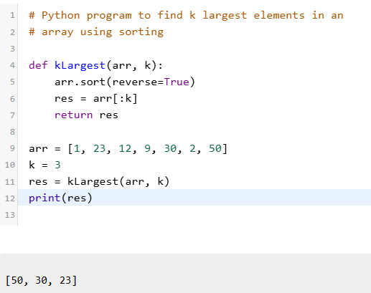

///////////////////////////////////////////////////////
The given function is going to find the sum of the values of the nodes in the singly linked list. Fill in the blank.

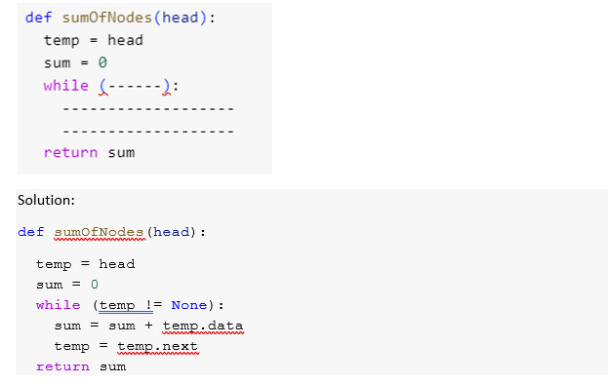
////////////////////////
Trace the Quicksort algorithm over the array here. A = [ 45,23,87,12,72,4,54,32,52]
What would be the array after the first complete iteration? Take 45 as pivot.
A = [4,23,32,12,45,72,54,87,52]
//////////////////////////////////////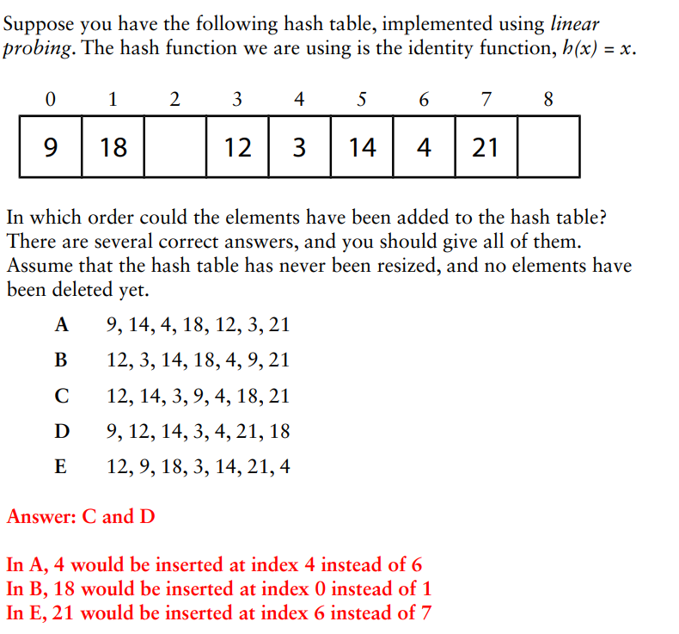
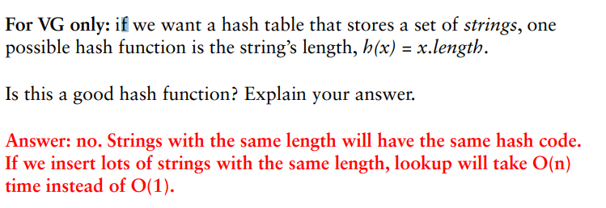
//////////////////////////////////

/////////////////////////////////////
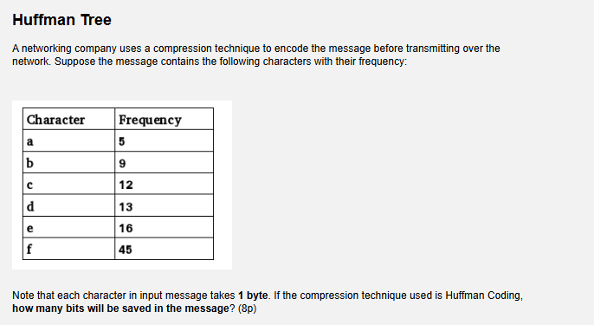
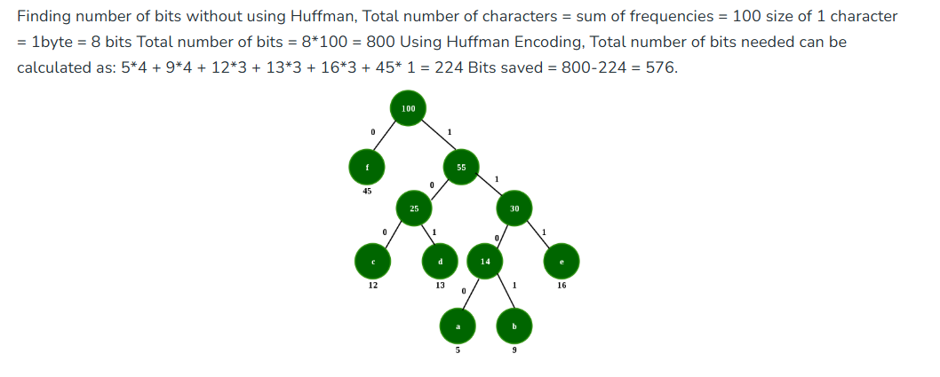
A 1100
B 1101
C 100
D 101
E 111
F 0

/////////////////////////////////////////////////////////////////
/////////////////////////////////////
Reconstructing the tree based on the given pre-order and in-order traversal.
Find the post order traversal for the tree later on.
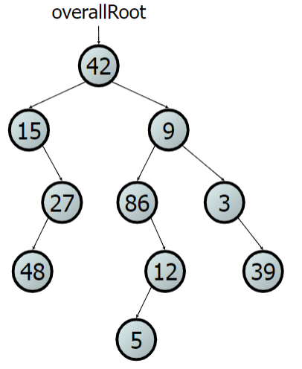
Pre: 42,15,27,48,9,86,12,5,3,39
in: 15,48,27,42,86,5,12,9,3,39

Post order = 48, 27, 15, 5, 12, 86, 39, 3, 9, 42

///////////////////////////////////////////////////////////////////
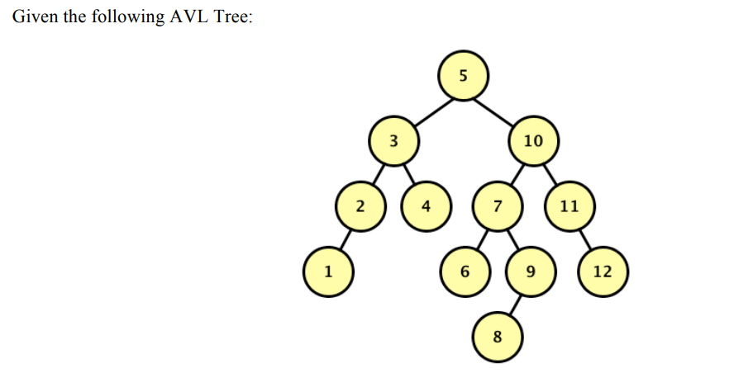
- Draw the resulting BST after 5 is removed, but before any rebalancing takes place. Label each node in the resulting tree with its balance factor. (4p)
Use paper and draw the tree on the sheet.

- Now rebalance the tree that results from (a). Draw a new tree for each rotation that occurs when rebalancing the AVL Tree. You do not need to label these trees with balance factors. (6p)
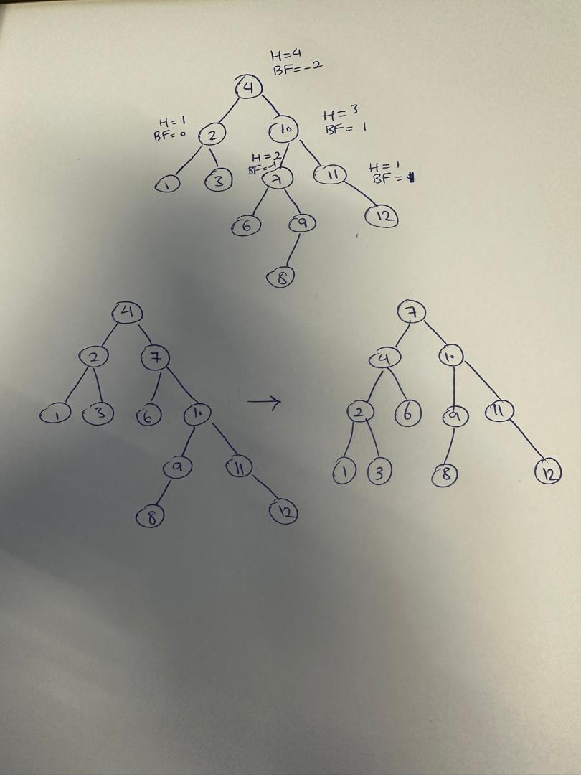

Or

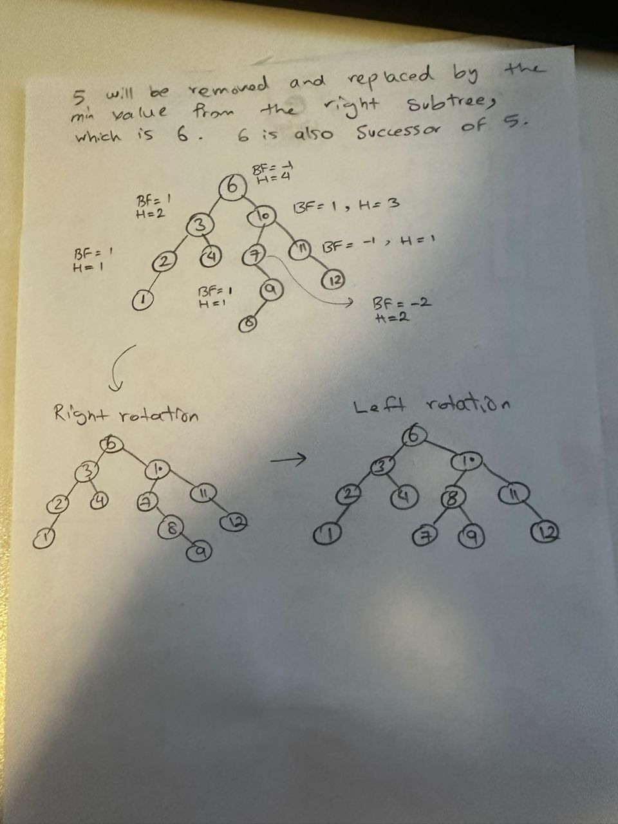
//////////////////////////////////////////////////
a) Draw the graph corresponding to the following list of edges. You should draw the graph on the sheet. (4p)
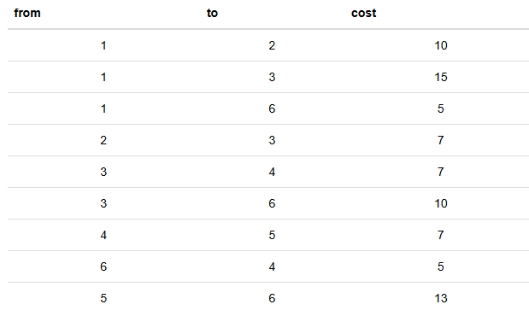

Solution:
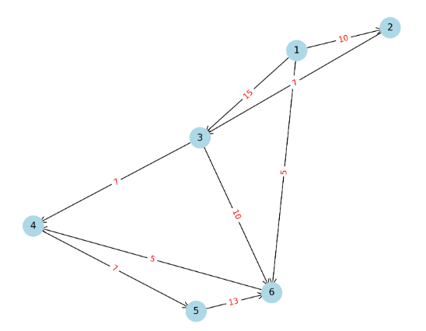

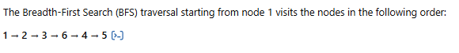
//////////////////////////////////////////////////
Consider the graph you have drawn in the previous question. Show each step in applying Dijkstra’s algorithm to the graph to find the shortest path starting from node 1 to other nodes. Please the shortest path clearly. (4p)
 | 2 | 3 | 4 | 5 | 6
1 | 10 | 15 | 10 | 17 | 5

///////////////////////////
Using Prim’s algorithm, find the minimum weight spanning tree for the graph (6p)
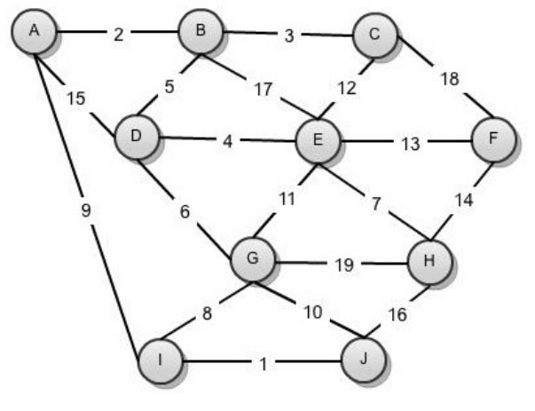

Solution: 2 + 3 + 5 + 4 + 13 +6 +7 +8 +1 = 49
