NexusCon
Three-day gaming convention.

Sergio Ferreira 25247418
Rafael de Gouveia 25054903
Johannes van Rensburg 25407725
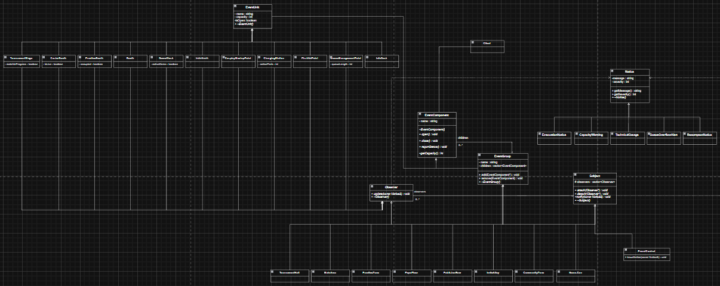

Task 1:
  - Event name: NexusCon — a three-day gaming convention

NexusCon is a large-scale gaming convention, which includes competitive esports tournaments, a publisher/indie expo floor, and community-based activities. The event runs across multiple halls and outdoor areas, with thousands of attendees moving between zones. Because tournaments run on live schedules, expo booths run demo hardware continuously, and the event must respond to real-time issues (technical issues, capacity overflows, safety alerts), the venue needs both a nested spatial structure (to organise and query areas) and a notification structure (so necessary changes spread quickly to only their relevant areas).
The event is organised as a tree of nested areas. At the top level, NexusCon contains three major zones: the Tournament Hall (competitive play), the Expo Floor (publisher and indie exhibits), and the Community Zone (community and support services). Each of these zones contains further sub-zones, giving the event depth — a change at the top (e.g. an evacuation) must go through multiple levels before reaching the units that actually need to act on it, while a small/narrow change (e.g. one hall's Wi-Fi failing) should only affect that specific hall's subtree.

At least 3 kinds of grouping:
- Venue root: The entire convention itself, treated as a Composite so client can call several functions on the entire event when necessary.
- Zone: top-level operational areas of the convention.
- Sub-zone: sub-areas within a zone, which group related units.

At least 5 concrete event units:
- Tournament Stage: hosts live competitive matches; can pause/resume matches.
- Caster Booth: broadcasts commentary and streams footage.
- Booth: exhibit stand to show off merchandise, and make announcements
- Demo Kiosk: exhibit for showing demonstrations of hardware.
- Charging Station: area where attendees can charge their devices.
- Queue Management Point: manages queues for popular attractions.
- First Aid Point: Remains open at all times for potential medical emergencies.

  - Composite:
- Component: EventComponent
- Leaf: Tournament Stage, Caster Booth, Booth, Demo Kiosk, Charging Station, Queue Management Point, First Aid Point, Indie Booth, CosplayMeetupPoint, InfoDesk
- Composite: NexusCon, TournamentHall, MainArea, PracticeZone, ExpoFloor, PublisherRow, IndieAlley, CommunityZone
- Client: main.cpp

Observer:
- Subject: Subject
- Observer: Observer
- ConcreteSubject: EventControl, and each of Nexuscon, TournamentHall, MainArea, PracticeZone, ExpoFloor, PublisherRow, IndieAlley, CommunityZone
- ConcreteObject: TournamentStage, CasterBooth, Booth, DemoKiosk, IndieBooth, CosplayMeetupPoint, ChargingStation, FirstAidPoint, QueueManagementPoint, and each of TournamentHall, MainArena, PracticeZone, ExpoFloor, PublisherRow, IndieAlley, CommunityZone

Classes with more than 1 role:
- NexusCon:
- Composite: aggregates TournamentHall, ExpoFloor, CommunityZone as children
- ConcreteSubject: When receiving alert, it calls notify() on TournamentHall, ExpoFloor, CommunityZone
- TournamentHall:
- Composite: aggregates MainArea and PracticeZone as children
- ConcreteObserver: reacts in its own update() when notified by Nexuscon
- ConcreteSubject: calls notify() on MainArea and PracticeZone after handling its own update()

- MainArea:
- Composite: aggregates TournamentStage and CasterBooth
- ConcreteObserver: registered with TournamentHall
- ConcreteSubject: calls notify() on TournamentStage and CasterBooth

- PracticeZone:
- Composite: aggregates PracticeBooth
- ConcreteObserver: registered with TournamentHall
- ConcreteSubject: calls notify() on PracticeBooth

- ExpoFloor:
- Composite: aggregates PublisherRow and IndieAlley
- ConcreteObserver: registered with NexusCon
- ConcreteSubject: calls notify() on PublisherRow and IndieAlley

- PublisherRow:
- Composite: aggregates Booth and DemoKiosk
- ConcreteObserver: registered with ExpoFloor
- ConcreteSubject: calls notify() on Booth and DemoKiosk

- IndieAlley:
- Composite: aggregates IndieBooth
- ConcreteObserver: registered with ExpoFloor
- ConcreteSubject: calls notify() on IndieBooth

- CommunityZone:
- Composite: aggregates CosplayMeetupPoint, ChargingStation, InfoDesk, FirstAidPoint, QueueManagementPoint
- ConcreteObserver: registered with NexusCon
- ConcreteSubject: calls notify() on its 5 children (stated above)

  - a) An EventGroup (e.g. PublisherRow) doesn’t simply reference its children — it cannot exist independently of the structure once built. Deleting PublisherRow should delete its Booth and Demo Kiosk instances (they have no independent lifetime outside their parent). Calling a function like getCapacity() on PublisherRow produces a value produced entirely from its parts. This is a part-whole relationship (composition, not aggregation); the whole owns and is defined by its parts, not just linked to them with references.

b) EventControl (or any EventGroup) does not know in advance which leaves or sub-areas exist, how many there are, or which of them care about which alert type — that set changes at runtime (units close for the night and reopen, new booths can register). If EventControl hard-coded calls to TournamentStage::update(), Booth::update(), etc., it would need to know every concrete class, making the design impossible to extend without changing the co-ordinator. Observer decouples the alert source from the alert recipients: the Subject only needs to know it holds a list of Observer*, and any new leaf type can participate simply by implementing Observer and calling attach() — no existing code changes.

c) EventGroup owns its children using composition — it stores raw pointers to EventComponent and deletes them in its own destructor.

d) Subject does not own its observers. It holds Observer pointers purely to know who to notify, but the actual object lifetime is managed by the Composite ownership described above (an EventGroup node is often both a Composite-owned child and an attached Observer of its parent). If Subject also deleted its observers, the same object could be deleted twice —by its Composite parent and by the Subject it was attached to — causing a double-free. Subject's destructor therefore only clears its observer list, never calls delete on the pointers it holds.

e) Each role serves a distinct role with a distinct interface and a distinct set of collaborators. When TournamentHall acts as an Observer, it is participating in a collaboration with its parent (NexusCon/EventControl). When the same object acts as a Subject, it is participating in a separate collaboration with its own children. These are two independent relationships that happen to be implemented by the same object because, structurally, a mid-tree zone is positioned between an alert source and other recipients. The patterns are not merged into one: update() and notify() are distinct operations, and called by different collaborators, over different observer lists.

Task 2:
2.3) 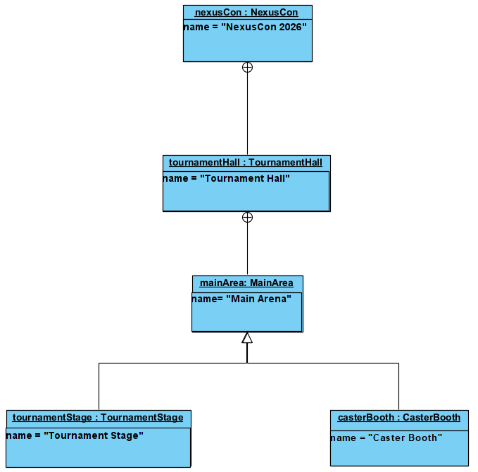

2.4) Calling delete NexusCon invokes EventGroup::~EventGroup(), which iterates its children vector and calls delete on each pointer. Because TournamentHall, ExpoFloor, and CommunityZone are themselves EventGroup-derived objects, deleting them triggers the same destructor recursively on their own children (CasterBooth, PublisherRow, IndieAlley, etc.), which continues down to the leaves (TournamentStage, Booth, DemoKiosk, and so on), where ~EventUnit() and each leaf's own destructor run.
Every object is deleted exactly once because every EventComponent* in the tree is stored in the children vector of exactly one parent — no object is ever add()ed to two different EventGroups simultaneously in this design. Since ownership is non-shared, the recursion visits each node exactly once as it travels the tree depth-first, and there is no path by which the same pointer could be reached and deleted a second time.
This is also why Subject's destructor (on TournamentHall, etc.) is safe alongside this: it only clears its observers list, it never calls delete on the pointers it holds — because those same objects are also Composite-owned children elsewhere in the tree, and deleting them a second time via the observer list would cause a double-free. This is precisely why 1.4(d)'s ownership split (Composite owns, Subject does not) is important.

Task 5:
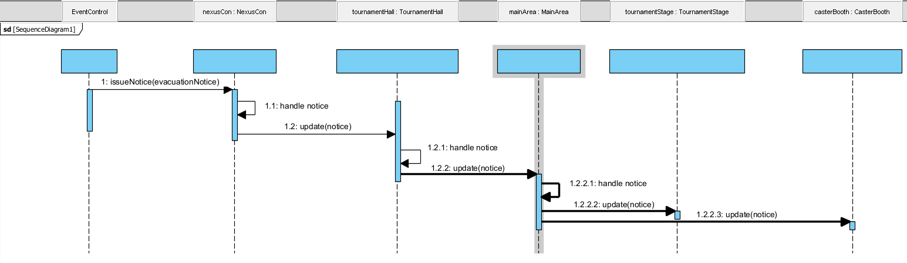
5.1)

