Task assignment.

1)Analyze the structure of the /etc/passwd and /etc/group file, what fields are present in it, what users exist on the system? Specify several pseudo-users, how to define them?

/etc/passwd has following file format:  
user, encrypted password (or x if use /etc/shadow), user ID, Group ID (users can be in several groups), comments, home directory,

/etc/group:  
group name, encrypted password (or x if use /etc/shadow), group ID number, optional list of user IDs.

2)What are the uid ranges? What is UID? How to define it(SETUID )?

UID – user identifier.

UID helps OS to recognize the user (not login). UID range 0-232.  
root always has UID 0, nobody mainly has UID opposite to root (for example 65535).

UIDs from 0 to 100 are reserved for system needs.

3)What is GID? How to define it(SETGID).?  
GID – group identifier. It is comfortable for OS way to express group which related with process, file, etc   
GID is defined by 4 numbers which separately means access rights.

4)How to determine belonging of user to the specific group?

5)What are the commands for adding a user to the system? What are the basic parameters required to create a user?

Useradd

6)How do I change the name (account name) of an existing user?

Usermod -l newusername oldusername

7)What is skell_dir? What is its structure?

The /etc/skel directory contains files and directories that are automatically copied over to a new user’s when it is created from useradd command.

8)How to remove a user from the system (including his mailbox)?  
sudo deluser --remove-home username

9)What commands and keys should be used to lock and unlock a user account?

Lock  
passwd -l username  
usermod -l username  
  
unlock  
passwd -u username  
usermod -U username

10)How to remove a user's password and provide him with a password-free login for subsequent password change?

11)Display the extended format of information about the directory, tell about the information columns displayed on the terminal.

12)What access rights exist and for whom (i. e., describe the main roles)? Briefly describe the acronym for access rights.

13)What is the sequence of defining the relationship between the file and the user?

**1.**read the file

**2.**write to the file

**3.**execute the file

14)What commands are used to change the owner of a file (directory), as well as the mode of access to the file? Give examples, demonstrate on the terminal.

chown

15)What is an example of octal representation of access rights? Describe the umask command.

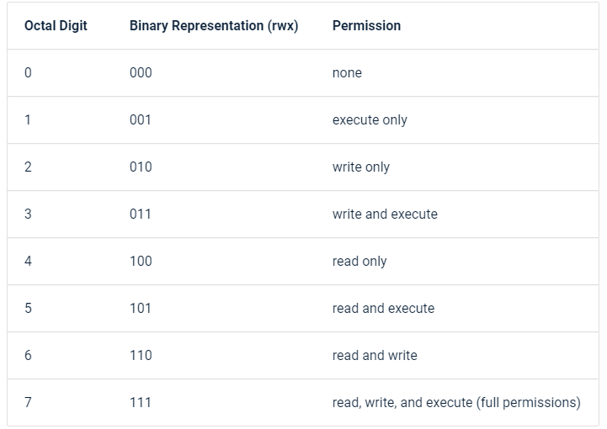

16)Give definitions of sticky bits and mechanism of identifier substitution. Give an example of files and directories with these attributes.

A Sticky bit is a permission bit that is set on a file or a directory that lets only the owner of the file/directory or the root user to delete or rename the file.  
  
mkdir all

Chmod 777 all

Ls -ld all  
  
if another user (instead root) tries to rename, delete … file l.txt error will appear

17)What file attributes should be present in the command script?