Part1

1. How many states could has a process in Linux?

Basically 5 status  
R – running

S – sleeping

D - Uninterruptible Sleep   
T- stopped  
Z –zombie

I-idle

2. Examine the pstree command. Make output (highlight) the chain (ancestors) of the current process.

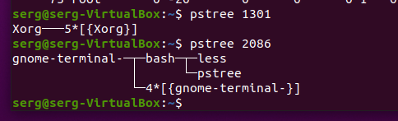

3. What is a proc file system?

The proc filesystem (procfs) is a special filesystem in Unix OS that presents information about processes and system information in a hierarchical structure, providing a more convenient method for dynamically accessing process data held in the kernel than traditional tracing methods or direct access to kernel memor

4. Print information about the processor (its type, supported technologies, etc.).

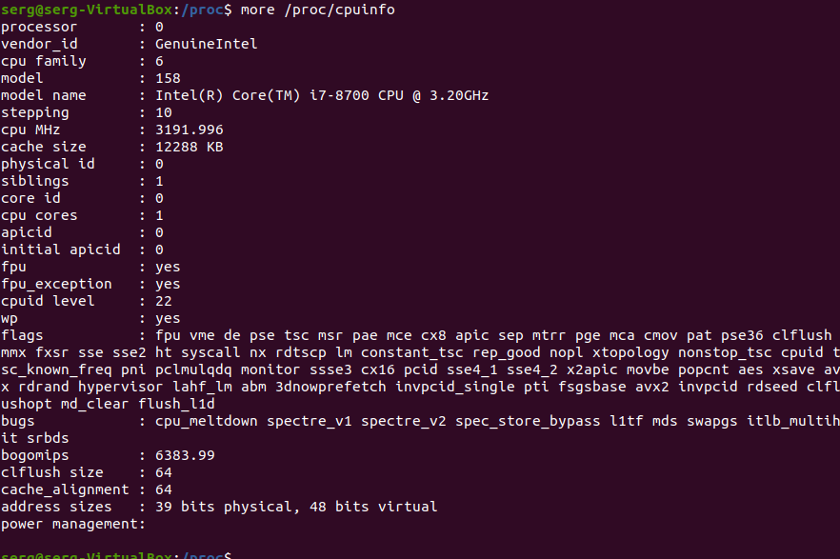

5. Use the ps command to get information about the process. The information should be as follows: the owner of the process, the arguments with which the process was launched for execution, the group owner of this process, etc.

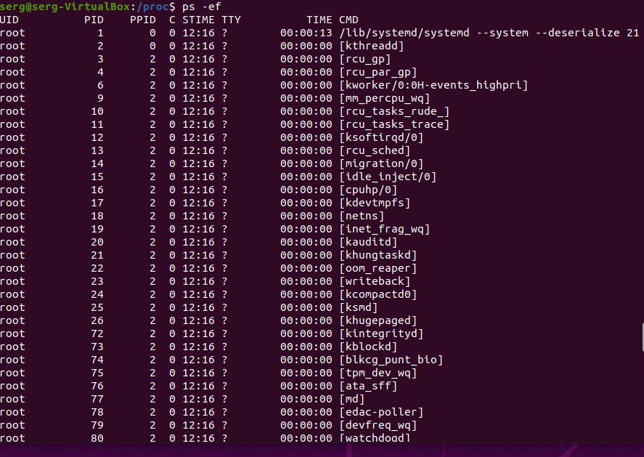

6. How to define kernel processes and user processes?

Kernel processes or threads do not have their own address space, they operate within kernel address space only. And they may be started before the kernel has started any user process (e.g. init).

7. Print the list of processes to the terminal. Briefly describe the statuses of the processes. What condition are they in, or can they be arriving in?

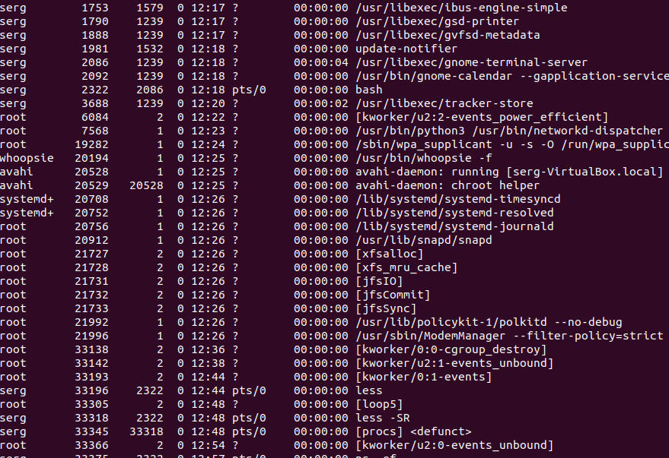

8. Display only the processes of a specific user.

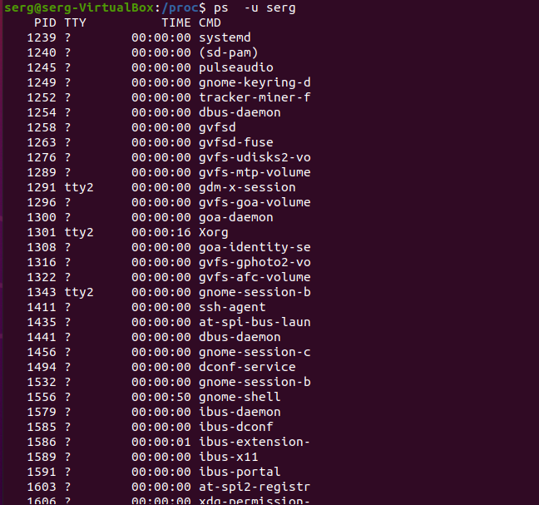

9. What utilities can be used to analyze existing running tasks (by analyzing the help for the ps command)?

10. What information does top command display?

top command displays **processor activity of your Linux box and also displays tasks managed by kernel in real-time**

11. Display the processes of the specific user using the top command.

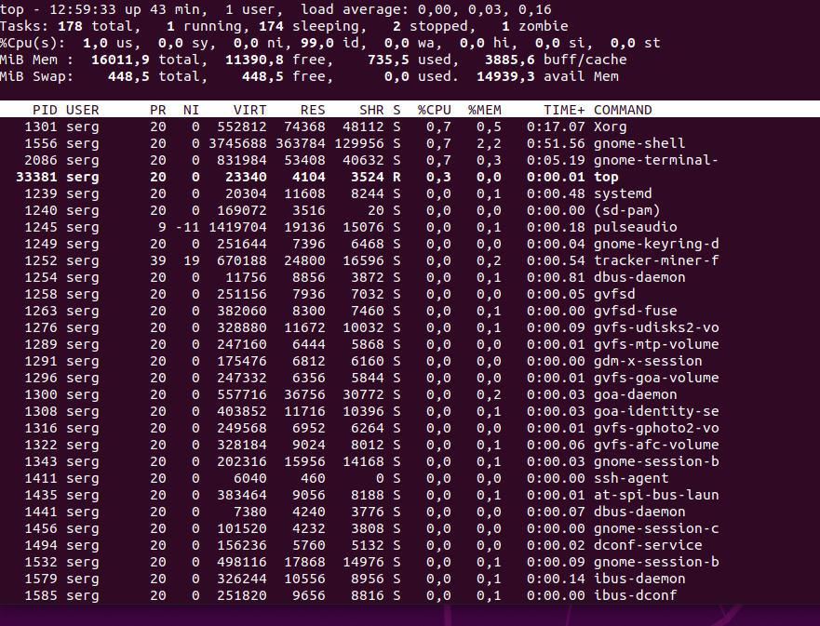

12. What interactive commands can be used to control the top command? Give a couple of examples.

л



Shift + P

top -n 1 -b > top-output.txt

13. Sort the contents of the processes window using various parameters (for example, the amount of processor time taken up, etc.)

14. Concept of priority, what commands are used to set priority?

nice

15. Can I change the priority of a process using the top command? If so, how?

renice -n - -p

16. Examine the kill command. How to send with the kill command process control signal? Give an example of commonly used signals.

sudo kill -9 process_id

killall program_name

SIGINT (Ctrl + C) – You know this already. Pressing Ctrl + C kills the running foreground process. This sends the SIGINT to the process to kill it.

You can send SIGQUIT signal to a process by pressing Ctrl + \ or Ctrl + Y

17. Commands jobs, fg, bg, nohup. What are they for? Use the sleep, yes command to demonstrate the process control mechanism with fg, bg.

Part2

1. Check the implementability of the most frequently used OPENSSH commands in the MS Windows operating system. (Description of the expected result of the commands + screenshots: command – result should be presented)s

2. Implement basic SSH settings to increase the security of the client-server connection (at least 3. List the options for choosing keys for encryption in SSH. Implement

3 of them.4. Implement port forwarding for the SSH client from the host machine to the guest Linux virtual machine behind NAT.5*. Intercept (capture) traffic (tcpdump, wireshark) while authorizing the remote client on the server using ssh, telnet, rlogin. Analyze the result.

