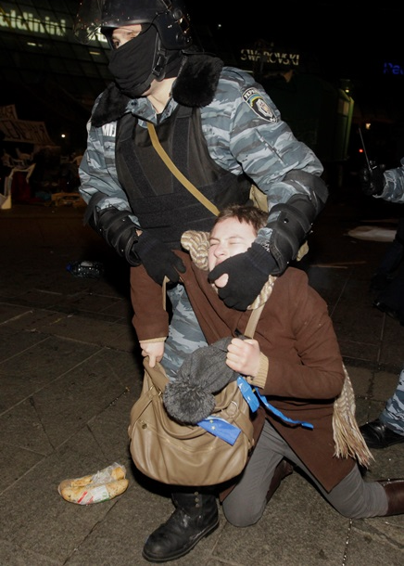

http://korrespondent.net/ukraine/politics/3273751-kak-eto-bylo-foto-s-maidana-za-polchasa-do-y-posle-razghona-mytynhuuischykh-berkutom