MMDQ-codec

Content

- Overview
- MMDQ-codec description
- MATLAB simulation of MMDQ-codec
- C-language implementation of MMDQ-codec
- Comparing MMDQ with G.711 and G.726

1.Overview

This document contains short description of Min-Max-Difference-Quantization (MMDQ) codec.

2.MMDQ-codec description

MMDQ-codec has been created as very low MIPS (i.e. very low CPU usage) alternative of G.726-32 (ADPCM codec with 32 kbits/sec bitrate, 8000 Hz sample rate).

Main properties of MMDQ-codec:

- Very low MIPS (CPU usage)
- Waveform lossy compression
- No restoration delay after corrupter/lost received frame (Note: G.726 has this).
- Transparancy for fax (up to ???? bod) or DTMF signals (for bitrates >= 32 kbits/sec)
- Easy adaptation to other bitrates or/and sample rates
- Algorithm simplicity

2.1. Min-Max-Differencies-Quantization Frame Format

Note: MATLAB/Octave/FreeMat array index notation is used, so index of first array element is 1 (not 0)!

Encoded data frame has next format:

MINX/MAXX
MAXX/MINX
SMOOTH-BITS[2..S]
DIFF[1..(N-1)]

Where:

MINX - minimal signal value in signal frame to be encoded (it may be encoded by A-law/mu-law encoder or by other compander method)

MINX - maximal signal value in signal frame to be encoded (it may be encoded by A-law/mu-law encoder or by other compander method)

Note: if MINX is first and MAXX is next, decoder must set SMOOTH-BIT[0]=0,
if MAXX is first and MINX is next decoder must set SMOOTH-BIT[0]=1.

S - total number of smooth bits.

SMOOTH-BITS[1..S] - array of smooth bits. Smooth bits define code of decoder function/table will be used to restore linear differencies from DIFF[] array elements.

N - number of signal samples in single frame to be encoded.

DIFF[1..(N-1)] - array of companded relative differencies between signal samples.

For example, 32 kbits/sec version of MMDQ-codec encoded data frame format is:

MINX (8 bits) - A-law companded signal value
MAXX (8 bits) - A-law companded signal value
SMOOTH-BITS (1 bit) - smooth bit number 2 (number 1 is defined by MIN/MAX order).
DIFF[1..13] (13*3=39 bits) - differencies (3 bits per difference, samples per frame is 14).

Total frame size (for 14 voice samples to be encoded) is 8+8+1+39=56 bits (7 bytes).

2.2.MMDQ Algorithm Description

Note: MATLAB/Octave/FreeMat array index notation is used, so index of first array element is 1 (not 0)!

Encoding:

- Get sound samples X[i], i=1..N in linear format (these may be decoded A-law).
- Find MINX, MAXX over X[i], i=1..N
- Calculate DIFFX=MAXX-MINX
- Calculate DX[i]=X[i+1]-X[i], i=1..(N-1)
- Get AMPDX = max(abs(DX[i])), i=1..(N-1) - maximum amplitude of DX[i].
- For every difference companding function DV[s]=F[s](DX), s=1..SMOOTH_N calculate maximum reconstruction error ERR[s]:

6.1. Get DV[s][i]=F[s](DX[i]), i=1..(N-1)
Note: different companding functions F[s](DX) are used to minimize encode/decode reconstruction error.

Default F[s](DX) is linear function:
F[s](DX)=DX

6.2. Quantize DV[i] into DIFF[i] values. Here i=1..(N-1). If encoder use
BITS bits per difference, then DIFF[i] will be of range [0..(FACTOR-1)],
where FACTOR=2^BITS.
Approximate quantization function is: DIFF[i]=FACTOR*DV[i]/AMPDX + FACTOR/2,
where i=1..(N-1).

Note special case: AMPDX==0

6.2. Prepare data_frame[s] for MINX, MAXX, SMOOTH==s, DIFF[s][i], i=1..(N-1)

Note: if SMOOTH(bit0)==0, put MINX first, MAXX second.
If SMOOTH(bit0)==1, put MAXX first, MINX second.

6.3. Decode data_frame[s] into sound waveform: Y[s][i], i=1..N

6.4. Calculate ERR[s]=max(abs(X[i]-Y[s][i])), i=1..N

7.Find MINERR=min(ERR[s]), s=1..SMOOTH_N. Let's s0 - SMOOTH for
data_frame with best (minimal) reconstruction error: ERR[s0]=MINERR.

8.Ouput data_frame[s0].

--------------------------------------------------------------------------------

Decoding:

1.Get encoded data: data_frame=B[k], k=1..M (M-total size of data, bits).

2.Get MINX, MAXX, SMOOTH_BIT[1..s], DIFF[1..(N-1)] from data_frame.
For example, for 32 kbits/sec 8000 Hz format:

M1=B[1..8]
M2=B[9..16]
if M1<=M2
SMOOTH_BIT[1]=0
MINX=M1
MAXX=M2
else
SMOOTH_BIT[1]=1
MINX=M2
MAXX=M1
end
SMOOTH_BIT[2]=B[17]
i=1
k=18
while(k<=M)
DIFF[i]=B[k..k+2]
i=i+1
k=k+3
end

3.Calculate used smooth: s0=SMOOTH_BIT[1..s]

4.Calculate DIFFX=MAXX-MINXX

5.Calculate first estimation of sound samples values:
Y[1]=0
for i=2:N
DY = R[s0]( 2*DIFF[i-1]/FACTOR - 1 )
Y[i] = Y[i-1] + DY
end

Where DY=R[s](DIFF) is difference decompanding function for defined smooth s0.
This function is inverse for DIFF=F[s](DY).

6.Find MINY, MAXY over Y[i], i=1..N.

7.Calculate DIFFY=MAXY-MINY

8.Scale and shift Y[i], i=1..N to the range [MINX..MAXX] by formula:

for i=1:N
Y[i] = DIFFX * ( Y[i]-MINY ) / DIFFY + MINX
end

Note special case: DIFFY==0

3.MATLAB simulation of MMDQ-codec

MMDQ-codec has been implemented in MATLAB/Octave/FreeMat. All source code is available. There are two main implementations: floating point (CODEC_VERSION=1) and fixed point (CODEC_VERSION=2). Fixed point implementation works with precalculated tables for encoding and decoding and table for integer division. 16-bit, 32-bit and 64-bit integer arithmetics is used. Fixed point implementation was used as base code for C-language implementation. It has a (very) little lower quality than floating point variant.

Both implementations have been tested and some results are described below.

Next results have been generated with main_test.m script for female sample and CODEC_VERSION=1, bitrate=32 kbit/sec (SAMPLES_PER_FRAME=14, BITS_PER_SAMPLE=3), SMOOTH_ON=1.

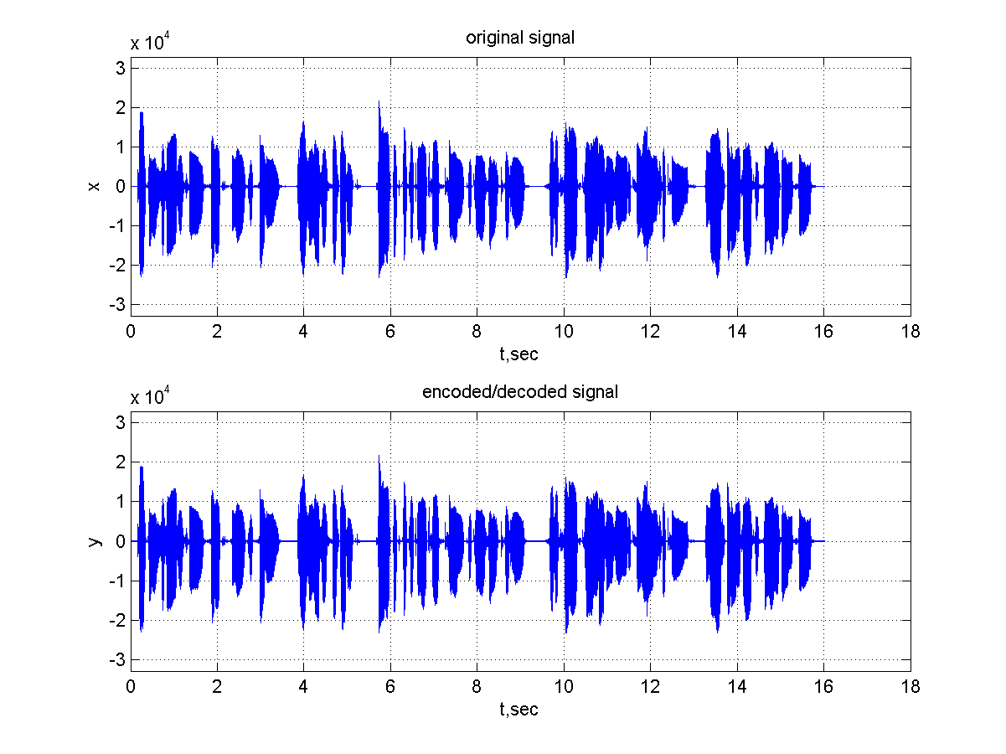
Figure 1. Original and encoded/decoded female voice sample waveforms

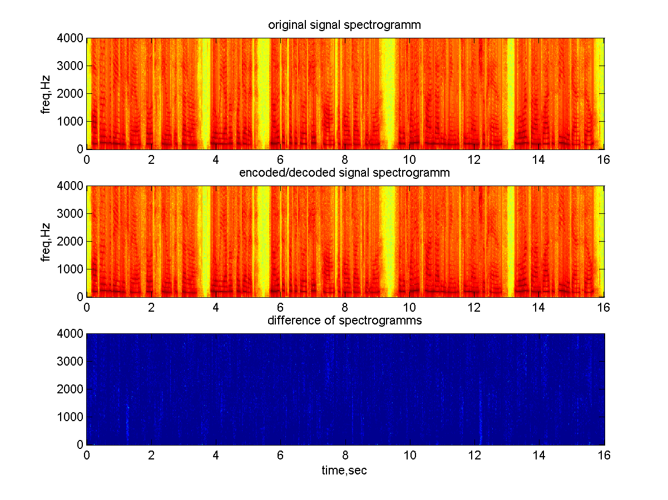
Figure 2. Original and encoded/decoded female voice sample spectrograms

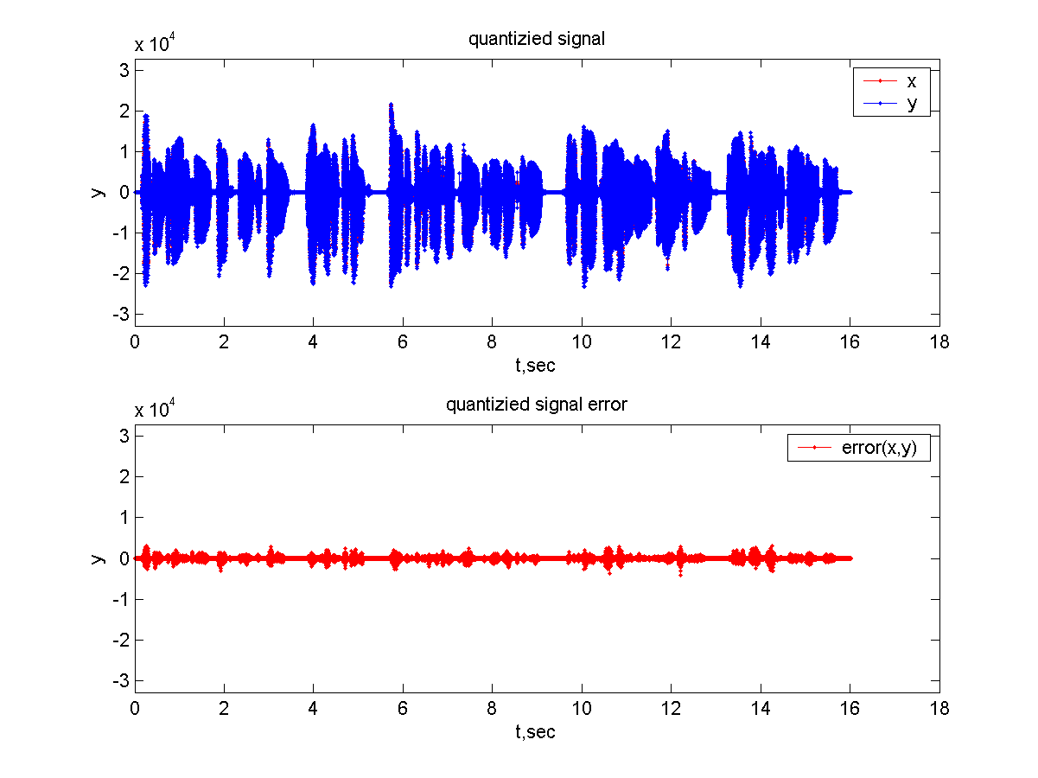
Figure 3. Original (x) and encoded/decoded (y) female voice sample waveform (quantized signal) and absolute errors (quantized signal error)

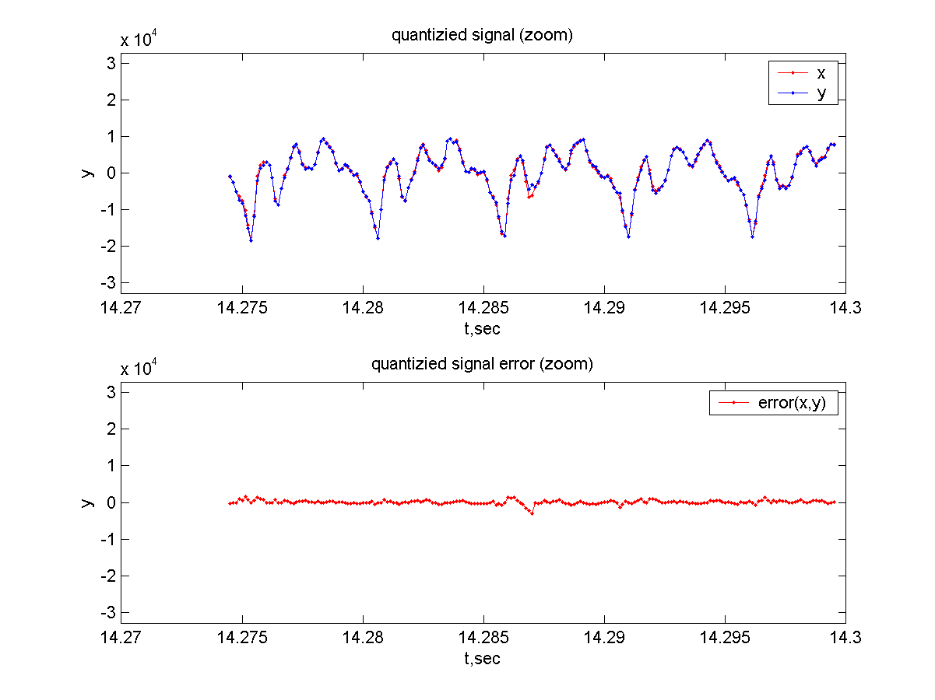
Figure 4. Original (x) and encoded/decoded (y) female voice sample waveform (quantized signal) and absolute errors (quantized signal error) near big error samples.

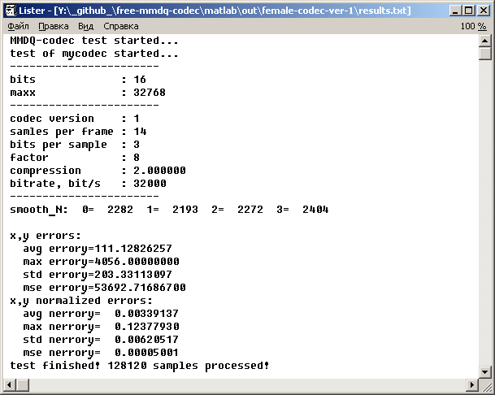
Figure 5. Text file with results of MMDQ-codec test for female sample.

Next table contains results for female, male, modem samples for both (floating-point and fixed-point) versions of MMDQ-codec.

Table 1. Results of MMDQ-codec MATLAB simulation

sample | Max normalized error |  | MSE
sample | Codec ver.1 | Codec ver.2 | Codec ver.1 | Codec ver.2
female | 0.12377930 | 0.12374878 | 0.00005001 | 0.00005006
male | 0.13555908 | 0.13562012 | 0.00006900 | 0.00006883
modem | 0.70791626 | 0.70791626 | 0.00540838 | 0.00540749

4.C-language implementation of MMDQ-codec

MMDQ-codec has been implemented in C-language and compiled with GCC in Linux.

5.Comparing MMDQ with G.711 and G.726

Next tables and plots contain results of comparing G.711, G.726, MMDQ codecs. C-language implementations of these codecs has been used.

Table 2. Comparing of codecs results (MSE)

codec | female | male | modem (psk8)
G.711 A-law | 0.00000314 | 0.00000191 | 0.000039
G.711 mu-law | 0.00000326 | 0.00000202 | 0.000042
G.726-32 | 0.00002662 | 0.00002580 | 0.020866
G.726-40 | 0.00001206 | 0.00001418 | 0.003685
MMDQ-32 | 0.00001920 | 0.00001956 | 0.014622
MMDQ-32 no smooth | 0.00003469 | 0.00003712 | 0.022521
MMDQ-40 | 0.00001995 | 0.00001761 | 0.004886
MMDQ-40 no smooth | 0.00002568 | 0.00002429 | 0.007104
MMDQ-40x | 0.00001920 | 0.00001956 | 0.006325
MMDQ-40x no smooth | 0.00003469 | 0.00003712 | 0.010453

To evaluate codecs speed very long wave-file (60.0 minutes / 57 MB) has been encoded/decoded with every codec. Results are in Table 3.

Table 3. Comparing of codecs results (speed)

codec | Encode time, ms | Decode time, ms | MSE
G.711 A-law | 1838 | 3346 | 0.000002
G.711 mu-law | 1926 | 3693 | 0.000002
G.726-32 | 7770 | 9368 | 0.000031
G.726-40 | 7680 | 7606 | 0.000018
MMDQ-32 | 3224 | 1059 | 0.000069
MMDQ-32 no smooth | 1187 | 1237 | 0.000130
MMDQ-40 | 3338 | 1254 | 0.000020
MMDQ-40 no smooth | 1276 | 1979 | 0.000029
MMDQ-40x | 3704 | 1601 | 0.000022
MMDQ-40x no smooth | 1469 | 1824 | 0.000040

NOTE: It seems, that such test is not fine, because of hard disk access time. For example, files, that is compressed with MMDQ/G.726 codecs, have smaller size than G.711 files, so, decode time of G.711 codec is much bigger.

It is obviously, that MMDQ encoder with disabled smoothing is about 3 time faster, than with enabled one. But error is about 2 time bigger without smoothing.

Size of compressed MMDQ and G.726 files are equal, so disk access times are equal.

So it seems that current C-language implementation of MMDQ encoder with enabled smoothing is about 2.4 time faster than G.726 encoder, and MMDQ encoder with disabled smoothing is about 6.4 time faster than G.726 encoder.

So it seems that current C-language implementation of MMDQ decoder is about 6.4 time faster than G.726 decoder.

6.Modem signal transparency of MMDQ and G.726 codecs

Sometimes we need to transmit modem signal over VoIP channel (for example, FAX signal), so we need to evaluate transparency of codec we used.

Modem signal samples for random input data (16000 words) have been generated with MATLAB Communications Toolbox. Then these signals were encoded/decoded and demodulated back. Results are in table:

Next table shows some modems standards characteristics:

Table. Modem recommendations and their simulation in MATLAB
Recom-mendation | Bit rate,  bit/s | Carrier frequency, Hz | Symbol rate, baud | Modula-tion | MATLAB Communications Toolbox function to model modem
- | - | - | - | - | ask2:  dmod(data,1600,1600,8000, 'ask',2)
V.21 | 300 | 1300,2100 | 300 | FSK | -
V.23 | 1200 | 1800 | 1200 | FSK | fsk2:  dmod(data,1600,1600,8000, 'fsk',2)
V.26 | 2400 | 1800 | 1200 | 4-DPSK | psk4:  dmod(data,1600,1600,8000, 'psk',4)
V.26 bis | 2400 | 1800 | 1200 | 4-DPSK | -
V.27 ter | 4800 | 1700 | 1600 | 8-DPSK | psk8:  dmod(data,1600,1600,8000, 'psk',8)
V.29 | 9600 | 1200,2400 | 2400 | 16-QAM | qask16:  dmod(data,1600,1600,8000, 'qask',16)
V.22 | 1200 | 1200,2400 | 600 | 4-DPSK | -
V.22 bis | 2400 | 1800 | 600 | 16-QAM | -
V.32 | 9600 | 1800 | 2400 | 16-QAM | qask16:  dmod(data,1600,1600,8000, 'qask',16)
V.33 | 14400 | 1800 | 2400 | 32-QAM | qask32:  dmod(data,1600,1600,8000, 'qask',32)
V.34 | 28800  31200  33600 |  | 2400  2800  3000  3200  3249 | 16-QAM  32-QAM  64-QAM | qask64:  dmod(data,1600,1600,8000, 'qask',64)

Table 4. Modem transparency of G.726-32 and MMDQ-32
modem | MSE |  | Error rate
modem | G.726-32 | MMDQ-32 | G.726-32 | MMDQ-32
ask2 | 0.092969 | 0.011311 | 0 | 0
fsk2 | 0.003321 | 0.023609 | 0 | 0
psk4 | 0.020406 | 0.016082 | 0 | 0
psk8 | 0.020866 | 0.014622 | 4 | 4
qask16 | 0.159933 | 0.223148 | 186 | 52
qask32 | 0.298936 | 0.449115 | 1054 | 430
qask64 | 0.596903 | 0.983963 | 2173 | 2347

Table 5. Modem transparency of G.726-40 and MMDQ-40
modem | MSE |  | Error rate
modem | G.726-40 | MMDQ-40 | G.726-40 | MMDQ-40
ask2 | 0.058492 | 0.002087 | 0 | 1
fsk2 | 0.000843 | 0.005867 | 0 | 2
psk4 | 0.005813 | 0.003531 | 0 | 2
psk8 | 0.003685 | 0.004886 | 1 | 2
qask16 | 0.881899 | 0.071589 | 968 | 4
qask32 | 0.093240 | 0.161528 | 261 | 26
qask64 | 1.187385 | 0.338832 | 810 | 234

Table 6. Modem transparency of G.726-40 and MMDQ-40x
modem | MSE |  | Error rate
modem | G.726-40 | MMDQ-40x | G.726-40 | MMDQ-40x
ask2 | 0.058492 | 0.006467 | 0 | 0
fsk2 | 0.000843 | 0.009548 | 0 | 0
psk4 | 0.005813 | 0.006436 | 0 | 0
psk8 | 0.003685 | 0.006325 | 1 | 0
qask16 | 0.881899 | 0.096164 | 968 | 1
qask32 | 0.093240 | 0.190681 | 261 | 70
qask64 | 1.187385 | 0.398889 | 810 | 656

Table 7. Modem transparency of MMDQ-32 and MMDQ-32nosm (no smooth)
modem | MSE |  | Error rate
modem | MMDQ-32 | MMDQ-32nosm | MMDQ-32 | MMDQ-32nosm
ask2 | 0.011311 | 0.024533 | 0 | 0
fsk2 | 0.023609 | 0.028530 | 0 | 0
psk4 | 0.016082 | 0.024059 | 0 | 0
psk8 | 0.014622 | 0.022521 | 4 | 48
qask16 | 0.223148 | 0.360753 | 52 | 236
qask32 | 0.449115 | 0.839409 | 430 | 1362
qask64 | 0.983963 | 1.665224 | 2347 | 3675

Table 8. Modem transparency of MMDQ-40 and MMDQ-40nosm (no smooth)
modem | MSE |  | Error rate
modem | MMDQ-40 | MMDQ-40nosm | MMDQ-40 | MMDQ-40nosm
ask2 | 0.002087 | 0.006580 | 1 | 1
fsk2 | 0.005867 | 0.005572 | 2 | 2
psk4 | 0.003531 | 0.004971 | 2 | 2
psk8 | 0.004886 | 0.007104 | 2 | 3
qask16 | 0.071589 | 0.097918 | 4 | 12
qask32 | 0.161528 | 0.273556 | 26 | 180
qask64 | 0.338832 | 0.506876 | 234 | 554

Table 9. Modem transparency of MMDQ-40x and MMDQ-40xnosm (no smooth)
modem | MSE |  | Error rate
modem | MMDQ-40x | MMDQ-40xnosm | MMDQ-40x | MMDQ-40xnosm
ask2 | 0.006467 | 0.012644 | 0 | 0
fsk2 | 0.009548 | 0.017219 | 0 | 0
psk4 | 0.006436 | 0.011064 | 0 | 0
psk8 | 0.006325 | 0.010453 | 0 | 4
qask16 | 0.096164 | 0.153555 | 1 | 49
qask32 | 0.190681 | 0.359989 | 70 | 562
qask64 | 0.398889 | 0.696995 | 656 | 1936

Table 10. Modem transparency of G.711-A-law and G.711-mu-law
modem | MSE |  | Error rate
modem | G.711-A-law | G.711-mu-law | G.711-A-law | G.711-mu-law
ask2 | 0.000042 | 0.000057 | 0 | 0
fsk2 | 0.000042 | 0.000057 | 0 | 0
psk4 | 0.000059 | 0.000067 | 0 | 0
psk8 | 0.000039 | 0.000042 | 0 | 0
qask16 | 0.000479 | 0.000631 | 0 | 0
qask32 | 0.002215 | 0.001884 | 0 | 0
qask64 | 0.002156 | 0.002386 | 0 | 0

