Tabby: a shared-expense splitter
SDD Individual Assignment 1: report
Serge Hagopian · 12 October 2026 · github.com/SergeGod/Software-Assignment-1

1. The application
Tabby lets flatmates and trip groups record shared expenses and settle up with as few bank transfers as possible. Users sign up once and stay logged in, add each other as friends by username, put friends into groups (a flat, a trip), record who paid for what and how it is split (equally, by weighted shares or by exact amounts), and see each member's balance and a suggested settle-up plan. The invented pilot stakeholder is a student housing co-operative with about 400 shared flats, whose residents currently settle shared costs in spreadsheets and group chats.
Tabby is one Python process (FastAPI on uvicorn) with one SQLite file, packaged with the course Dockerfile template. It has two required feature domains, the ledger (Domain A: groups, members, expenses, split rules) and settlement (Domain B: balances, the settle-up algorithm, recorded payments), plus a supporting accounts domain (sign-up, sessions, friends) that I added after deciding that real users need accounts.

2. SDLC model: Incremental
I followed an incremental model: the work was cut into five increments, and each one was designed, built, verified and pushed as a working version before the next started. I chose it over Waterfall because the most important risk, the container contract checked by run.sh, could be tested as soon as the first domain existed instead of at the end, and because a four-day deadline needed a working product at every step. A Scrum-style process was rejected because it assumes a team, a product owner and a backlog that a solo four-day project does not have.

SMART goals
Goal | Measure | Deadline | Result
Container contract | run.sh passes every check | Oct 9 (incr. 2) | Met on Oct 9; re-run Oct 11 and 12
Two working domains | Ledger and settlement read and write SQLite | Oct 10 | Met on Oct 11 (one day late)
Test coverage | ≥ 70% with pytest-cov | Oct 11 | 94%, 422 tests
Decision log | 5 ADRs on ≥ 3 commit dates | Oct 12 | Met: 4 dates
Commit cadence | ≥ 12 commits, ≥ 6 days, ≤ 40% per day | Oct 12 | 21 commits, max 33% per day, but only 4 days

How the plan was followed in practice
Increment | Date | Delivered | Commits
1 Skeleton | Oct 8 | Repo, env config (PORT, DATA_DIR), first-boot schema creation, ADR-1 | 6
2 Domain A + container | Oct 9 | Accounts and ledger domains, Dockerfile, first passing run.sh, ADR-2 | 4
3+4 Domain B, seed, tests, UI | Oct 11 | Settlement, category seed, ADR-3, 94% tests, frontend, ADR-4 | 7
5 Documentation | Oct 12 | ADR-5, diagrams, final README and run.sh, this report | 4

Two deviations show the model being used honestly rather than perfectly. First, scope changed during increment 2: I replaced name-only group members with real accounts and friends, which added a third domain; because each increment was small, this cost one increment's worth of time instead of a redesign. Second, no work happened on October 10, so increments 3 and 4 were merged into one day. As a result the history spans 4 calendar days instead of the 6 the brief asks for. I did not backdate any commit to hide this.

3. Architecture
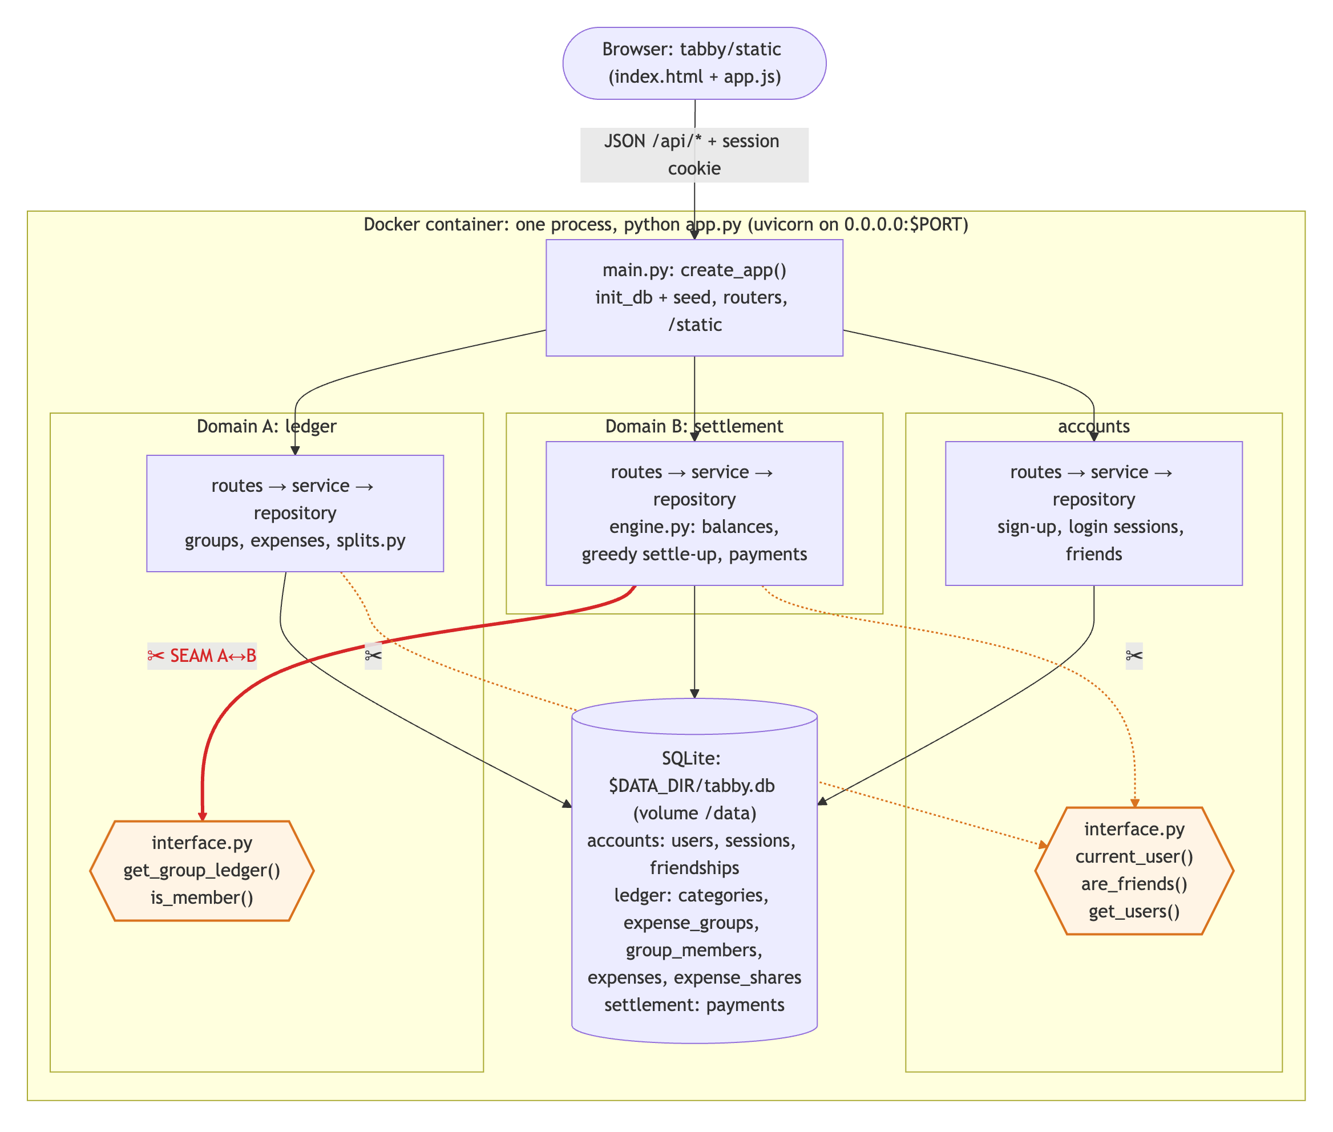
Figure 1. Architecture. The red arrow is the seam between Domain A and Domain B.
Each domain is a Python package with the same layers: routes.py (HTTP and Pydantic validation), service.py (business rules), repository.py (all SQL) and its own schema.sql. The rule that keeps them separable is that a domain may only import another domain's interface.py (ADR-2). The seam between the two required domains is `ledger.interface.get_group_ledger(group_id)`: settlement never reads ledger tables, it receives a plain GroupLedger (member ids plus each expense's payer, amount and per-member shares). What crosses the seam is therefore only ids and integer cents. In Assignment 2 this call becomes GET /groups/{id}/ledger on a ledger service, and the accounts functions current_user(), are_friends() and get_users() become calls to an accounts service, without rewriting the services behind them.

4. Database model
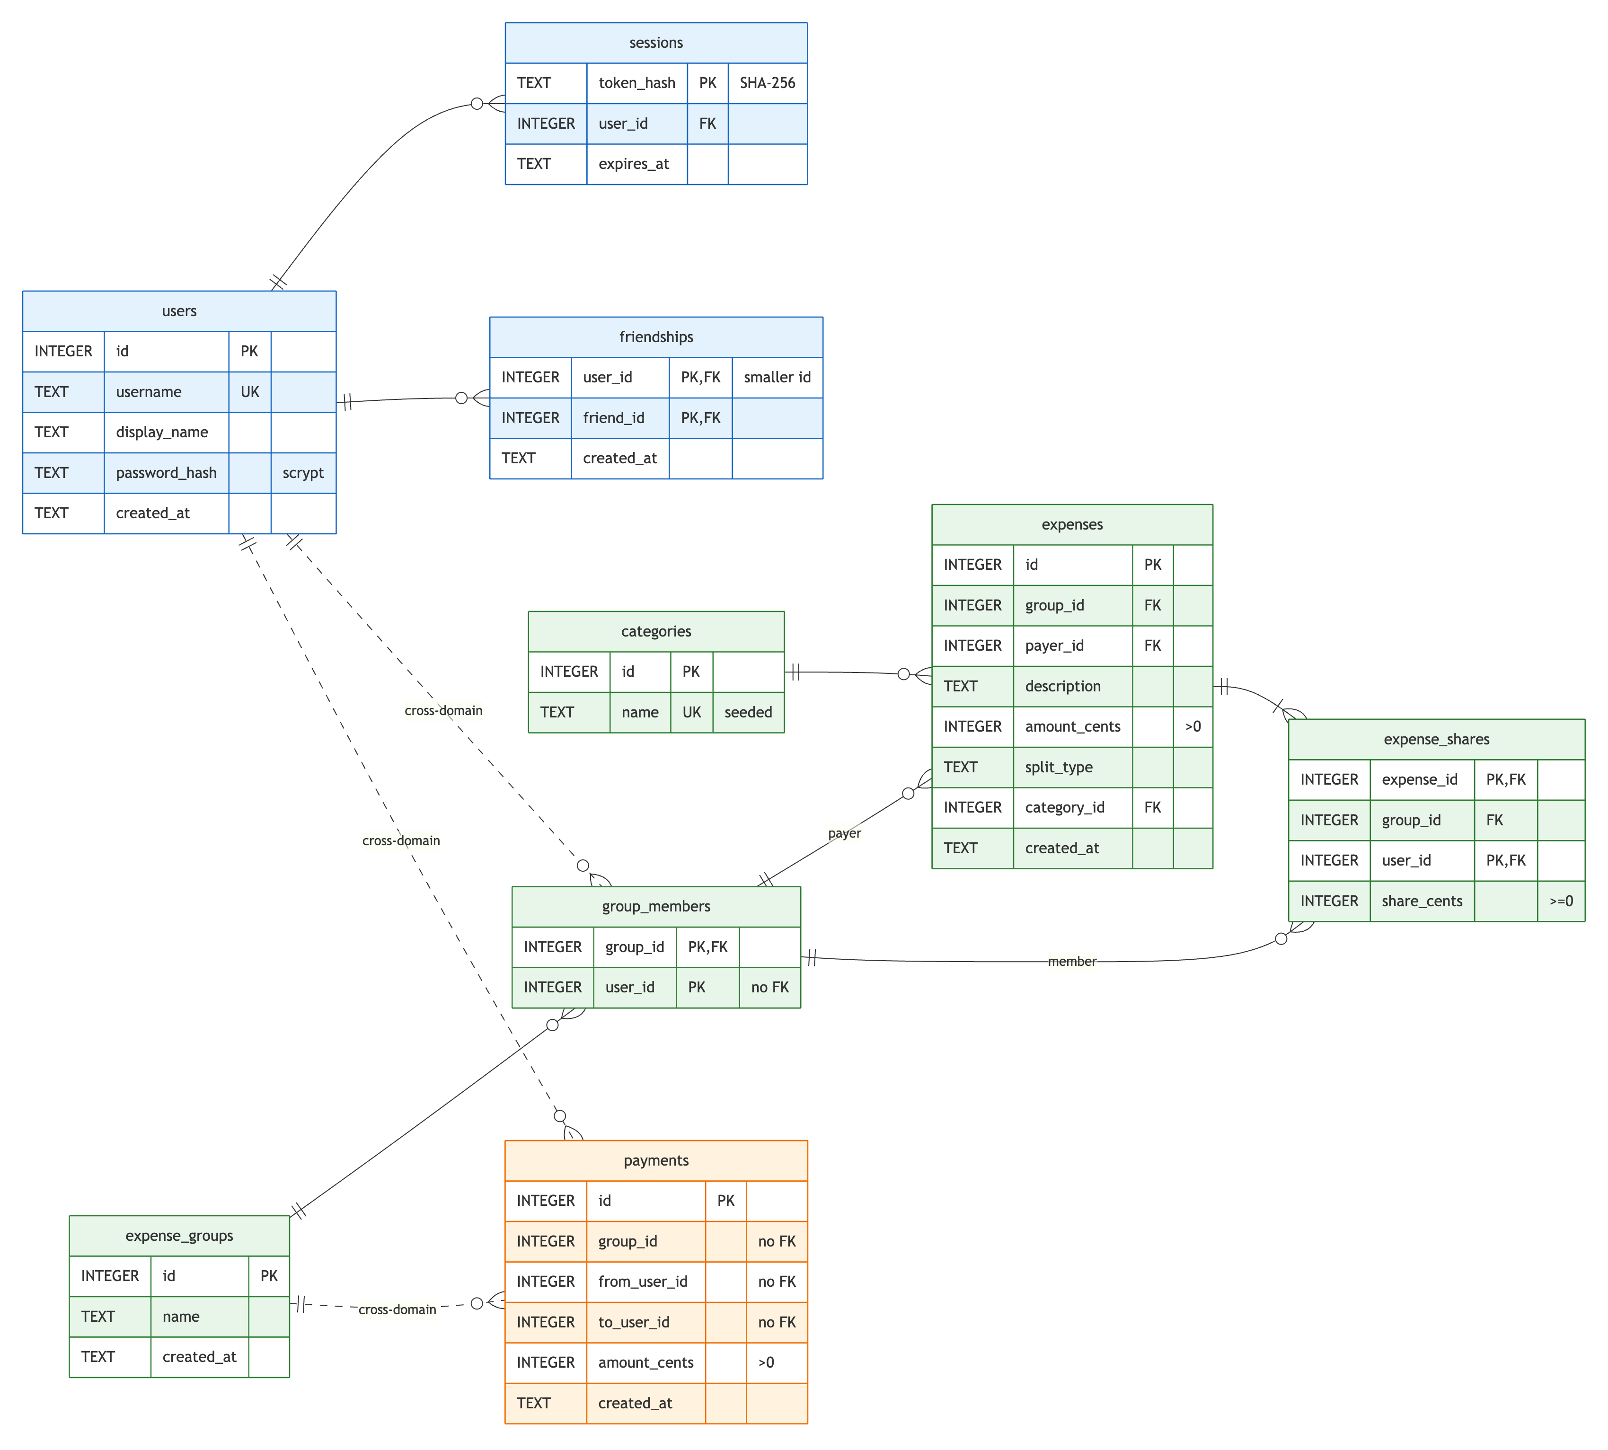
Figure 2. SQLite schema, colour-coded by owning domain. Dashed lines are cross-domain ids without foreign keys.
All nine tables live in $DATA_DIR/tabby.db, and the schema files only use CREATE ... IF NOT EXISTS, so a restart creates what is missing and never drops data. Three decisions shape the model (ADR-3):
- Money is integer cents. Floating point cannot represent most cent values exactly, so every amount is an INTEGER and all sums are exact.
- Splits are resolved when an expense is saved. splits.py turns equal, shares or exact input into one expense_shares row per participant using the largest-remainder method (10.00 between three people is 3.34 / 3.33 / 3.33), so the shares always add up to the amount and settlement never needs the split rules.
- Foreign keys stay inside a domain. Composite keys from expenses and expense_shares to group_members stop a member who appears in any expense from being removed. Ids that cross a domain (for example group_members.user_id, or payments.group_id) are plain integers, so each domain's tables can later move to their own database.
The only seed data is nine expense categories, committed as tabby/ledger/seed_categories.csv and inserted only when the categories table is empty, which run.sh confirms by finding categories=9 on both boots.

5. Key decisions
ADR | Decision | Main alternative rejected
1 Stack | Python 3.12, FastAPI, stdlib sqlite3, hand-written SQL | Flask (manual validation, no API docs); SQLAlchemy (overkill for 9 tables)
2 Seam | Domains only call each other's interface.py; no cross-domain foreign keys | Settlement joining ledger tables directly
3 Schema | Integer cents; splits stored as resolved per-member shares | REAL euros; recomputing shares from stored weights
4 Testing | Pure logic plus services against a real temporary SQLite file | HTTP-level TestClient tests; a mocked database
5 Not built | Friend requests: adding a friend is instant and mutual | A pending/accept/decline flow

Settlement uses a greedy algorithm: compute each member's net balance (positive means the group owes them), then repeatedly let the biggest debtor pay the biggest creditor the smaller of the two amounts. Every transfer brings at least one person to zero, so a group of n people needs at most n − 1 transfers. I chose it over an exact minimum because the exact problem is exponential and much harder to explain, while greedy is optimal or within one transfer of optimal for realistic groups.

6. Testing
The suite has 422 tests (many parametrized) and reaches 94% coverage of the whole tabby package with python -m pytest --cov=tabby. Every business-logic module (splits.py, engine.py, security.py and all three services) is at 100%. Each test gets a fresh SQLite file from a pytest fixture, so service tests exercise real SQL and constraints. Two property-style tests check that every split adds up to its amount and that 50 random groups always settle to zero in at most n − 1 transfers. The tests found a real bug: a negative SESSION_DAYS produced the SQLite modifier +-1 days and crashed login; it was fixed in its own commit. Left thinner on purpose: route bodies, the cookie check and the frontend JavaScript, which I verified by driving the UI in a headless browser with two accounts.

7. Running it and the container contract
Locally: pip install -r requirements.txt then python app.py. With Docker: docker build -t tabby . then docker run -p 8000:8000 -v tabby-data:/data tabby. The app reads PORT (default 8000), DATA_DIR (default ./data, /data in the container) and SESSION_DAYS (default 30), always binds 0.0.0.0, and needs no setup step. The final run.sh run on the submitted code passed every check: one manifest, a clean 57 MB build, HTTP 200 on port 8000, tabby.db under /data, data persisting across container recreation, unchanged row counts on a second boot, and HTTP 200 on port 9123. The full output is in the README.

8. Limitations and next steps
- No friend requests (ADR-5), no password reset and euros only; friend requests must come before opening Tabby to strangers.
- The ledger only blocks removing a member who appears in an expense; it cannot see settlement's payments, so a member who only made or received payments can still be removed. This cross-domain consistency gap will need a check through the settlement interface.
- Because CREATE TABLE IF NOT EXISTS never changes existing tables, future column changes need explicit migrations, which Assignment 2 will add.

9. AI disclosure
I acknowledge the use of Claude Code (Anthropic, model Claude Opus 5.5) to propose design options at each decision point, generate the application code, tests, diagrams and documentation drafts, and run and verify the application. The prompts used include "give me four app ideas with two separable domains", "give me options for Domain A: login, split types, member rules and how settlement gets the data", "build the settlement domain with balances, a greedy settle-up plan and recorded payments" and "write unit tests for the business logic to reach at least 70% coverage". The output of these prompts was used to build the Tabby code base, its tests, the ADR and AI usage log entries, the diagrams and this report, after I chose between the presented options at every decision; each interaction is logged in AI_USAGE.md.

