- Design:
  - Metric assumptions and principles
    - Volume is measured as comment-free lines of source code by reading each file using readFileLines from the IO module. This function will be used for the rest of the metrics where lines of code (LOC) are needed. Comments were filtered out for this and the rest of the metrics using regular expressions. The regular expressions will fail to match if comment markers e.g. // appears later in the line (inside a string or after some code).
    - The number of units is measured as the total count of methods in a project. Method locations are obtained from the M3 model using the methods() function, which includes constructors and static initializers. This function will be used for the rest of the metrics.
    - Unit size is measured by counting the source LOC per method. Unit size thresholds are based on the 70th, 80th, and 90th percentiles from benchmark data (Visser et al., Deriving Metric Thresholds from Benchmark Data), classifying methods as simple (≤ 30 LOC), moderate (> 30 and ≤ 44 LOC), high (> 44 and ≤ 74 LOC), and very high (> 74 LOC). Percentages are computed as a division of LOC per category by the total LOC in the files. During the online sessions in the course it was said that one could also choose the CC tresholhds, or the SIG/tüvit evaluation criteria but since the author of the aforementioned article also is one of the creators of the SIG we opt for these treshholds.
    - Cyclomatic complexity (CC) is approximated for each method to assess its structural complexity and associated risk, based on McCabe’s original metric (number of predicates + 1). Each method’s CC is calculated by counting decision points in the method’s abstract syntax tree, including conditional statements, loops, case labels in switch statements, exception handling, and logical operators (&&, ||), with a base complexity of 1 for the method itself. A check is performed on the scheme to verify whether the scheme is a method,constructor or initializer (to conform to the previous metrics). Methods are then classified into risk categories according to SIG-thresholds: simple (CC 1–10), moderate (11–20), high (21–50), and very high (> 50). The CC per risk category are summed up, and percentages are calculated with regards to the total complexity.
    - Code duplication is measured as the percentage of all comment-free, normalized, leading/trailing spaces-free source code that occurs more than once in equal code blocks of at least 6 lines. The function processes all Java files in the project, constructs overlapping six-line blocks, maps each block to its occurrences, and identifies blocks that appear more than once. Each duplicated block except the initial one counts as 6 lines. Percentages are calculated with regards to the total, also comment-free, normalized, leading/trailing spaces-free, source code lines.

  - Scoring

Each calculated metric is evaluated against a set of predefined values provided by the SIG maintainability model. Each score is mapped to a qualitative rating ranging from very poor to very good, which represented using a combination of ‘-‘ and ‘+’ signs.

    - Volume
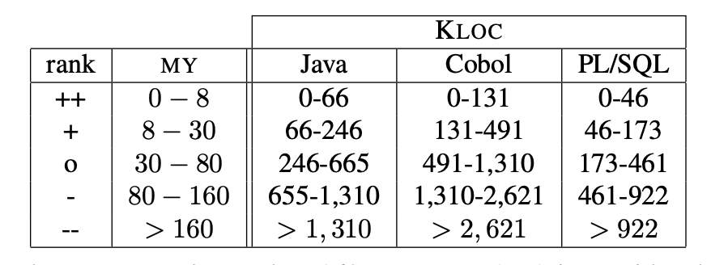
The total lines of code are categorised in certain thresholds, measured in Lines of Code (LOC). The measured LOC are categorised in predefined thresholds, expressed in thousands of lines of code (KLOC), as shown in the table below.
- Unit size

Unit size is is the size of the individual units. They are categorised in the distribution of ‘moderate’, ‘high’ and ‘Very High’ based on their size. For each risk category, the proportion of units must remain below predefined thresholds. The metrics used are the same as Cyclomatic complexity because there is a strong statistical correlation between LOC and Complexity. The thresholds can be seen in the table under the Cyclomatic complexity section.

- Cyclomatic complexity

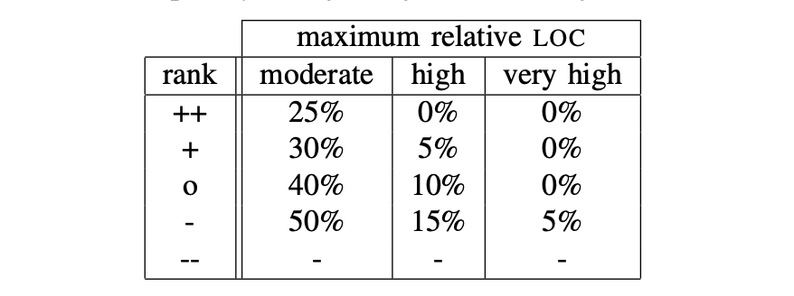
Cyclomatic complexity measures the complexity per unit. Like Unit size, units are classified into different risk levels based on their complexity. The distribution of these risk levels is then compared against predefined thresholds provided by the Software Engineering Institute (SEI).
- Duplication

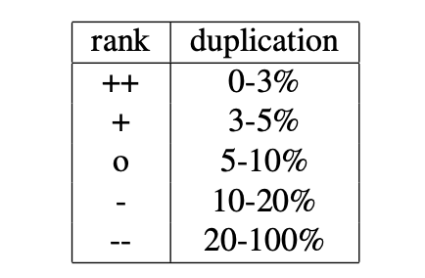
The amount of duplicates lines is measured in a percentage. This percentage is then again compared to a rating scheme. This states that a well-designed system should not have more than 5% of code duplication.

- Design of visualisation.
We chose the treemap fine-grained visualization because maintainability issues in mainly arise at the method level, where size and complexity directly affect analysability,testability and changeability. Since both systems have a substantial amount of units and low unit size and complexity scores, it is important to quickly identify which methods contribute most to maintenance risk. The treemap makes this possible by mapping each method to a rectangle whose size reflects LOC and whose color indicates risk. When hovering over the method, one sees the real numbers and the file to which the method belongs. This allows maintainers to immediately spot large, high-risk methods and clusters of problematic code.
The bar chart showing total LOC per file was chosen to reveal maintainability problems at a higher scoarse grained level. Large files are harder to analyse. By clearly highlighting files that contain an excessive amount of code, the bar chart helps identify maintenance hotspots where refactoring would be most effective. Together, these visualizations connect the low maintainability score to concrete code locations and support targeted improvement efforts.
The node-link diagram visualizes code duplication between source files to identify structural dependencies caused by duplicated code. The nodes represent java source files which contain an amount of duplicated code. The total amount of duplicated LOC is indicated by the color of the node. The edges represent the amount of duplicated LOC between two source files. The weight of the edge notes the specific amount and a color gives a quick indication on the risk level.
By visualising the LOC between source files, we can clearly detect clusters which contain high amount of duplication. This can indicate that there is a lot of copy-paste or insufficient use of abstraction. These clusters are useful for identifying candidates for refactoring. Changes to on file may require updates to subsequent files that are related.
- Results - Interpretation. What do the results say about the maintainability of the system(s) you reviewed? Base your analysis on the scores from the SIG maintainability model and on the developed visualisation. Can you identify any risk areas? Does the visualisation provide new insights into the maintainability?
  - SmallSql metrics

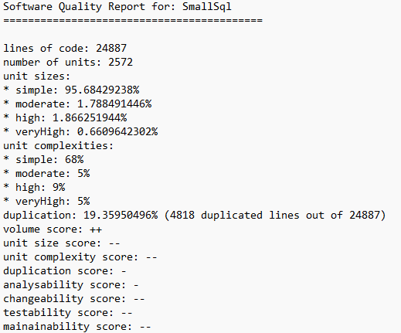
The SIG maintainability results indicate that the system’s maintainability is overall weak, despite having a manageable size. The volume score is positive (++), reflecting that with around 24,887 lines of code and 2,572 units, the system is not excessively large and thus pretty analysable. The majority of the units are small, further supporting analysability and testability. However, this benefit is undermined by poor unit complexity scores, suggesting that a subset of large or complex units has a disproportionate negative impact.
Complexity and duplication are the dominant factors reducing maintainability. Around 14% of units fall into high or very high complexity categories, which strongly affects analysability and testability in the ISO 9126 model. Furthermore, nearly 19.4% code duplication significantly reduces changeability and analysability, since duplicated logic increases the risk of inconsistent updates and defects. These issues make the system harder to understand, modify, and verify. Despite a positive volume score, the negative effects of complexity, duplication result in a poor overall maintainability score (--), indicating that refactoring would be necessary to improve long-term maintainability.

  - SmallSql visualization
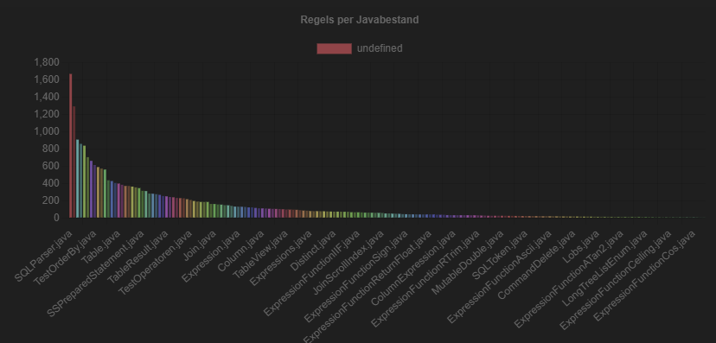
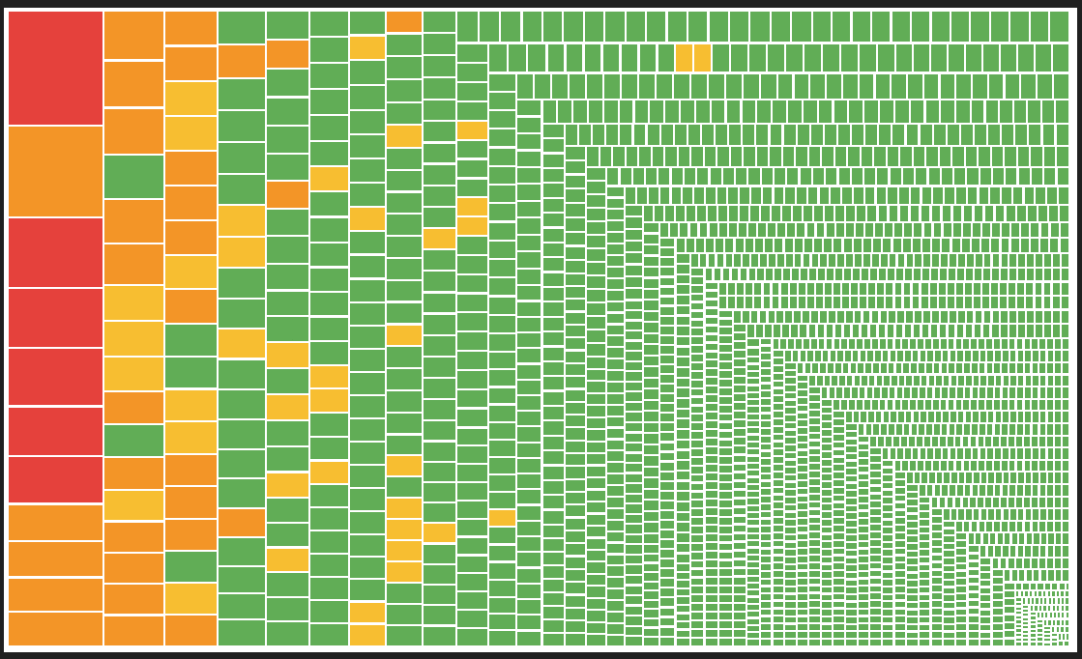
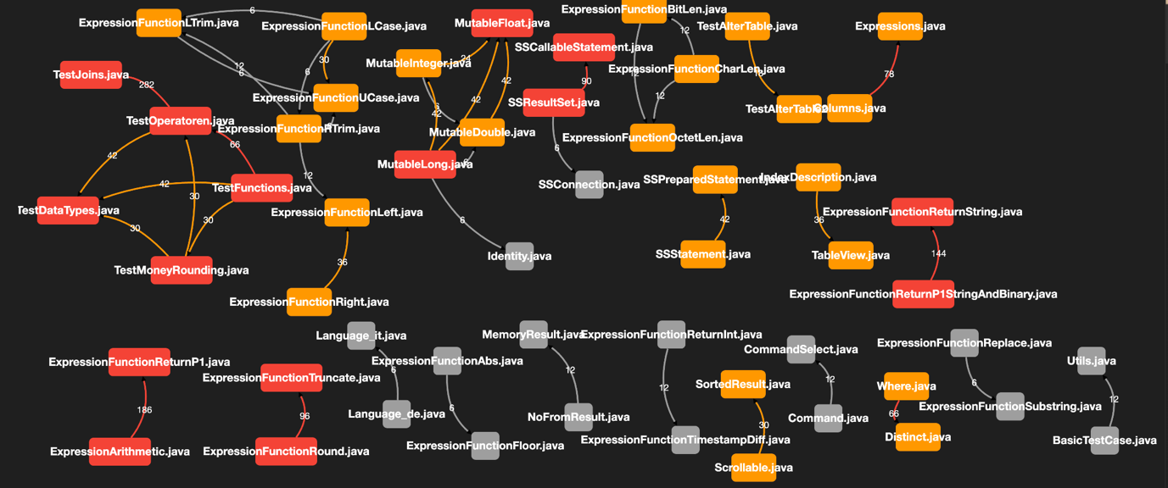
The nodes in the treemap show the methods in the system, where the LOC defines the size, and the color the risk. The large red (cc> 50) and orange methods (CC > 20) act as (very) high-risk bottlenecks. The "Very High" risk methods would require a disproportionate amount of maintenance effort because their high cyclomatic complexity makes them nearly impossible to fully test, leading to a higher probability of bugs whenever changes are made. While the vast majority of the system consists of "Simple" green methods that are modular and easy to maintain, the presence of the methods on the left suggests that core business logic is likely entangled in these complex blocks.

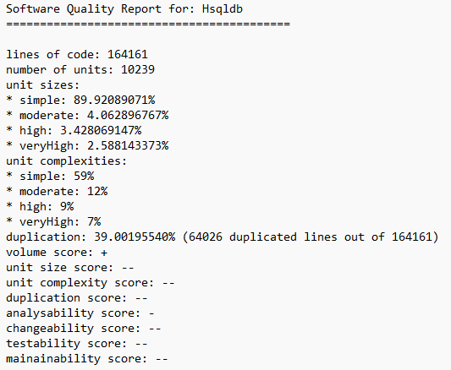
The SIG maintainability results show that the system has poor overall maintainability. With more than 164,000 lines of code and over 10,000 units, the system is substantially larger than the previous one. While most units are classified as simple, a noticeable proportion of high and very high unit sizes negatively affects analysability and testability and increases maintenance effort.
Complexity and duplication are once again the dominant factors reducing maintainability.
Nearly 16% of units fall into the high or very high complexity categories, which strongly reduces changeability and testability. The very high level of code duplication of 39% severely undermines changeability and analysability. The results suggest that substantial refactoring, particularly focused on reducing duplication and simplifying complex units, would be required to significantly improve the system’s maintainability.

- Evaluation and reflection
  - Validity. How accurate are the results you found and how have you validated the accuracy?
Manual testing of each metric
  - Evaluation of visualisation. Critically assess the developed visualisation, mention strength and weaknesses.
- Cooperation.
Version control was done via Github. Initially the work was done on the main branch to get the project started. We then transitioned to working with fseperate eature branches, which we then completed using pull requests. This approach reduced the risk of merge conflicts and a clear understanding between the team member of the specific features.

Task division was discussed during weekly meetings. Serge was responsible for developing the evaluation metrics, the barchart and treemap visualizations, while Tibo helped refine the metrics, implemented the scoring system and visualised the duplication metric. The software-independent file generation was a joint effort, with both members contributing collaboratively. This approach ensured clear ownership of tasks while maintaining effective collaboration and consistency across the codebase.

The length of your report should be equivalent to 3 text-filled pages, excluding pro-
gram output, figures and tables.

