Capstone Project I

Goal: I will act as if I was an employee of a movie company who desires what artist has the best options for the movie. The final goal is to send a report to be read by all departments as an introduction to give each one a taste of the current most popular artist. This is more of a roleplay and this report will be given to all departments during the first meeting to decide what datasets or analysis we need to go forward.

**INTRODUCTION**

This report includes a comprehensive collection of artists and their songs based on both popularity and their number of streams. Popularity in this context is defined as the rate in which the number of streams in relation to time. Streams in this context are defined by the number of views or the number of times a song is played. In the case of our top 40 artists, it’s the sum of all song’s views.

**Analysis**

One metric for measuring the popularity of an artist is the supply of music as if supply is high, then it might suggest there is high demand. Below shows each artist and the total number of songs for the top 40 artist with the most songs however it doesn’t necessarily mean its popular.

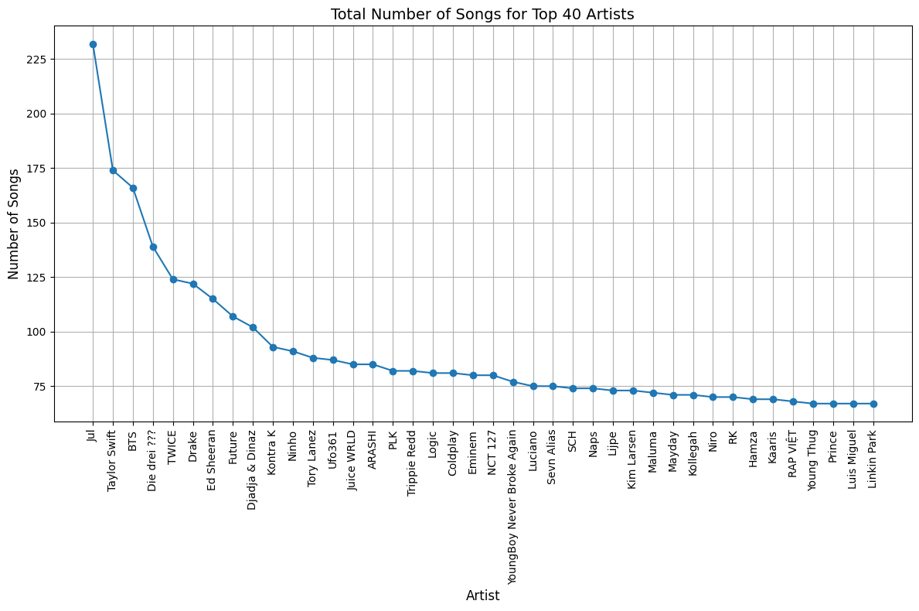

However, the count of songs is already one part of the story. The second part of the story is the total view count. While Jul shows up as the highest in the graph above, it does not show up in the top 40 for views but some of the artists above appear below.

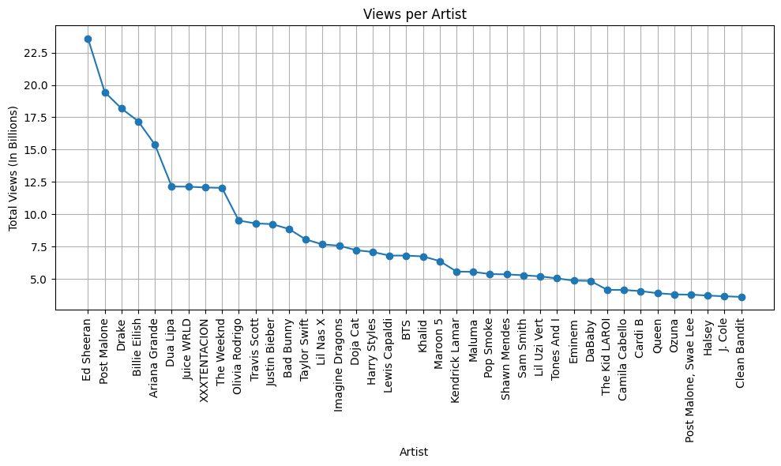

The presence of artists such Taylor Swift, Ed Sheeran, Drake in both graphs indicates that there is a slight relationship between supply and popularity however the correlation of higher supply equals higher demand is not necessarily valid, rather it is more the other way around, as demand gets higher, supply tries to meet it hence why Taylor Switch, Ed Sheeran, and Drake with some of the highest view counts appear in both graphs

Additionally, this can be confirmed by popularity which is defined by the total weeks the artist has first released on Spotify divided by the total number of views. This metric sets a clear relationship between time and view count. Like an odometer in a car, views only go up through time, but the rate differs.

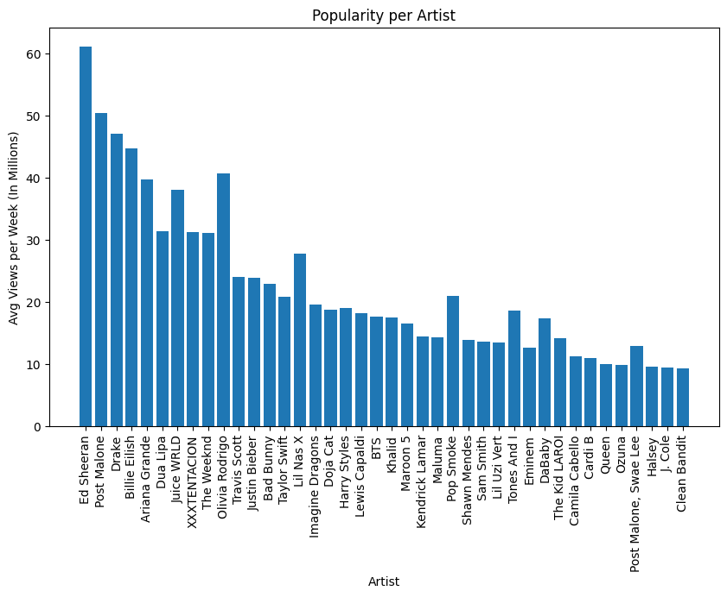

The similar shapes between all graphs indicate a strong relationship that popularity can be defined by the number of views and the number of songs made. While the number of songs doesn’t directly match the popularity, views define the demand while the supply tries to meet that demand results in a higher popularity.

This report has shown what defines a popular artist and thus, gives insight into what artist should be used to create the song for the movie. The final decision will most likely be based off the desired genre. One important note is collaboration between artists such as Post Malone and Swae Lee. Should this go forward, a new dataset would have to be collected. The dataset desired would be based mostly on the desires of the Creative Team. Should any departments have interest in the data source or the code, it has been included within the email sent.