* joocfkna vefoifd kmkm absfnvsofbnsf bjsrfikvnkqenrvkaefnv akdcjnfvjaejofvnaejuvnqujbnvajefnvnf vkengjiJjnhpadvfsjnfbns ksfnknOJNjpbPJIBpbhhiBIPHJVBpbjupjBPJBPBJb*

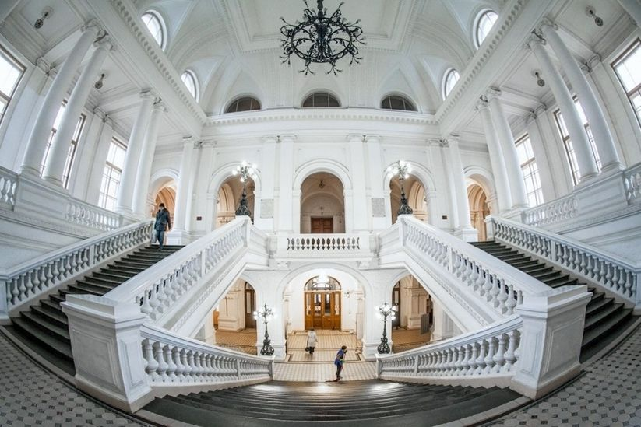

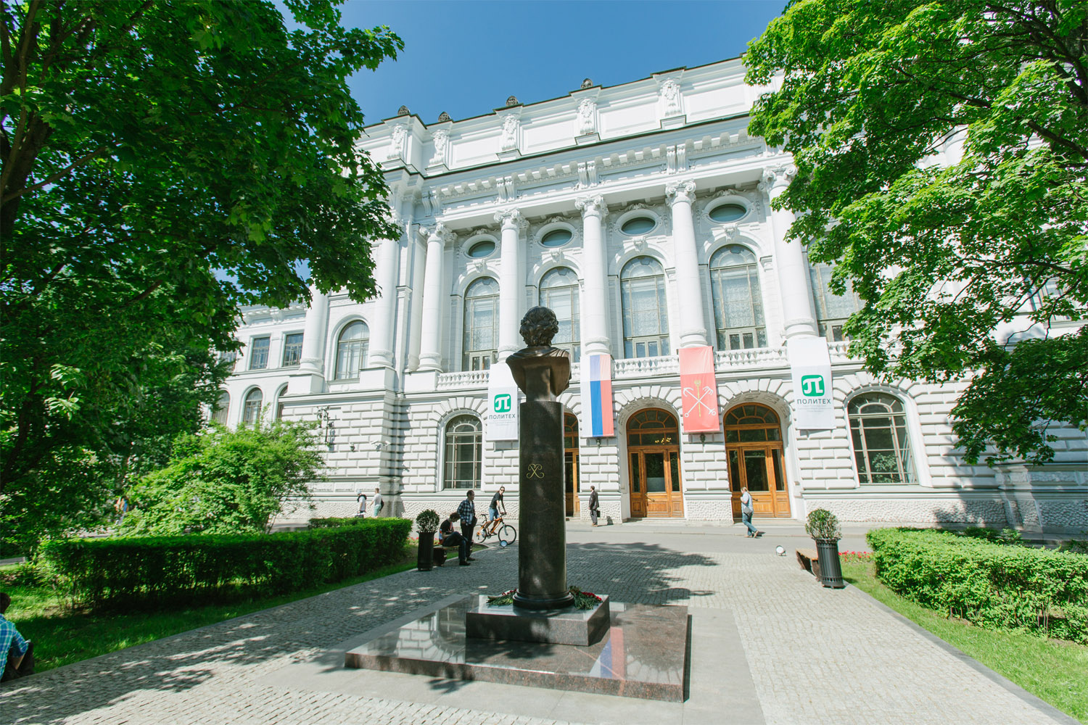

*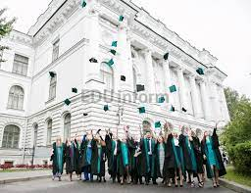*

* joocfkna vefoifd kmkm absfnvsofbnsf bjsrfikvnkqenrvkaefnv akdcjnfvjaejofvnaejuvnqujbnvajefnvnf vkengjiJjnhpadvfsjnfbns ksfnknOJNjpbPJIBpbhhiBIPHJVBpbjupjBPJBPBJb*