|  |  |
| --- | --- |
| Предмет | МДК 03.01 ТРПО |
| Дата | 15.11.2019 |
| Группа | 374 |
| Студент | Безуглый С.Д. |
| Работа | №10 |

1. Создадим приложение для операций с датами.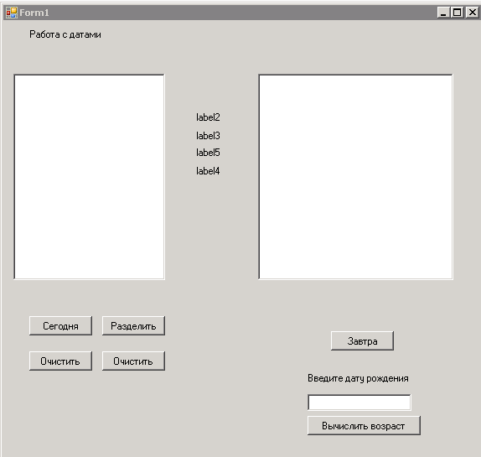
2. Программа в рабочем состоянии.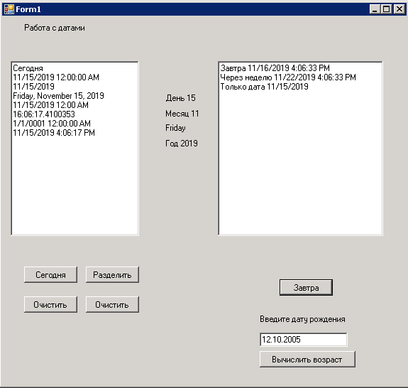
3. Исходный код:
4. using System;
5. using System.Collections.Generic;
6. using System.ComponentModel;
7. using System.Data;
8. using System.Drawing;
9. using System.Linq;
10. using System.Text;
11. using System.Threading.Tasks;
12. using System.Windows.Forms;
13. namespace L11
14. {
15. public partial class Form1 : Form
16. {
17. public Form1()
18. {
19. InitializeComponent();
20. }
21. private void button4_Click(object sender, EventArgs e)
22. {
23. richTextBox1.Clear();
24. richTextBox1.Text += "Cегодня\n";
25. DateTime thisDay = DateTime.Today;
26. richTextBox1.Text += thisDay.ToString() + "\n";
27. richTextBox1.Text += thisDay.ToString("d") + "\n";
28. richTextBox1.Text += thisDay.ToString("D") + "\n";
29. richTextBox1.Text += thisDay.ToString("g") + "\n";
30. string currentTime = DateTime.Now.TimeOfDay.ToString();
31. richTextBox1.Text += currentTime + '\n';
32. var someTime = new DateTime();
33. richTextBox1.Text += someTime.ToString() + '\n';
34. richTextBox1.Text += DateTime.Now.ToString() + '\n';
35. }
36. private void button1_Click(object sender, EventArgs e)
37. {
38. richTextBox1.Clear();
39. }
40. private void button3_Click(object sender, EventArgs e)
41. {
42. DateTime sDay = DateTime.Today;
43. label2.Text = "День " + sDay.Day;
44. label3.Text = "Месяц " + sDay.Month;
45. label4.Text = "Год " + sDay.Year;
46. label5.Text = Convert.ToString(sDay.DayOfWeek);
47. }
48. private void button2_Click(object sender, EventArgs e)
49. {
50. label2.Text = "";
51. label3.Text = "";
52. label4.Text = "";
53. label5.Text = "";
54. }
55. private void button6_Click(object sender, EventArgs e)
56. {
57. richTextBox2.Clear();
58. DateTime sDay = DateTime.Now;
59. DateTime zDay = sDay.AddDays(1);
60. richTextBox2.Text += "Завтра " + zDay;
61. zDay = sDay.AddDays(7);
62. richTextBox2.Text += "\nЧерез неделю " + zDay;
63. DateTime tDay = DateTime.Today;
64. richTextBox2.Text += "\nТолько дата " + tDay.ToString("d");
65. }
66. private void button5_Click(object sender, EventArgs e)
67. {
68. DateTime nowDate = DateTime.Today;
69. DateTime dt = Convert.ToDateTime(textBox1.Text);
70. int age = nowDate.Year - dt.Year;
71. richTextBox2.Text = Convert.ToString(age) + " лет";
72. }
73. }
74. }